B1
mkdir MyECommerce
cd MyECommerce
dotnet new sln -n MyECommerce

B2
- tạo Directory.Packages.props
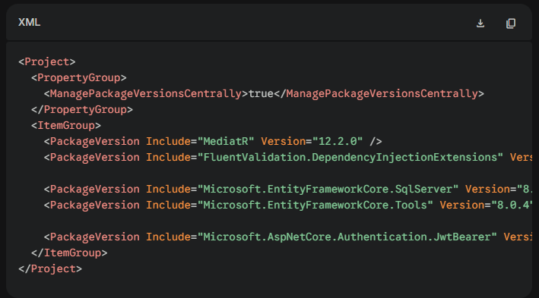

B3 :
mkdir BuildingBlocks
cd BuildingBlocks

# Tạo 4 project Class Library
dotnet new classlib -n Shared.Domain
dotnet new classlib -n Shared.Application
dotnet new classlib -n Shared.Infrastructure
dotnet new classlib -n Shared.API

# Quay lại thư mục gốc và add chúng vào Solution
cd ..
dotnet sln add "BuildingBlocks/Shared.Domain/Shared.Domain.csproj"
dotnet sln add "BuildingBlocks/Shared.Application/Shared.Application.csproj"
dotnet sln add "BuildingBlocks/Shared.Infrastructure/Shared.Infrastructure.csproj"
dotnet sln add "BuildingBlocks/Shared.API/Shared.API.csproj"

Cài đặt thư viện cho phần Shared: Chúng ta chỉ cài những thứ chắc chắn dùng chung. (Do đã có file Directory.Packages.props, lệnh cài không cần kèm theo --version).
# Shared.Application cần dùng MediatR để làm Base Response / CQRS
dotnet add BuildingBlocks/Shared.Application/Shared.Application.csproj package MediatR

# Shared.Infrastructure cần EF Core để làm Base Repository
dotnet add BuildingBlocks/Shared.Infrastructure/Shared.Infrastructure.csproj package Microsoft.EntityFrameworkCore.SqlServer

# Shared.API cần JWT để viết Middleware giải mã Token chung
dotnet add BuildingBlocks/Shared.API/Shared.API.csproj package Microsoft.AspNetCore.Authentication.JwtBearer

B4 : tạo template service
mkdir Services
cd Services
mkdir TemplateService
cd TemplateService
mkdir src
cd src

# Tạo 4 tầng cho Service. Lưu ý tầng API phải là project WebAPI
dotnet new classlib -n Template.Domain
dotnet new classlib -n Template.Application
dotnet new classlib -n Template.Infrastructure
dotnet new webapi -n Template.API

# Quay lại thư mục gốc và add vào Solution
cd ../..
dotnet sln add "Services/TemplateService/src/Template.Domain/Template.Domain.csproj"
dotnet sln add "Services/TemplateService/src/Template.Application/Template.Application.csproj"
dotnet sln add "Services/TemplateService/src/Template.Infrastructure/Template.Infrastructure.csproj"
dotnet sln add "Services/TemplateService/src/Template.API/Template.API.csproj"

B5:
// add ref external
dotnet add Services/TemplateService/Template.Application/Template.Application.csproj reference Services/TemplateService/Template.Domain/Template.Domain.csproj

dotnet add Services/TemplateService/Template.Infrastructure/Template.Infrastructure.csproj reference Services/TemplateService/Template.Application/Template.Application.csproj

dotnet add Services/TemplateService/Template.API/Template.API.csproj reference Services/TemplateService/Template.Infrastructure/Template.Infrastructure.csproj

=======building block=============
dotnet add Services/TemplateService/Template.Domain/Template.Domain.csproj reference BuildingBlocks/Shared.Domain/Shared.Domain.csproj

dotnet add Services/TemplateService/Template.Application/Template.Application.csproj reference BuildingBlocks/Shared.Application/Shared.Application.csproj

dotnet add Services/TemplateService/Template.Infrastructure/Template.Infrastructure.csproj reference BuildingBlocks/Shared.Infrastructure/Shared.Infrastructure.csproj

dotnet add Services/TemplateService/Template.API/Template.API.csproj reference BuildingBlocks/Shared.API/Shared.API.csproj

B6 : vào MyECommerce/Services/TemplateService/
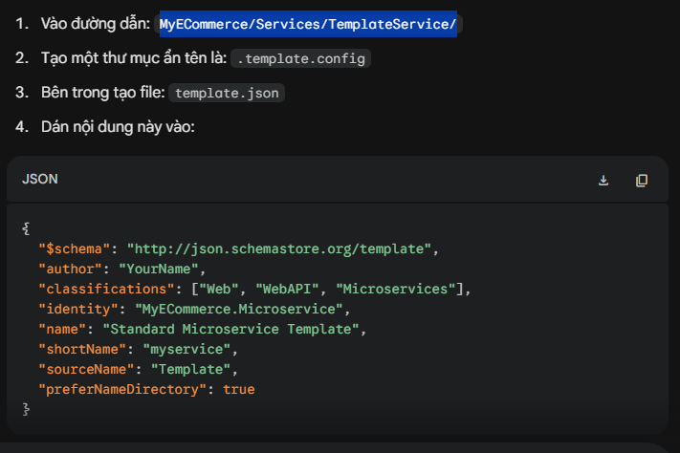

- dotnet new install ./Services/TemplateService

- nếu có sửa template.json thì phải
dotnet new install ./TemplateService --force (ở file services)

dotnet new myservice -n ProductService --force (ở file services)

