**INSTRUCTION OF RUNNING SELENIUM AUTOMATION TEST DEMO.**

**Project purpose:**

This project is to demonstrate the automation test for job application to Youi, using environment http://demowebshop.tricentis.com/

**Website analysis:**

The demo environment is a website which is selling products online, including: books, computers, electronic devices etc.

The website also contains register function, which allow user to register as a member. It also provides number of other functions like Login, Logout, Searching Shopping cart, and Wishlist...

As a standard online shopping website, there are numbers of critical functions which users will interact mostly with the system, so that those functions always need to be responsible at all time.

**In purpose of test requirements**, I would like to address 5 high risk areas of the application:

1. Search store function: this is very import function which a user or buyer would like to use every time they access to the system. Users will not have much time to browse each of categories of products. Instead, they will prefer to use search function to navigate to the right product they are looking for.
2. Register user: this is critical function which allows a new user to become a loyal customer of shop. Those loyal customers are the most important income source of any organization. Therefore, a bug which will prevent customer to be registered is unacceptable of any shop.
3. Login user: a loyal customer is usually stored his favor search items, payment information in his profile. If a customer can not log in, then it will prevent user to buy new products and make payment and that means the shop will lose the sale.
4. Logout user: a loyal customer is usually stored his favor search items, payment information in his profile. That information is very important and can not be leaked to any unauthorize person. A succeed logout action will prevent security breach, and protect customer to expose financial and personal information.
5. Shopping cart: This is the fifth high risk function of the sale website. All products which are selected by customers have to be recorded and retrievable when clients want to checkout and process payment. Any missing item will result bad shopping experience from clients. Also, as a consequence, the shop will lose money for those missing items.

**Automation test scripts:**

I have written the first four testcases using Selenium WebDriver. The project is pushed in Github and it is public to be downloadable. The 4 test cases are: Register new user, Login, Logout, and search for item.

**Running project instruction:**

1. Project is built in C# .NET Core in Visual Studio Community 2019.
2. Browser to compatible with project: Google Chrome version 102.x.xxxx. The browser and version can be changed base configuration. In this test, I write it specifically for Chrome only, and due to time limitation, I did not configurate test project to run in multi versions. The following is instruction change version of Chrome to run demo. First step: check google chrome version in your computer: paste chrome://settings/help in Chrome address bar and look for version number. Second step: Open test project in Visual Studio 2019 (VS 2019), then open menu Project->Manage NuGet Package. In the UI, switch to tab Installed and scroll down to Selenium.WebDriver.ChrmoeDriver package. Select that package, and select version which is similar to Google Chrome version on the right of solution and update.

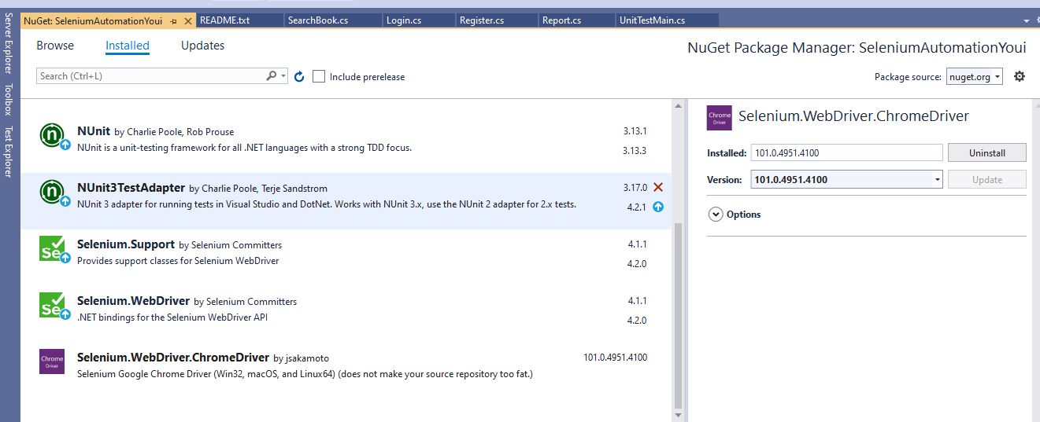

1. Run NUnit Testcripts: Build project. Then select Test menu on top of solution, then select Test Explorer.

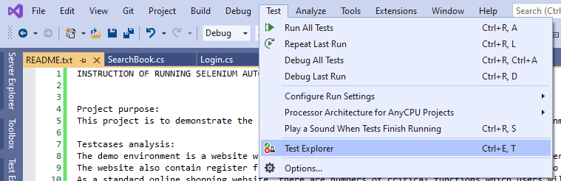

In test explorer tab, you can expand to a testcase name FullTestScenario and click play button on top left of Test Explorer to perform automation test.

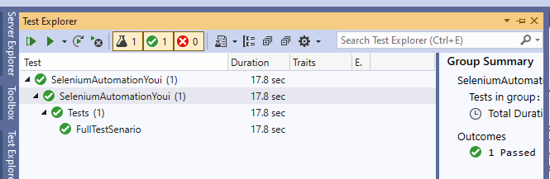

When the test is running, it will automatically open the Chrome browser and perform all action in fast speed. When the test is finished, you can see the checkbox say pass or fail..

1. Also, I built a extent report in html which allow you to view all steps log as a final report. The location of the report will be inside project and follow as SeleniumAutomationYoui/SeleniumAutomationYoui/bin/Debug/netcoreapp3.1/index.html

Report will look like this.

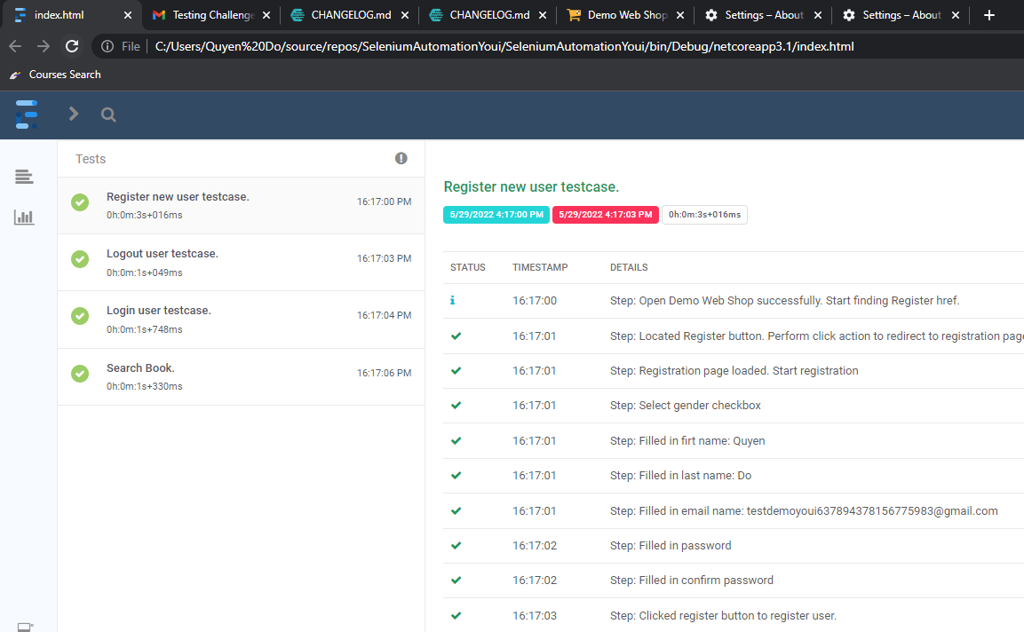

1. Should you need more instruction, please feel free to email me [quyen.galiso@gmail.com](mailto:quyen.galiso@gmail.com) or phone 0421649083