Do Tien Dat – 24110211
CSE3057

Machine Learning Class Midterm Project Report

[1] Load the MNIST dataset (introduced in Chapter 3), and split it into a
training set, a validation set, and a test set (e.g., use 50,000 instances for
training, 10,000 for validation, and 10,000 for testing).

[2] Then train various classifiers, such as a random forest classifier, an extra-
trees classifier, and an SVM classifier.

1. Random forest
Model Stats:
+Train score: 1.0
+Validation accuracy: 0.9709
+Precision: 0.9709
+Recall: 0.9709
+F1-score: 0.9709
RF confusion matrix
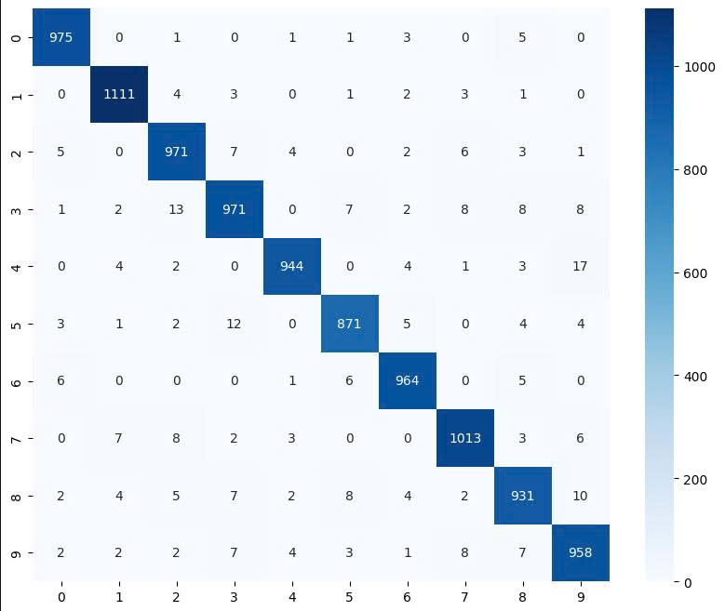

Evaluate:
- Model score on the train_set is 1.0 (100%) but the score on the validation_set (0.9709) is lower, that’s a sign of overfitting. This overfitting level is is quite moderate. The fact that model achieved 97.09% accuracy on an unseen validation set is still impressive.
- In the confusion matrix, the main diagonal line is lighting up, this show that the model has identified the vast majority of digits from 0 to 9 with extreme accuracy.
- Model’s blind spots:
+ Confusing 4 for 9 (17 cases)
+ Confusing 3 for 2 (13 cases):
+ Confusing 5 for 3 (12 cases)
+ …

2. Extra Trees Classifier
Model Stats:
+Train_set score: 1.0
+Validation_set accuracy: 0.9731
+Precision: 0.9731
+Recall: 0.9731
+F1-score: 0.9731
Extra Trees confusion matrix
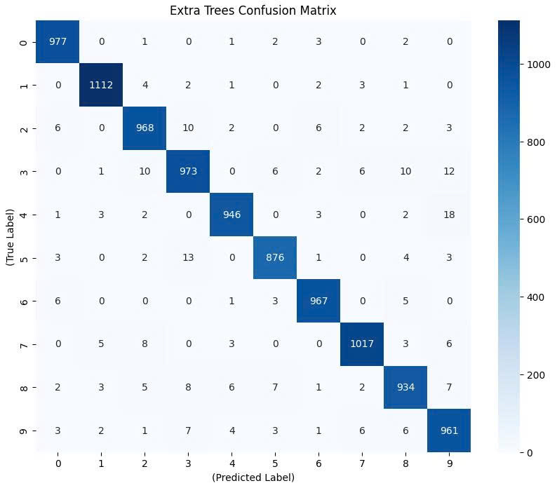

Evaluate: On the validation set an increase of 0.0022 means Extra Trees model correctly classified roughly 22 more images. Overfitting is still present, Extra Trees are still memorizing the training dataset entirely.. ET still belongs to the decision tree-based, it remains ineffective against digits with very similar structural patterns (4 – 9, 5 – 3).

3. SVM Classification
- The SVM need scaled data to perform its best so its need to be wrap in a pipeline to preprocess automatically. I’m gonna use standard scaler to scale the data as its turn pixel numbers from 0-255 to numbers around 0.
- Model Stats:
+ Train score: 0.9979
+ Validation accuracy: 0.9722
+ Precission: 0.9724
+ Recall: 0.9722
+ F1-score: 0.9722
SVC Confusion Matrix
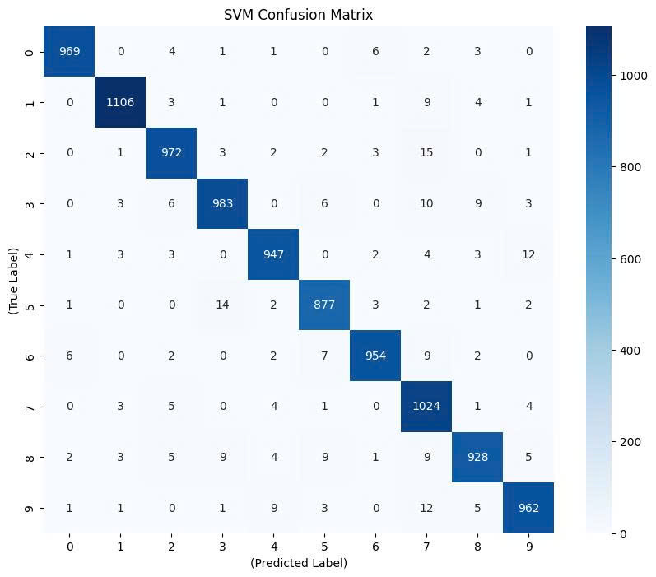

Evaluate: This model is still overfitting but compare to RF, SVC is perform slightly better generaliztion abilities. Precission, Recall and F1-score are almost exactly the same and very close to the Accuracy point indicates that model is developing very evenly. It is not "biased" or experiencing any particular difficulty with any specific number.

[3] Next, try to combine them into an ensemble that outperforms each
individual classifier on the validation set, using soft or hard voting.

1. Ensemble ‘hard’
- The combine of 3 models RF, ET and SVC.
- Model Stats:
+ Train score: 1.0
+ Precision: 0.9751
+ Recall: 0.9751
+ F1-score: 0.9751

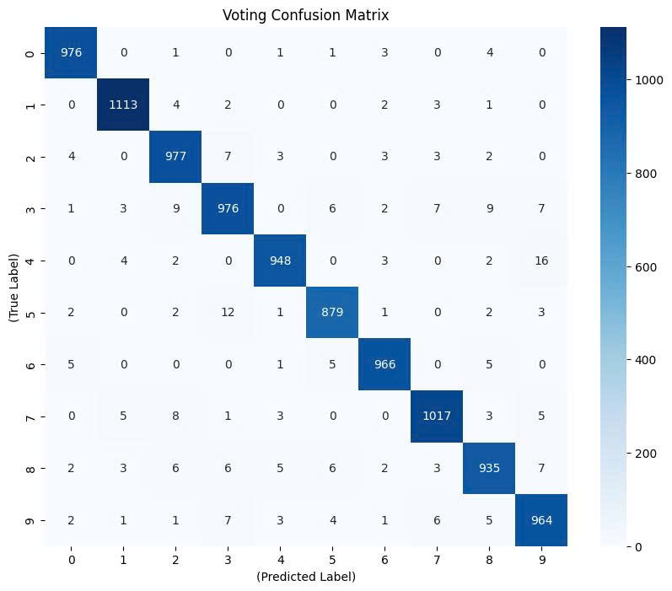

Evaluate: Due to the combination of 3 models, every stats improve, the gap between validation accuracy and train score its getting closer but still the model is slightly overfitting. Every stats of this model is balanced.

2. Ensemble ‘soft’
- Hard voting count the vote of models, soft voting priortise the confident level of every model, this would be a better solution for this problem.
- Model stats:
+ Train score: 1.0
+ Accuracy: 0.9817
+ Recall: 0.9817
+ F1- score: 0.9817
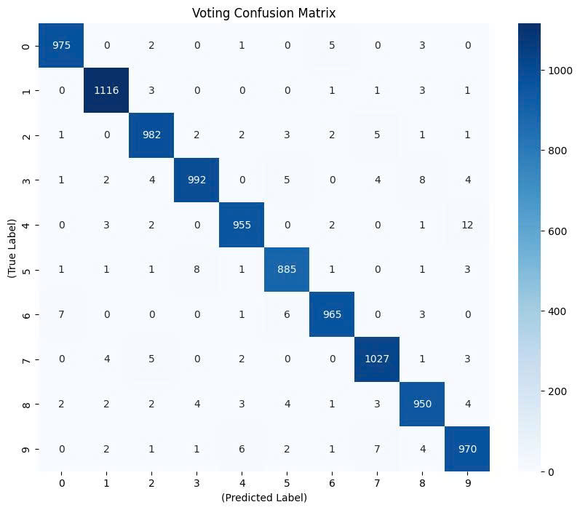

Evaluate: This is the best model so far, every stats is balanced, highest score in every stats, the gap between validation and train score is really close. Even though its slightly overfit, its still smart enough to generalize very well.

[4] Once you have found one, try it on the test set.

Trying Voting Soft on the test set: 0.9785
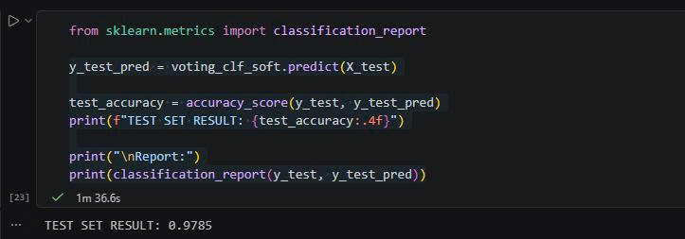

Individual Models:
+ Random Forest: 0.9657
+ Extra Trees: 0.9706
+ SVM: 0.9694

[5] How much better does it perform compared to the individual classifiers?
- Compare to individual classifier, Voting Soft model clearly out perform 3 individual models.

Conclusion: This project showing the power of ensembling models in classification problem, how its improve and complete the result. Suggested improvements for this problem could be Data Augment, create new data by moving the pixel in picture to getting closer to 99% on validation set.

