P4. An examination consists of multiple-choice questions, each having five possible answers. Suppose you are a student taking the exam. and that you reckon you have probability 0.75 of knowing the answer to any question that may be asked and that, if you do not know, you intend to guess an answer with probability 1/5 of being correct. What is the probability you will give the correct answer to a question?

- Answer:

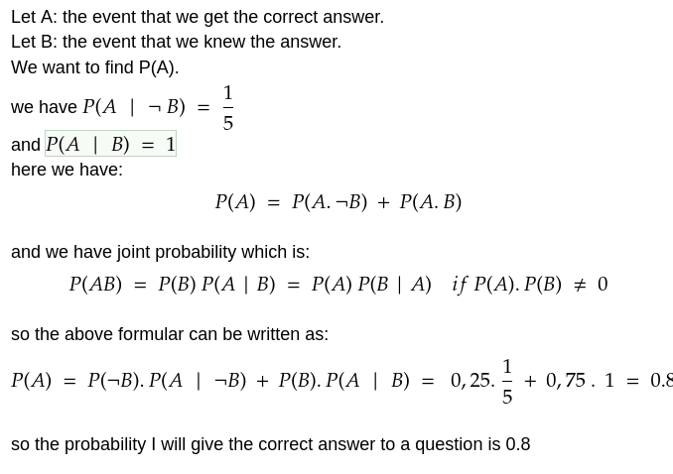

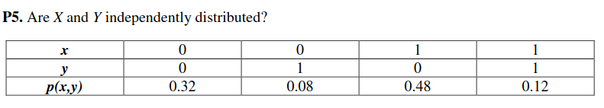

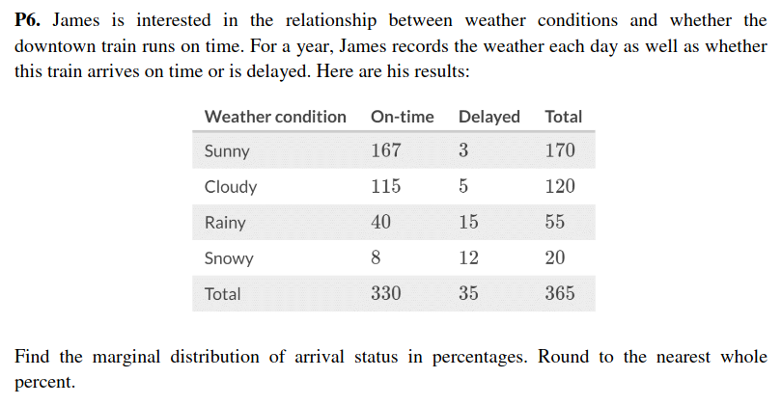Answer:

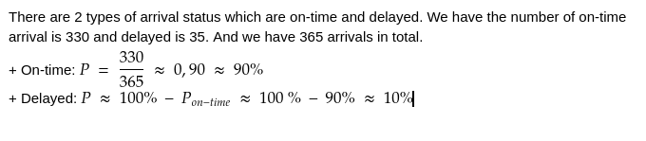4)

