**Hardware**

+ Window 10

**Software**

1. Install Java

Install Java SDK

-https://www.oracle.com/java/technologies/javase/javase-jdk8-downloads.html

Install Java Runtime Environment 8

-https://www.oracle.com/java/technologies/javase-jre8-downloads.html

1. Install Ecllipse 2019

Download and install step by step

<https://www.eclipse.org/downloads/packages/release/2019-12/r/eclipse-ide-enterprise-java-developers>

1. Install e(fx)clipse

On Eclipse, go to Help -> Eclipse Marketplace. Search for “e(fx)clipse” and install e(fx)clipse 3.6.0

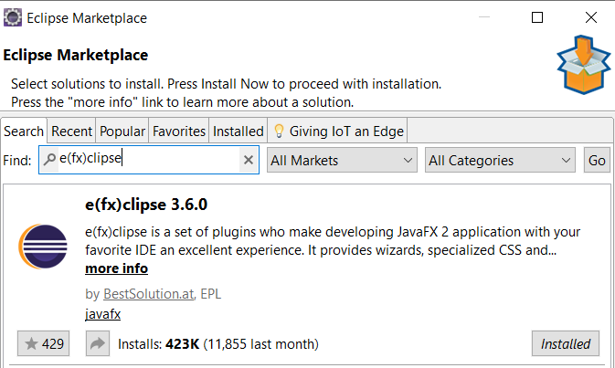

Restart Eclipse when the progress is done

1. Clone project, then open Eclipse, go to File -> Open Project from File System. Direct to project folder, then select Programing folder.
2. Install JavaFX User Library

* Add JavaFX to eclipse

On Eclipse, go to Window -> Preferences -> Java -> Build Path -> User Library

Click on New, enter “JavaFX” and click OK

Click on JavaFX, then click on Add External JARs, direct to the document folder (TKXDPM.20201-18 -> Programing -> document), go to javafx-sdk-11.0.2\lib, select all libraries and click Open, then Apply and Close

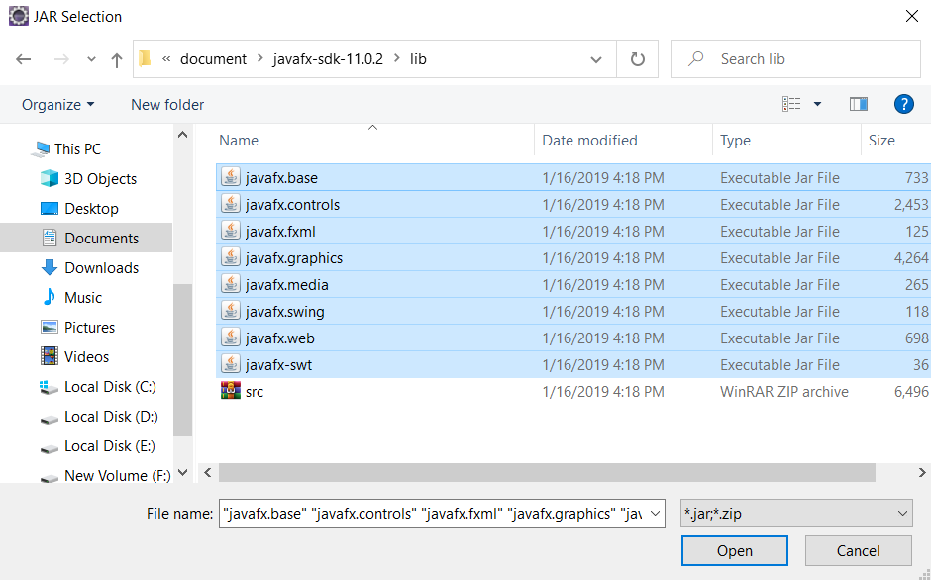

* Add JavaFX to project

On Eclipse, right click to the project name, click Properties, click on Java Build Path -> Libraries -> Add Library -> User Library -> Next. Select JavaFX you have been added, click Finish then Apply and Close.

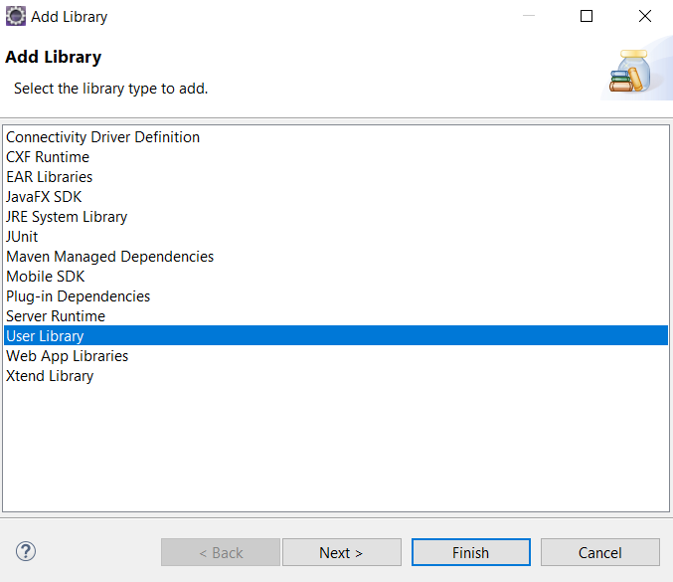 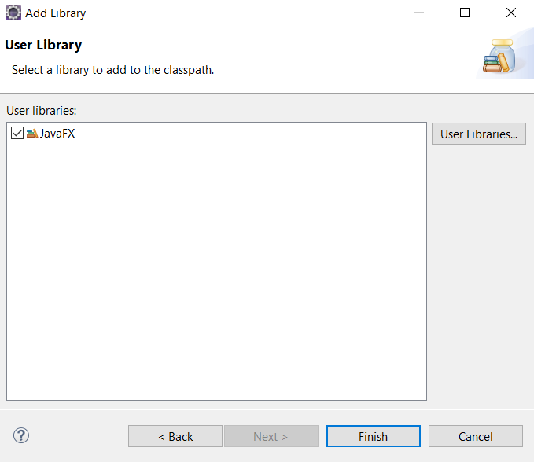

1. Install JDBC, HTTP, JSON Libraries

Right click to the project name, click Properties, click on Java Build Path -> Libraries -> Add External JARs

Direct to document folder, go to lib folder, select all libraries, click Open then Apply and Close

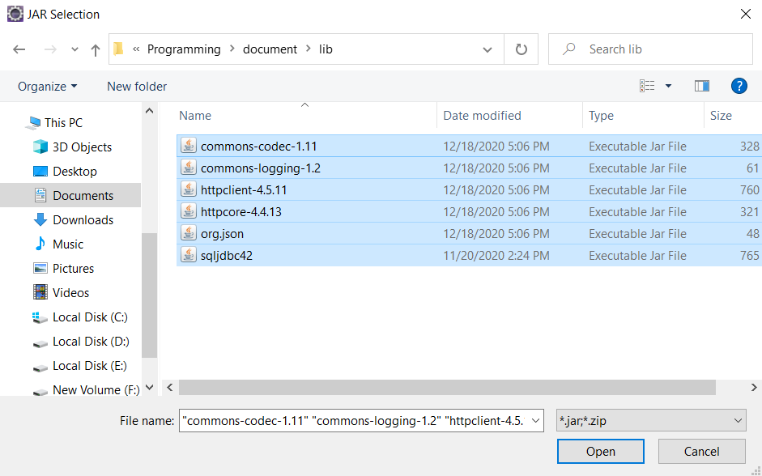

1. Run Project

After install SQL server, run query to create database, you can run project.

Right click to the project name, click Run as -> Java Application

**Database**

1. Install SQL Server 2012

Download and install follow the guide

1. Create User

Create a new user with name: group18, password: 123456

1. Create Database

Open query from ….. and run.

1. Grant access to user

Go to Security -> Login, right click to group 18, click on User Mapping, select EcobikeRentalDatabase then click OK

Right click to EcobikeRentalDatabase from Database, click Properties -> Permission. Select all rows on Grant column, then click OK.