LAB 3

OUTLINE
I. Clock Definition
II. Register Setup Time
III. Input Ports (sequential logic)
IV. Output Ports (sequential logic)
V. Combinational Logic

Design Schematic
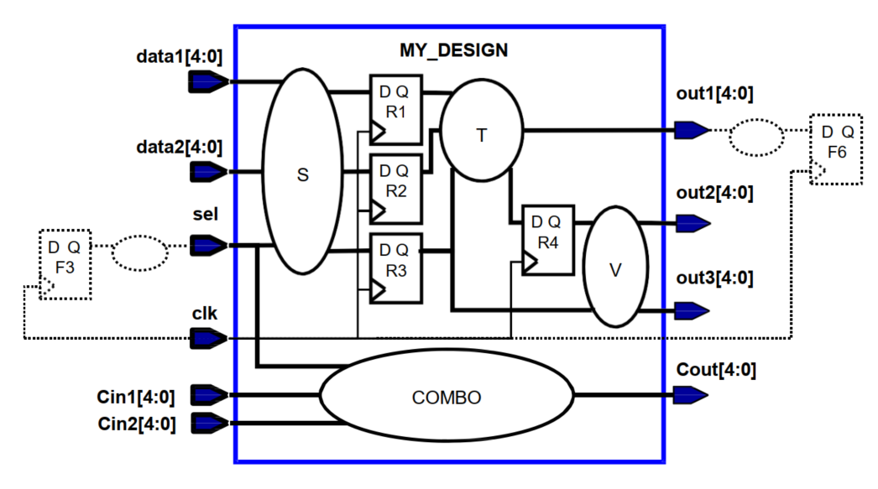

I. Clock Definition
DESIGN SPECIFICATION | COMMAND AND  COMMAND EXPLANATION
1. Clock clk has a frequency of 333.33/Mhz.  (All inputs and outputs are launched/captured by this same clock – no virtual clocks needed for I/Os) | Command:  create_clock -name CLK -period 3.0 [get_ports clk]  Explantion:  + Period  per spec use 3.0 ns.  + DC time unit follows the technology library (typically ns), so 3.0 is used directly.  + create_clock creates a clock object in DC; this constrains all register-to-register timing paths driven by that clock.  + -name CLK assigns a readable name CLK to the created clock.  + -period 3.0 sets the clock cycle time to 3.0 ns (calculated from 333.33 MHz). The tool assumes a 50% duty cycle by default unless otherwise specified.  + [get_ports clk] specifies the design input port clk as the clock source pin. The clock object propagates through ideal clock networks to sequential elements during synthesis.  + Since all I/Os are launched and captured by the same clock, no virtual I/O clocks are required; a single create_clock on port clk is sufficient.
2. The maximum clock generator delay (located outside MY_DESIGN) to the clk port is 700 ps.  (HINT: source latency) | Command:  set_clock_latency -source -max 0.70 [get_clocks CLK]  Explantion:  + Defines the source clock latency — delay from the external clock generator to the design clock port.  + -source indicates this latency is outside the design (before entering clk).  + -max 0.70 sets the worst-case latency to 0.70 ns (700 ps).  + [get_clocks CLK] applies this constraint to clock CLK.  + Models the external clock delay for accurate timing analysis.
3. The maximum insertion delay from the clock port to all the register clock pins is 300 ps ± 30 ps.  (HINT: Treat the 300 ps as network latency and the ±30 ps as clock skew) | Command:  set_clock_latency -max 0.30 [get_clocks CLK]  Explanation of ±30 ps:  + 300 ps is the nominal insertion delay from the clock port to all register clock pins (network latency).  + ±30 ps represents clock skew, meaning some registers may receive the clock earlier or later than others.  + This variation models the uneven distribution of clock arrival times across the design.  + Clock skew is later included in set_clock_uncertainty to ensure safe setup and hold timing margins.  Explantion:  + Specifies the internal clock network latency from the clock port to all FF pins.  + -max 0.30 sets the maximum latency to 0.30 ns (300 ps).  + [get_clocks CLK] applies to the defined clock.  + Represents the internal clock distribution delay to registers.
4. The clock period can fluctuate ± 40 ps due to jitter.  5. Apply 50 ps of “setup margin” to the clock period. | Command:  set_clock_uncertainty -setup 0.12 [get_clocks CLK]  Explanation of ±40 ps:  + ±40 ps indicates clock jitter, which is the variation in clock period from cycle to cycle.  + The clock signal may arrive 40 ps earlier or later than its ideal edge due to phase noise or instability in the clock source.  + This uncertainty affects the accuracy of timing analysis because actual edges can shift.  + Jitter is also modeled in set_clock_uncertainty to guarantee timing robustness under real operating conditions.  Explantion:  + Defines clock uncertainty for setup timing analysis.  + -setup 0.12 combines skew (±30 ps), jitter (±40 ps), and setup margin (50 ps) → 0.12 ns total.  + [get_clocks CLK] applies this uncertainty to CLK.  + Ensures timing safety by accounting for clock variation and design margin.
6. The worst-case rise/fall transition time of any clock pin is 120 ps. | Command:  set_clock_transition -max 0.12 [get_clocks CLK]  Explantion:  + Specifies the rise/fall transition time of the clock edge.  + -max 0.12 limits the maximum transition to 0.12 ns (120 ps).  + [get_clocks CLK] applies to clock CLK.  + Models realistic clock edge slew for accurate delay calculation.

II. Register Setup Time
DESIGN SPECIFICATION | EXPLANATION
1. Assume a maximum setup time of 0.2 ns for any register in MY_DESIGN. | Explantion:  + Setup time is the minimum amount of time that input data must remain stable before the active clock edge arrives at a register.  + The value 0.2 ns represents the maximum setup requirement of flip-flops used in the target technology library.  + This parameter is automatically extracted from the library (.lib) file, so no manual command is needed in the synthesis script.  + Design Compiler automatically considers this setup time when performing timing analysis to ensure correct data capture at all registers.

III. Input Ports (sequential logic)
DESIGN SPECIFICATION | COMMAND AND  COMMAND EXPLANATION
1. The maximum delay from ports data1 and data2 through the internal input logic is 2.2 ns. | Command:  set_input_delay -max 0.48 -clock CLK [get_ports {data1[*] data2[*]}]  Explantion:  + set_input_delay defines the maximum delay of input signals relative to the clock.  + -max 0.48 is calculated as follows:  Input_delay = T - t_{setup} – t_{clock uncertainty} - t_{data}  = 3 – 0.2 – 0.12 – 2.2 = 0.48 ns  + -max 0.48 specifies that the latest data arrival time from ports data1 and data2 is 0.48 ns after the active clock edge.  + -clock CLK links this delay to the reference clock CLK.  + [get_ports {data1[*] data2[*]}] selects all bits of both input buses.  + Ensures that signals entering through data1 and data2 arrive within 0.48 ns for proper synchronization with the clock.
2. The latest F3 data arrival time at the sel port is 1.4 ns absolute time.  (HINT: Input delay is specified relative to the launching clock edge.) | Command:  set_input_delay -max 1.40 -clock CLK [get_ports sel]  Explantion:  + Defines the latest input arrival time relative to the clock edge.  + -max 1.40 sets the maximum input delay to 1.40 ns.  + -clock CLK links the delay to the launching clock domain.  + [get_ports sel] applies to the input port sel.  + Describes when external data arrives at the input relative to the clock.

IV. Output Ports (sequential logic)
DESIGN SPECIFICATION | COMMAND AND  COMMAND EXPLANATION
1. The maximum delay of the external combo logical port out1 is 420 ps; F6 has a setup time of 80 ps. | Command:  set_output_delay -max 0.50 -clock CLK [get_ports {out1[*]}]  Explantion:  + Defines the output timing requirement relative to the capturing clock.  + -max 0.50 equals 0.42 ns external logic delay + 0.08 ns setup time.  + -clock CLK sets the reference clock for this delay.  + [get_ports {out1[*]}] specifies the output bus.  + Reserves 0.50 ns for external logic and ensures correct data capture timing.
2. The maximum internal delay to out2 is 810 ps. | Command:  set_output_delay -max 2.07 -clock CLK [get_ports {out2[*]}]  Explantion:  + set_output_delay specifies the maximum required delay at the output port relative to the capturing clock.  + -max 2.07 is calculated as follows:  Output_delay = T - t_{clock uncertainty} - t_{data}  = 3 – 0.12 – 0.81 = 2.07 ns  + -max 2.07 defines that the total internal delay from the launching flip-flops to port out2 must not exceed 2.07 ns (2070 ps).  + -clock CLK associates the output delay constraint with the reference clock CLK.  + [get_ports {out2[*]}] selects all bits of the output bus out2.  + Ensures the internal logic and routing from flip-flops to the output port out2 meet the 2.07 ns timing requirement according to the design schematic.
3. The out3 port has a 400 ps setup-time requirement with respect to its capturing register clock pin. | Command:  set_output_delay -max 0.40 -clock CLK [get_ports {out3[*]}]  Explantion:  + Sets the setup-time requirement of the external device connected to out3.  + -max 0.40 assigns 400 ps as the required setup time.  + -clock CLK specifies the capturing clock.  + [get_ports {out3[*]}] selects the output bus.  + Ensures the receiving device samples data at the correct time.

V. Combinational Logic
DESIGN SPECIFICATION | COMMAND AND  COMMAND EXPLANATION
1. The maximum delay from Cin1 and Cin2 to Cout is 2.45 ns.  (HINT: Use appropriate input and output delay constraints with respect to clock clk.) | Command:  set_max_delay 2.45 -from [get_ports {Cin1[*] Cin2[*]}] -to [get_ports {Cout[*]}]  Explantion:  + Constrains the pure combinational path delay between input and output ports.  + -from defines source ports Cin1 and Cin2.  + -to defines destination port Cout.  + -datapath_only ignores clock effects and includes only logic delay.  + Limits the maximum propagation delay of the combinational path to 2.45 ns.  Explain the time from Cin1 and Cin2 to Combinational is 0 and from Combinational to Cout is 2.45ns:  + The delay from Cin1/Cin2 to the Combinational block is 0 ns because these signals are direct inputs to the logic block (no additional logic or register before it).  + The delay from the Combinational block to Cout is 2.45 ns, meaning the total propagation delay through the internal combinational logic (gates, paths, and routing) takes 2.45 ns before the signal appears at the output port Cout.

