LAB 4

OUTLINE
I. Input Ports (Transition)
II. Output Ports (Capacitive Load)

Design Schematic
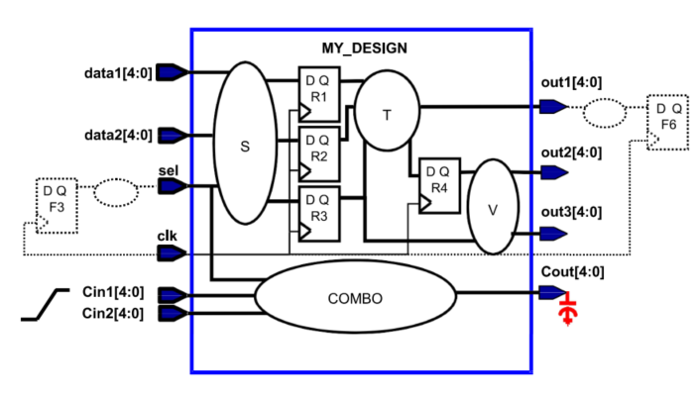

I. Input Ports (Transition)
DESIGN SPECIFICATION | COMMAND AND  COMMAND EXPLANATION
1. Specify a driving cell called bufbd1 on all inputs, except clk as well as Cin* | Command:  set_driving_cell -lib_cell bufbd1 [remove_from_collection [all_inputs] [get_ports {clk Cin1[*] Cin2[*]}]]  Explantion:  + set_driving_cell assigns a driving strength model to all input ports (except clk, Cin1, and Cin2) using the standard cell bufbd1.  + The option -lib_cell bufbd1 specifies that the signal source behaves like cell bufbd1, defining its drive capability and output slew.  + [remove_from_collection [all_inputs] [get_ports {clk Cin1[*] Cin2[*]}]] ensures the driving cell is applied to all inputs except the specified ports.  + Ensures accurate modeling of input drive strength for synthesis and timing analysis.
2. The Cin* ports are chip-level inputs and have a 120 ps maximum input transition. | Command:  set_input_transition -max 0.12 [get_ports {Cin1[*] Cin2[*]}]  Explantion:  + set_input_transition constrains the maximum input transition time (slew) for the specified ports.  + -max 0.12 represents 0.12 ns, which is equivalent to 120 ps, the maximum transition allowed for Cin1 and Cin2.  + [get_ports {Cin1[*] Cin2[*]}] selects all bits of the Cin buses.  + Ensures proper modeling of input signal transitions for top-level (chip-level) input ports.

II. Output Ports (Capacitive Load)
DESIGN SPECIFICATION | COMMAND AND  COMMAND EXPLANATION
1. All outputs, except Cout, drive a maximum load equivalent to 2 times the capacitance of the “I” pin of the cell bufbd7. | Command:  set_load [expr 2 * [load_of cb13fs120_tsmc_max/bufbd7/I]] [remove_from_collection [all_outputs] [get_ports {Cout[*]}]]  Explantion:  + set_load defines the output capacitive load for timing calculation.  + [expr 2 * [load_of cb13fs120_tsmc_max/bufbd7/I]] doubles the capacitance of the input pin “I” of cell bufbd7 to model higher load conditions.  + [remove_from_collection [all_outputs] [get_ports {Cout[*]}]] applies this load to all outputs except Cout.  + Ensures realistic output loading for accurate synthesis and timing.
2. The Cout port drives a maximum load of 25 fF. | Command:  set_load 0.025 [get_ports {Cout[*]}]  Explantion:  + set_load defines the fixed capacitive load for the output port Cout.  + 0.025 represents a load value of 0.025 picofarads (pF), which is equivalent to 25 femtofarads (fF).  + [get_ports {Cout[*]}] selects the entire output bus Cout.  + Ensures that the Cout port meets its specified load requirement of 0.025 pF, providing accurate timing and power modeling during synthesis.

