

Library Management System
Documentation

Group 1
Group Member | Huynh Minh Trung  Le Khanh Duy  Nguyen Minh Duc
Instructor | Nguyen Huu Phi

- DaNang, 8/2015 -
INDEX
1. Problem Definition 3
1.1. Problem Abstraction 3
1.2. The Current System 3
1.3. The Proposed System 3
1.4. Boundaries of the System 3
1.5. Hardware and Software Requirements 3
1.5.1. Minimum Requirements 3
1.5.2. Recommended Requirements 3
2. Customer Requirements Specification 4
2.1. Users of the System 4
2.2. System functions 4
3. Architecture and Design of Project 5
3.1. Data Flow Diagram 5
3.2. Entity Relationship Diagram(Table Design) 5
3.3. Database Structure 5
3.4. Screen Design 5
4. Task Sheet 6
5. Checklists 7
5.1. Check List of Validation 7
5.2. Submission Checklist 7

Problem Definition

Problem Abstraction
Today , almost all universities have libraries , the library contains many books of different genres . Want to manage the books that will definitely not simple , the annual cost for this work is not low. this can easily lead to budget deficits , nottells readers that management is not simple at all. Therefore , we would like to introduce the library management software to help work in the library becomes easier

The Current System
University has a library which is managed by staff manually. All records are on paper and staff finds it very difficult to manage when somebody issues or returns the books. They has to maintain list of books along with details such as Author name, book title etc. When a book is to be issued, they has to manually search for that book and again for issuing book she has to maintain a register which will have details of book issued such as Name of the book, Author, Employee details (name, department etc) , Date of issue, Date of return, etc. This process is tedious and time consuming. they has brought it to the notice of her seniors and they have proposed the solution of developing a system which will help staff managing the things more effectively and also save her time. They will be the only user of the system.

The Proposed System
- Software Library Management Book of we will help to all staff, can manage book have library same manage business borrow and return book.

Boundaries of the System
Boundaries of system will built:

- Software Library Management Book of we, have size small only use to a company.

Hardware and Software Requirements

Minimum Requirements

Minimum
PC Pentium II 600 MHz
128MB RAM
500 MB hard drive

Recommended Requirements

Preferred
PC Pentium III 1800 MHz
2G RAM
2 GB hard drive

Software
Software:

-JDK 1.8
-Netbean 8.0
-Sql server 2014

2. Customer Requirements Specification

Users of the System
The object influence system include:

- User

System functions

Function User

- Add, edit Book

Description | User add, edit book.
Input | -Book ID.  -CallNumber(XX-XX-XXX)  -ISBN.(XXX-XXXX)  -Title.  -Phone Number.  -PubHouse.
Process | Update data in database when add, edit book.
Output | Display book edit và book new.

- Delete Book

Description | User delete book.
Input | -Book ID.
Process | Update data in database when delete book.
Output | Display announcement you deleted successful.

- Add, edit, delete User

Description | User add, edit, delete user.
Input | -User ID.  -Name.  -User Status.
Process | Update data in database when add, edit, delete user.
Output | Display user edit và user new.

- Check Out

Description | User give Employee borrow book ,search book.
Input | -Call number.  -ISBN number.  -Title.  -Author.  -Employee ID
Process | Update data in database when librarian add the ballok give borrow book.
Output | -Display result the ballok borrow book.

- Check In

Description | User agree the book return from Employee, search Employee Name.
Input | -Date borrow.  -Date due.  -Employee Name.
Process | Access data from database and to take information the ballok give borrow book, compare the due date and return date if The Employee keep a borrowed book in excess of the time limit then Employee was punish 10 cent each day.
Output | -Display result the ballok give the book return.

- Display information detail book

Description | Function give the librarian see the book detail.
Input | -Choose the book need see.
Process | To take the information book from database.
Output | -Display the information require.

- Display information detail employee

Description | Function give the librarian see the book detail.
Input | -Choose the Employee need see.
Process | To take the information book from database.
Output | -Display the information require.

- Log in

Description | To allow the librarian log in.
Input | -UserName and Password.
Process | Check UserName and Password in database.
Output | -Display the result log in.

- Log out

Description | To allow the librarian log out.
Input | - UserName and Password.
Process | Check UserName and Password in database.
Output | -Display the result log out.

Architecture & Design of Project

Data Flow Diagram
Level 0:
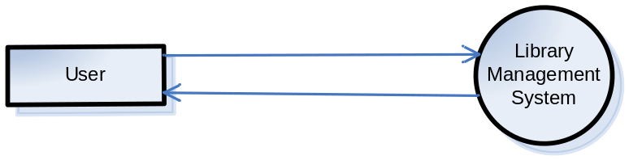
Level 1:

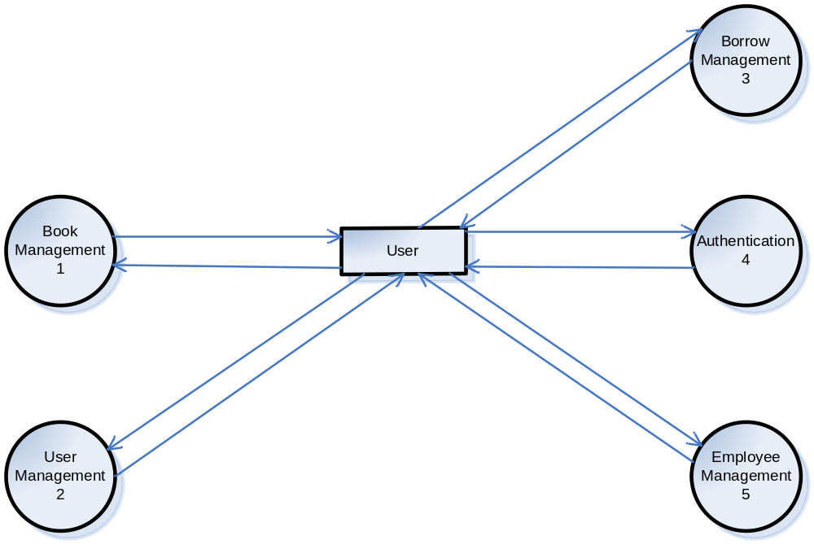

Level 2:

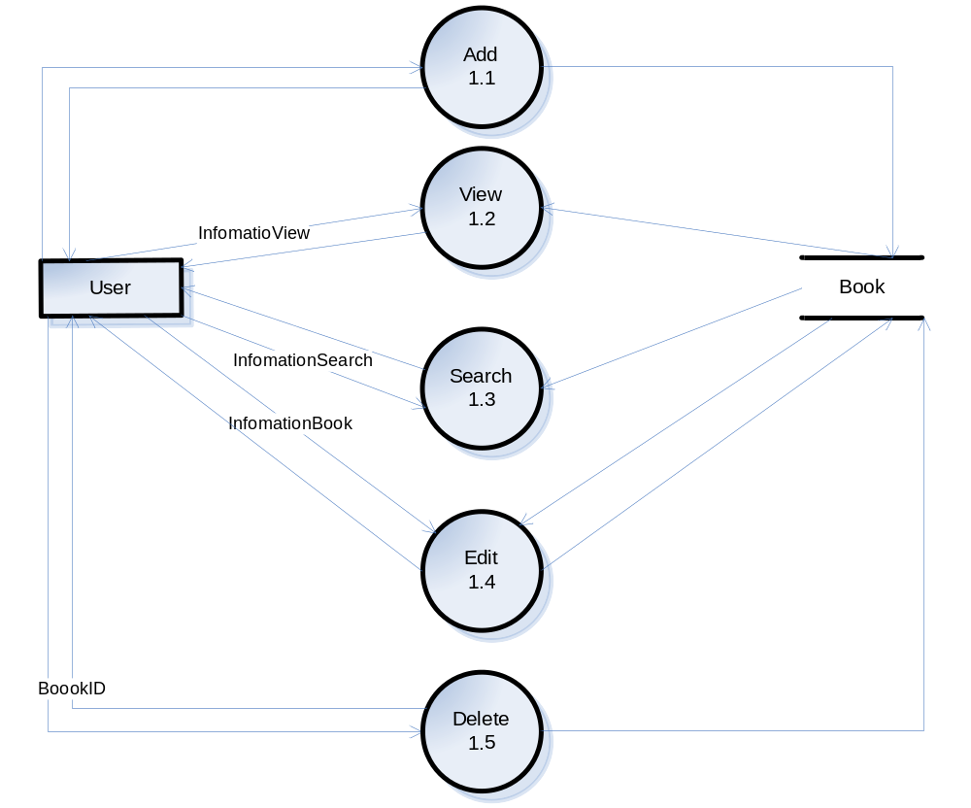
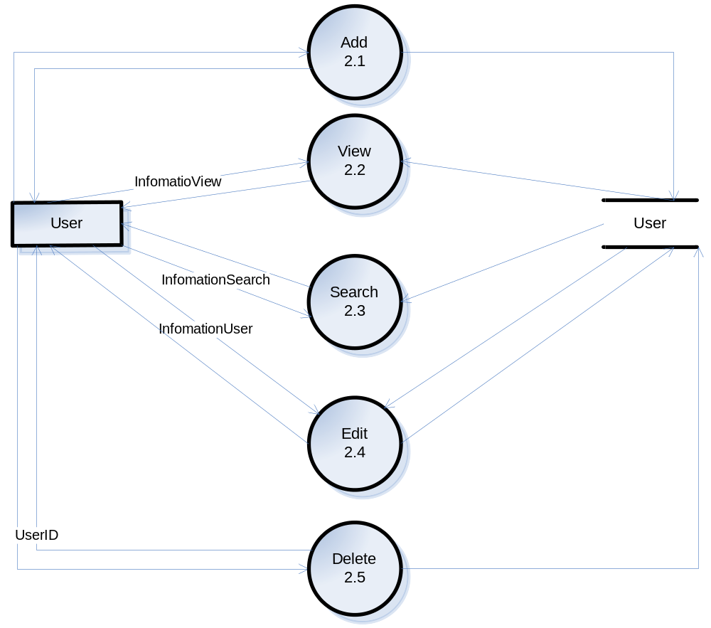

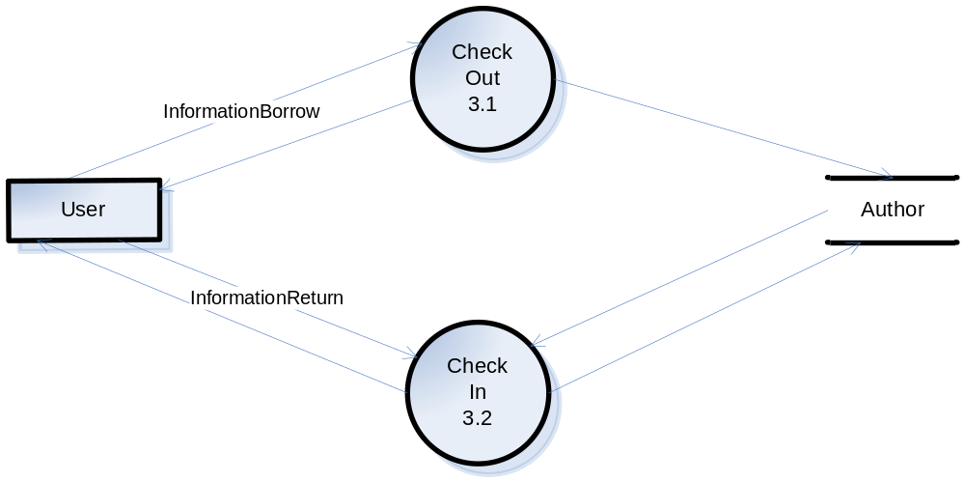

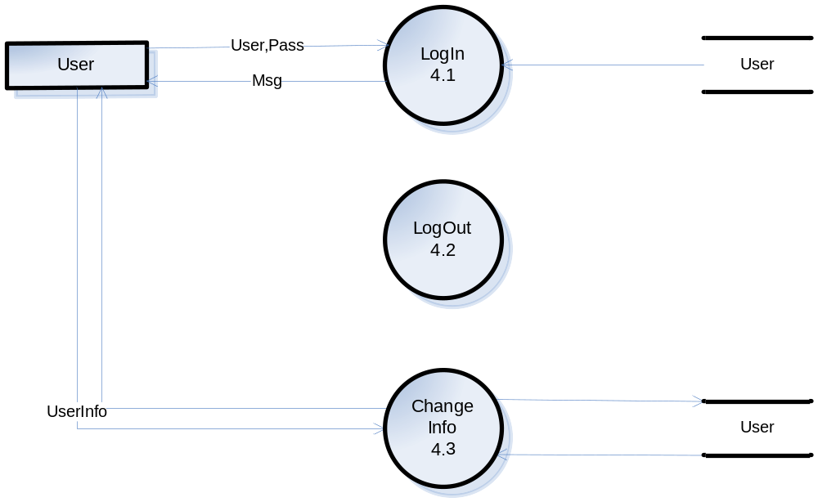

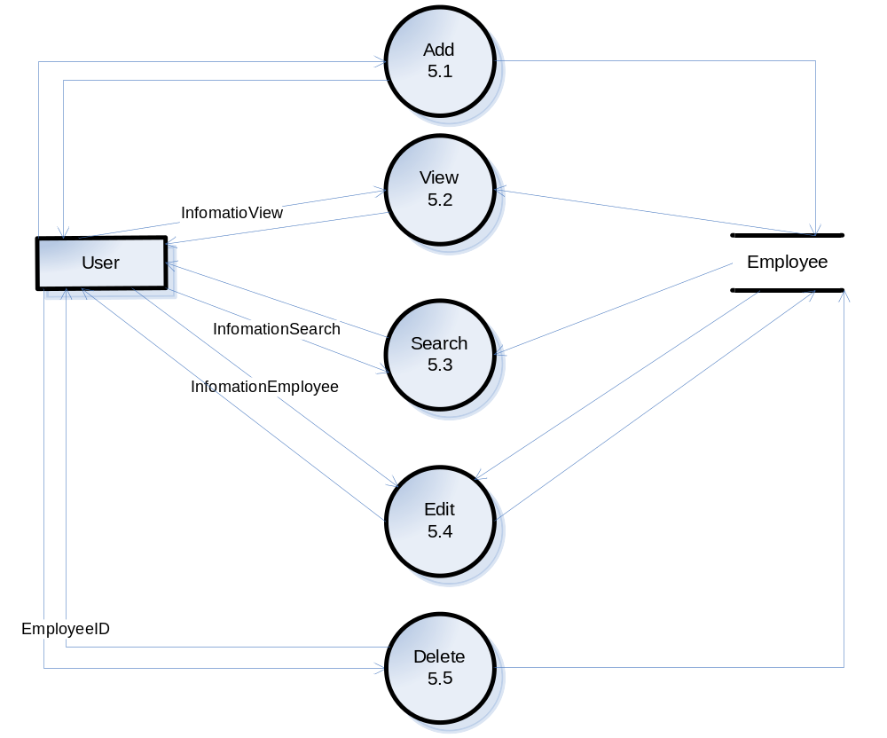

Level 3:
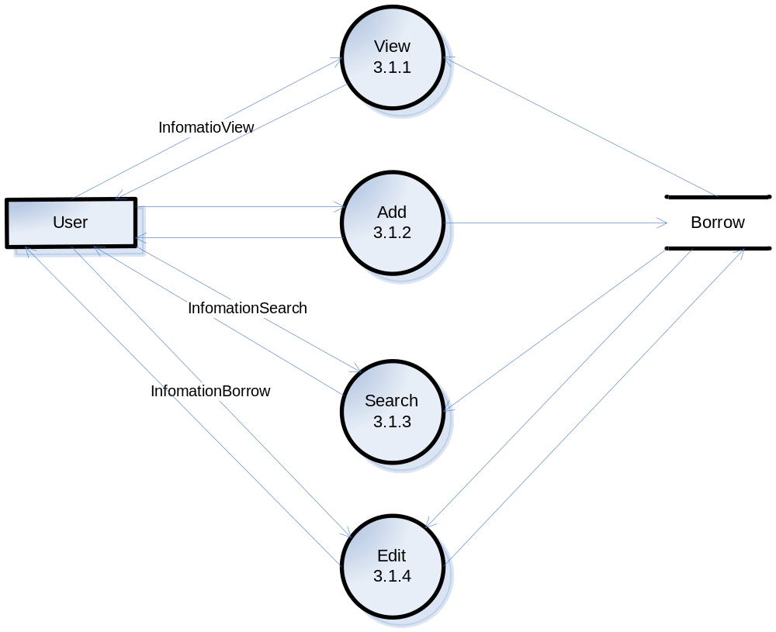

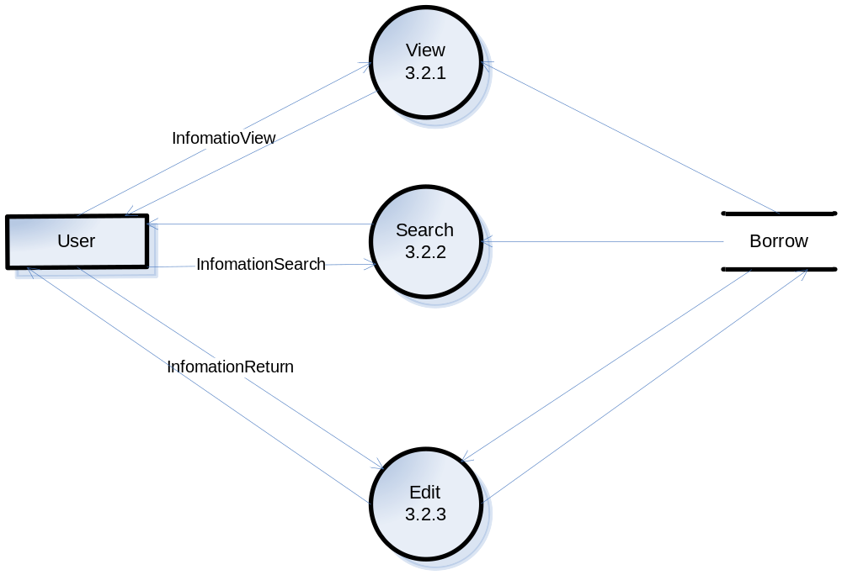

Entity Relationship Diagram (Table Design)
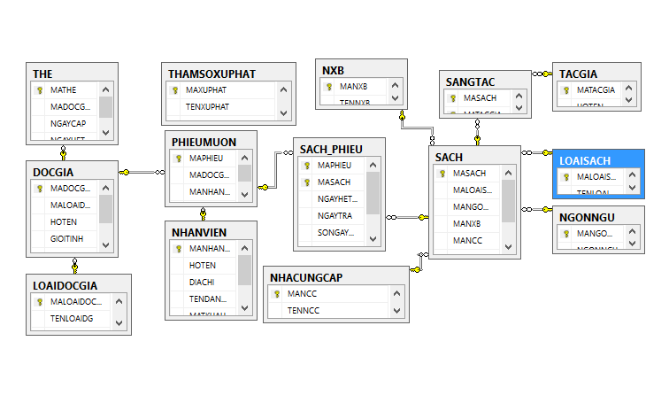

Database Structure
- DOCGIA
MADOCGIA | Char(10)
MALOAIDOCGIA | char(10)

DOCGIA
HOTEN | nvarchar(50)
GIOITINH | char(10)
NGAYSINH | Datetime
DIACHI | nvarchar(50)

NHANVIEN
MANHANVIEN | Char(10)
HOTEN | nvarchar(10)
DIACHI | Nvarchar(50)
TENDANGNHAP | Char(30)
MATKHAU | Char(20)
QUYENHAN | Nvarchar(50)

PHIEUMUON
MAPHIEU | char(10)
MADOCGIA | char(10)
MANHANVIEN | char(10)
NGAYMUON | datetime

THE
MATHE | char(10)
MADOCGIA | char(10)
NGAYCAP | Datetime
NGAYHETHAN | Datetime

THAMSOXUPHAT
MAXUPHAT | char(10)
TENXUPHAT | char(30)
MUCPHAT | Money

SANGTAC
MASACH | char(10)
MATACGIA | char(10)

NXB
MANXB | char(10)
TENNXB | nvarchar(50)

SACH
MASACH | char(10)
MALOAISACH | char(10)
MANGONNGU | Char(10)
MANXB  MANCC | Char(10)  Char(10)
TENSACH | Nvchar(50)
GIA | money

TACGIA
MATACGIA | Char(10)
HOTEN | Nvarchar(50)

LOAISACH
MALOAISACH | Char(10)
TENLOAISACH | Nvarchar(50)

NHACUNGCAP
MANCC | Char(10)
TENNCC | Nvarchar(50)

NGONNGU
MANGONNGU | Char(10)
NGONNGU | Nvarchar(50)

SACHPHIEU
MAPHIEU | Char(10)
MASACH | Char(10)
NGAYHETHANTRA | Datetime
NGAYTRA | Datetime
SONGAYQUAHAN | Int
MATSACH | Bit
TIENPHAT | money

LOAIDOCGIA
MALOAIDOCGIA | Char(10)

Screen Design

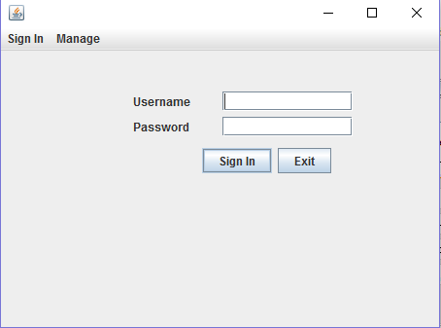
Login

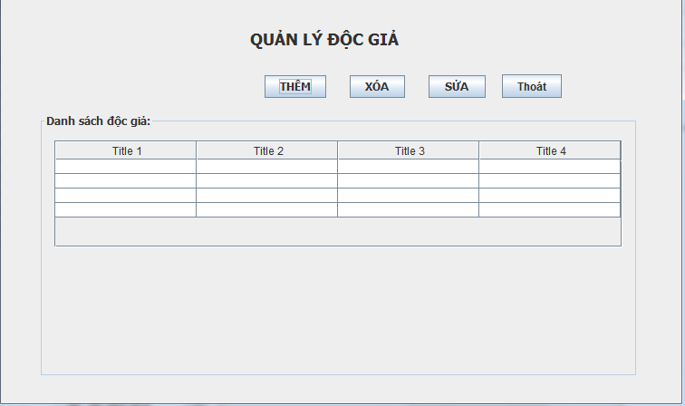
USER MANAGER

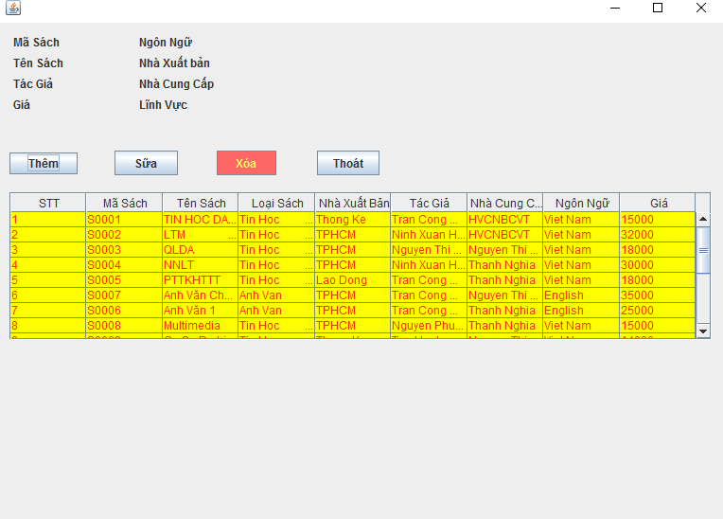
BOOK MANAGER

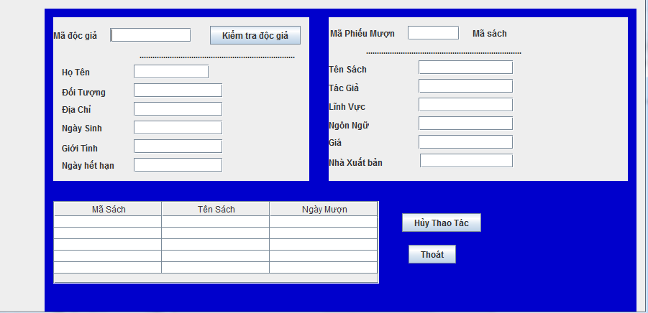
BORROW MANAGER

4.Task Sheet
Project Ref. No.: |  | Project title | Activity Plan Prepared by : | Date of Preparation of Activity Plan :
Sr.  No. | Task | Project title | Activity Plan Prepared by : | Actual Start Date | Actual Days | Team Member Names | Status
I.Document
1 | Problem Definition | LibraryManagerSystem |  |  |  | - Huynh Minh Trung | Completed
2 | Customer Requirements Specification | LibraryManagerSystem |  |  |  | -Huynh Minh Trung  -Nguyen Minh Duc  - Le Khanh Duy | Completed
3 | DFD | LibraryManagerSystem |  |  |  | -Huynh Minh Trung  - Le Khanh Duy | Completed
4 | ERD, Table Design | LibraryManagerSystem |  |  |  | -Nguyen Minh Duc | Completed
II.Coding
1 | Login | LibraryManagerSystem |  |  |  | Huynh Minh Trung | Completed
2 | User Manager | LibraryManagerSystem |  |  |  | Le Khanh Duy  Huynh Minh Trung | Complete
3 | Borrow Manager | LibraryManagerSystem |  |  |  | Huynh Minh Trung | Completed
4 | Search | LibraryManagerSystem |  |  |  | Le Khanh Duy | Completed
5 | Book Manager | LibraryManagerSystem |  |  |  | Nguyen Minh Duc | Completed

5. Checklists
Option | Validated
Do all the options present in the application display the correct result? | Yes
Dose the application’s functionality resolve the user problem, and satisfy their needs? | Yes
Has the hardware and software been correctly chosen? | Yes

