Companies cannot connect with all customers in large, broad, diverse markets. But they can divide such markets into groups of consumers or segments with distinct needs and wants. A company can decide which market segment they can serve effectively based on the consumer behaviour and careful strategic thinking. Best marketing plans can only be employed when a marketer understands the uniqueness and differences of each segments. Targeting right market segment is essential for a company’s success.

**What is Segmentation?**

Segmentation is the process of dividing a company’s target [market](https://en.wikipedia.org/wiki/Market_(economics)" \o "Market (economics)), consisting of potential [customers](https://en.wikipedia.org/wiki/Customer" \o "Customer), into sub-groups of [consumers](https://en.wikipedia.org/wiki/Consumer" \o "Consumer) (known as *segments*) based on similar product needs, tastes and preferences.

A marketer’s task is to identify the segments and decide which one to target.

Segmentation helps to satisfy customer needs more closely and can improve competitive position of the organization.

Segmentation helps to identify new opportunities in terms of products and markets.

**Bases for Segmentation**

The common bases for market Segmentation are:

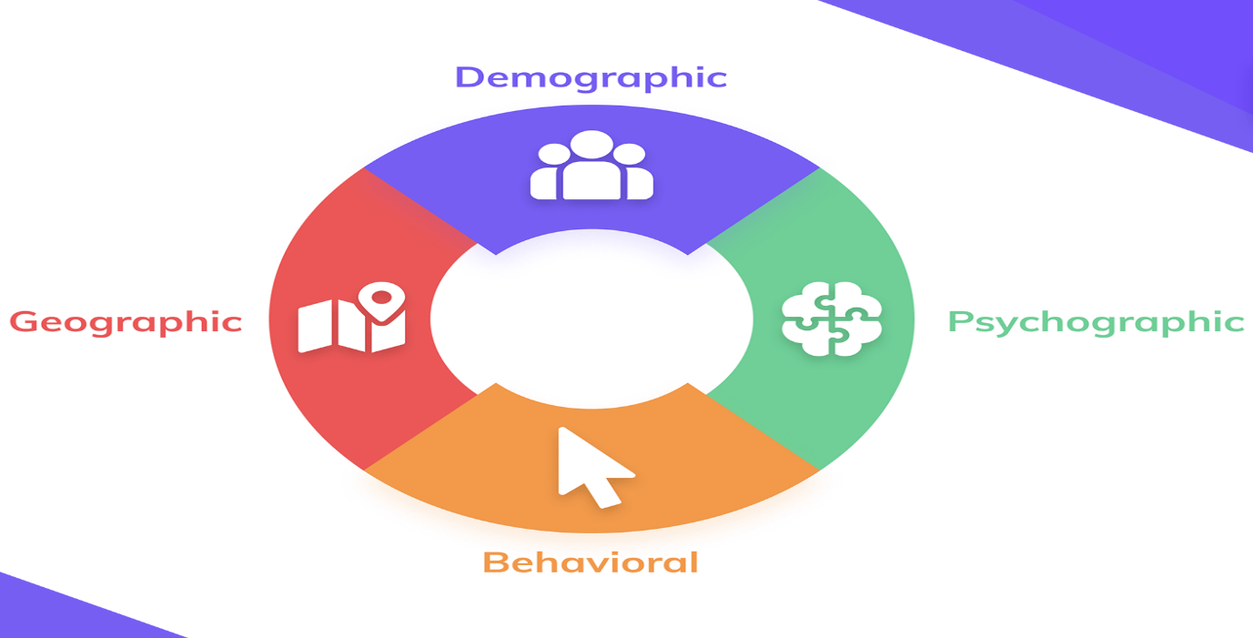

**Geographic segmentation**

In this segmentation, the market is divided on the bases of different geographic regions such as states, region, nations, continents/countries, climatic zones, cities, districts and rural/urban area. The differences in geographical variables such as weather conditions, density of population, region etc. influence consumer needs and wants. It is believed that each geographic area has a similar preferences and consumption patterns.

This segmentation is useful for organizations which intend to slowly grow and enter different markets/regions in sequences.

The requirements of consumers in different regions like North India and South India are very different for the products like food items, clothes and cosmetics.

McDonald’s menu offerings are based on local tastes and preferences of different countries. For example, in India, McDonald’s has introduced burgers with no beef and no pork in it but In Mexico, more chilli sauce is used.

**Demographic segmentation**

It is easy for marketers to segment the market based on geographic area, but again the geographic area may show a large differences in terms of different demographic variables. Person’s needs, choice, purchasing and consumption patterns differs with demographic variables.

Demographic segmentation divides a market into segments based on different demographic variables such as age, gender, family size, family life cycle, income, education, occupation, marital status, race, religion, nationality, language and social class.

Demographic variables are easy to identify and measure and they are often associated with consumer needs and wants. Hence this segmentation criterion is more popular with marketers.

Needs and consumption patterns changes with one’s age and life cycle. Needs and wants of male and female population also differ. Individuals in similar income categories are more likely to have similar purchasing patterns. A person’s social status is correlated with his/her income.

Toys, garments, T.V. channels are having multiple segments based on age. Beauty products and automobiles are divided on the basis of gender. Materials for religious rituals are differentiated on the basis of religions.

An Italian chocolate manufacturer Ferrero’s sub-brand kinder manufacture chocolate for children and it also has separate colours and toys for girls and boys.

Manufacturers of Camphor, dhoop, Agarbathi mainly target Hindu community where as candle manufacturer targets Christian community.

**Psychographic Segmentation**

Geographic and demographic variables are not enough to define consumers’ choice. People of same age, social class living in same geographical area exhibits different lifestyles. The factors which causes these differences are known as psychographics.

Compared to other two segmentation, this segmentation is difficult to identify. Research is required to discover and understand psychographic profile of a person.

Psychographics is the science of using psychology and demographics to better understand customers. In psychographic segmentation, consumers are divided into different groups on the basis of lifestyles, interests, beliefs, attitudes, personality and values.

In other words, Psychographic segmentation combines the effect of demographics with elements like of lifestyles, interests, beliefs, attitudes, personality and values.

Lifestyle represents person’s entire way of living and this determines his/her needs and purchase patterns. A persons choices speak a lot about his/her personality. By doing this segmentation one can know about the person and then connect back to their consumer purchase decision.

For example, Luxury brands focus on psychographics segmentation by observing their consumer’s lifestyle.

Car companies in India came up with Sport Utility Vehicles targeting buyers having a particular lifestyle and an outgoing, adventurous, nature-loving and risk taking attitude.

Facebook ads are one of the best example of psychographic segmentation in digital marketing because everyone builds their Facebook account based on their personality and psychology.

**Behavioural Segmentation**

In this method, the market is segmented based on consumers knowledge, attitude, use and response to a product.

Behavioural segmentation includes segmentation on the basis of occasions, user status, usage rate, loyalty status, benefits sought and buyer readiness stage.

The buyers can be distinguished according to occasions. Purchase requirements vary according to different occasions. It helps the firm to expand product usage. For example, Cadbury advertising to promote the product during festivals.

The markets are segmented on the basis of user status, that is, on the basis of non-user, ex-user, first-time user, potential users and regular user of the product. Large firms target potential users, whereas smaller focus on current users.

Markets can be segmented on the basis on the usage rate, which is, light-user, medium-user, heavy-user. Marketers prefer to attract heavy- users even though they are very small percentage of the market, but account for a high percentage of total consumption. Marketers vary their promotional efforts accordingly.

Market can also be segmented on the basis of loyalty status. After using a product a consumers often develop loyalty. Based on this marketers can analyse loyalty status, that is, hard core loyal (consumer who buy one brand all the time), split loyal (consumer who are loyal to two or more brands), shifting loyal (consumer who shift from one brand to another) and switchers (consumers who show no loyal to any brand).

Buyers are classified according to the different benefits they seek or desire from a product. The benefits of the product attract customers to purchase the product. For example, airlines convincing customers that it has the benefit of very low fares when tickets are bought earlier.

A person has to pass through six psychological stages when he/she decides to purchase a product that are, awareness of the product, knowledge of what it does, interest in the product, preference over competing products, conviction of products suitability and purchase. Marketing campaigns are there to move target audiences through the buyer readiness stages.

*Links:*

*https://www.bloomreach.com/en/blog/2021/customer-segmentation-options-marketers-should-know-in-2021*