**Car Demo**

**Using Fuzzy Logic**

**Victor Yu**

**StudentID:2000173**

***Abstract* –** With the development of the game industry, AI is becoming more and more widely used in game area and there are many Artificial Intelligence Algorithms that can help make the game more attractive.

The purpose of this project was to develop an application that can demonstrate the selected Artificial Intelligence Algorithms. The application is a car simulator demo and creates using the Unity game engines and C# programming language. The Artificial Intelligence Algorithms used in the application was Fuzzy logic.

1. **Introduction**

The intent of this project was to design and develop a 3 – dimensional car simulator using Unity. It was not easy to decide what application is going to make at start as there are many AI Algorithms that can choose from. The original idea was to create the application using the artificial neural network, but as this was already been used on other application so the Fuzzy logic was used.

The idea of this game was inspired by the video found online.[1][2] The game used the Fuzzy Logic so that the AI will control and decide the movement of the car. The key learning for the AI was when the car is in the racetrack and it need to decide when to make turn and the angle it should turn when the car is near the edge of the track.

## AI Techniques

The game use Fuzzy Logic as main AI Techniques

### Fuzzy Logic Algorithm

The mathematical principles of fuzzy sets and fuzzy logic was first introduced by Lotfi A.Zadeh at 1965.[3] Fuzzy logic enables computers and other artificial intelligences to consider and reason in the same way as human think about problems with fuzzy concepts such as “fast”, “Slow”.

Fuzzy logic is good at expressing qualitative knowledge and experience with unclear boundaries. It uses the concept of membership function to distinguish fuzzy sets, deals with the fuzzy relationships and simulate the human brain to implement rule-based reasoning.

* Fuzzy sets – is uncertain sets, is a set used to express the concept of fuzziness. This method puts the object to be investigated and the fuzzy concept together as a certain fuzzy set, create an appropriate membership function and then analyzes the fuzzy object through related operations and transformations of the fuzzy set.
* Membership functions – Membership functions characterize fuzziness and are represented by graphical forms.

### Fuzzy Logic System Architecture

The Fuzzy Logic System contains four parts.

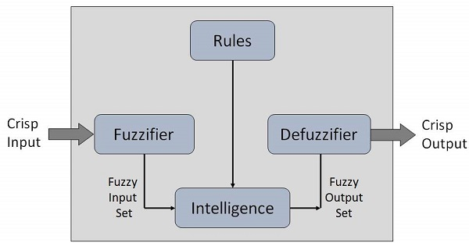Figure1 [4]

* Fuzzification – it’s the process of transforming a crisp set to a fuzzy set or a fuzzy set to fuzzier set.
* Knowledge Base System– After the input is fuzzified, it needs to recombine through rules and fuzzy logic operations, this knowledge base system stores rules provided.
* Inference Engine- it famulated the human reasoning process by making fuzzy inference on the input and rules.
* Defuzzification Module – this is used to interpret this set through many fuzzy rules so that the fuzzy value is calculated and obtain a certain value.

So how the Fuzzy Logic flow works? They can be described as the follow steps:

1. Define linguistic variable and terms.

So, for the application it is:

Right = {HardRight, NeutralRight, BarelyRight}

Left = [HardLeft, NeutralLeft, BarelyRight]

1. Construct membership function.
2. Construct knowledge base rules

|  |  |  |  |  |  |
| --- | --- | --- | --- | --- | --- |
|  | Far Left | Left | center | right | Far Right |
| Large Left | Extreme left | Large Left | Left | Slight Left | None |
| left | Large Right | Left | Slight Left | None | Slight Right |
| none | left | Slight Left | None | Slight right | Right |
| right | Slight Left | None | Slight Right | Right | Large Right |
| Large Right | none | Slight Right | Right | Large Right | Extreme Right |

1. Obtain fuzzy value
2. Perform defuzzification.

## Unity

### Prefabs

* Player:

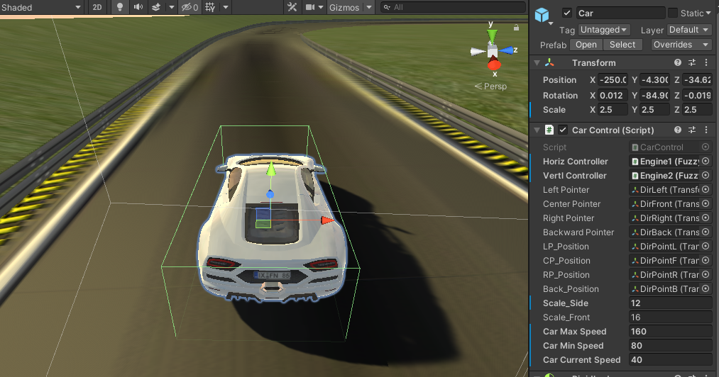

Figure 2

Player prefab contains CarControl scripts, both the Horizontal and Vertical Controller represent the Fuzzy Logic algorithm. The Horizontal is used to check the left and right of the car and vertical controller can be used to check the front and back. Figure2 The value of the scale_side is set to 12 which can be used to compare to the distance between the car and objects.

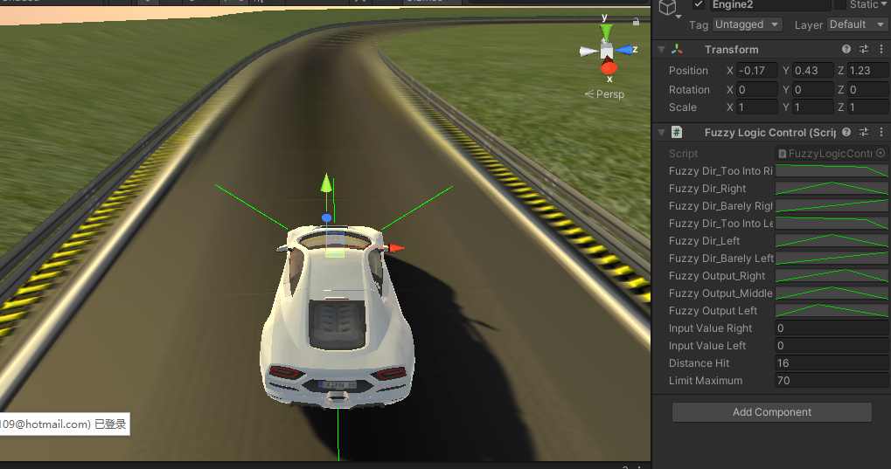

Figure2.1

The four-green line in the Figure2.1 is the Raycast line set to the car object, the color will change to red when the car is near the edge of the track. The curve on the right-side inspector was used to represent the membership function in the fuzzy logic

## Scripts

### Normal Scripts

* CarControl -

This script was created to allow the car to move in the game. this script can be used to set the speed of the car such as current speed and maximum speed. The script uses the raycast functionality so in the update() it checks if the car near right or left then pass the value to the fuzzy logic script where then the fuzzy logic script will do the calculation and pass the value to this script and used to make the car turned.

### AI Scripts

### FuzzyLogicControl –

### This script contains all the fuzzy logic functions.

### The AnimationCurve was used to show the fuzzy membership function. Figure 3.1

### 

### Figure 3.1

### SetFuzzy()

### This method is where the fuzzification take place.

### EvaluateRuleBase()

### In this method the universe of discourse was chosen as -600 to 600 and the rule was set.

### 

Figure3.2

### calculateTrapezoidArea()

### this method is used to find the trapezoid area by divide the membership curve into two rectangle triangles and sum up.

### Defuzzy()

### This is the method where defuzzification took places.

## Test

### The test was carried out by vary the car speed and the hit check value. After few tests, the overall result was good if the car speed wasn’t set too high as if the speed is too high the car are having higher chance run off the race track where as if the speed is set in a reasonable limit the car will stay in the track. Because if the front ray cast value is set to lower value, the car is less chance to react and reduce their speed when near an object.

## Conclusion

### The demo was success create using the fuzzy logic algorithm. The fuzzy logic can control the car to make the turn if needed to and assign the angle based on the rule. However, the demo scene wasn’t look realistic and some function still have problem, but the basic concepts was success implement. If there was more time, the feature for the car animation could’ve add as to simulate the tyre when make turn and also another problem need to work is how to not let the car run off the track if the speed is too high when the front raycast value is low.

**Video**

[**https://youtu.be/ZEDvSM-9bCw**](https://youtu.be/ZEDvSM-9bCw)

**Reference**

1. “Car AI ” <https://www.youtube.com/watch?v=o1XOUkYUDZU>
2. “Car Fuzzy Logic” <https://www.youtube.com/watch?v=X83walKgtSk>
3. “Lotfi A. Zadeh” <https://en.wikipedia.org/wiki/Lotfi_A._Zadeh>
4. “Fuzzy Logic System” <https://www.tutorialspoint.com/artificial_intelligence/artificial_intelligence_fuzzy_logic_systems.htm>
5. “Rule” <https://iopscience.iop.org/article/10.1088/1742-6596/1367/1/012068/pdf>
6. <https://www.youtube.com/watch?v=ubCKh4ZJGfc>