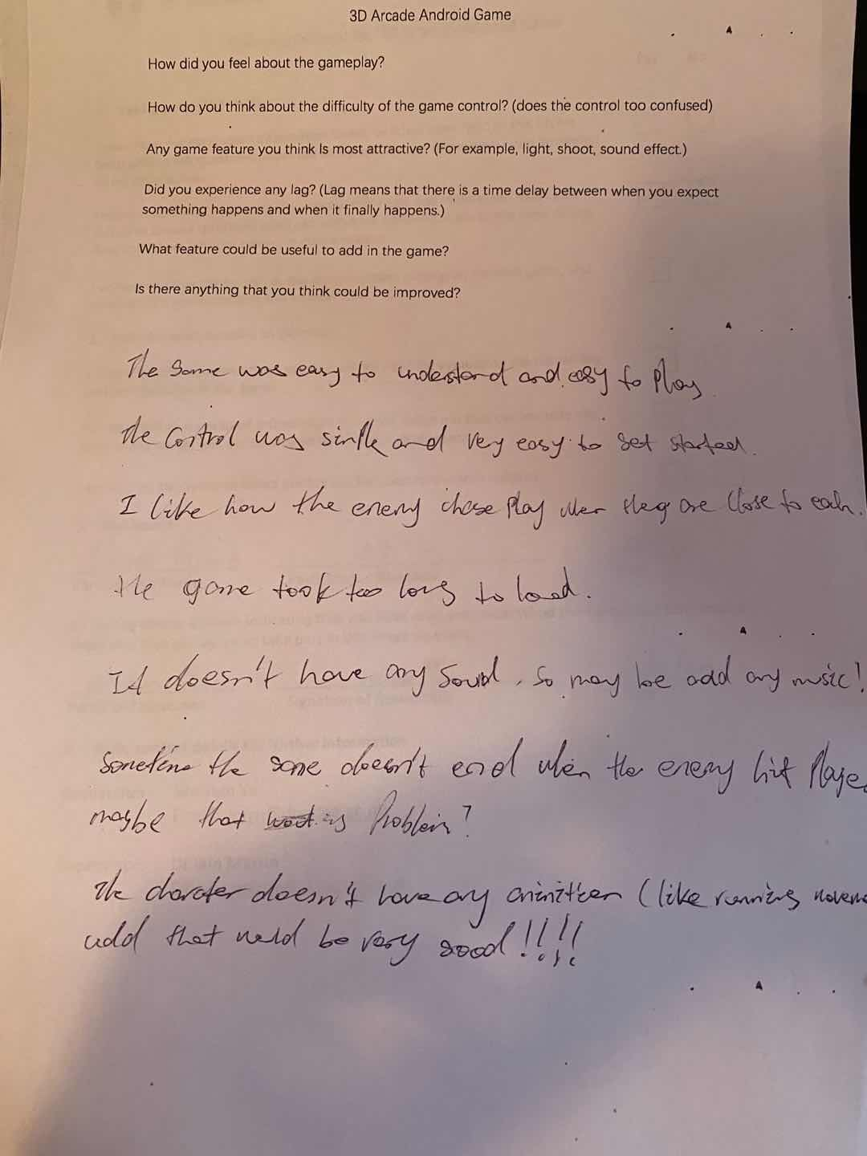

* The game was easy to understand and easy to play.
* The control was simple and very easy to get started.
* The way that enemy would chase player if player close to it was good.
* The game took too long to load.
* The game doesn’t have any sound, so maybe any music?
* Sometime the game doesn’t end even the player was hit by the enemy, maybe that’s a problem?
* The character doesn’t have any animation (like running movement), add that would be very good

|  |  |  |  |
| --- | --- | --- | --- |
| Requirement | Priority | Complexity | Complete |
| The game should have better collision detection | 10 | 5 | yes |
| The game should have background music | 10 | 5 | yes |
| The gameplay should improve | 10 | 4 | yes |
| The game should load scene smoother | 10 | 7 | no |
| The game should contain some animation | 5 | 7 | no |