**How to execute the test case**

1. First of all, after downloading the project zip file, open the “automation.conf.dir” file with notepad++ (any text editor) and give it the actual path on your machine (where the project is downloaded).
2. Basically the framework I use is built up as follows:

* Using data driven test framework which is mainly separating the test logic (business) from the test data.
* Automated.Application solution is the one related to test logic and business, each webpage has a corresponding page and JSON file under the “Pages” and “Domain/Repository” folders respectively
* The “Object repository” carries JSON files that I used for element inspections.
* Pages contains classes each class refers to a webpage; the elements are called using the page factory.
* The “Automated. Tests” solution I use it for the tests, under the scripts folder you will find the “OrderWorkflowTests” class that carries the test case “Submit_Valid_Order_Test”

1. In this path “~\My_Project\Automated.Tests\Data” you will find the TakeawayTestData.xlsx sheet where my test case reads the data from.

* Rows in TakeawayTestData.xlsx sheet represents test cases in WorkflowOrderTests class in the Autoamted.Tests solution
* Columns like “ResturantPcName, “ResturantName”, “Dishes” ... etc. these are actually where I provide real/desired test data that will be used while executing the “Submit_Valid_Order_Test” test case.

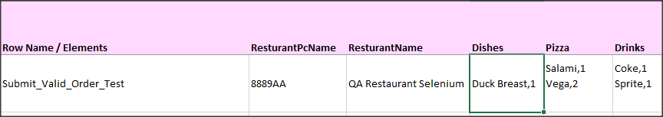

* For the “Dishes”, “Pizza” and “Drinks” columns, I read the test data as follows:
* Meal name, quantity -> i.e. Duck Breast,1
* If you want to order different Pizza types with different quantity enter them as follows

Salami,1

Vega,2

* Feel free to change in the data in the excel sheet as you want, just make sure to follow the instructions above while you enter the preferred data.

1. Finally, in the “automation.conf.dir” file, this file I read from it the following:

* URL (now it’s set to Thuisbezorgd.nl url).
* Browser (set to chrome but could be IE or Firefox)
* TestDataPath
* Object Repository Path

1. There will be a comment before any method explaining why and what exactly the method does.
2. In the assertion section, I would use entity framework to create a DB connection and to check out that the order id that is showing up on the UI is really created in the DB along with all the order data that I provided in the excel sheet, but now I’m only checking that the order Id is showing up in the UI and the restaurant name is the one that I submitted the order on.
3. Please note that sometimes I had to break the framework rules and I was creating elements in a for loop for example because I was getting stale element exception so I had to do that.