

**FPT ACADEMY INTERNATIONAL**

**FPT-APTECH COMPUTER EDUCATION**

**CELLINFO MOBILE**

**Center Name:** FPT – Aptech – HCM2

**Address:** 590 Cach Mang Thang Tam St, Ward 11, District 3, HCM City

**Instructor:** Mrs. Le Mong Thuy

**Class:** **T1.2110.E1**

|  |  |
| --- | --- |
| **Group Member** | |
| **Student Name** | **Student ID** |
| Mr Pham Anh Doan | Student1345184 |
| Mr Le Duy Tu | Student1341518 |
| Ms. Nguyen Thanh Thao | Student1345346 |
| Ms. Nguyen Thi Ut Huong | Student1341595 |

**Duration:**

Start Date: 13th Jan 2022 End Date: 27th Feb 2022

**This is to certify that:**

Mr**.** Phạm Anh Đoàn

Mr. Lê Duy Tú

**Has successfully designed & developed:** eProject: HTML5 - ASKME_MOBILE

**Submitted by:** Phạm Anh Đoàn

**Date of issue:** 14th Jan 2022

**Authorized Signature:**

Table of Contents

**ACKNOWLEGMENT**4

**SYNOPSIS** 4

**PROBLEM DEFINITION** 5

**CUSTOMER'S REQUIREMENTS SPECIFICATIONS (CRS)** 6

**SCOPE OF THE WORK (IN BRIEF)** 9

**DIAGRAM OF THE WEBSITE** 10

**ACHITECTURE AND DESIGN OF THE SYSTEM** 11

**TASK SHEET REVIEW 1** 12

**SITE MAP** 13

**LAYOUT OF WEBSITE** 14

# **ACKNOWLEGMENT**

On behalf of all the members of group 7, I would like to thank you all for the hard works, supports to make this eProject complete successfully. Especially, Ms. Le Mong Thuy, our teacher, she helped us a lot from the day that we started to study at FPT Aptech. With this eProject, she has guided us with her enthusiasm and rigorous, because of her guiding, we would be able to finish this project. Besides, I want to thank all the team member of group …, each of the team member has been working continuously in 4 weeks in order to complete this project. The last but not least, we would like to say thank you to our family for always supporting us, creating the best conditions for us to focus on the project, and putting faith in the dreams we pursue.

# **SYNOPSIS**

We need to create a website that meet all the requirement of the BOD, CELLINFO.com is a webpage which provides all the information about the various cell phones available in the market of any brand on a click of a Button. We have a big collection of information and features about mobile phones in the market of any brand and so on. The main purpose of this website is to explain the entire features of the product to various customers who have interest in cell phones. Come to TND Mobile, customer can also be a member that has a lot of discount and special offer.

# **PROBLEM DEFINITION**

The Web site is to be created based on the following requirements.

1. The Home Page should be created with proper sections, graphics and logo.
2. A Menu should be created which would categorize all the information about the features provided in the Site For e.g. a Menu for Various Cell phones, a Menu for Features of Cell phones etc etc something like that.
3. The information should be categorized according to the Brand names of Mobiles like if a User wants to see only Nokia Phones then he clicks on Some Nokia Link/button etc and he will see only That Brand phones and so on.
4. A Brief summary of features of Individual phones should be displayed on the Web Page along with the Cell phone but detailed Features should be stored in Individual Word documents which can be downloaded or viewed by the User who wishes to see the same.
5. A Comparison Web Page should also be there where there are Phone comparisons done with various models of the same brand or various models of various brands.
   * The Comparison information should be provided in Tabular format comparing the features of different phones.
   * This information would be for 5 Phones of similar brands and 2 phones of different brands for 1 month and then it will change so for the time being the Page should handle the above requirement.
6. The Color Schemes should be soothing, more Pastel Colors can be chosen for the same.
7. When a particular brand phone is being displayed the background image of the Web page should show the Logo of that brand for e.g. if Nokia Phones are being displayed then that page should have the Logo of NOKIA as the background image and the same in case of other Brands.
8. There should be a "Contact Us" page which will have the Address of the Company which is as follows and the mail address which when clicked will invoke the local mail client from where they can send an email.
   * **Address of the Company:** A-65, ACME Co., Street no 12, New York
   * **Phone Numbers:** +001-28272300, 2466, 2469
   * **Email Address:** webmaster@cellinfo.com
9. The information on the mobile phones and all can be picked up from the Sites of Nokia, Samsung etc.
10. To avoid creation of html pages you can make use of layers, flash buttons and other components of Dreamweaver for creation of pages.
11. The appearance and organization of the site will carry more chances of your selection for getting the contract so both the factors are important to be considered.

# **CUSTOMER'S REQUIREMENTS SPECIFICATIONS (CRS)**

**Client:** ASKME Ltd.

**Project Objective:** Build a website name **CELLINFO.com**

ASKME Ltd. Is a Multi-National Company providing Information services to General People they have been providing information to people through Telephone calls which could include anything from Pin to Piano. Their major source of income comes from informing the customers about those products first for which ASKME is getting paid for.

They want to launch a website by the name **CELLINFO.com** where the user will get all the information about the various cell phones available in the market of any brand on a click of a Button. The site should work well in all leading browsers including Chrome, IE, Firefox etc.

* **Input to the system:**
  + - * Search for Cell Phone Model Number, features and price,…
      * Assistance with phone comparisons on site.
      * It is allowed to download all of the information about user’s interested phones.
* **Output from the system:** 
  + - * A menu will categorize all the website functions.
      * Detailed information about the phone the information about the features provided in the Site For e.g. a Menu for Various Cell phones, a Menu for Features of Cell phones etc etc (year of establishment, related to the storage of artifacts ...)
      * Clip or image will be public in gallery.
      * Promotion and sales programs updated continuously.
      * Sort by brand name.
      * Support with English.
      * Link to other official pages of well-known cellphone companies.
* **Process**: Validate data input from users.
* **Expected delivery date:** 27-Feb-2022
* **List of deliverables:**
  + - * Document Word.
      * User Guide.
      * Source code.
* **Hardware/ Software Requirements:**

1. **For developer**

**Hardware**

* + - * A minimum computer system that will help you access all the tools in the courses is a Pentium 166 or better
      * 64 Megabytes of RAM or better

**Software**

* Notepad/HTML editor
* Dreamweaver
* IE 5.0/ Netscape 6.0

1. **For web users**

**Hardware**

* + - * Intel Pentium 4 processor or higher
      * 512 Megabytes of RAM or higher

**Software**

* Windows XP OS or higher
* Web browsers such as IE, Chrome or Firefox are supporting HTML5, CSS3 and Javascript

# **SCOPE OF THE WORK (IN BRIEF)**

After a long and detailed discussion, our group has decided to create a website contain the following webpages:

1. ***Homepage***: Display the main information about cellinfo, information of best seller phones and latest promotions.
2. ***Gallery***: Display the cell phones from various brands.
3. ***Services***: Display all services available of other cellphone retailers.
4. ***Branch***: Display the branch name around the world
5. ***Contact us***: Display the address of the company, allow customers to request any information
6. ***Feedback***: Display all comments and the score of user.
7. ***Site map***: Display the information of the company, clients’ review and about us.
8. ***About us***: Show the information that users need to figure out about the website
9. ***FAQ:*** A set of question that usually repeat from researchers/users.

# **DIAGRAM OF THE WEBSITE**

**GALERY**

**SERVICES**

**BRANCH**

**FEEDBACK**

**ABOUT US**

**CONTACT US**

**FAQ**

**HOME**

# **ACHITECTURE AND DESIGN OF THE SYSTEM**

**WEB BROSWER**

**WEB SERVER**

**RENDERING**

**ENGINE**

Webpage request

Requested page

# **TASK SHEET REVIEW 1**

|  |  |  |  |  |  |  |  |
| --- | --- | --- | --- | --- | --- | --- | --- |
| **Project Ref. No.: E**P/Advertisement Portal Management System/01 | | **Project Title** | **Activity Plan Prepared By** | **Date of Preparation of Activity Plan:** | | | |
| **No.** | **Task** | **CellInfo.com** | **Pham Anh Doan** | **Actual Start Date** | **Actual Days** | **Team Mate Names** | **Status** |
| 1 | Problem definition | 13-Jan-22 | 1 | Mr. Tu | Completed |
| 2 | Requirement specification | 13-Jan-22 | 1 | Mr. Tu | Completed |
| 3 | The scope of the work (in brief) | 13-Jan-22 | 1 | Mr. Tu | Completed |
| 4 | Function diagram | 13-Jan-22 | 1 | Mr. Doan | Completed |
| 5 | Task sheet Review 1 | 13-Jan-22 | 1 | Mr. Doan | Completed |

**Date:** 20/01/2022

**Signature of Instructor Signature of Team Leader:**

Mrs. Le Mong Thuy Mr. Pham Anh Doan

# **SITE MAP**

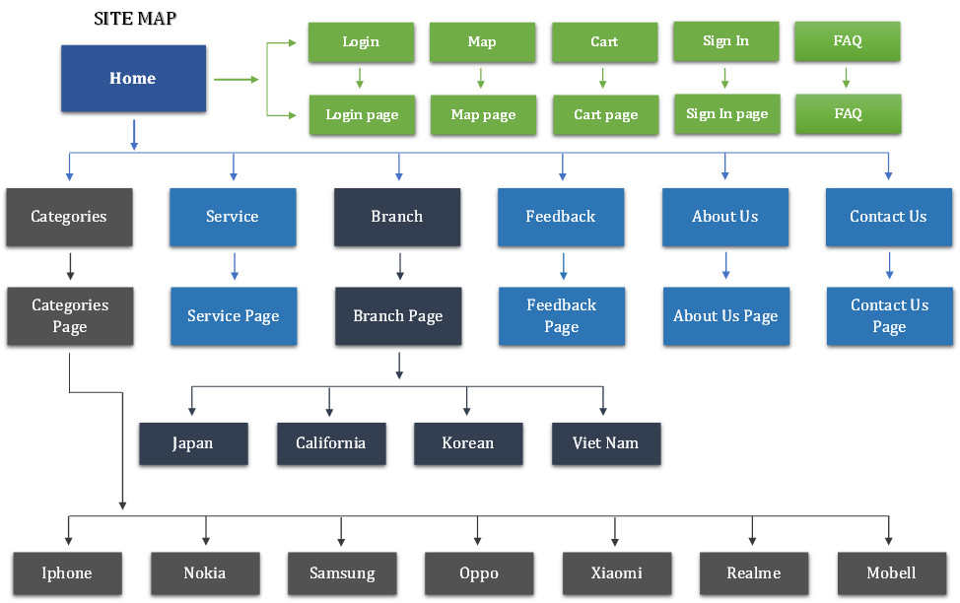

# **LAYOUT OF WEBSITE**

**HOME PAGE**

Header 01 **NAVIGATION BAR 01**

Header 02 **NAVIGATION BAR 02**

**(Slide)-PROMOTION PICTURE OF MOBILE**

**SPECIAL PRODUCT- (Picture) CONTENT**

**CONTENT SPECIAL PRODUCT- (Picture)**

**FOOTER**

**CATEGORIES PAPE**

Header - **NAVIGATION BAR**

**Brand of product**

**FOOTER**

Control Table for filtering product

GALLERY OF PRODUCT

**SERVICES**

Header - **NAVIGATION BAR**

**CUSTOMER SERVICE - (Content)**

**FOOTER**

**FEEDBACK**

Header - **NAVIGATION BAR**

**FEEDBACK FORM - (Content)**

**FOOTER**

**ABOUT US**

Header - **NAVIGATION BAR**

**ABOUT US - (Content)**

**FOOTER**

Header - **NAVIGATION BAR**

**CONTACT FORM - (Content)**

**FOOTER**

**CONTACT US**

Header - **NAVIGATION BAR**

**FAQ - (Content)**

**FOOTER**

**FAQ**

**REGISTRATION FORM**

Header - **NAVIGATION BAR**

**REGISTRATION FORM - (Content)**

**FOOTER**

Header - **NAVIGATION BAR**

**LOGIN FORM - (Content)**

**FOOTER**

LOGIN

Header - **NAVIGATION BAR**

**CART FORM - (Content)**

**FOOTER**

CART

# **TASK SHEET REVIEW 2**

|  |  |  |  |  |  |  |  |
| --- | --- | --- | --- | --- | --- | --- | --- |
| **Project Ref. No.: E**P/Advertisement Portal Management System/01 | | **Project Title** | **Activity Plan Prepared By** | **Date of Preparation of Activity Plan:** | | | |
| **No.** | **Task** | **CellInfo.com** | **Pham Anh Doan** | **Actual Start Date** | **Actual Days** | **Team Mate Names** | **Status** |
| 1 | Site map | 18-Jan-22 | 1 | Mr. Tu | Completed |
| 2 | Mock of the website | 20-Jan-22 | 2 | Mr. Doan | Completed |
| 3 | Task sheet | 21-Jan-22 | 1 | Mr. Doan | Completed |

**Date:** 23/01/2022

**Signature of Instructor Signature of Team Leader:**

Mrs. Le Mong Thuy Mr. Pham Anh Doan