ListeningPart1
/AMTHANH/Test1Part1.mp3
 | What’s the time?
 | 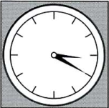 | 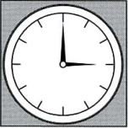 | 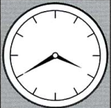
 | ANH\TEST1\1.vidu.a.png | ANH\TEST1\1.vidu.b.png | ANH\TEST1\1.vidu.c.png
1. | Where will the girls meet?
 | 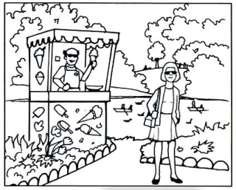 | 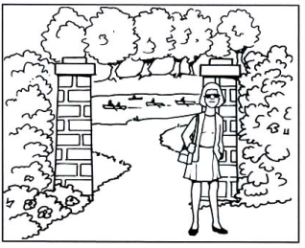 | 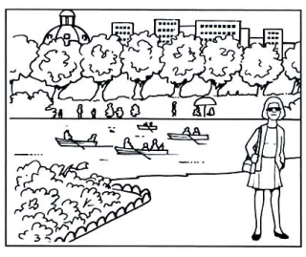
 | ANH\TEST1\1.1a.png | ANH\TEST1\1.1b.png | ANH\TEST1\1.1c.png
2. | Which chair does the man want?
2. | 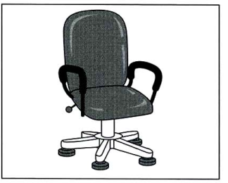 | 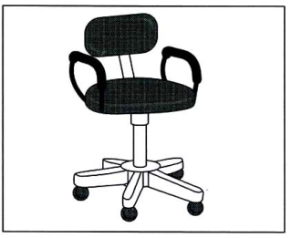 | 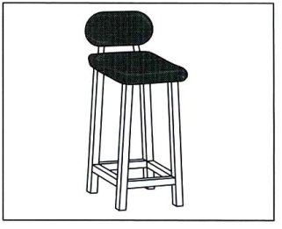
2. | ANH\TEST1\1.2a.png | ANH\TEST1\1.2b.png | ANH\TEST1\1.2c.png
3. | Which picture shows what the girls need?
3. | 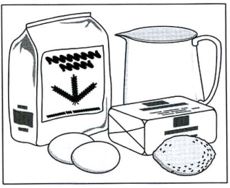 | 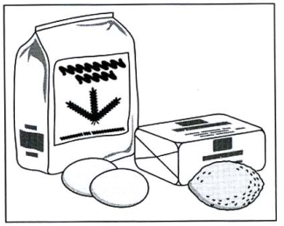 | 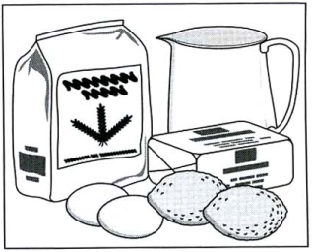
3. | ANH\TEST1\1.3a.png | ANH\TEST1\1.3b.png | ANH\TEST1\1.3c.png
4. | Which picture shows what happened?
4. | 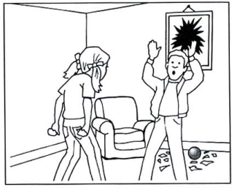 | 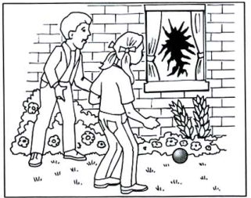 | 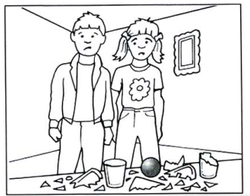
 | ANH\TEST1\1.4a.png | ANH\TEST1\1.4b.png | ANH\TEST1\1.4c.png
5. | What is Sarah’s mother doing?
 | 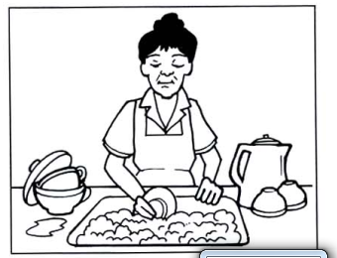 | 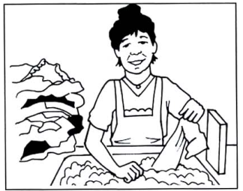 | 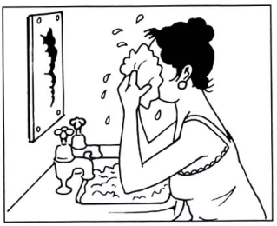
 | ANH\TEST1\1.5a.png | ANH\TEST1\1.5b.png | ANH\TEST1\1.5c.png
6. | Which luggage is the man taking on holiday?
 | 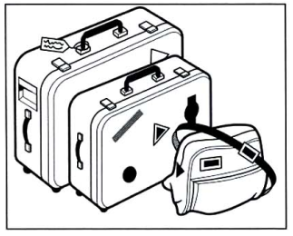 | 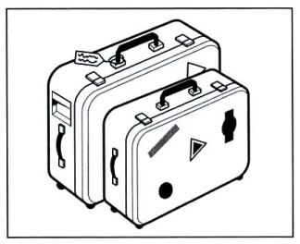 | 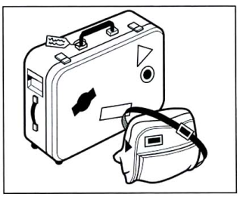
 | ANH\TEST1\1.6a.png | ANH\TEST1\1.6b.png | ANH\TEST1\1.6c.png
7. | Which photograph does the man like?
 | 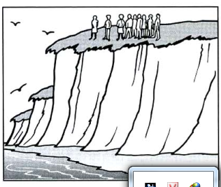 | 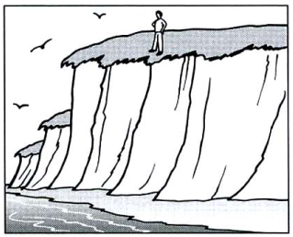 | 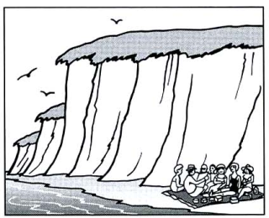
 | ANH\TEST1\1.7a.png | ANH\TEST1\1.7b.png | ANH\TEST1\1.7c.png

#ListeningPart1
/AMTHANH/Test2Part1.mp3
 | What’s the time?
 | ANH\TEST2\2.vidu.a.png | ANH\TEST2\2.vidu.b.png | ANH\TEST2\2.vidu.c.png
1. | When and where are they meeting?
 | 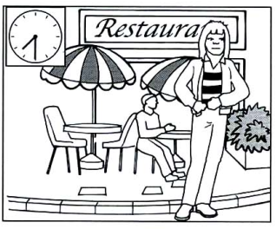 | 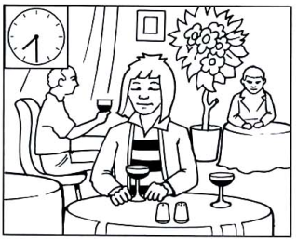 | 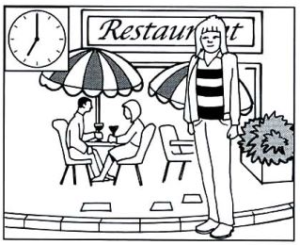
 | ANH\TEST2\2.1a.png | ANH\TEST2\2.1b.png | ANH\TEST2\2.1c.png
2. | What will Chris get for his birthday?
2. | 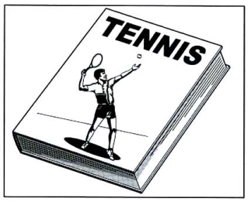 | 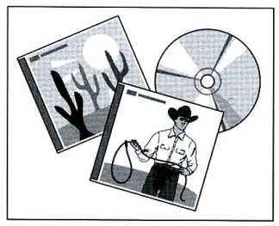 | 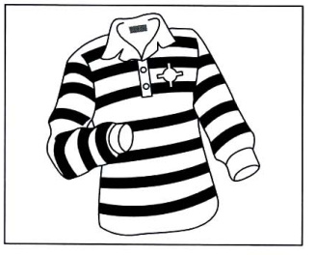
2. | ANH\TEST2\2.2a.png | ANH\TEST2\2.2b.png | ANH\TEST2\2.2c.png
3. | What does Mr Jones look like?
3. | 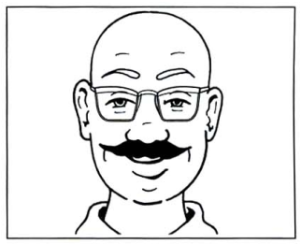 | 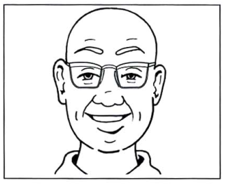 | 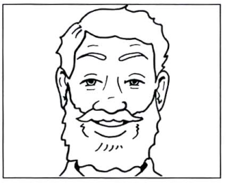
3. | ANH\TEST2\2.3a.png | ANH\TEST2\2.3b.png | ANH\TEST2\2.3c.png
4. | Where is he going to plant the tree?
4. | 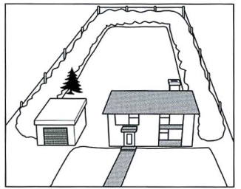 | 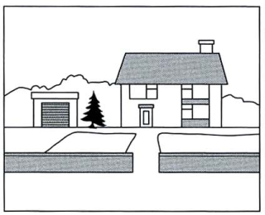 | 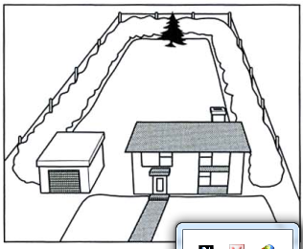
 | ANH\TEST2\2.4a.png | ANH\TEST2\2.4b.png | ANH\TEST2\2.4c.png
5. | What is the man going to buy?
 | 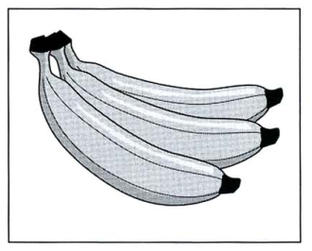 | 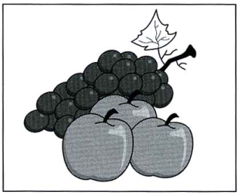 | 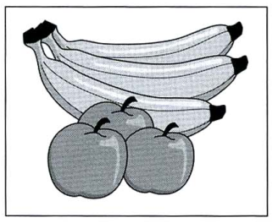
 | ANH\TEST2\2.5a.png | ANH\TEST2\2.5b.png | ANH\TEST2\2.5c.png
6. | Which is Gary’s room?
 | 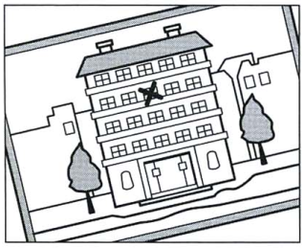 | 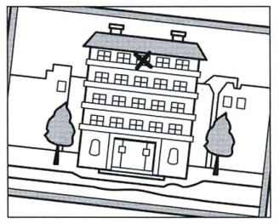 | 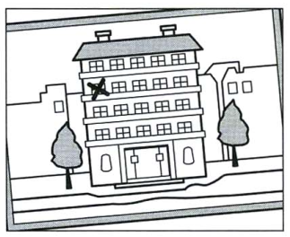
 | ANH\TEST2\2.6a.png | ANH\TEST2\2.6b.png | ANH\TEST2\2.6c.png
7. | Which is the best vehicle for the man?
 | 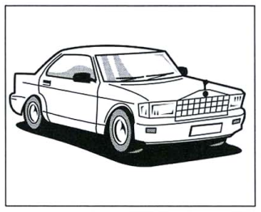 | 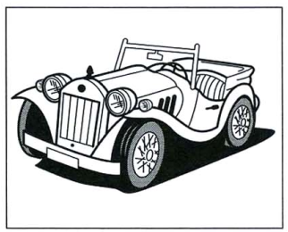 | 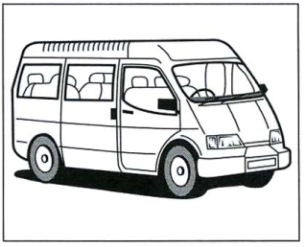
 | ANH\TEST2\2.7a.png | ANH\TEST2\2.7b.png | ANH\TEST2\2.7c.png

#ListeningPart1
/AMTHANH/Test3Part1.mp3
 | What’s the time?
 | ANH\TEST3\3.vidu.a.png | ANH\TEST3\3.vidu.b.png | ANH\TEST3\3.vidu.c.png
1. | Where is the station?
 | 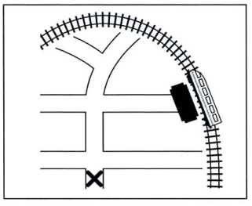 | 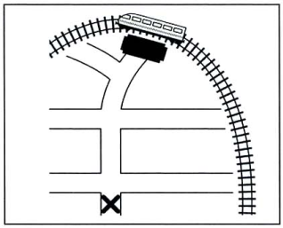 | 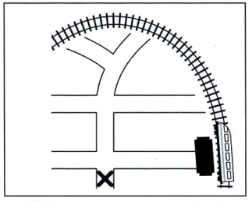
 | ANH\TEST3\3.1a.png | ANH\TEST3\3.1b.png | ANH\TEST3\3.1c.png
2. | Where did the woman put the calculator?
2. | 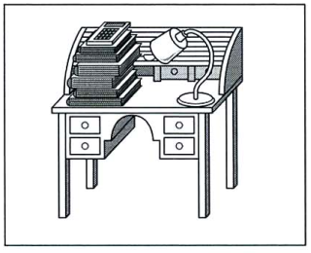 | 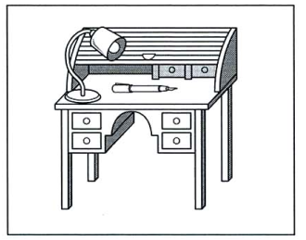 | 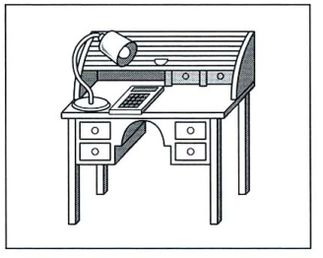
2. | ANH\TEST3\3.2a.png | ANH\TEST3\3.2b.png | ANH\TEST3\3.2c.png
3. | Where is Helen?
3. | 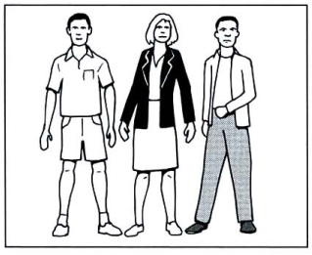 | 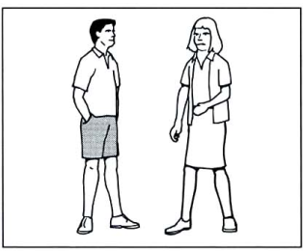 | 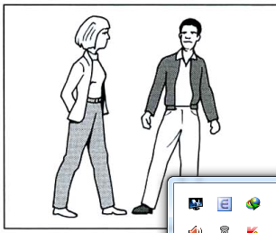
3. | ANH\TEST3\3.3a.png | ANH\TEST3\3.3b.png | ANH\TEST3\3.3c.png
4. | Which building was hit by lightening?
4. | 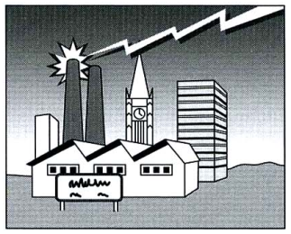 | 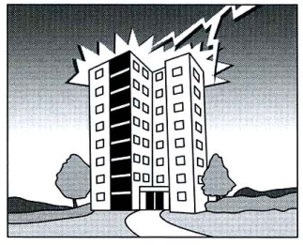 | 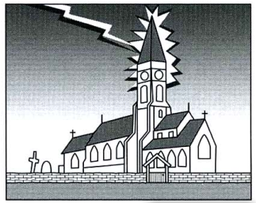
 | ANH\TEST3\3.4a.png | ANH\TEST3\3.4b.png | ANH\TEST3\3.4c.png
5. | What does the woman want to buy?
 | 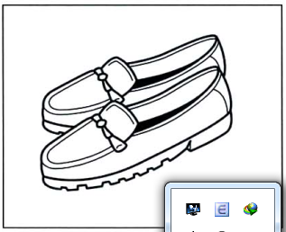 | 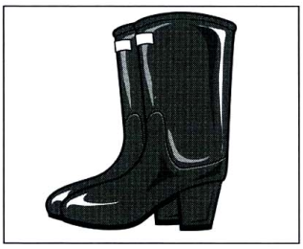 | 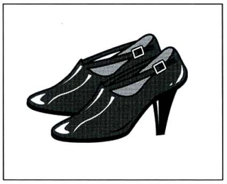
 | ANH\TEST3\3.5a.png | ANH\TEST3\3.5b.png | ANH\TEST3\3.5c.png
6. | Which picture does the woman decide to send?
 | 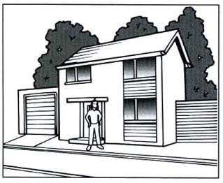 | 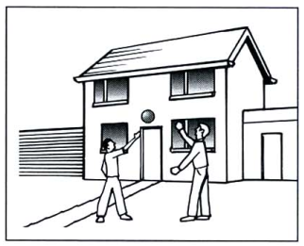 | 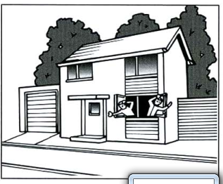
 | ANH\TEST3\3.6a.png | ANH\TEST3\3.6b.png | ANH\TEST3\3.6c.png
7. | Which hotel has the man chosen?
 | 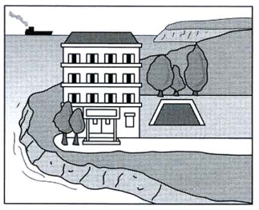 | 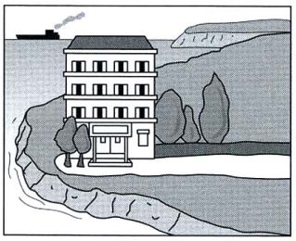 | 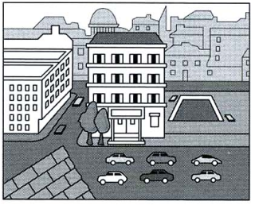
 | ANH\TEST3\3.7a.png | ANH\TEST3\3.7b.png | ANH\TEST3\3.7c.png

#ListeningPart1
/AMTHANH/Test4Part1.mp3
 | What’s the time?
 | ANH\TEST4\4.vidu.a.png | ANH\TEST4\4.vidu.b.png | ANH\TEST4\4.vidu.c.png
1. | Where are the woman’s glasses?
 | 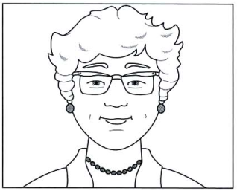 | 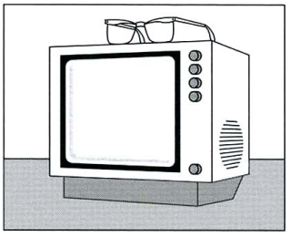 | 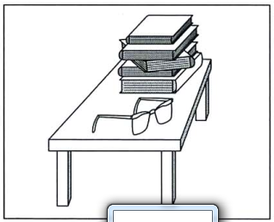
 | ANH\TEST4\4.1a.png | ANH\TEST4\4.1b.png | ANH\TEST4\4.1c.png
2. | What damage was done to the car?
2. | 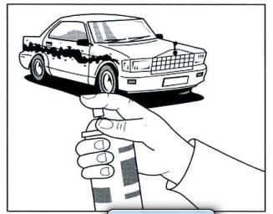 | 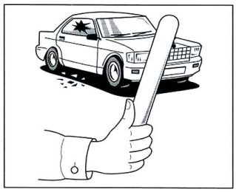 | 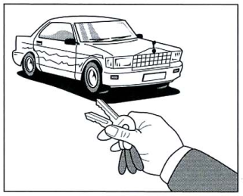
2. | ANH\TEST4\4.2a.png | ANH\TEST4\4.2b.png | ANH\TEST4\4.2c.png
3. | What did she bring?
3. | 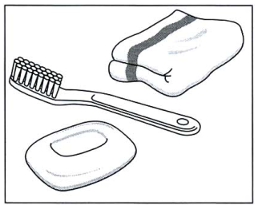 | 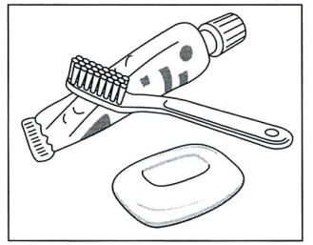 | 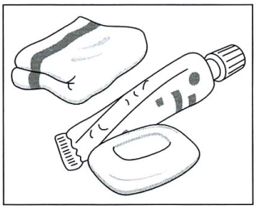
3. | ANH\TEST4\4.3a.png | ANH\TEST4\4.3b.png | ANH\TEST4\4.3c.png
4. | What did Sally buy?
4. | 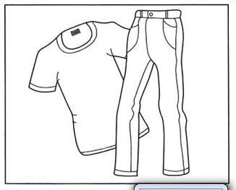 | 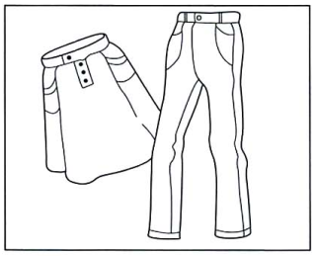 | 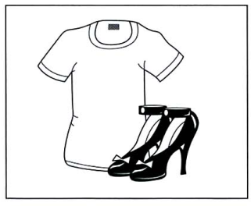
 | ANH\TEST4\4.4a.png | ANH\TEST4\4.4b.png | ANH\TEST4\4.4c.png
5. | Where are the man and his grandma?
 | 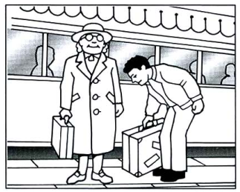 | 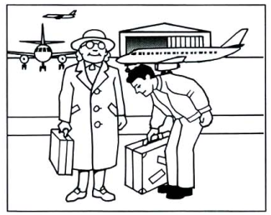 | 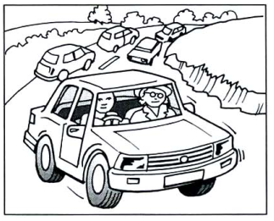
 | ANH\TEST4\4.5a.png | ANH\TEST4\4.5b.png | ANH\TEST4\4.5c.png
6. | What would John like to be?
 | 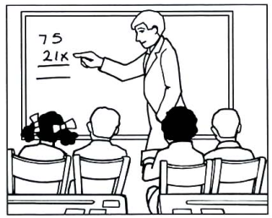 | 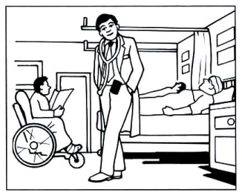 | 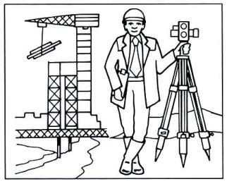
 | ANH\TEST4\4.6a.png | ANH\TEST4\4.6b.png | ANH\TEST4\4.6c.png
7. | Which pianist are the two people talking about?
 | 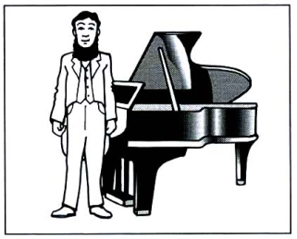 | 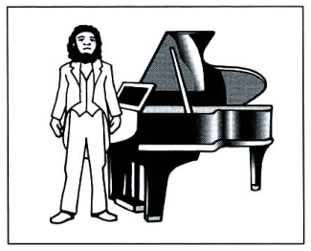 | 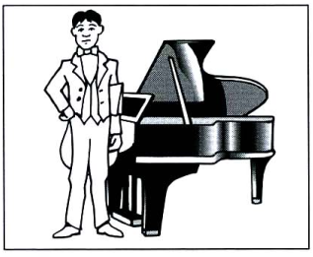
 | ANH\TEST4\4.7a.png | ANH\TEST4\4.7b.png | ANH\TEST4\4.7c.png
#ListeningPart1
/AMTHANH/Test5Part1.mp3
 | What’s the time?
 | ANH\TEST5\5.vidu.a.png | ANH\TEST5\5.vidu.b.png | ANH\TEST5\5.vidu.c.png
1. | What was in the woman’s bag?
 | 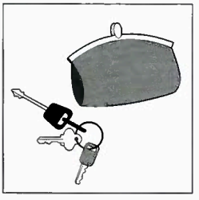 | 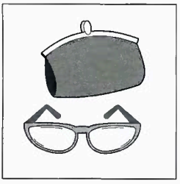 | 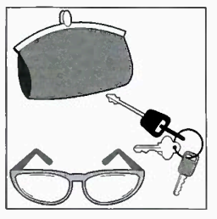
 | ANH\TEST5\5.1a.png | ANH\TEST5\5.1b.png | ANH\TEST5\5.1c.png
2. | Which film is the man talking about?
2. | 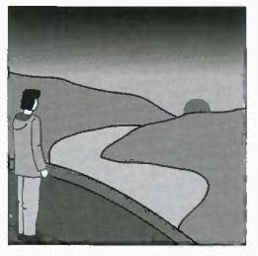 | 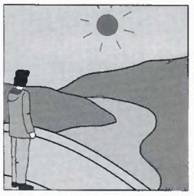 | 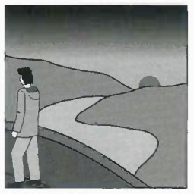
2. | ANH\TEST5\5.2a.png | ANH\TEST5\5.2b.png | ANH\TEST5\5.2c.png
3. | What should the woman do first?
3. | 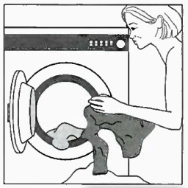 | 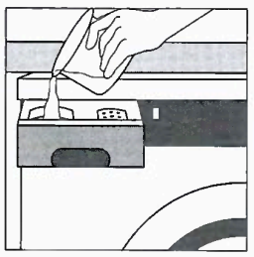 | 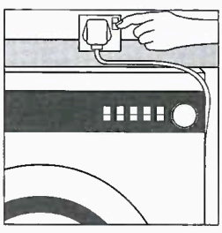
3. | ANH\TEST5\5.3a.png | ANH\TEST5\5.3b.png | ANH\TEST5\5.3c.png
4. | What is David going to do this weekend?
4. | 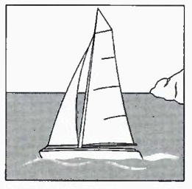 | 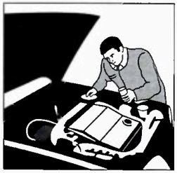 | 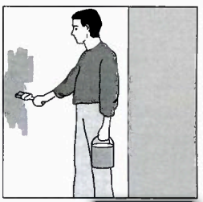
 | ANH\TEST5\5.4a.png | ANH\TEST5\5.4b.png | ANH\TEST5\5.4c.png
5. | How did the man get to work today?
 | 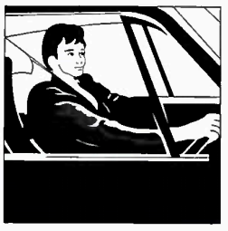 | 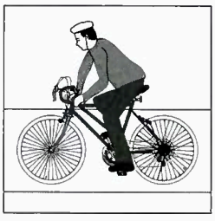 | 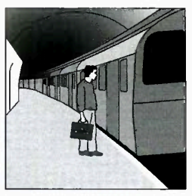
 | ANH\TEST5\5.5a.png | ANH\TEST5\5.5b.png | ANH\TEST5\5.5c.png
6. | Which tie does the man choose?
 | 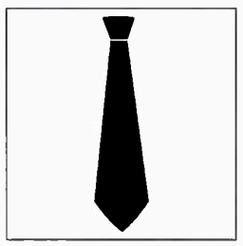 | 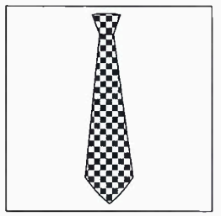 | 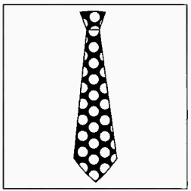
 | ANH\TEST5\5.6a.png | ANH\TEST5\5.6b.png | ANH\TEST5\5.6c.png
7. | What time is the appointment?
 | 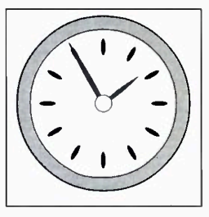 | 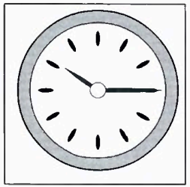 | 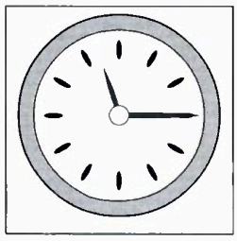
 | ANH\TEST5\5.7a.png | ANH\TEST5\5.7b.png | ANH\TEST5\5.7c.png
#ListeningPart1
/AMTHANH/Test6Part1.mp3
 | What’s the time?
 | ANH\TEST6\6.vidu.a.png | ANH\TEST6\6.vidu.b.png | ANH\TEST6\6.vidu.c.png
1. | How did the film end?
 | 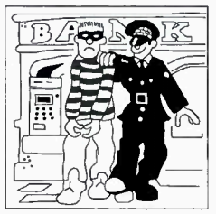 | 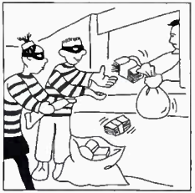 | 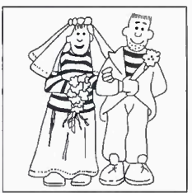
 | ANH\TEST6\6.1a.png | ANH\TEST6\6.1b.png | ANH\TEST6\6.1c.png
2. | What time does the train to Rome leave?
2. | 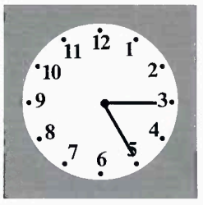 | 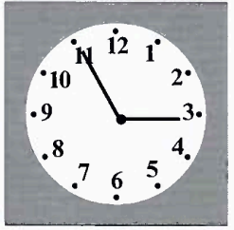 | 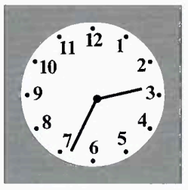
2. | ANH\TEST6\6.2a.png | ANH\TEST6\6.2b.png | ANH\TEST6\6.2c.png
3. | What is broken?
3. | 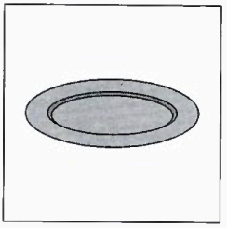 | 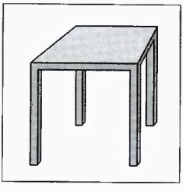 | 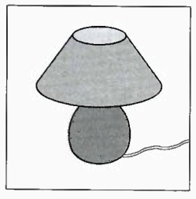
3. | ANH\TEST6\6.3a.png | ANH\TEST6\6.3b.png | ANH\TEST6\6.3c.png
4. | Where are the man’s shoes?
4. | 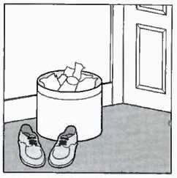 | 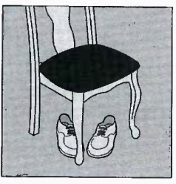 | 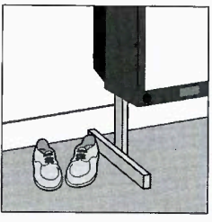
 | ANH\TEST6\6.4a.png | ANH\TEST6\6.4b.png | ANH\TEST6\6.4c.png
5. | What will Paul get at the shop?
 | 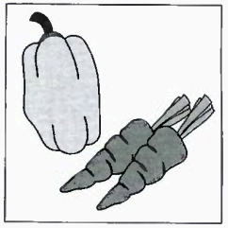 | 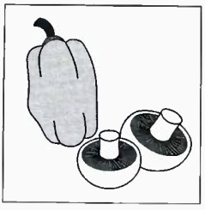 | 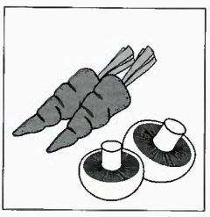
 | ANH\TEST6\6.5a.png | ANH\TEST6\6.5b.png | ANH\TEST6\6.5c.png
6. | How were they told to do their homework?
 | 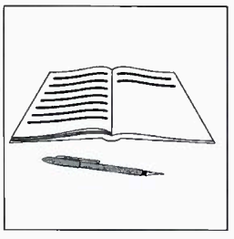 | 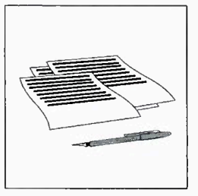 | 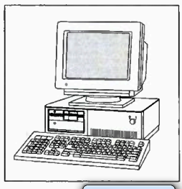
 | ANH\TEST6\6.6a.png | ANH\TEST6\6.6b.png | ANH\TEST6\6.6c.png
7. | What did Helen buy?
 | 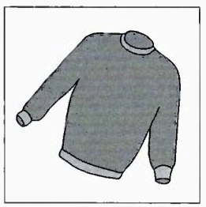 | 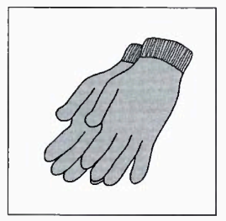 | 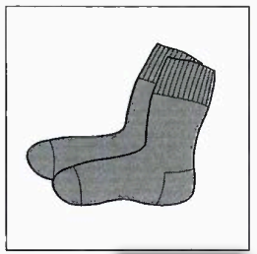
 | ANH\TEST6\6.7a.png | ANH\TEST6\6.7b.png | ANH\TEST6\6.7c.png
#ListeningPart1
/AMTHANH/Test7Part1.mp3
 | What’s the time?
 | ANH\TEST7\7.vidu.a.png | ANH\TEST7\7.vidu.b.png | ANH\TEST7\7.vidu.c.png
1. | How did the woman get to work today?
 | 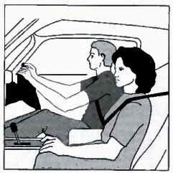 | 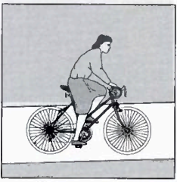 | 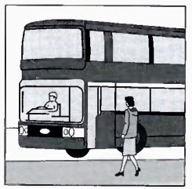
 | ANH\TEST7\7.1a.png | ANH\TEST7\7.1b.png | ANH\TEST7\7.1c.png
2. | Where does the pollution come from?
2. | 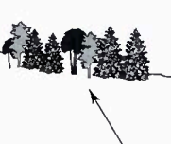 | 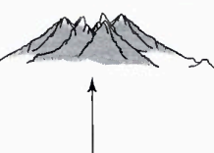 | 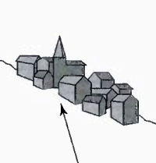
2. | ANH\TEST7\7.2a.png | ANH\TEST7\7.2b.png | ANH\TEST7\7.2c.png
3. | When must the boys get on the coach?
3. | 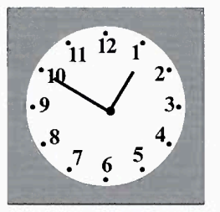 | 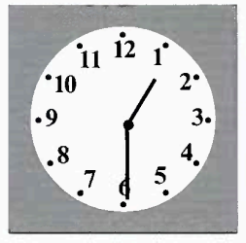 | 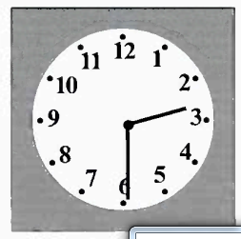
3. | ANH\TEST7\7.3a.png | ANH\TEST7\7.3b.png | ANH\TEST7\7.3c.png
4. | What fruit do they take?
4. | 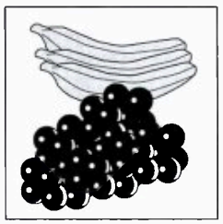 | 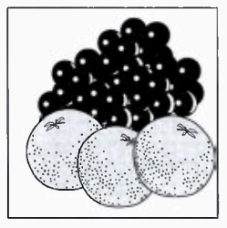 | 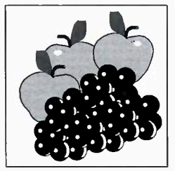
 | ANH\TEST7\7.4a.png | ANH\TEST7\7.4b.png | ANH\TEST7\7.4c.png
5. | Which present has the man bought?
 | 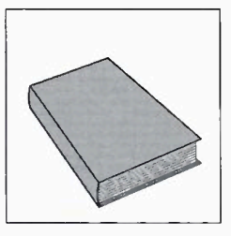 | 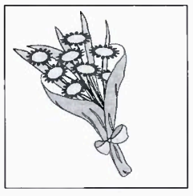 | 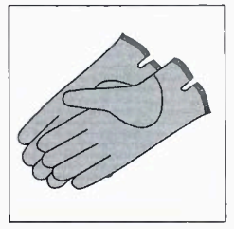
 | ANH\TEST7\7.5a.png | ANH\TEST7\7.5b.png | ANH\TEST7\7.5c.png
6. | Where are the photographs?
 | 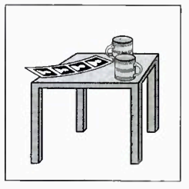 | 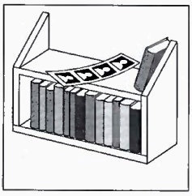 | 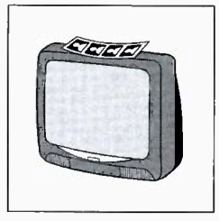
 | ANH\TEST7\7.6a.png | ANH\TEST7\7.6b.png | ANH\TEST7\7.6c.png
7. | What did Ben break?
 | 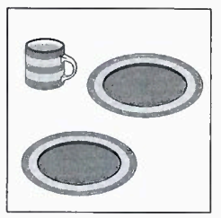 | 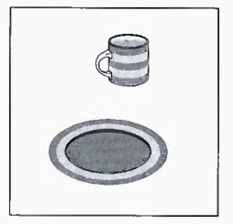 | 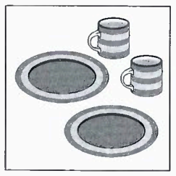
 | ANH\TEST7\7.7a.png | ANH\TEST7\7.7b.png | ANH\TEST7\7.7c.png
#ListeningPart1
/AMTHANH/Test8Part1.mp3
 | What’s the time?
 | ANH\TEST8\8.vidu.a.png | ANH\TEST8\8.vidu.b.png | ANH\TEST8\8.vidu.c.png
1. | What time will the flight leave?
 | 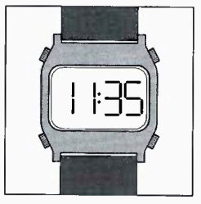 | 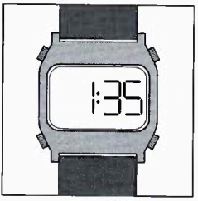 | 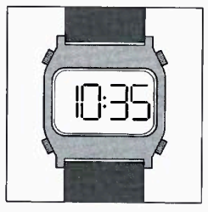
 | ANH\TEST8\8.1a.png | ANH\TEST8\8.1b.png | ANH\TEST8\8.1c.png
2. | Which is the photo of the girl’s father?
2. | 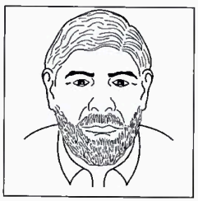 | 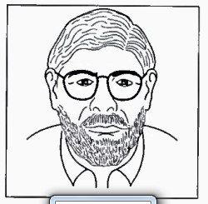 | 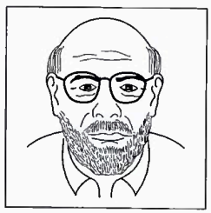
2. | ANH\TEST8\8.2a.png | ANH\TEST8\8.2b.png | ANH\TEST8\8.2c.png
3. | What must the woman wear at work?
3. | 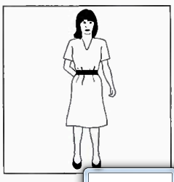 | 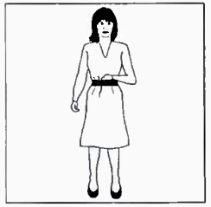 | 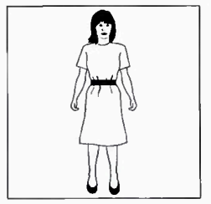
3. | ANH\TEST8\8.3a.png | ANH\TEST8\8.3b.png | ANH\TEST8\8.3c.png
4. | Where will they sit in the library?
4. | 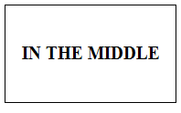 | 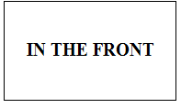 | 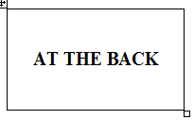
 | ANH\TEST8\8.4a.png | ANH\TEST8\8.4b.png | ANH\TEST8\8.4c.png
5. | How did the woman cook the onions?
 | 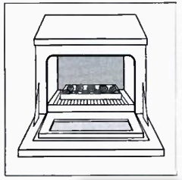 | 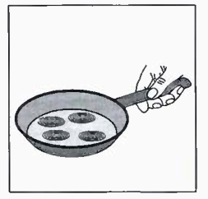 | 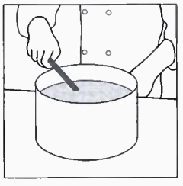
 | ANH\TEST8\8.5a.png | ANH\TEST8\8.5b.png | ANH\TEST8\8.5c.png
6. | What will the man buy?
 | 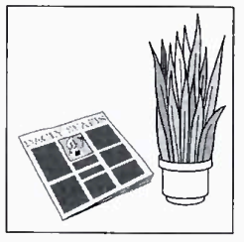 | 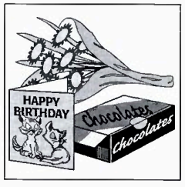 | 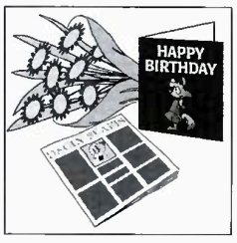
 | ANH\TEST8\8.6a.png | ANH\TEST8\8.6b.png | ANH\TEST8\8.6c.png
7. | How will they travel to Edinburgh?
 | 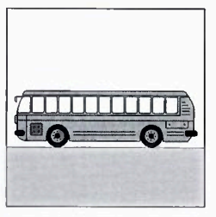 | 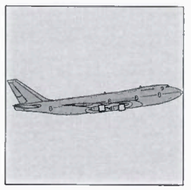 | 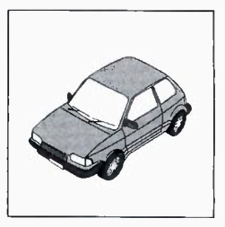
 | ANH\TEST8\8.7a.png | ANH\TEST8\8.7b.png | ANH\TEST8\8.7c.png
#ListeningPart1
/AMTHANH/Test9Part1.mp3
 | Where did the man leave his camera?
 | 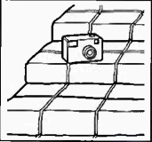 | 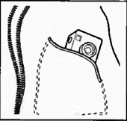 | 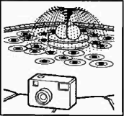
 | ANH\TEST9\9.vidu.a.png | ANH\TEST9\9.vidu.b.png | ANH\TEST9\9.vidu.c.png
1. | Which activity will the family do this year?
 | 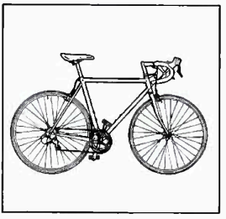 | 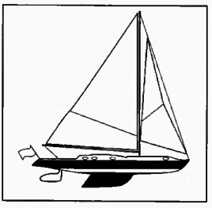 | 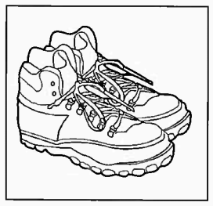
 | ANH\TEST9\9.1a.png | ANH\TEST9\9.1b.png | ANH\TEST9\9.1c.png
2. | Which is the woman’s house?
2. | 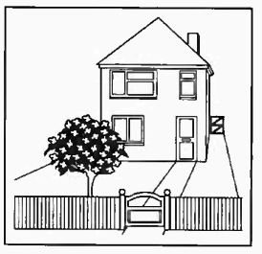 | 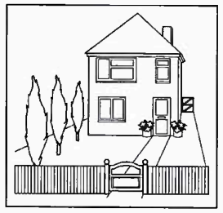 | 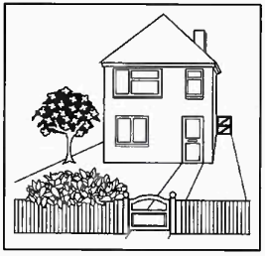
2. | ANH\TEST9\9.2a.png | ANH\TEST9\9.2b.png | ANH\TEST9\9.2c.png
3. | Why will drivers have problems this morning?
3. | 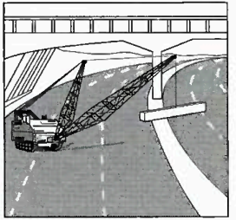 | 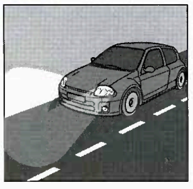 | 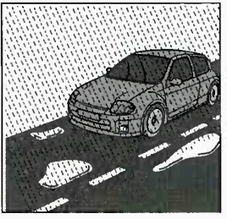
3. | ANH\TEST9\9.3a.png | ANH\TEST9\9.3b.png | ANH\TEST9\9.3c.png
4. | What time will Robin leave the house?
4. | 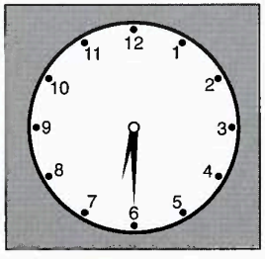 | 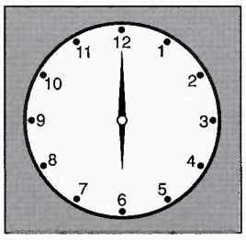 | 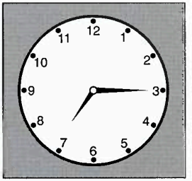
 | ANH\TEST9\9.4a.png | ANH\TEST9\9.4b.png | ANH\TEST9\9.4c.png
5. | What did Simon do this morning?
 | 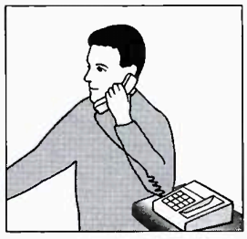 | 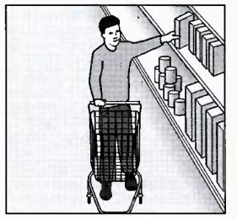 | 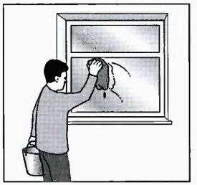
 | ANH\TEST9\9.5a.png | ANH\TEST9\9.5b.png | ANH\TEST9\9.5c.png
6. | What hasn’t the girl packed yet?
 | 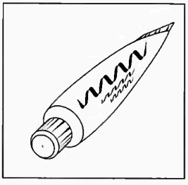 | 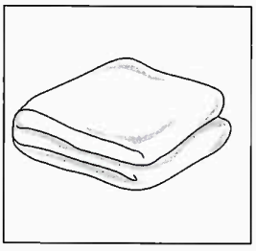 | 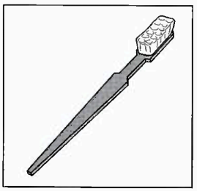
 | ANH\TEST9\9.6a.png | ANH\TEST9\9.6b.png | ANH\TEST9\9.6c.png
7. | What has the woman just bought?
 | 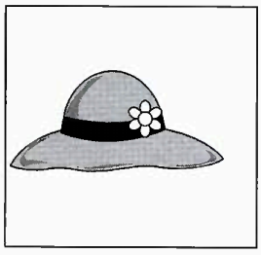 | 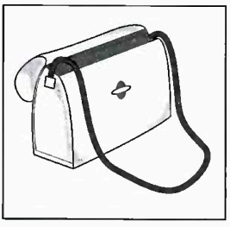 | 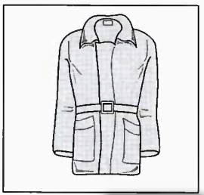
 | ANH\TEST9\9.7a.png | ANH\TEST9\9.7b.png | ANH\TEST9\9.7c.png
#ListeningPart1
/AMTHANH/Test10Part1.mp3
 | What’s the time?
 | ANH\TEST10\10.vidu.a.png | ANH\TEST10\10.vidu.b.png | ANH\TEST10\10.vidu.c.png
1. | How much is the man’s ticket?
 |  | 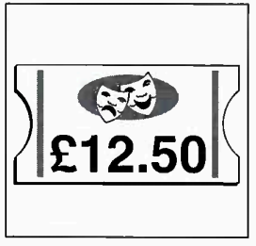 | 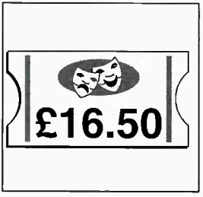
 | ANH\TEST10\10.1a.png | ANH\TEST10\10.1b.png | ANH\TEST10\10.1c.png
2. | What will they have for lunch?
2. | 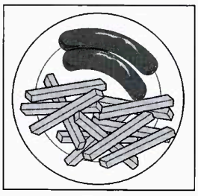 | 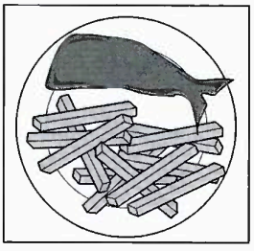 | 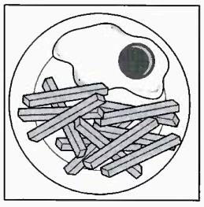
2. | ANH\TEST10\10.2a.png | ANH\TEST10\10.2b.png | ANH\TEST10\10.2c.png
3. | Why was the man late home?
3. | 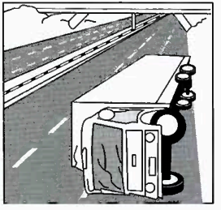 | 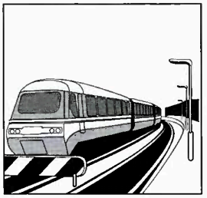 | 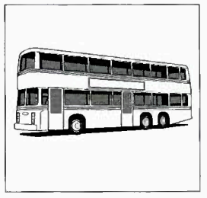
3. | ANH\TEST10\10.3a.png | ANH\TEST10\10.3b.png | ANH\TEST10\10.3c.png
4. | What was the weather like on John’s holiday?
4. | 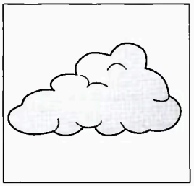 | 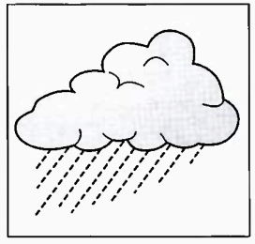 | 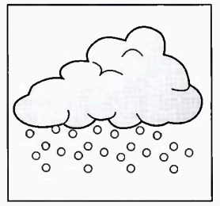
 | ANH\TEST10\10.4a.png | ANH\TEST10\10.4b.png | ANH\TEST10\10.4c.png
5. | What time was the woman’s appointment?
 | 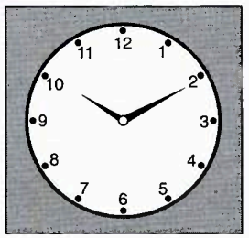 | 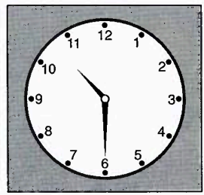 | 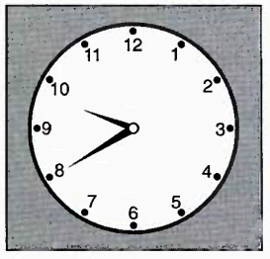
 | ANH\TEST10\10.5a.png | ANH\TEST10\10.5b.png | ANH\TEST10\10.5c.png
6. | What did the woman buy?
 | 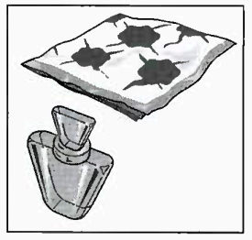 | 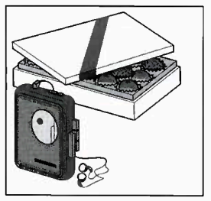 | 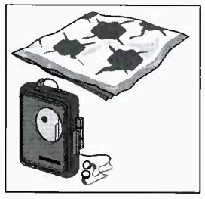
 | ANH\TEST10\10.6a.png | ANH\TEST10\10.6b.png | ANH\TEST10\10.6c.png
7. | Where are the man and the woman talking?
 | 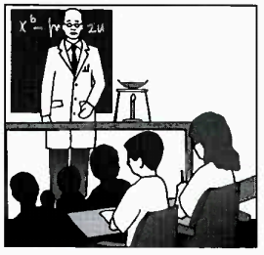 | 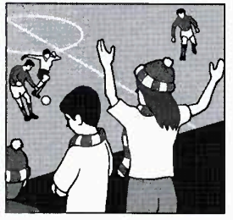 | 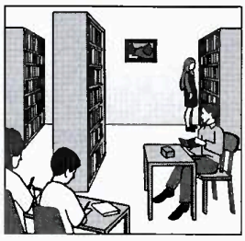
 | ANH\TEST10\10.7a.png | ANH\TEST10\10.7b.png | ANH\TEST10\10.7c.png
#ListeningPart1
/AMTHANH/Test11Part1.mp3
 | What’s the time?
 | ANH\TEST11\11.vidu.a.png | ANH\TEST11\11.vidu.b.png | ANH\TEST11\11.vidu.c.png
1. | What is the man going to buy?
 | 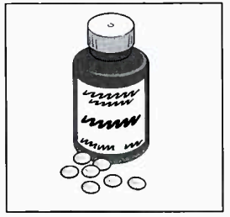 | 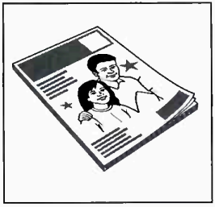 | 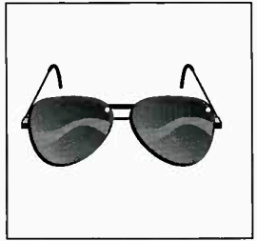
 | ANH\TEST11\11.1a.png | ANH\TEST11\11.1b.png | ANH\TEST11\11.1c.png
2. | Which dress is Kate talking about?
2. | 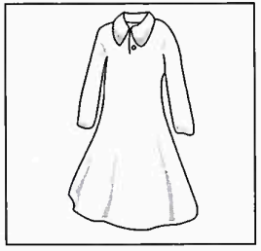 | 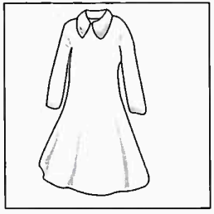 | 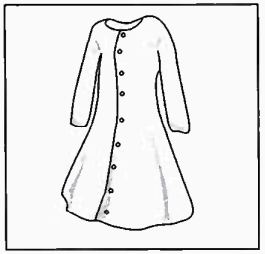
2. | ANH\TEST11\11.2a.png | ANH\TEST11\11.2b.png | ANH\TEST11\11.2c.png
3. | When will Jane meet them?
3. | 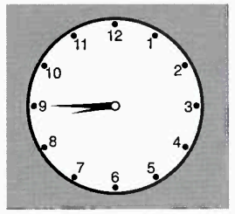 | 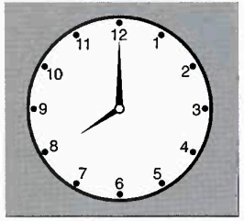 | 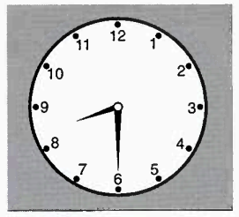
3. | ANH\TEST11\11.3a.png | ANH\TEST11\11.3b.png | ANH\TEST11\11.3c.png
4. | Which morning activity is for beginners?
4. | 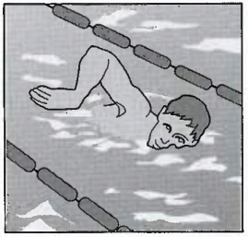 | 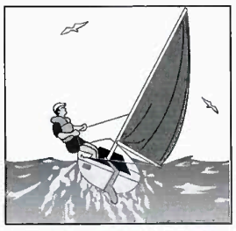 | 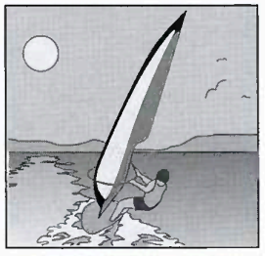
 | ANH\TEST11\11.4a.png | ANH\TEST11\11.4b.png | ANH\TEST11\11.4c.png
5. | Which painting does the woman decide to buy?
 | 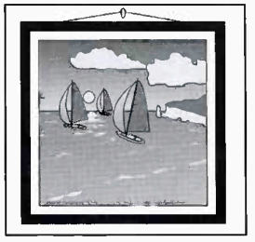 | 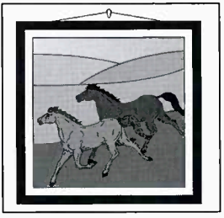 | 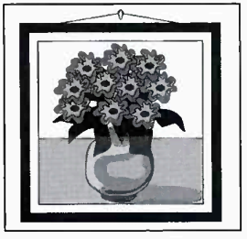
 | ANH\TEST11\11.5a.png | ANH\TEST11\11.5b.png | ANH\TEST11\11.5c.png
6. | What is the man selling?
 | 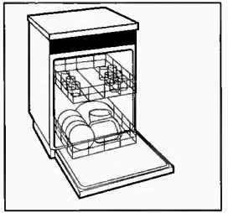 | 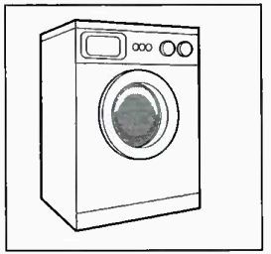 | 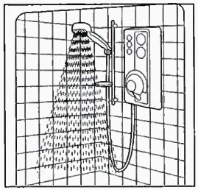
 | ANH\TEST11\11.6a.png | ANH\TEST11\11.6b.png | ANH\TEST11\11.6c.png
7. | What is the weather forecast for tomorrow?
 | 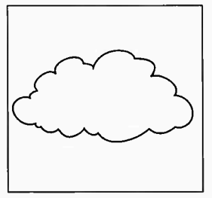 | 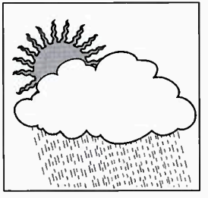 | 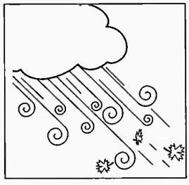
 | ANH\TEST11\11.7a.png | ANH\TEST11\11.7b.png | ANH\TEST11\11.7c.png
#ListeningPart1
/AMTHANH/Test12Part1.mp3
 | Where did the man leave his camera?
 | 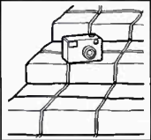 | 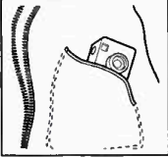 | 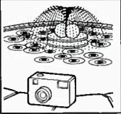
 | ANH\TEST12\12.vidu.a.png | ANH\TEST12\12.vidu.b.png | ANH\TEST12\12.vidu.c.png
1. | Where will the woman go first after work?
 | 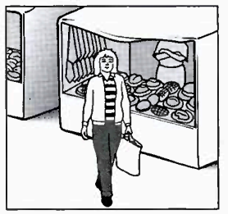 | 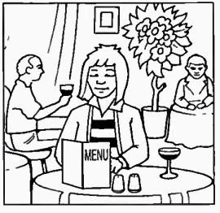 | 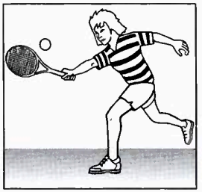
 | ANH\TEST12\12.1a.png | ANH\TEST12\12.1b.png | ANH\TEST12\12.1c.png
2. | What can festival visitors see every day?
2. | 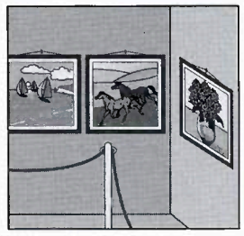 | 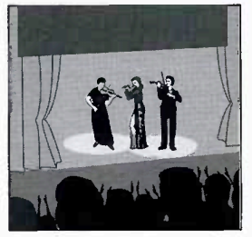 | 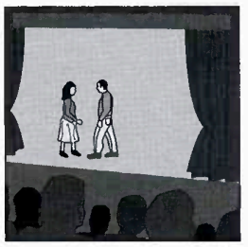
2. | ANH\TEST12\12.2a.png | ANH\TEST12\12.2b.png | ANH\TEST12\12.2c.png
3. | What souvenir will the boy’s mother bring?
3. | 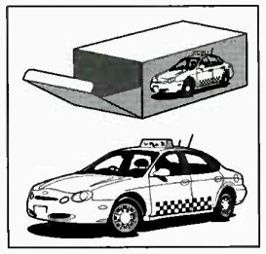 | 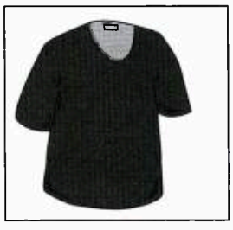 | 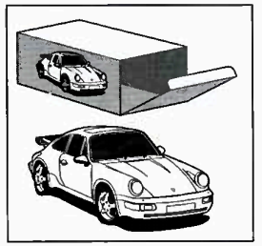
3. | ANH\TEST12\12.3a.png | ANH\TEST12\12.3b.png | ANH\TEST12\12.3c.png
4. | What time is the woman’s hair appointment?
4. | 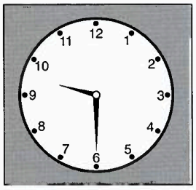 | 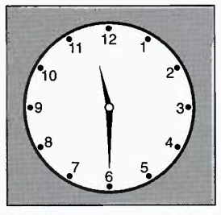 | 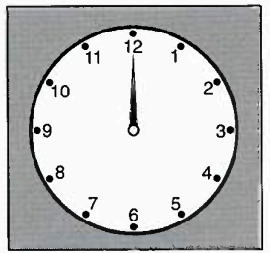
 | ANH\TEST12\12.4a.png | ANH\TEST12\12.4b.png | ANH\TEST12\12.4c.png
5. | Where’s the TV guide?
 | 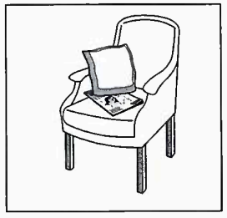 | 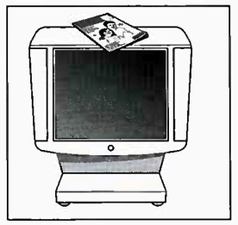 | 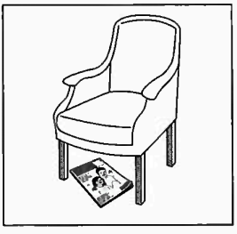
 | ANH\TEST12\12.5a.png | ANH\TEST12\12.5b.png | ANH\TEST12\12.5c.png
6. | What does the man decide to take Tracy?
 | 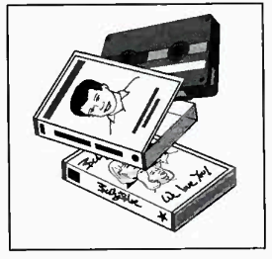 | 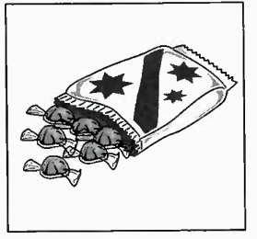 | 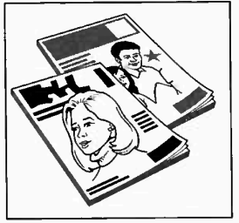
 | ANH\TEST12\12.6a.png | ANH\TEST12\12.6b.png | ANH\TEST12\12.6c.png
7. | Which sport has the man just started?
 | 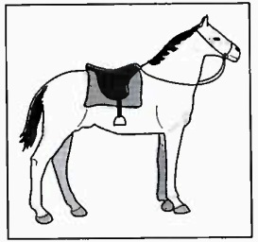 | 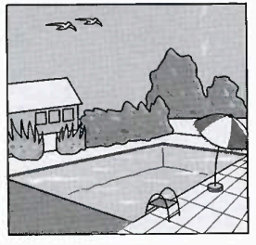 | 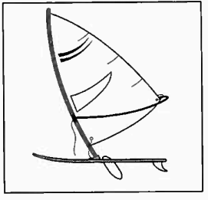
 | ANH\TEST12\12.7a.png | ANH\TEST12\12.7b.png | ANH\TEST12\12.7c.png
#ListeningPart1
/AMTHANH/Test13Part1.mp3
 | Where is the girl’s hat?
 | 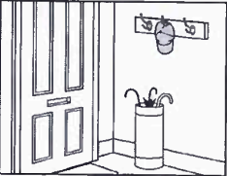 | 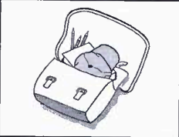 | 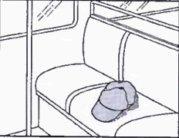
 | ANH\TEST13\13.vidu.a.png | ANH\TEST13\13.vidu.b.png | ANH\TEST13\13.vidu.c.png
1. | What was damaged in the storm?
 | 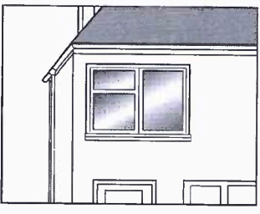 | 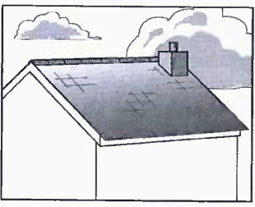 | 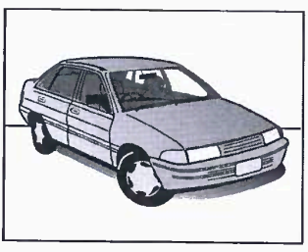
 | ANH\TEST13\13.1a.png | ANH\TEST13\13.1b.png | ANH\TEST13\13.1c.png
2. | What present does the man decide to take?
2. | 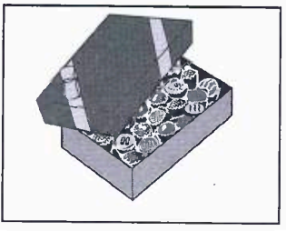 | 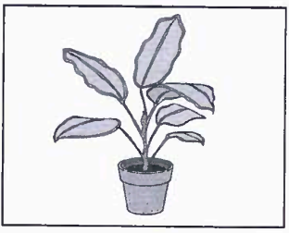 | 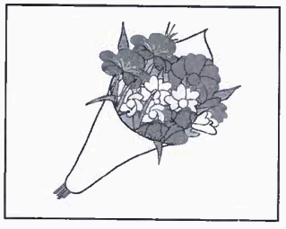
2. | ANH\TEST13\13.2a.png | ANH\TEST13\13.2c.png | ANH\TEST13\13.2c.png
3. | Which is the woman’s jacket?
3. | 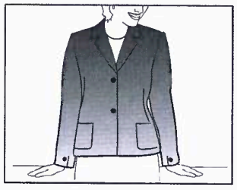 | 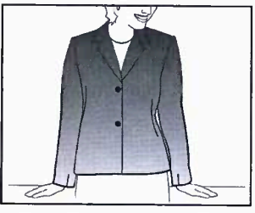 | 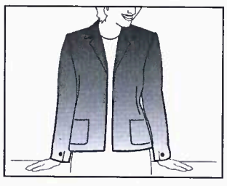
3. | ANH\TEST13\13.3a.png | ANH\TEST13\13.3b.png | ANH\TEST13\13.3c.png
4. | Which sport is not included in the price of the holiday?
4. | 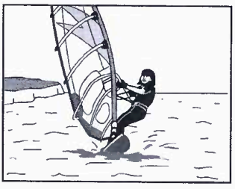 | 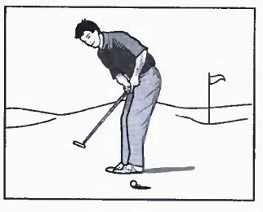 | 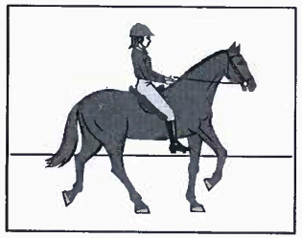
 | ANH\TEST13\13.4a.png | ANH\TEST13\13.4b.png | ANH\TEST13\13.4c.png
5. | Which postcard will they send?
 | 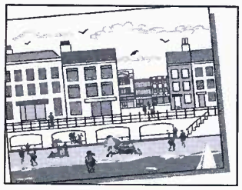 | 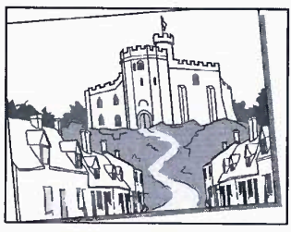 | 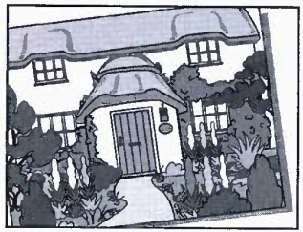
 | ANH\TEST13\13.5a.png | ANH\TEST13\13.5b.png | ANH\TEST13\13.5c.png
6. | Where do they decide to go?
 | 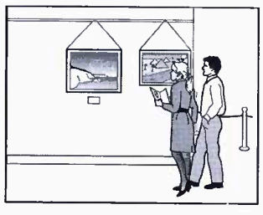 | 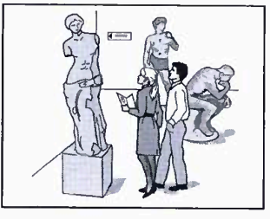 | 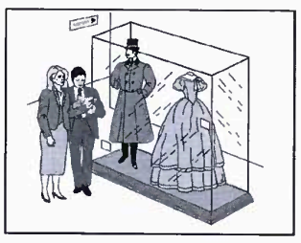
 | ANH\TEST13\13.6a.png | ANH\TEST13\13.6b.png | ANH\TEST13\13.6c.png
7. | What will the boy do first?
 | 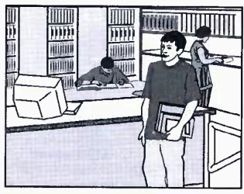 | 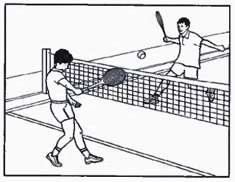 | 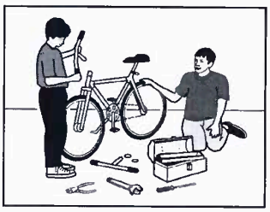
 | ANH\TEST13\13.7a.png | ANH\TEST13\13.7b.png | ANH\TEST13\13.7c.png
#ListeningPart1
/AMTHANH/Test14Part1.mp3
 | Where did the man leave his camera?
 | 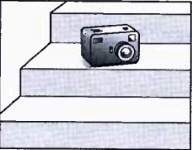 | 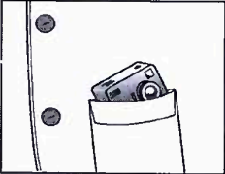 | 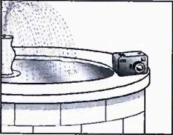
 | ANH\TEST14\14.vidu.a.png | ANH\TEST14\14.vidu.b.png | ANH\TEST14\14.vidu.c.png
1. | Which sport will the woman learn on holiday?
 | 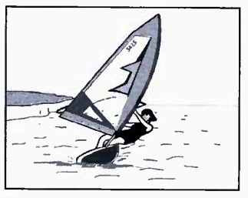 | 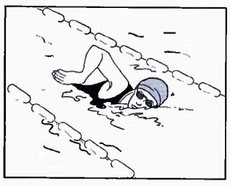 | 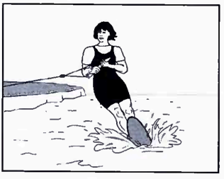
 | ANH\TEST14\14.1a.png | ANH\TEST14\14.1b.png | ANH\TEST14\14.1c.png
2. | What does the girl’s pen friend look like now?
2. | 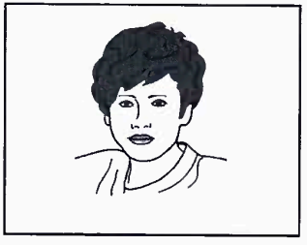 | 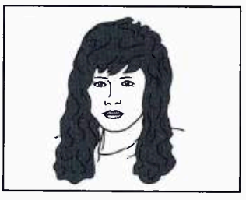 | 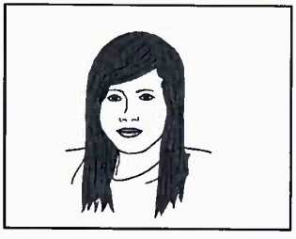
2. | ANH\TEST14\14.2a.png | ANH\TEST14\14.2b.png | ANH\TEST14\14.2c.png
3. | Which animals did the children see?
3. | 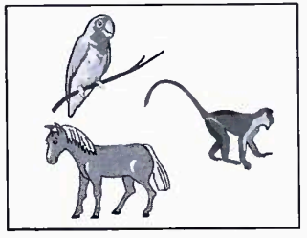 | 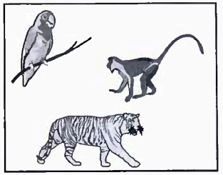 | 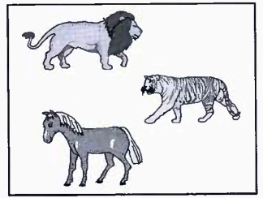
3. | ANH\TEST14\14.3a.png | ANH\TEST14\14.3b.png | ANH\TEST14\14.3c.png
4. | Which TV programme is on first?
4. | 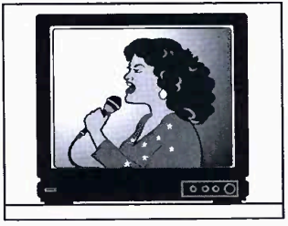 | 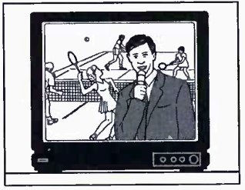 | 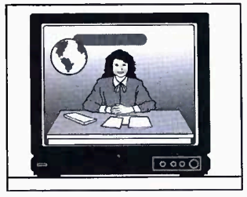
 | ANH\TEST14\14.4a.png | ANH\TEST14\14.4b.png | ANH\TEST14\14.4c.png
5. | What does the boy decide to buy for his grandmother>
 | 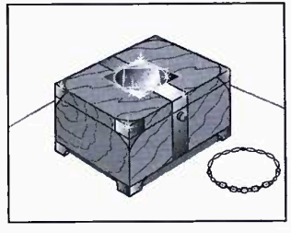 | 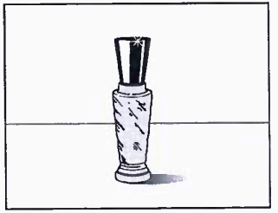 | 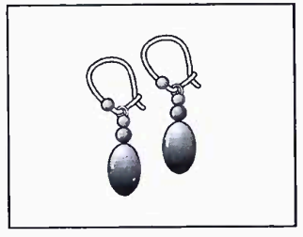
 | ANH\TEST14\14.5a.png | ANH\TEST14\14.5b.png | ANH\TEST14\14.5c.png
6. | What time is the man’s appointment?
 | 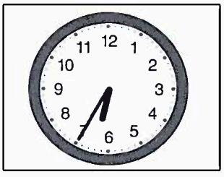 | 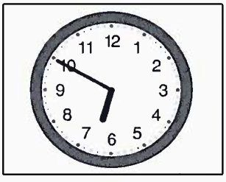 | 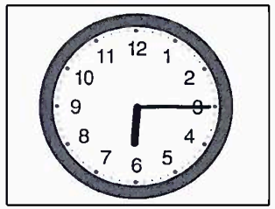
 | ANH\TEST14\14.6a.png | ANH\TEST14\14.6b.png | ANH\TEST14\14.6c.png
7. | What has the woman lost?
 | 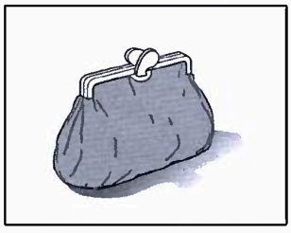 | 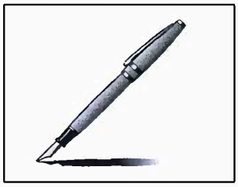 | 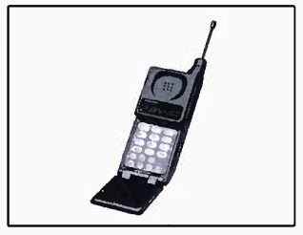
 | ANH\TEST14\14.7a.png | ANH\TEST14\14.7b.png | ANH\TEST14\14.7c.png
#ListeningPart1
/AMTHANH/Test15Part1.mp3
 | Where did the man leave his camera?
 | 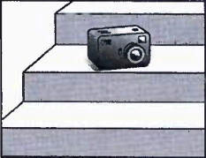 | 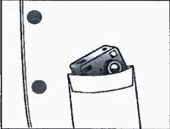 | 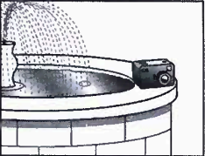
 | ANH\TEST15\15.vidu.a.png | ANH\TEST15\15.vidu.b.png | ANH\TEST15\15.vidu.c.png
1. | What is the weather forecast for tomorrow?
 | 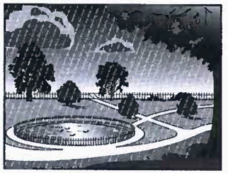 | 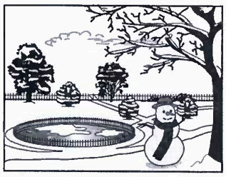 | 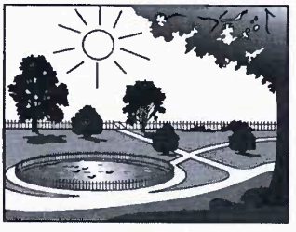
 | ANH\TEST15\15.1a.png | ANH\TEST15\15.1b.png | ANH\TEST15\15.1c.png
2. | What will they buy at the supermarket?
2. | 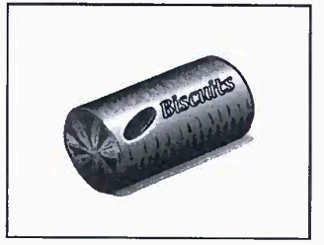 | 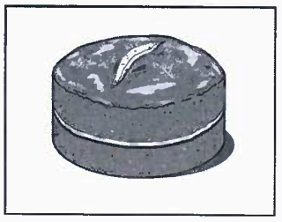 | 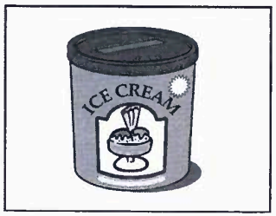
2. | ANH\TEST15\15.2a.png | ANH\TEST15\15.2b.png | ANH\TEST15\15.2c.png
3. | Which T-shirt does the woman buy?
3. | 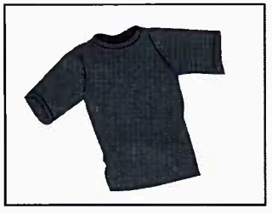 | 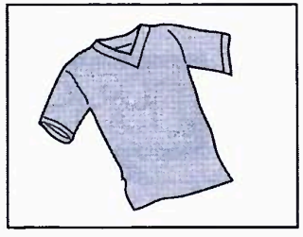 | 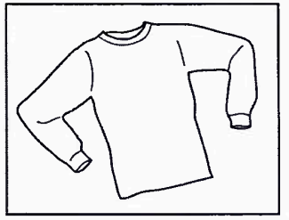
3. | ANH\TEST15\15.3a.png | ANH\TEST15\15.3b.png | ANH\TEST15\15.3c.png
4. | What will the girl take with her on holiday?
4. | 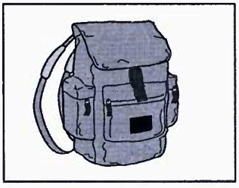 | 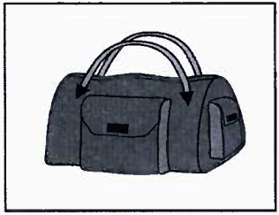 | 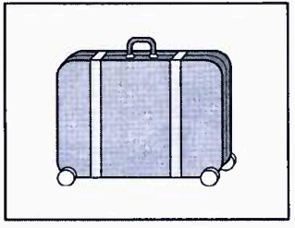
 | ANH\TEST15\15.4a.png | ANH\TEST15\15.4b.png | ANH\TEST15\15.4c.png
5. | Which exercise is the teacher describing?
 | 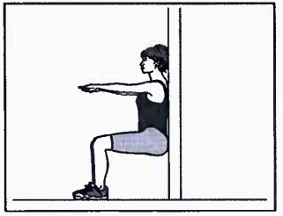 | 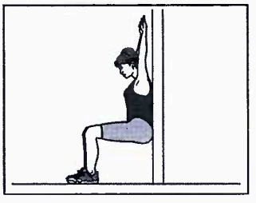 | 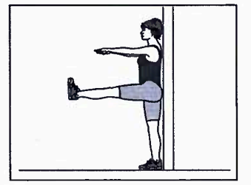
 | ANH\TEST15\15.5a.png | ANH\TEST15\15.5b.png | ANH\TEST15\15.5c.png
6. | What time will the train to London leave?
 | 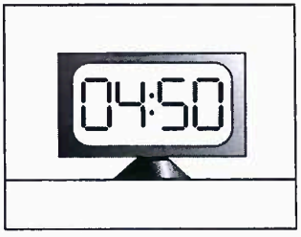 | 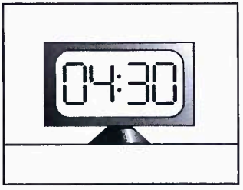 | 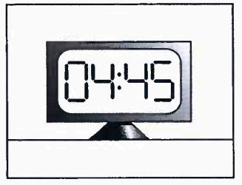
 | ANH\TEST15\15.6a.png | ANH\TEST15\15.6b.png | ANH\TEST15\15.6c.png
7. | Which sport will the boy do soon at the centre?
 | 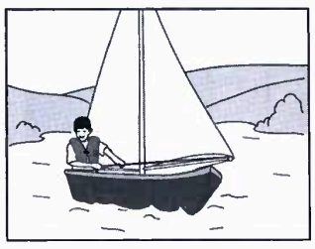 | 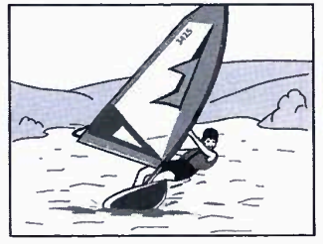 | 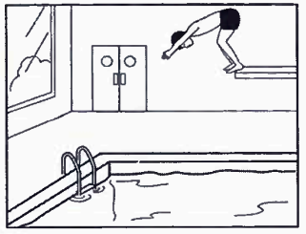
 | ANH\TEST15\15.7a.png | ANH\TEST15\15.7b.png | ANH\TEST15\15.7c.png

TEST 16
Part1
/AMTHANH/Test16Part1.mp3
 | Where did the man leave his camera?
 | 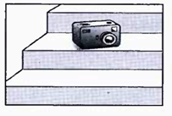 | 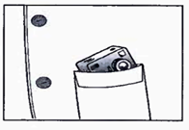 |  | 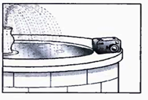
 | ANH\TEST16\test16.vidu.a.png | ANH\TEST16\test16.vidu.b.png |  | ANH\TEST16\test16.vidu.c.png
1. | Which of Miranda’s things will Lucy be able to use?
 | 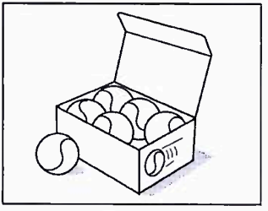 |  | 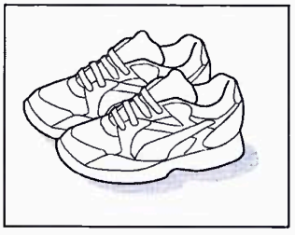 |  |  | 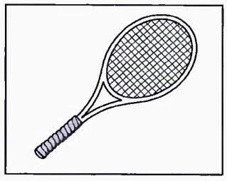
 | ANH\TEST16\test16.1a.png |  | ANH\TEST16\test16.1b.png |  |  | ANH\TEST16\test16.1c.png
2. | What can’t the woman find?
2. | 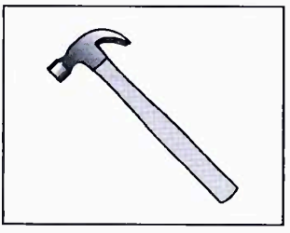 |  | 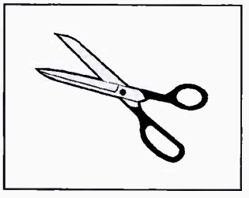 |  |  | 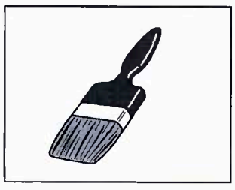
2. | ANH\TEST16\test16.2a.png |  | ANH\TEST16\test16.2b.png |  |  | ANH\TEST16\test16.2c.png
3. | Which ring has the woman lost?
3. | 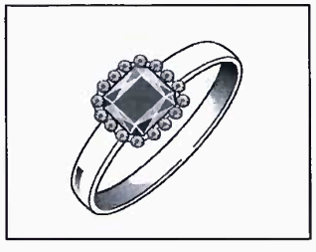 |  | 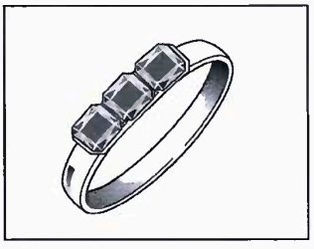 |  |  | 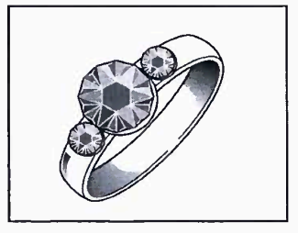
3. | ANH\TEST16\test16.3a.png |  | ANH\TEST16\test16.3b.png |  |  | ANH\TEST16\test16.3c.png
4. | What time did the girl arrive?
4. | 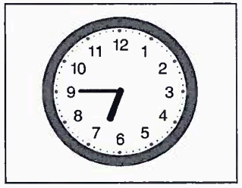 |  | 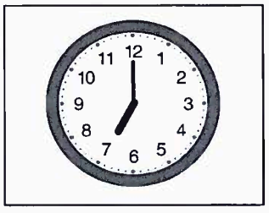 |  |  | 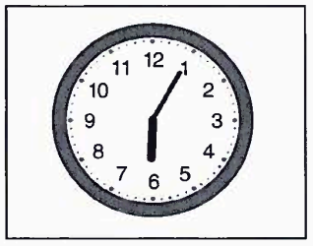
 | ANH\TEST16\test16.4a.png |  | ANH\TEST16\test16.4b.png |  |  | ANH\TEST16\test16.4c.png
5. | What will be on television at 10 o’clock this evening?
 | 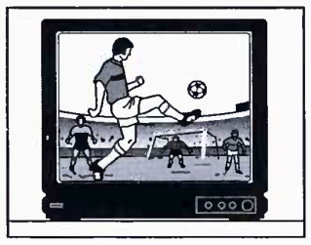 |  | 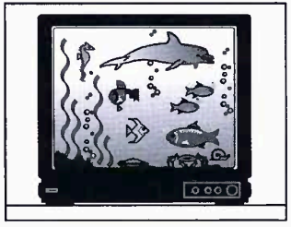 |  |  | 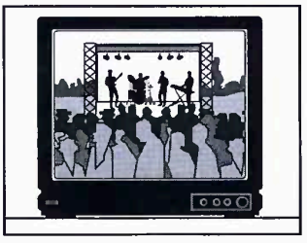
 | ANH\TEST16\test16.5a.png |  | ANH\TEST16\test16.5b.png |  |  | ANH\TEST16\test16.5c.png
6. | What will the party be?
 | 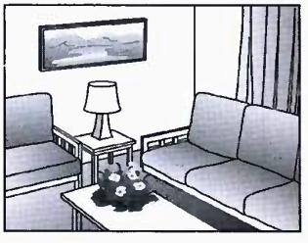 |  | 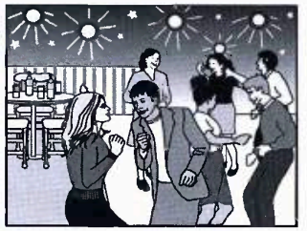 |  | 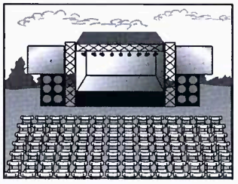
 | ANH\TEST16\test16.6a.png |  | ANH\TEST16\test16.6b.png |  | ANH\TEST16\test16.6c.png
7. | What did the man buy?
 | 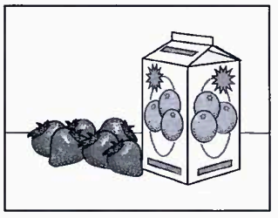 |  | 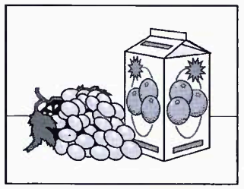 | 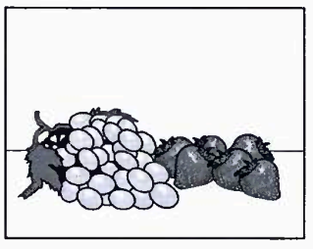
 | ANH\TEST16\test16.7a.png |  | ANH\TEST16\test16.7b.png | ANH\TEST16\test16.7c.png

PART 2

AMTHANH\Test16Part2.mp3
8. | Why did Paul choose the part of Africa he visited?
A | It will soon change.
B | He had been there before.
C | It is good for walking.
9. | What made the team’s journey slow?
A | Clearing paths through the forest.
B | Finding somewhere safe to camp.
C | Carrying heavy equipment.
10. | What did Paul worry about during the trip?
A | Being responsible for a team of people.
B | The number of dangerous animals.
C | Getting the information he needed.
11. | Paul says that the team didn’t have enough food because
A | Some people ate more than they should.
B | The walk took longer than expected.
C | Some of the food went bad too quickly.
12. | Why were the team grateful to a fisherman they met?
A | He helped one of them who was ill.
B | He let everyone rest on his boat.
C | He told them which direction to take.
13. | How does Paul feel now he is back home?
A | He thinks the trip was a valuable experience.
B | He is planning to do another trip.
C | He misses people in the team.

TEST 17
PART 1
/AMTHANH/Test17Part1.mp3
 | Where is the girl’s hat?
 | 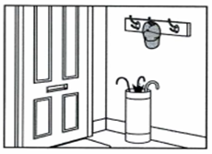 | 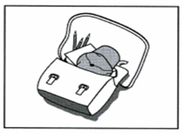 |  | 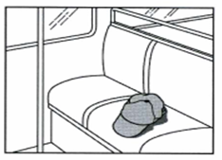
 | ANH\TEST17\test17.vidu.a.png | ANH\TEST17\test17.vidu.b.png |  | ANH\TEST17\test17.vidu.c.png
1. | Where will the friends meet?
 | 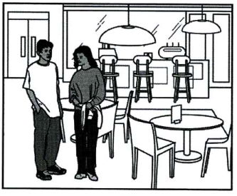 |  | 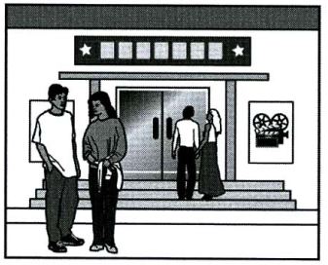 |  |  | 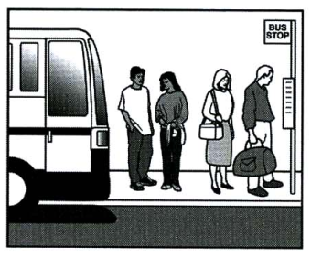
 | ANH\TEST17\test17.1a.png |  | ANH\TEST17\test17.1b.png |  |  | ANH\TEST17\test17.1c.png
2. | What has the girl forgotten to bring?
2. | 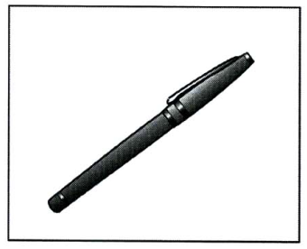 |  | 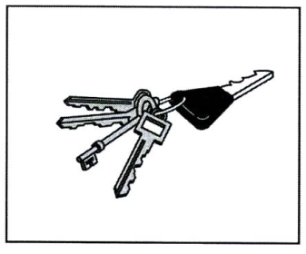 |  |  | 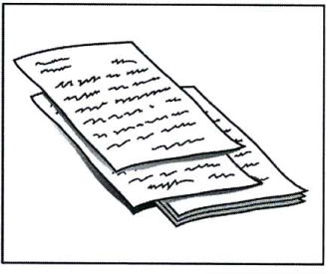
2. | ANH\TEST17\test17.2a.png |  | ANH\TEST17\test17.2b.png |  |  | ANH\TEST17\Test17.2c.png
3. | Which TV programme is on at 9 o’clock?
3. | 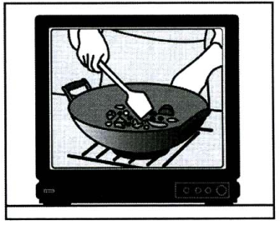 |  | 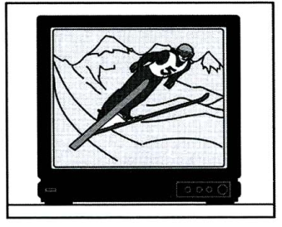 |  |  | 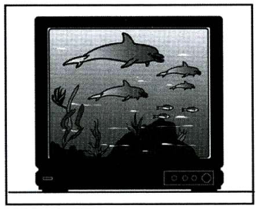
3. | ANH\TEST17\test17.3a.png |  | ANH\TEST17\test17.3b.png |  |  | ANH\TEST17\test17.3c.png
4. | How will the man book tickets for the show?
4. | 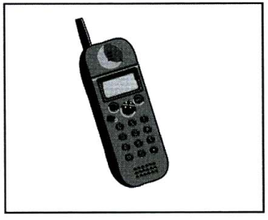 |  | 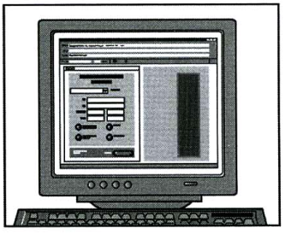 |  |  | 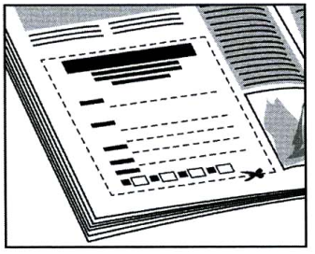
 | ANH\TEST17\test17.4a.png |  | ANH\TEST17\test17.4b.png |  |  | ANH\TEST17\test17.4c.png
5. | What will the man do this winter?
 | 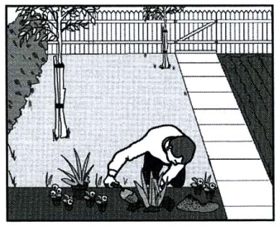 |  | 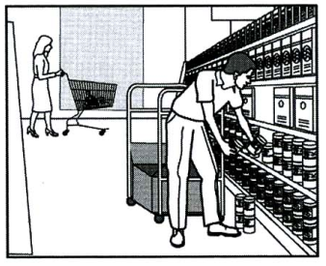 |  |  | 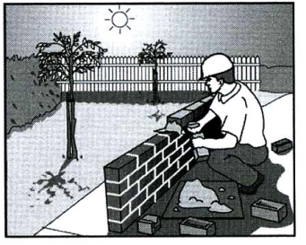
 | ANH\TEST17\test17.5a.png |  | ANH\TEST17\test17.5b.png |  |  | ANH\TEST17\test17.5c.png
6. | How does the man want the woman to help him?
 | 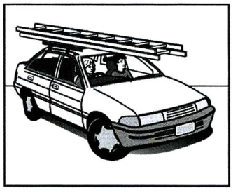 |  | 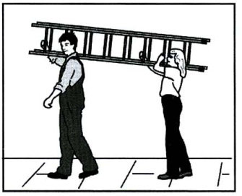 |  | 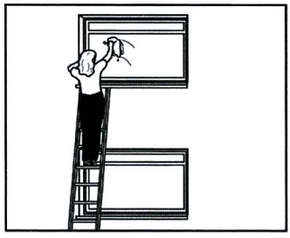
 | ANH\TEST17\test17.6a.png |  | ANH\TEST17\test17.6b.png |  | ANH\TEST17\test17.6c.png
7. | Which house did the woman stay in?
 | 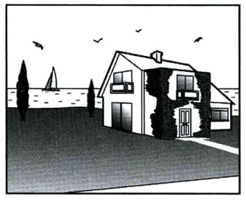 |  | 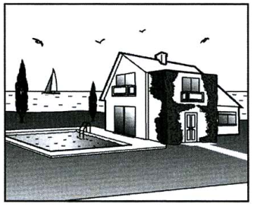 |  | 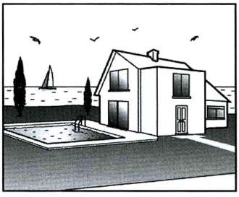
 | ANH\TEST17\test17.7a.png |  | ANH\TEST17\test17.7b.png |  | ANH\TEST17\test17.7c.png

PART 2
AMTHANH\Test17Part2.mp3
8. | Where is Angela working at the moment?
A | Britain.
B | The USA.
C | Asia.
9. | Angela likes her job because she
A | enjoys watching important events happen.
B | loves being in dangerous situations.
C | never knows where she’ll go next.
10. | What did Angela bring home from Hong Kong?
A | Furniture.
B | Pictures.
C | Carpets.
11. | What time does Angela’s working day begin?
A | 8.30 am.
B | 6.30 am.
C | 10.00 am.
12. | Where did Angela meet her boy friend?
A | At her sister’s house.
B | At university.
C | In Hong Kong.
13. | What does Angela do to relax?
A | She goes sailing.
B | She goes shopping.
C | She cooks a meal.

TEST 18
PART 1
/AMTHANH/Test18Part1.mp3
 | How many eggs do you need to make the cake?
 | 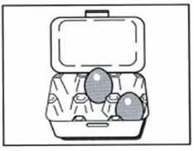 | 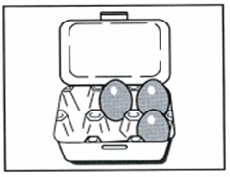 |  |  | 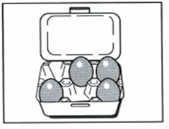
 | ANH\TEST18\test18.vidu.a.png | ANH\TEST18\test18.vidu.b.png |  |  | ANH\TEST18\test18.vidu.c.png
1. | Where are the dictionaries?
 | 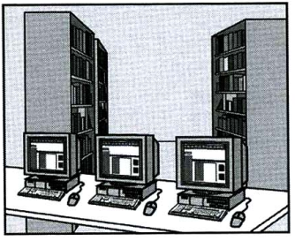 |  | 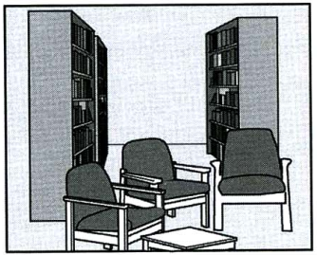 |  |  |  | 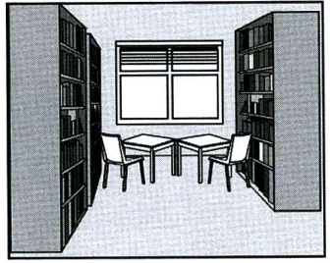
 | ANH\TEST18\test18.1a.png |  | ANH\TEST18\test18.1b.png |  |  |  | ANH\TEST18\test18.1c.png
2. | Which evening dress does the woman decide to wear?
2. | 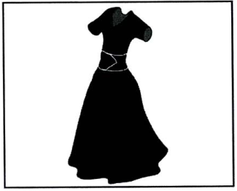 |  | 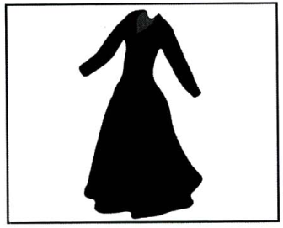 |  |  |  | 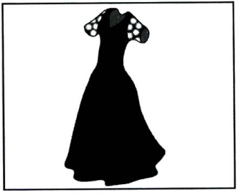
2. | ANH\TEST18\test18.2a.png |  | ANH\TEST18\test18.2b.png |  |  |  | ANH\TEST18\test18.2c.png
3. | What is the man’s job now?
3. | 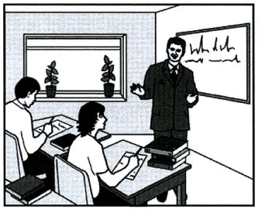 |  | 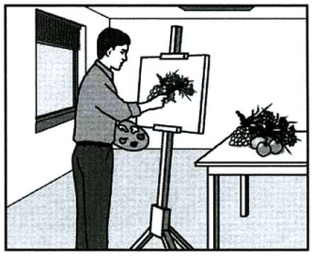 |  |  |  | 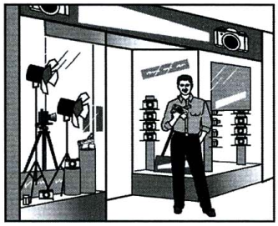
3. | ANH\TEST18\test18.3a.png |  | ANH\TEST18\test18.3b.png |  |  |  | ANH\TEST18\test18.3c.png
4. | Which calendar will the boy buy?
4. | 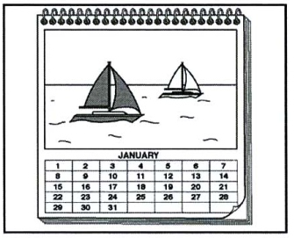 |  | 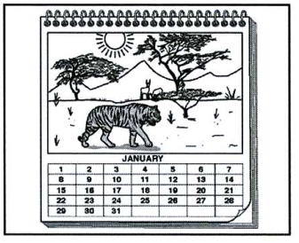 |  |  |  | 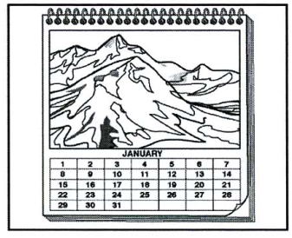
 | ANH\TEST18\test18.4a.png |  | ANH\TEST18\test18.4b.png |  |  |  | ANH\TEST18\test18.4c.png
5. | What time will the writer arrive at the bookshop?
 | 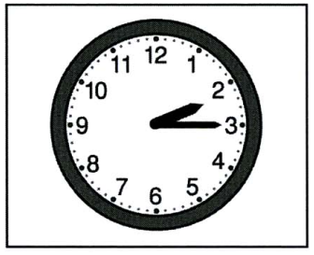 |  | 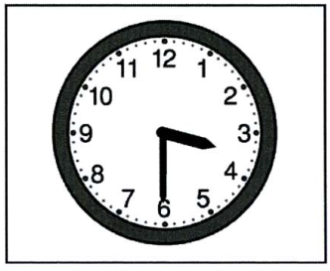 |  |  |  | 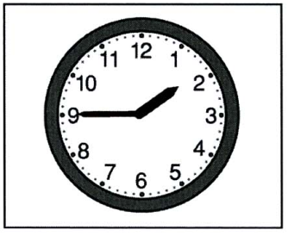
 | ANH\TEST18\test18.5a.png |  | ANH\TEST18\test18.5b.png |  |  |  | ANH\TEST18\test18.5c.png
6. | What did the woman leave in the restaurant?
 | 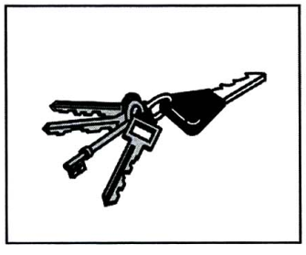 |  | 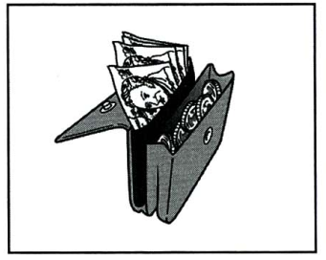 |  |  | 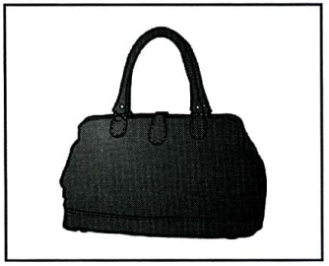
 | ANH\TEST18\test18.6a.png |  | ANH\TEST18\test18.6b.png |  |  | ANH\TEST18\test18.6c.png
7. | Where is the biclycle?
 | 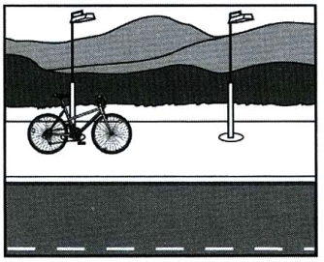 |  | 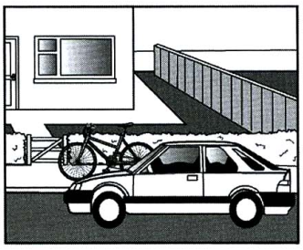 | 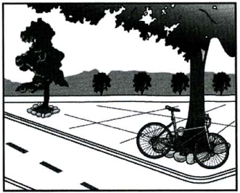
 | ANH\TEST18\test18.7a.png |  | ANH\TEST18\test18.7b.png | ANH\TEST18\test18.7c.png

TEST 19
PART 1

/AMTHANH/Test19Part1.mp3
 | How did the woman get to work?
 | 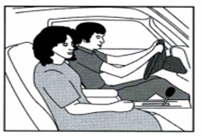 | 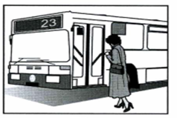 |  | 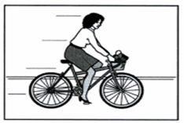
 | ANH\TEST19\test19.vidu.a.png | ANH\TEST19\test19.vidu.b.png |  | ANH\TEST19\test19.vidu.c.png
1. | What regular exercise does David do at the moment?
 | 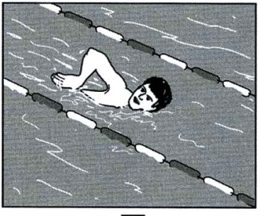 |  | 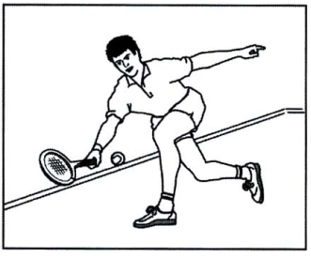 |  |  | 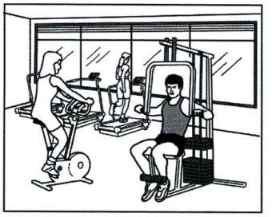
 | ANH\TEST19\test19.1a.png |  | ANH\TEST19\test19.1b.png |  |  | ANH\TEST19\test19.1c.png
2. | What should Suzie take to Emma’s house?
2. | 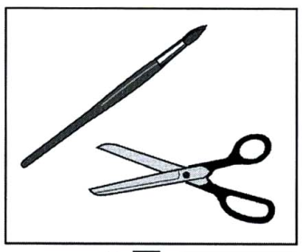 |  | 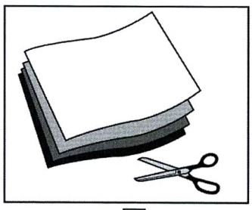 |  |  | 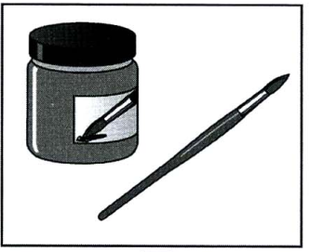
2. | ANH\TEST19\test19.2a.png |  | ANH\TEST19\test19.2b.png |  |  | ANH\TEST19\test19.2c.png
3. | Which type of T-shirt did the boy choose?
3. | 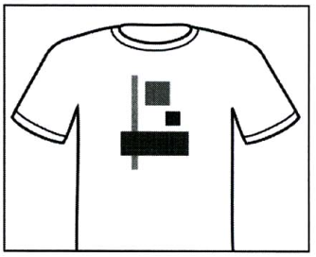 |  | 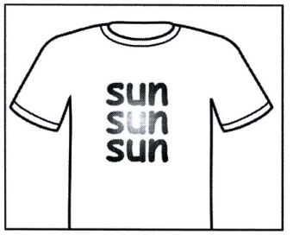 |  |  | 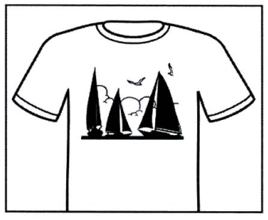
3. | ANH\TEST19\test19.3a.png |  | ANH\TEST19\test19.3b.png |  |  | ANH\TEST19\test19.3c.png
4. | What frightened the man?
4. | 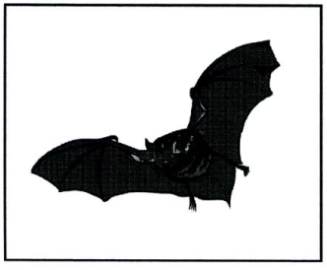 |  | 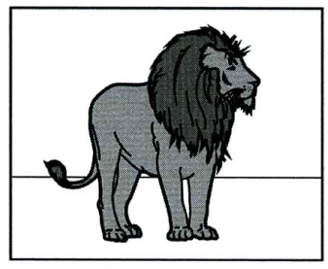 |  |  | 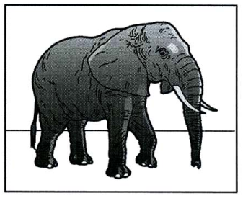
 | ANH\TEST19\test19.4a.png |  | ANH\TEST19\test19.4b.png |  |  | ANH\TEST19\test19.4c.png
5. | Where is the man calling from?
 | 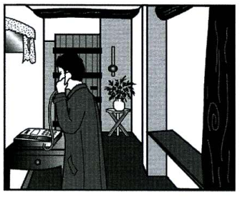 |  | 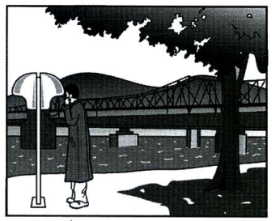 |  |  | 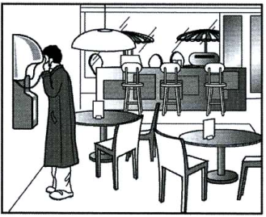
 | ANH\TEST19\test19.5a.png |  | ANH\TEST19\test19.5b.png |  |  | ANH\TEST19\test19.5c.png
6. | How did the woman spend on her last holiday?
 | 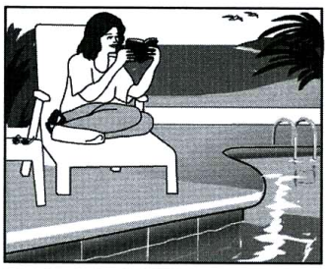 |  | 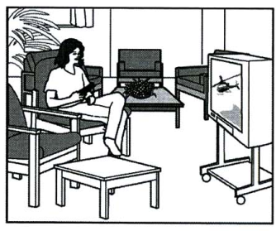 |  | 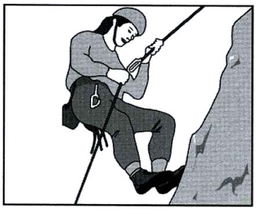
 | ANH\TEST19\test19.6a.png |  | ANH\TEST19\test19.6b.png |  | ANH\TEST19\Test19.6c.png
7. | Where is the girl’s purse?
 | 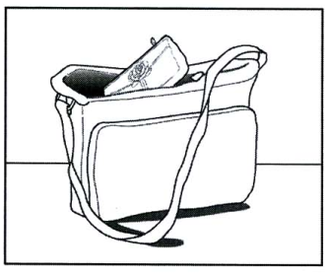 |  | 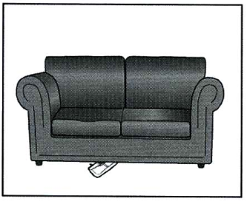 |  | 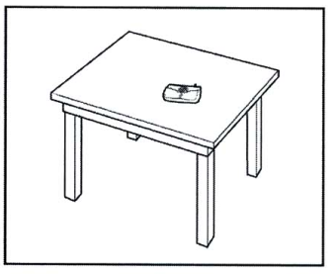
 | ANH\TEST19\test19.7a.png |  | ANH\TEST19\test19.7b.png |  | ANH\TEST19\test19.7c.png

TEST 20
PART 1

/AMTHANH/Test20Part1.mp3
 | How did the woman get to work?
 | 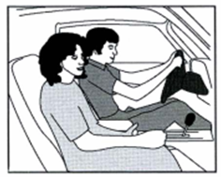 | 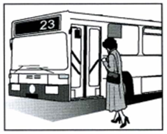 |  |  | 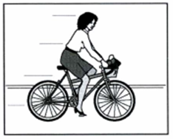
 | ANH\TEST20\test20.vidu.a.png | ANH\TEST20\test20.vidu.b.png |  |  | ANH\TEST20\test20.vidu.c.png
1. | What did the thieves steal?
 | 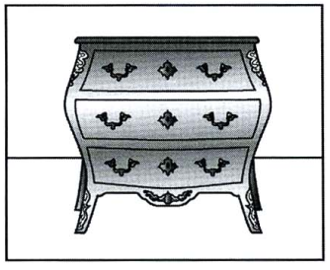 |  | 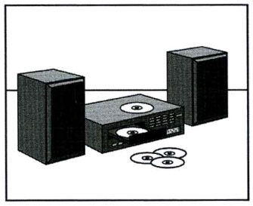 |  |  | 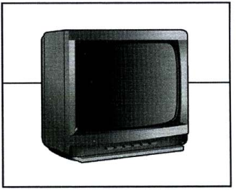
 | ANH\TEST20\test20.1a.png |  | ANH\TEST20\test20.1b.png |  |  | ANH\TEST20\test20.1c.png
2. | What present will they take?
2. | 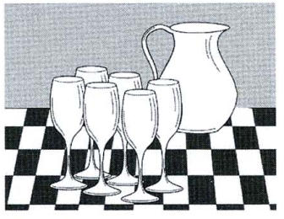 |  | 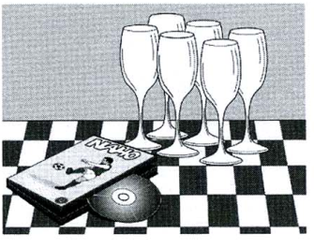 |  |  | 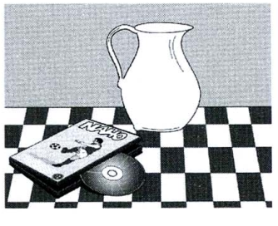
2. | ANH\TEST20\test20.2a.png |  | ANH\TEST20\test20.2b.png |  |  | ANH\TEST20\test20.2c.png
3. | What will the woman eat tonight?
3. | 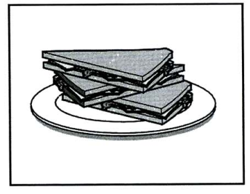 |  | 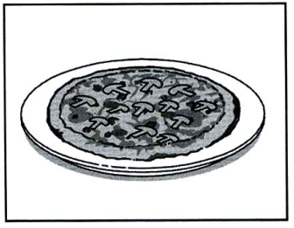 |  |  | 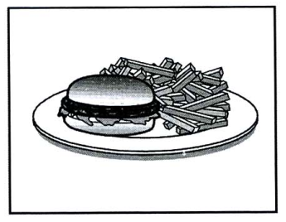
3. | ANH\TEST20\test20.3a.png |  | ANH\TEST20\test20.3b.png |  |  | ANH\TEST20\test20.3c.png
4. | How much will the girl’s ticket cost?
4. | 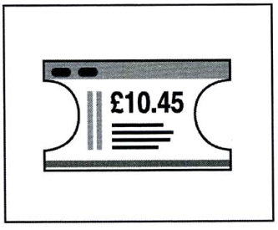 |  | 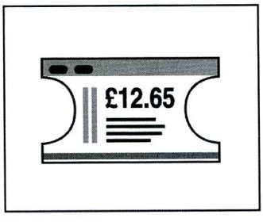 |  |  | 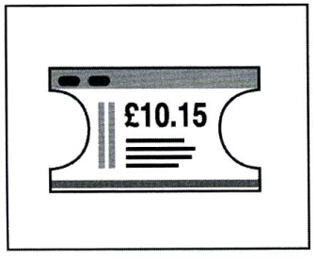
 | ANH\TEST20\test20.4a.png |  | ANH\TEST20\test20.4b.png |  |  | ANH\TEST20\test20.4c.png
5. | What is the grandmother’s job now?
 | 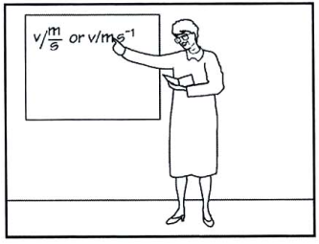 |  | 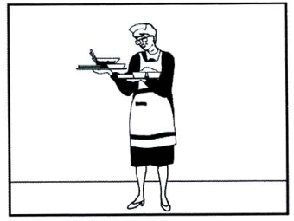 |  |  | 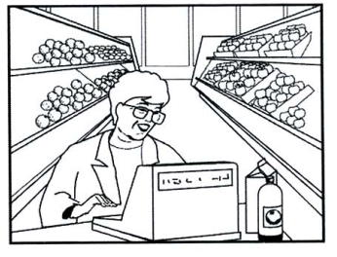
 | ANH\TEST20\test20.5a.png |  | ANH\TEST20\test20.5b.png |  |  | ANH\TEST20\test20.5c.png
6. | What button has the boy lost?
 | 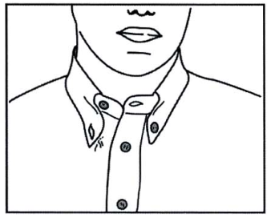 |  | 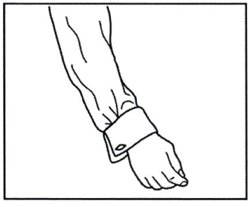 | 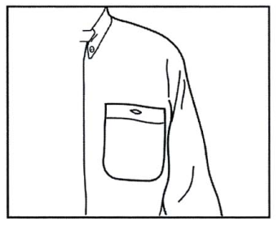
 | ANH\TEST20\test20.6a.png |  | ANH\TEST20\test20.6b.png | ANH\TEST20\test20.6c.png
7. | What will the man do first?
 | 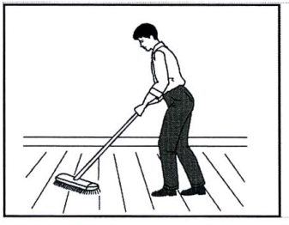 |  | 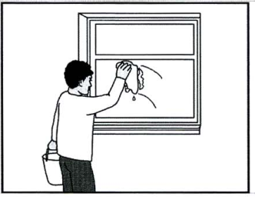 | 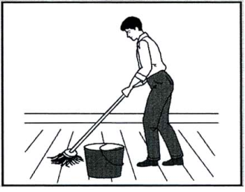
 | ANH\TEST20\test20.7a.png |  | ANH\TEST20\test20.7b.png | ANH\TEST20\test20.7c.png

TEST 21

PART 1
/AMTHANH/Test21Part1.mp3
 | Where’s the girl’s hat?
 | ANH\TEST21\test21.vidu.a.png |  | ANH\TEST21\test21.vidu.b.png |  |  | ANH\TEST21\test21.vidu.c.png
1. |  | How will they book their flights?
 |  | 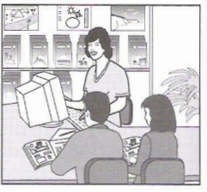 |  | 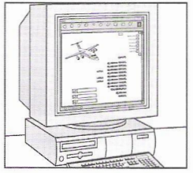 | 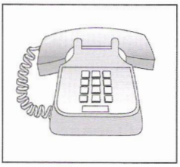
 |  | ANH\TEST21\test21.1a.png |  | ANH\TEST21\test21.1b.png | ANH\TEST21\test21.1c.png
2. |  | What has the daughter forgot to bring on holiday?
 |  | 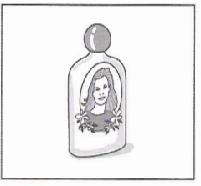 |  | 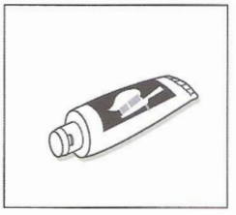 | 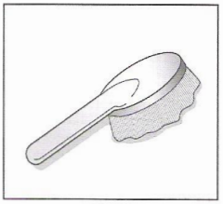
 |  | ANH\TEST21\test21.2a.png |  | ANH\TEST21\test21.2b.png | ANH\TEST21\test21.2c.png
3. |  | What will the man and woman do on Sunday?
 |  | 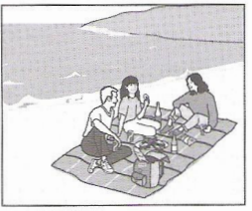 |  | 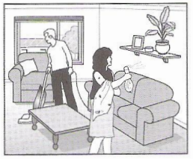 | 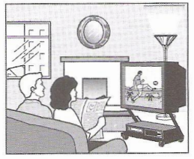
 |  | ANH\TEST21\test21.3a.png |  | ANH\TEST21\test21.3b.png | ANH\TEST21\test21.3c.png
4. |  | Which blouse does the girl decide to buy?
 |  | 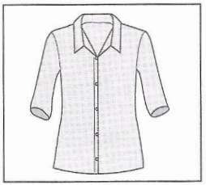 |  | 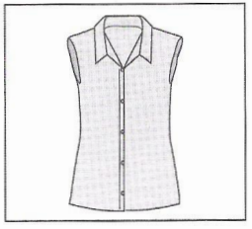 | 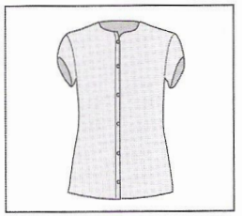
 |  | ANH\TEST21\test21.4a.png |  | ANH\TEST21\test21.4b.png | ANH\TEST21\test21.4c.png
5. |  | When is the girl having a party?
 |  | 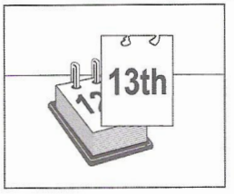 |  | 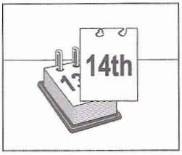 | 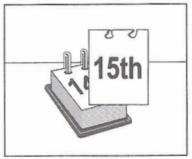
 |  | ANH\TEST21\test21.5a.png |  | ANH\TEST21\test21.5b.png | ANH\TEST21\test21.5c.png
6. |  | Where is the motorcycle race going to finish?
 |  | 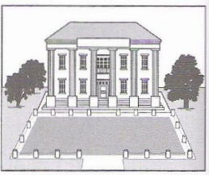 |  | 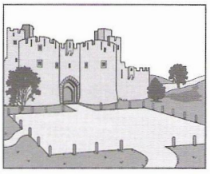 | 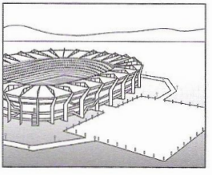
 |  | ANH\TEST21\test21.6a.png |  | ANH\TEST21\test21.6b.png | ANH\TEST21\test21.6c.png
7. |  | What will the woman repair nextweek?
 |  | 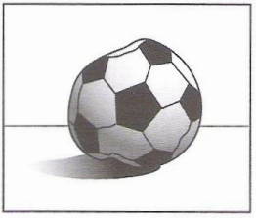 |  | 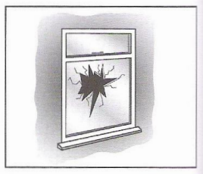 | 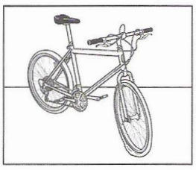
 |  | ANH\TEST21\test21.7a.png |  | ANH\TEST21\test21.7b.png | ANH\TEST21\test21.7c.png

TEST 22

PART 1
/AMTHANH/Test22Part1.mp3
 | How did the woman get to work?
 | 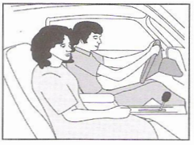 |  | 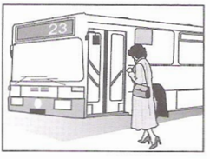 | 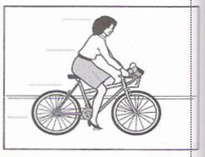
 | ANH\TEST22\test22.vidu.a.png |  | ANH\TEST22\test22.vidu.b.png | ANH\TEST22\test22.vidu.c.png
1. |  | What has the boy lost?
 |  | 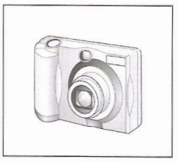 | 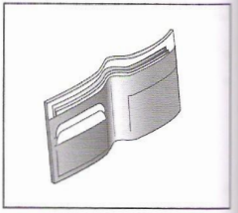 | 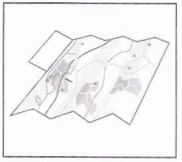
 |  | ANH\TEST22\test22.1a.png | ANH\TEST22\test22.1b.png | ANH\TEST22\test22.1c.png
2. |  | What time does the race begin?
 |  | 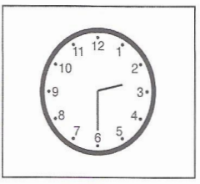 | 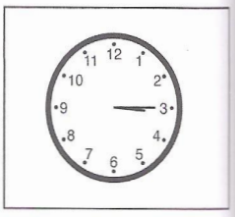 | 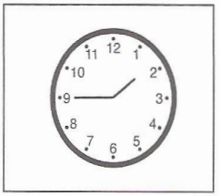
 |  | ANH\TEST22\test22.2a.png | ANH\TEST22\test22.2b.png | ANH\TEST22\test22.2c.png
3. |  | Which musical instrument does the boy play now?
 |  | 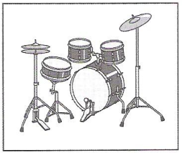 | 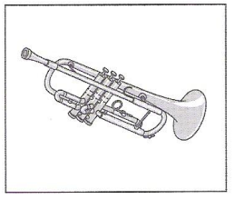 | 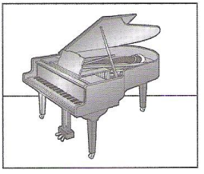
 |  | ANH\TEST22\test22.3a.png | ANH\TEST22\test22.3b.png | ANH\TEST22\test22.3c.png
4. |  | What will the weather be like tomorrow afternoon?
 |  | 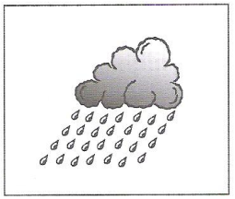 | 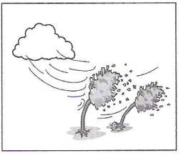 | 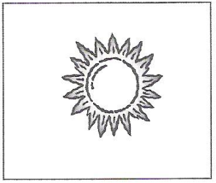
 |  | ANH\TEST22\test22.4a.png | ANH\TEST22\test22.4b.png | ANH\TEST22\test22.4c.png
5. |  | What is the subject of James Wilson’s book?
 |  | 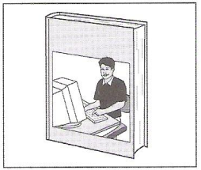 | 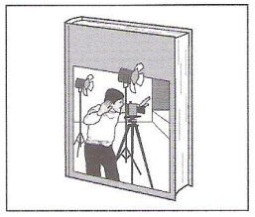 | 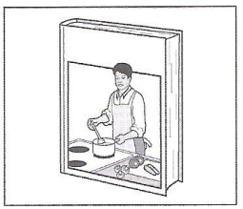
 |  | ANH\TEST22\test22.5a.png | ANH\TEST22\test22.5b.png | ANH\TEST22\test22.5c.png
6. |  | Which part of the man’s body hurts him at the moment?
 |  | 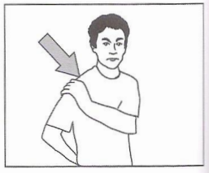 | 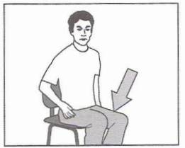 | 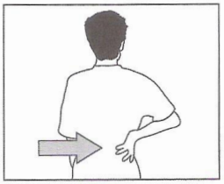
 |  | ANH\TEST22\test22.6a.png | ANH\TEST22\test22.6b.png | ANH\TEST22\test22.6c.png
7. |  | Where was the man’s knowledge of Spanish useful?
 |  | 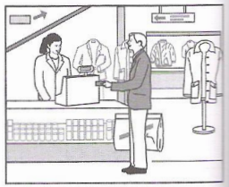 | 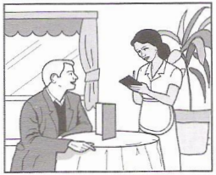 | 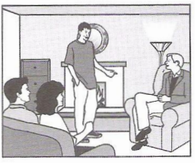
 |  | ANH\TEST22\test22.7a.png | ANH\TEST22\test22.7b.png | ANH\TEST22\test22.7c.png

TEST 23
PART 1

/AMTHANH/Test23Part1.mp3
 | Where did the man leave his camera?
 | 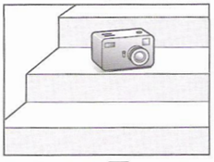 |  | 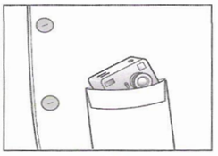 | 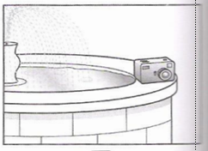
 | ANH\TEST23\test23.vidu.a.png |  | ANH\TEST23\test23.vidu.b.png | ANH\TEST23\test23.vidu.c.png
1. |  | Which present will the girl receive?
 |  | 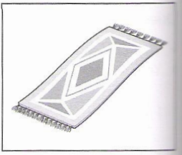 | 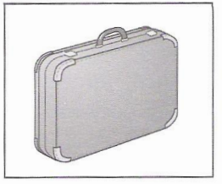 | 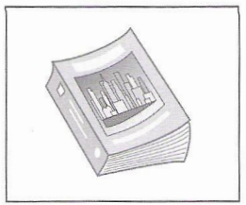
 |  | ANH\TEST23\test23.1a.png | ANH\TEST23\test23.1b.png | ANH\TEST23\test23.1c.png
2. |  | Where will the tourists go last?
 |  | 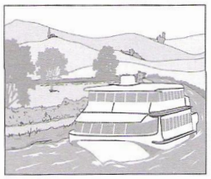 | 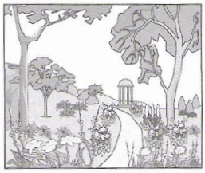 | 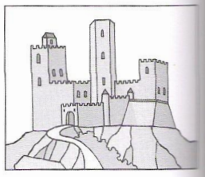
 |  | ANH\TEST23\test23.2a.png | ANH\TEST23\test23.2b.png | ANH\TEST23\test23.2c.png
3. |  | How much does the man pay for the postage?
 |  | 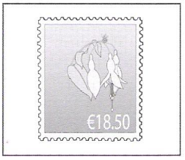 | 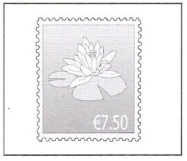 | 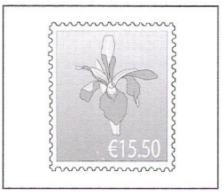
 |  | ANH\TEST23\test23.3a.png | ANH\TEST23\test23.3b.png | ANH\TEST23\test23.3c.png
4. |  | Where in the theatre did the woman leave her gloves?
 |  | 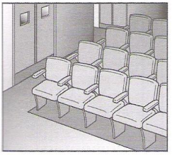 | 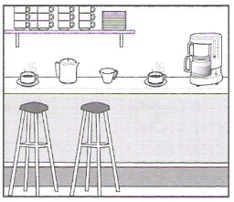 | 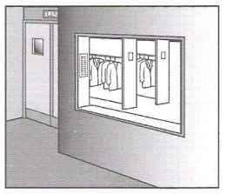
 |  | ANH\TEST23\test23.4a.png | ANH\TEST23\test23.4b.png | ANH\TEST23\test23.4c.png
5. |  | Which dress does the woman like best?
 |  | 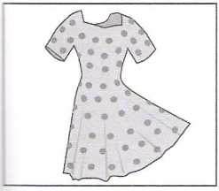 | 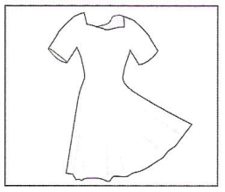 | 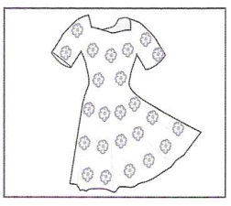
 |  | ANH\TEST23\test23.5a.png | ANH\TEST23\test23.5b.png | ANH\TEST23\test23.5c.png
6. |  | What is the television programme about?
 |  | 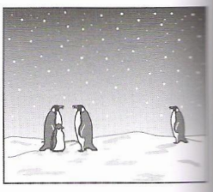 | 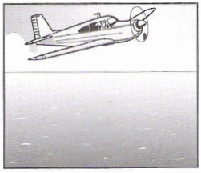 | 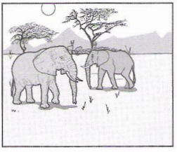
 |  | ANH\TEST23\test23.6a.png | ANH\TEST23\test23.6b.png | ANH\TEST23\test23.6c.png
7. |  | Which vehicle does Steve intend to buy?
 |  | 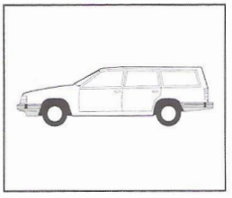 | 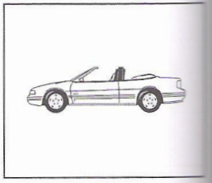 | 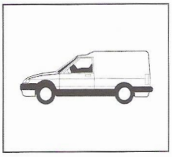
 |  | ANH\TEST23\test23.7a.png | ANH\TEST23\test23.7b.png | ANH\TEST23\test23.7c.png

TEST 24

PART 1
/AMTHANH/Test24Part1.mp3
 | Where did the man leave his camera?
 | 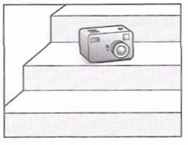 |  | 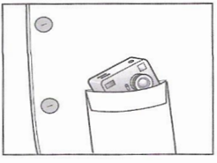 | 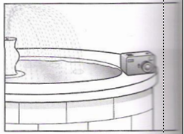
 | ANH\TEST24\test24.vidu.a.png |  | ANH\TEST24\test24.vidu.b.png | ANH\TEST24\test24.vidu.c.png
1. |  | Which prize has the man just won?
 |  | 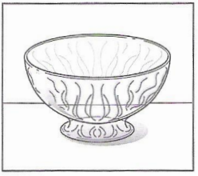 | 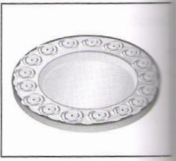 | 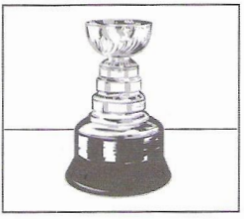
 |  | ANH\TEST24\test24.1a.png | ANH\TEST24\test24.1b.png | ANH\TEST24\test24.1c.png
2. |  | What was the man’s first job?
 |  | 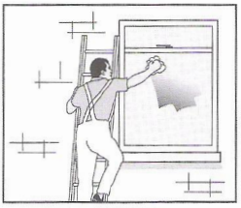 | 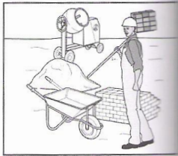 | 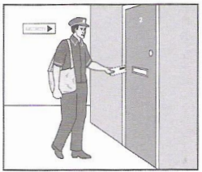
 |  | ANH\TEST24\test24.2a.png | ANH\TEST24\test24.2b.png | ANH\TEST24\test24.2c.png
3. |  | Where will they have something to eat?
 |  | 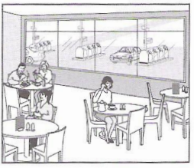 | 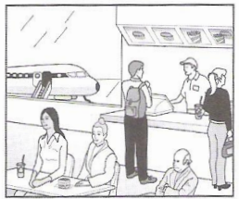 | 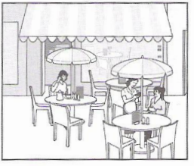
 |  | ANH\TEST24\test24.3a.png | ANH\TEST24\test24.3b.png | ANH\TEST24\test24.3c.png
4. |  | What does the woman’s house look like?
 |  | 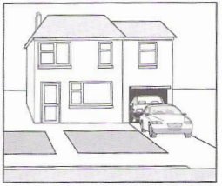 | 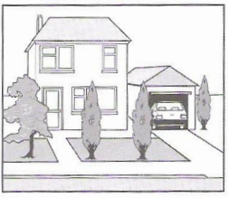 | 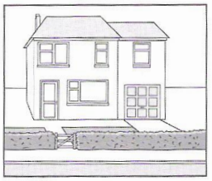
 |  | ANH\TEST24\test24.4a.png | ANH\TEST24\test24.4b.png | ANH\TEST24\test24.4c.png
5. |  | Which sport will they do tomorrow?
 |  | 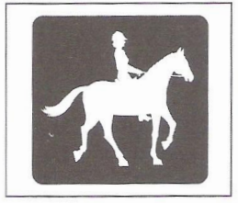 | 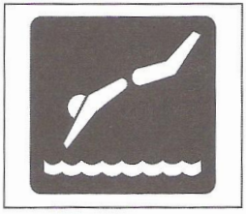 | 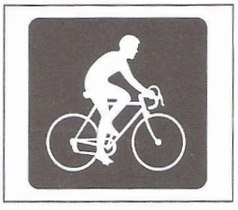
 |  | ANH\TEST24\test24.5a.png | ANH\TEST24\test24.5b.png | ANH\TEST24\test24.5c.png
6. |  | What can you see on the television programme?
 |  | 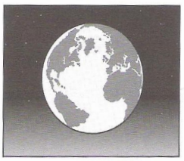 | 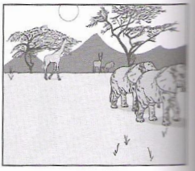 | 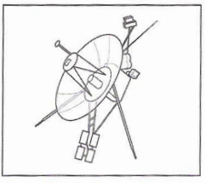
 |  | ANH\TEST24\test24.6a.png | ANH\TEST24\test24.6b.png | ANH\TEST24\test24.6c.png
7. |  | Where will the man sit on the plane?
 |  | 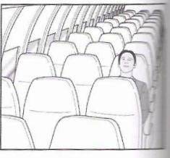 | 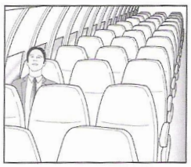 | 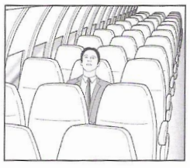
 |  | ANH\TEST24\test24.7a.png | ANH\TEST24\test24.7b.png | ANH\TEST24\test24.7c.png

TEST 25

PART 1
/AMTHANH/Test25Part1.mp3
 | Where did the man leave his camera?
 | 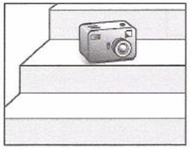 |  | 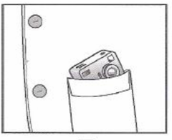 | 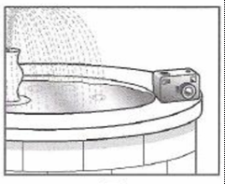
 | ANH\TEST25\test25.vidu.a.png |  | ANH\TEST25\test25.vidu.b.png | ANH\TEST25\test25.vidu.c.png
1. |  | What did the man buy?
 |  | 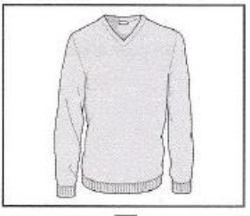 | 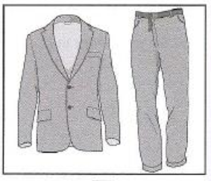 | 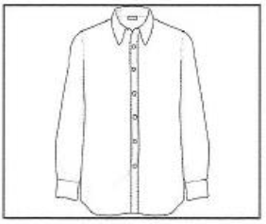
 |  | ANH\TEST25\test25.1a.png | ANH\TEST25\test25.1b.png | ANH\TEST25\test25.1c.png
2. |  | How will the woman help the man?
 |  | 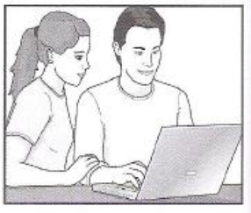 | 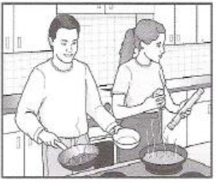 | 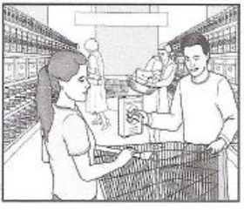
 |  | ANH\TEST25\test25.2a.png | ANH\TEST25\test25.2b.png | ANH\TEST25\test25.2c.png
3. |  | What will the students buy for their teacher?
 |  | 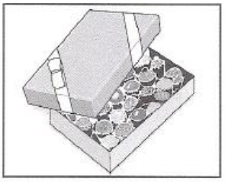 | 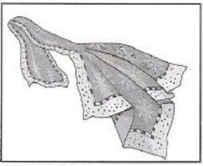 | 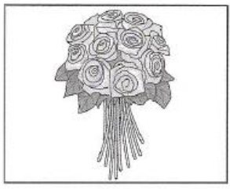
 |  | ANH\TEST25\test25.3a.png | ANH\TEST25\test25.3b.png | ANH\TEST25\test25.3c.png
4. |  | Which exhibition is the busiest today?
 |  | 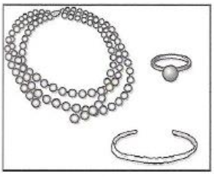 | 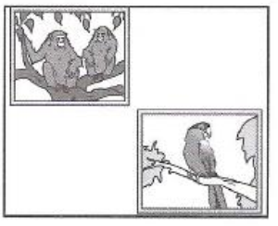 | 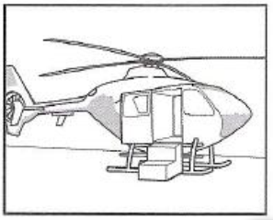
 |  | ANH\TEST25\test25.4a.png | ANH\TEST25\test25.4b.png | ANH\TEST25\test25.4c.png
5. |  | Where can visitors see the ducks?
 |  | 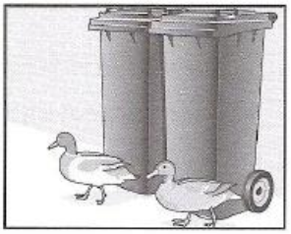 | 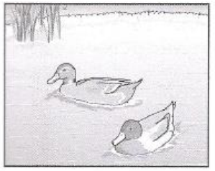 | 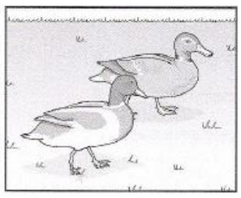
 |  | ANH\TEST25\test25.5a.png | ANH\TEST25\test25.5b.png | ANH\TEST25\test25.5c.png
6. |  | What will the weather be like when the festival starts?
 |  | 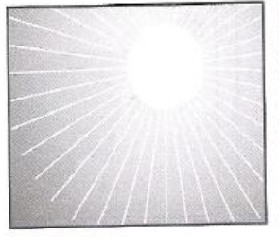 | 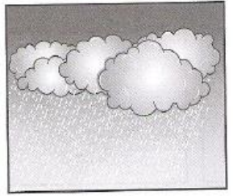 | 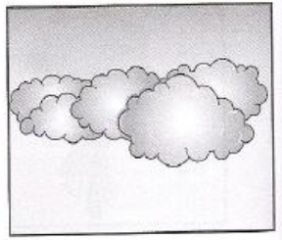
 |  | ANH\TEST25\test25.6a.png | ANH\TEST25\test25.6b.png | ANH\TEST25\test25.6c.png
7. |  | What has the man sent back to the company?
 |  | 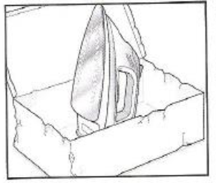 | 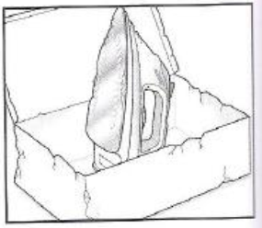 | 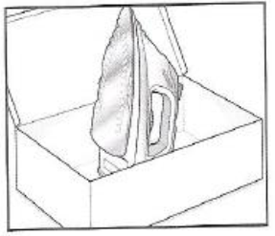
 |  | ANH\TEST25\test25.7a.png | ANH\TEST25\test25.7b.png | ANH\TEST25\test25.7c.png

TEST 26
PART 1
/AMTHANH/Test26Part1.mp3
 | What will the girl buy from the shop?
 | 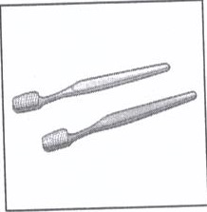 | 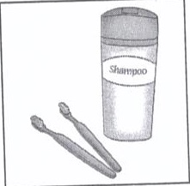 | 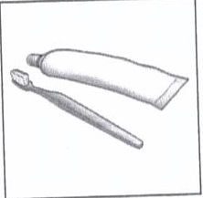
 | ANH\TEST26\26.vidu.a.png | ANH\TEST26\26.vidu.b.png | ANH\TEST26\26.vidu.c.png
1. | What is the girl doing?
 | 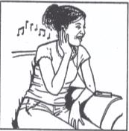 | 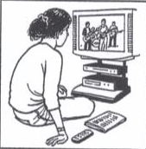 | 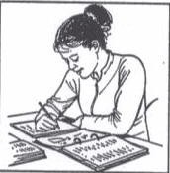
 | ANH\TEST26\26.1a.png | ANH\TEST26\26.1b.png | ANH\TEST26\26.1c.png
2. | What will the weather be like tomorrow?
2. | 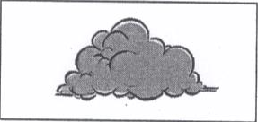 | 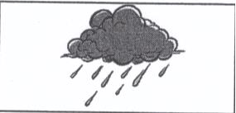 | 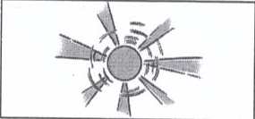
2. | ANH\TEST26\26.2a.png | ANH\TEST26\26.2b.png | ANH\TEST26\26.2c.png
3. | Which musical instrument is the girl learning to play?
3. | 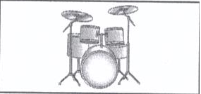 | 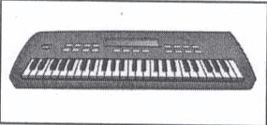 | 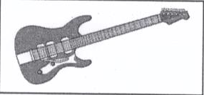
3. | ANH\TEST26\26.3a.png | ANH\TEST26\26.3b.png | ANH\TEST26\26.3c.png
4. | Where will they meet?
4. | 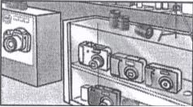 | 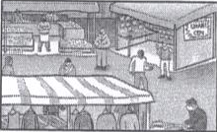 | 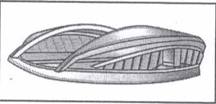
 | ANH\TEST26\26.4a.png | ANH\TEST26\26.4b.png | ANH\TEST26\26.4c.png
5. | What time dose the museum shut on Saturdays?
 | 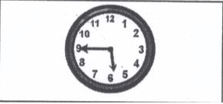 | 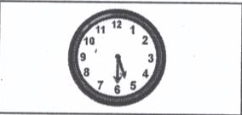 | 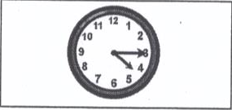
 | ANH\TEST26\26.5a.png | ANH\TEST26\26.5b.png | ANH\TEST26\26.5c.png
6. | Where is the flat?
 | 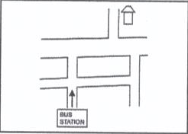 | 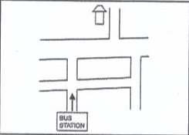 | 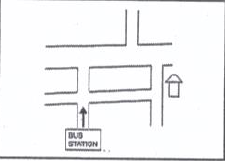
 | ANH\TEST26\26.6a.png | ANH\TEST26\26.6b.png | ANH\TEST26\26.6c.png
7. | What did the woman receive in the post?
 | 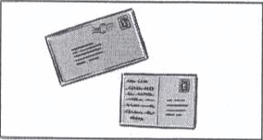 | 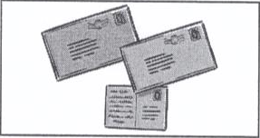 | 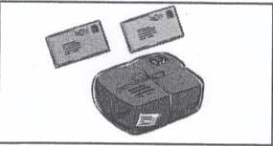
 | ANH\TEST26\26.7a.png | ANH\TEST26\26.7b.png | ANH\TEST26\26.7c.png

TEST 27

PART 1

/AMTHANH/Test27Part1.mp3
 | What is the first prize in the competition?
 | 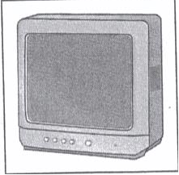 | 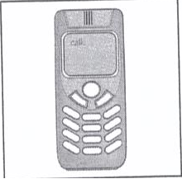 | 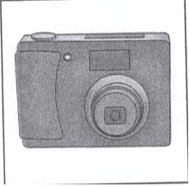
 | ANH\TEST27\27.vidu.a.png | ANH\TEST27\27.vidu.b.png | ANH\TEST27\27.vidu.c.png
1. | Where are the men’s gloves?
 | 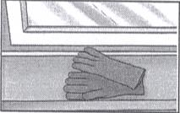 | 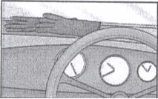 | 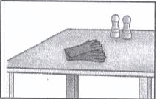
 | ANH\TEST27\27.1a.png | ANH\TEST27\27.1b.png | ANH\TEST27\27.1c.png
2. | Who is the girl’s new teacher?
2. | 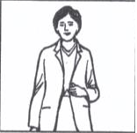 | 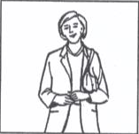 | 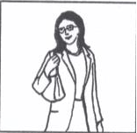
2. | ANH\TEST27\27.2a.png | ANH\TEST27\27.2b.png | ANH\TEST27\27.2c.png
3. | How much will they pay to hire the car?
3. | 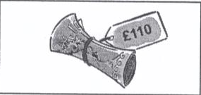 | 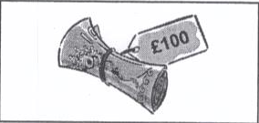 | 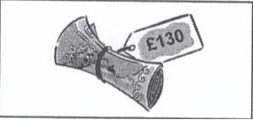
3. | ANH\TEST27\27.3a.png | ANH\TEST27\27.3b.png | ANH\TEST27\27.3c.png
4. | What present has the boy bought Alison?
4. | 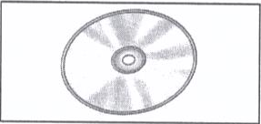 | 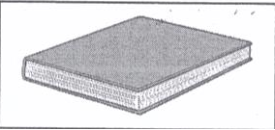 | 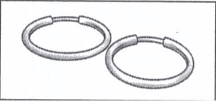
 | ANH\TEST27\27.4a.png | ANH\TEST27\27.4b.png | ANH\TEST27\27.4c.png
5. | What time will the next flight to Madrid leave?
 | 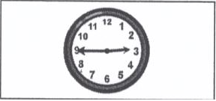 | 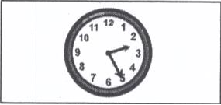 | 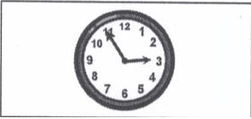
 | ANH\TEST27\27.5a.png | ANH\TEST27\27.5b.png | ANH\TEST27\27.5c.png
6. | What did the girl like best about her holiday?
 | 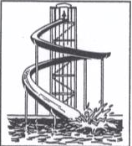 | 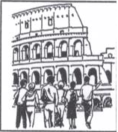 | 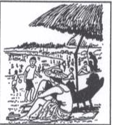
 | ANH\TEST27\27.6a.png | ANH\TEST27\27.6b.png | ANH\TEST27\27.6c.png
7. | What is the first programme after the news?
 | 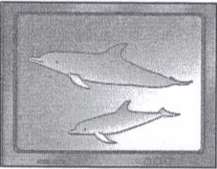 | 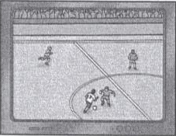 | 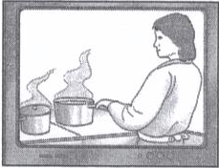
 | ANH\TEST27\27.7a.png | ANH\TEST27\27.7b.png | ANH\TEST27\27.7c.png

TEST 28

PART 1
/AMTHANH/Test28Part1.mp3
 | What is the first prize in the competition?
 | 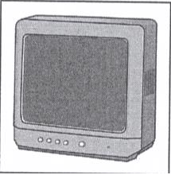 | 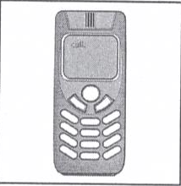 | 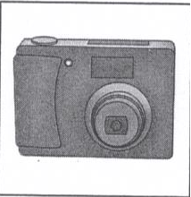
 | ANH\TEST28\28.vidu.a.png | ANH\TEST28\28.vidu.b.png | ANH\TEST28\28.vidu.c.png
1. | Which are the Emily’s cousins?
 | 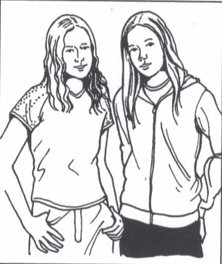 | 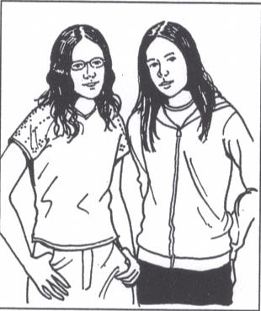 | 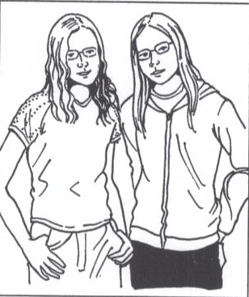
 | ANH\TEST28\28.1a.png | ANH\TEST28\28.1b.png | ANH\TEST28\28.1c.png
2. | What can Maria see from her window?
2. | 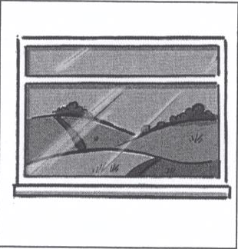 | 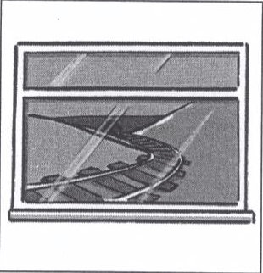 | 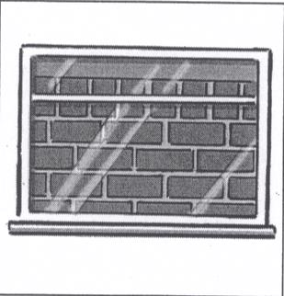
2. | ANH\TEST28\28.2a.png | ANH\TEST28\28.2b.png | ANH\TEST28\28.2c.png
3. | What can’t the boy find?
3. | 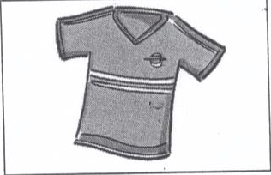 | 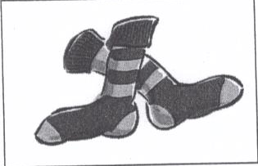 | 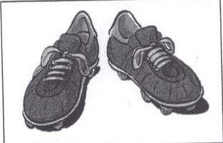
3. | ANH\TEST28\28.3a.png | ANH\TEST28\28.3b.png | ANH\TEST28\28.3c.png
4. | What does the woman buy?
4. | 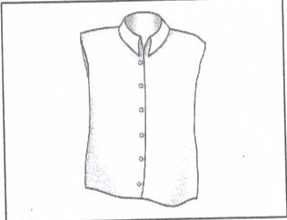 | 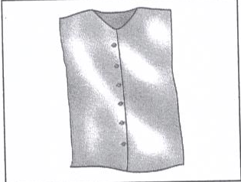 | 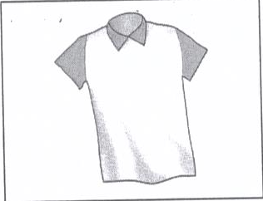
 | ANH\TEST28\28.4a.png | ANH\TEST28\28.4b.png | ANH\TEST28\28.4c.png
5. | What must the chidren bring?
 | 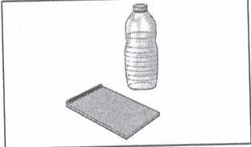 | 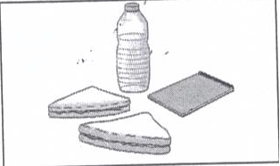 | 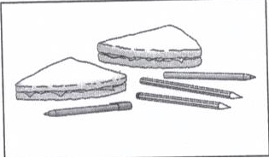
 | ANH\TEST28\28.5a.png | ANH\TEST28\28.5b.png | ANH\TEST28\28.5c.png
6. | What time will the woman meet her son?
 | 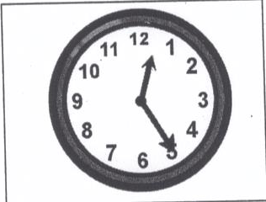 | 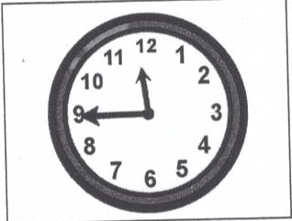 | 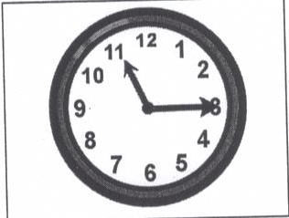
 | ANH\TEST28\28.6a.png | ANH\TEST28\28.6b.png | ANH\TEST28\28.6c.png
7. | Which hotel did the man stay in?
 | 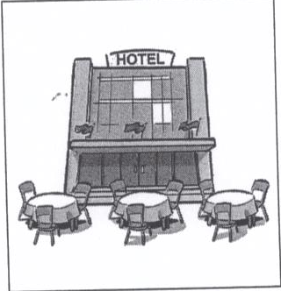 | 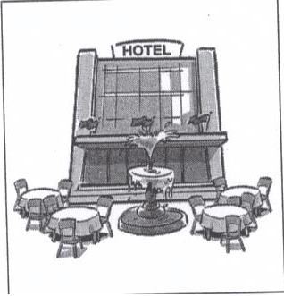 | 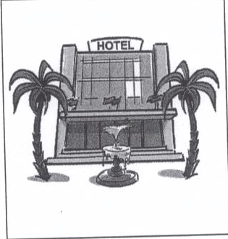
 | ANH\TEST28\28.7a.png | ANH\TEST28\28.7b.png | ANH\TEST28\28.7c.png

TEST 29

PART 1

/AMTHANH/Test29Part1.mp3
 | What will the girl buy from the shop?
 | 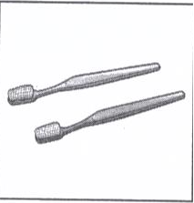 | 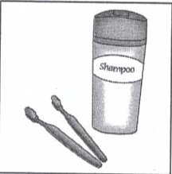 | 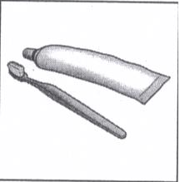
 | ANH\TEST29\29.vidu.a.png | ANH\TEST29\29.vidu.b.png | ANH\TEST29\29.vidu.c.png
1. | How will the girl travel from the airport?
 | 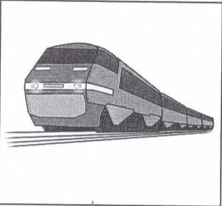 | 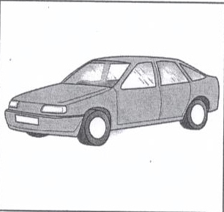 | 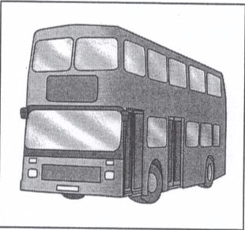
 | ANH\TEST29\29.1a.png | ANH\TEST29\29.1b.png | ANH\TEST29\29.1c.png
2. | Where is the post office?
2. | 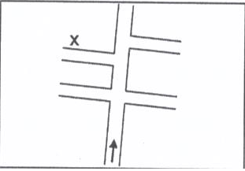 | 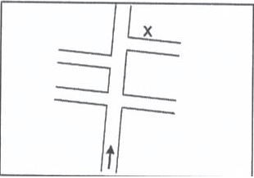 | 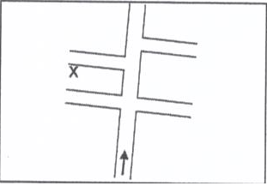
2. | ANH\TEST29\29.2a.png | ANH\TEST29\29.2b.png | ANH\TEST29\29.2c.png
3. | What was the weather like at the seaside?
3. | 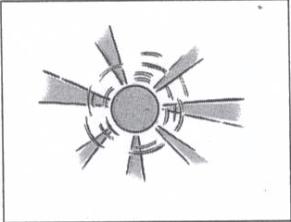 | 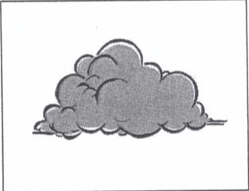 | 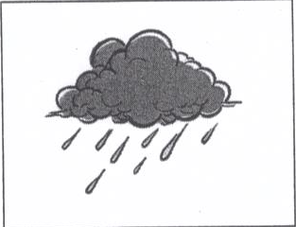
3. | ANH\TEST29\29.3a.png | ANH\TEST29\29.3b.png | ANH\TEST29\29.3c.png
4. | Where dis the boy leave his sunglasses?
4. | 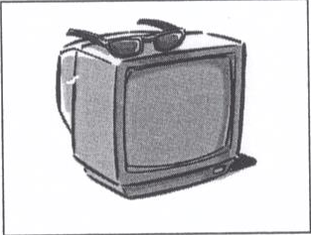 | 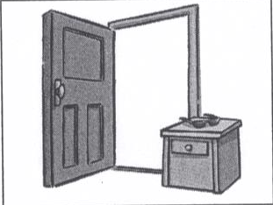 | 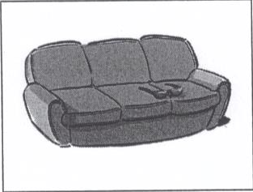
 | ANH\TEST29\29.4a.png | ANH\TEST29\29.4b.png | ANH\TEST29\29.4c.png
5. | Where will the tour guide be at eigth o’clock tomorrow morning?
 | 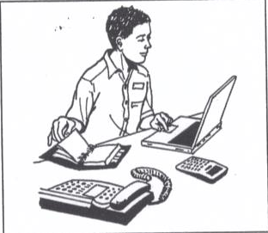 | 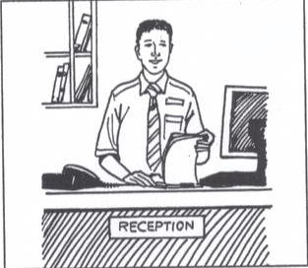 | 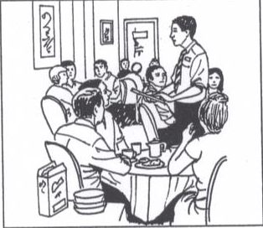
 | ANH\TEST29\29.5a.png | ANH\TEST29\29.5b.png | ANH\TEST29\29.5c.png
6. | What time is the man’s new appointment?
 | 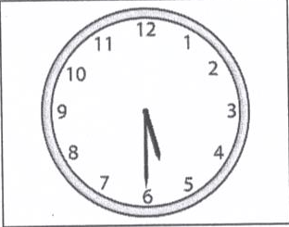 | 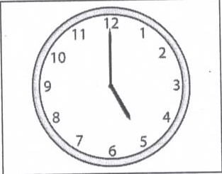 | 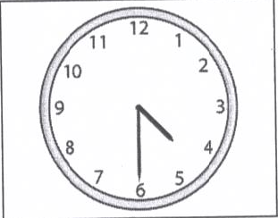
 | ANH\TEST29\29.6a.png | ANH\TEST29\29.6b.png | ANH\TEST29\29.6c.png
7. | Which postcard do they decide to send to Sarah?
 | 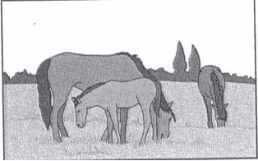 | 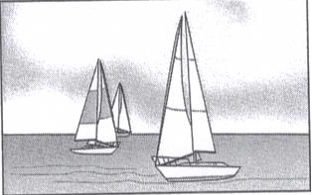 | 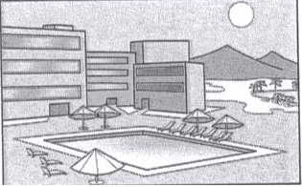
 | ANH\TEST29\29.7a.png | ANH\TEST29\29.7b.png | ANH\TEST29\29.7c.png

TEST 30
PART 1
/AMTHANH/Test30Part1.mp3
 | What is the first prize in the competition?
 | 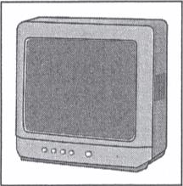 | 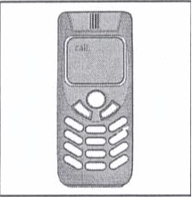 | 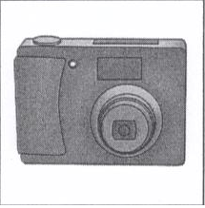
 | ANH\TEST30\30.vidu.a.png | ANH\TEST30\30.vidu.b.png | ANH\TEST30\30.vidu.c.png
1. | Why is the women going to be late?
 | 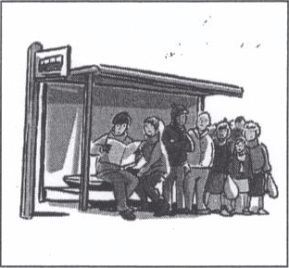 | 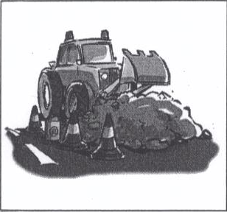 | 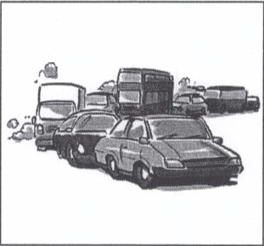
 | ANH\TEST30\30.1a.png | ANH\TEST30\30.1b.png | ANH\TEST30\30.1c.png
2. | What is the girl going to buy?
2. | 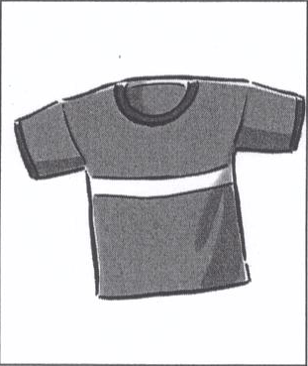 | 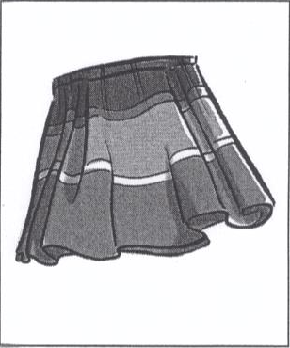 | 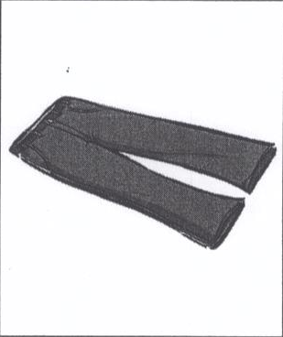
2. | ANH\TEST30\30.2a.png | ANH\TEST30\30.2b.png | ANH\TEST30\30.2c.png
3. | When dose the music festival start?
3. | 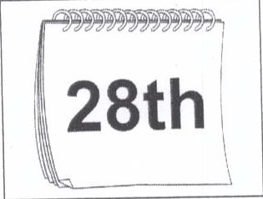 | 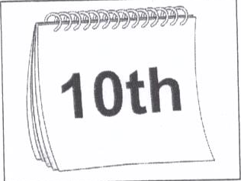 | 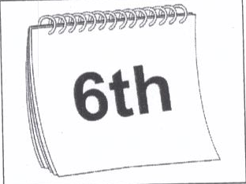
3. | ANH\TEST30\30.3a.png | ANH\TEST30\30.3b.png | ANH\TEST30\30.3c.png
4. | Which sport will they do this afternoon?
4. | 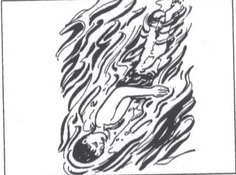 | 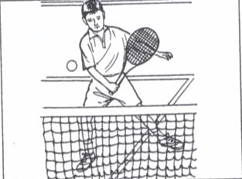 | 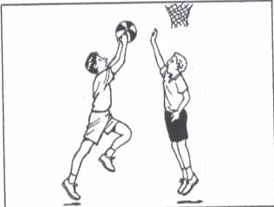
 | ANH\TEST30\30.4a.png | ANH\TEST30\30.4b.png | ANH\TEST30\30.4c.png
5. | Where is the girl’s mobile phone?
 | 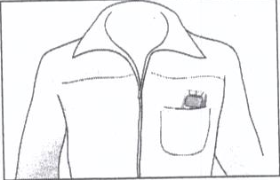 | 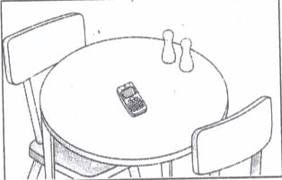 | 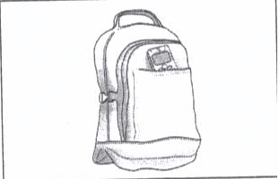
 | ANH\TEST30\30.5a.png | ANH\TEST30\30.5b.png | ANH\TEST30\30.5c.png
6. | What do they order?
 | 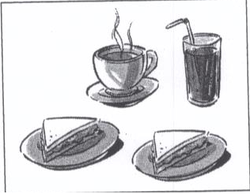 | 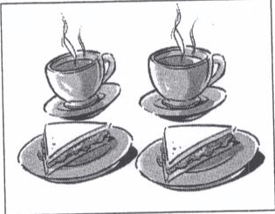 | 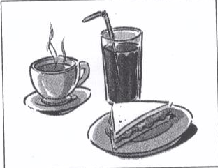
 | ANH\TEST30\30.6a.png | ANH\TEST30\30.6b.png | ANH\TEST30\30.6c.png
7. | Which photograp are they looking at?
 | 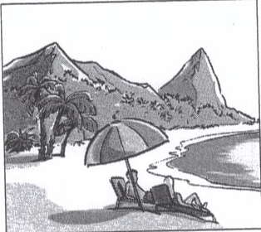 | 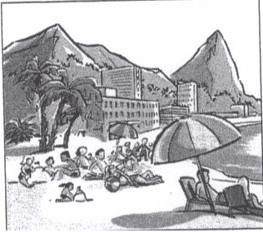 | 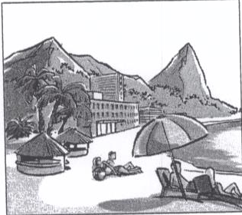
 | ANH\TEST30\30.7a.png | ANH\TEST30\30.7b.png | ANH\TEST30\30.7c.png

TEST 31
Part 1
Listen and choose the correct picture.AMTHANH\Test 1 part 1.mp3
Example: | Where did the man leave his camera?
 | test1.vidu.a.png | test1.vidu.b.png | test1.vidu.c.png
1. | What is the woman’s first memory?
 | 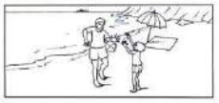 | 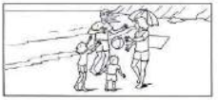 | 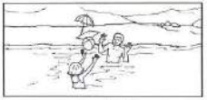
 | test1.1a.png | test1.1b.png | test1.1c.png
2. | Which train will the woman catch?
2. | 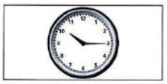 | 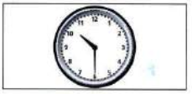 | 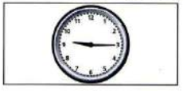
2. | test1.2a.png | test1.2b.png | test1.2c.png
3. | What should the students take with them tomorrow?
3. | 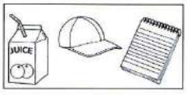 | 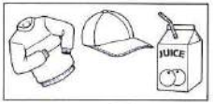 | 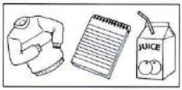
3. | test1.3a.png | test1.3b.png | test1.3c.png
4. | What will they do at the weekend?
4. | 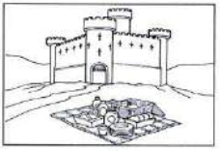 | 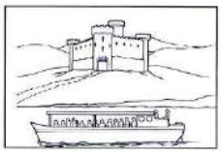 | 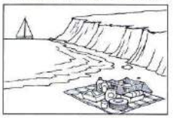
 | test1.4a.png | test1.4b.png | test1.4c.png
5. | What does the woman need to buy?
 | 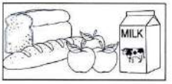 | 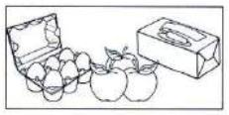 | 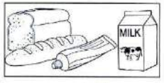
 | test1.5a.png | test1.5b.png | test1.5c.png
6. | How will the boy get to school?
 | 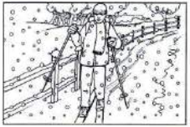 | 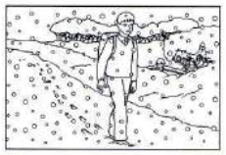 | 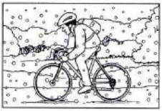
 | test1.6a.png | test1.6b.png | test1.6c.png
7. | Which is Tanya’s boyfriend?
 | 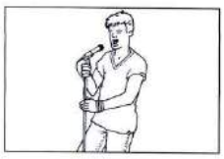 | 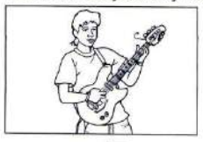 | 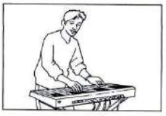
 | test1.7a.png | test1.7b.png | test1.7c.png

TEST 32
Part 1
Listen and choose the correct picture.AMTHANH\Test 2 part 1.mp3
Example: | Where did the man leave his camera?
 | 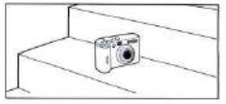 | 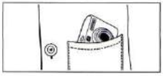 | 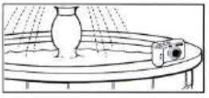
 | test 2.vidu.a.png | test 2.vidu.b.png | test 2.vidu.c.png
1. | What will the weather be like tomorrow?
 | 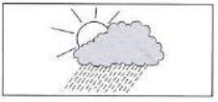 | 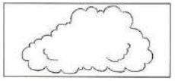 |  |  |  | 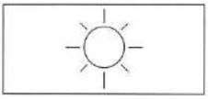
 | test2.1a.png | test2.1b.png |  |  |  | test2.1c.png
2. | What will the man do first?
2. | 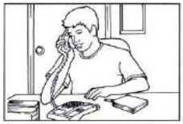 | 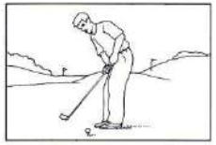 |  |  |  |  | 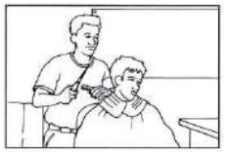
2. | test2.2a.png | test2.2b.png |  |  |  |  | test2.2c.png
3. | Where is the knife?
3. | 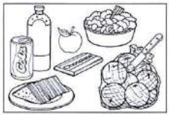 | 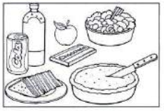 |  | 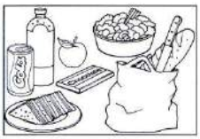
3. | test2.3a.png | test2.3b.png |  | test2.3c.png
4. | What happened to the girl this afternoon?
4. | 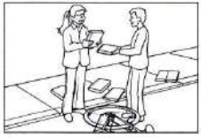 | 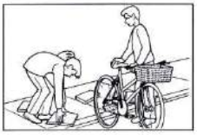 |  |  | 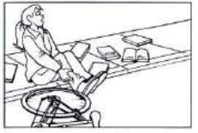
 | test2.4a.png | test2.4b.png |  |  | test2.4c.png
5. | Which man is waiting at the bus stop?
 | 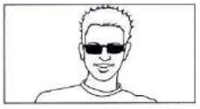 | 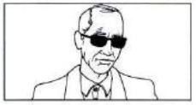 |  |  | 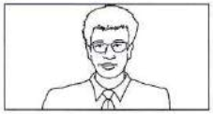
 | test2.5a.png | test2.5b.png |  |  | test2.5c.png
6. | What time does the television programme end?
 | 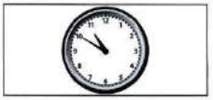 | 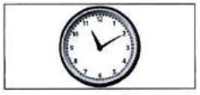 |  |  | 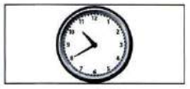
 | test2.6a.png | test2.6b.png |  |  | test2.6c.png
7. | Which postcard will they send to Mark?
 | 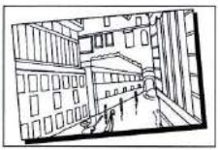 | 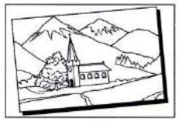 |  |  | 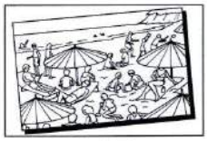
 | test2.7a.png | test2.7b.png |  |  | test2.7c.png

TEST 33
Part 1
Listen and choose the correct picture.AMTHANH\Test 3 part 1.mp3
Example: | Where did the man leave his camera?
 | test3.vidu.a.png | test3.vidu.b.png | test3.vidu.c.png
1. | Which present will the girl take?
 | 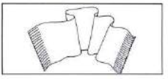 | 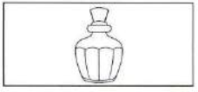 | 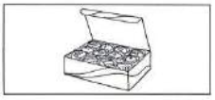
 | test3.1a.png | test3.1b.png | test3.1c.png
2. | Who lives in Joe’s house now?
2. | 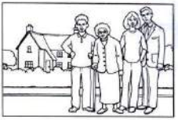 | 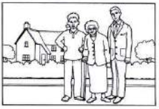 | 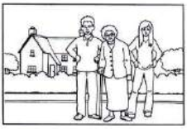
2. | test3.2a.png | test3.2b.png | test3.2c.png
3. | Who will be on the stage next?
3. | 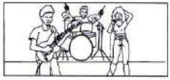 | 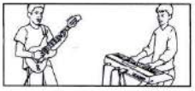 | 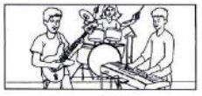
3. | test3.3a.png | test3.3b.png | test3.3c.png
4. | Where is the woman’s notebook now?
4. | 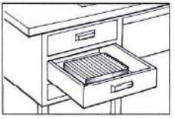 | 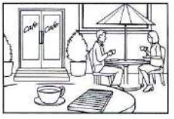 | 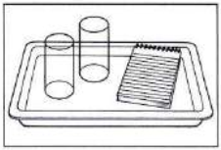
 | test3.4a.png | test3.4b.png | test3.4c.png
5. | What time will the cake be ready?
 | 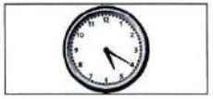 | 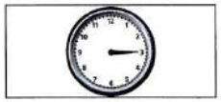 | 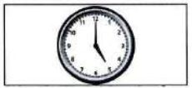
 | test3.5a.png | test3.5b.png | test3.5c.png
6. | Which TV programme will they watch together?
 | 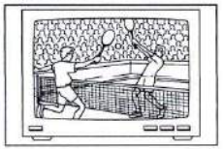 | 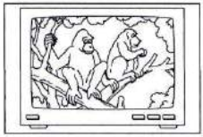 | 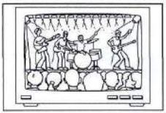
 | test3.6a.png | test3.6b.png | test3.6c.png
7. | How will the family get to Glasgow?
 | 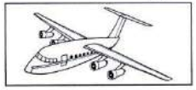 | 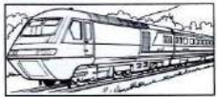 | 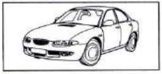
 | test3.7a.png | test3.7b.png | test3.7c.png

TEST 34
Part 1
Listen and choose the correct picture.AMTHANH\Test 4 part 1.mp3
Example: | How did the woman get to work?
 | 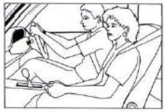 | 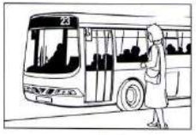 | 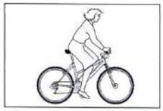
 | test4.vidua.png | test4.vidub.png | test4.viduc.png
1. | Which present has the girl bought her mother?
 | 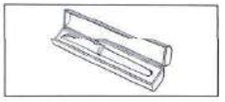 | 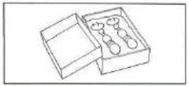 | 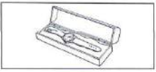
 | test4.1a.png | test4.1b.png | test4.1c.png
2. | What will the prize be in the painting competition?
2. | 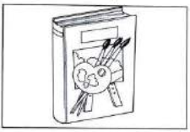 | 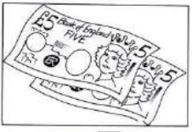 | 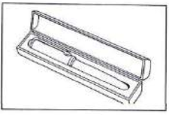
2. | test4.2a.png | test4.2b.png | test4.2c.png
3. | Which photo does the girl dislike?
3. | 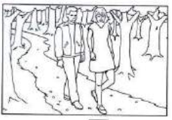 | 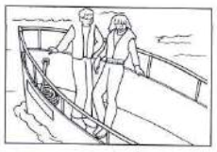 | 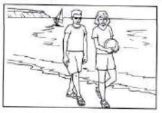
3. | test4.3a.png | test4.3b.png | test4.3c.png
4. | What should the students take on the school trip?
4. | 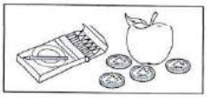 | 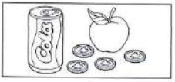 | 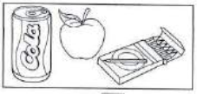
 | test4.4a.png | test4.4b.png | test4.4c.png
5. | Which subject does the boy like best?
 | 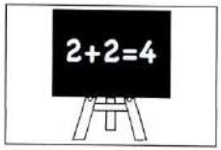 | 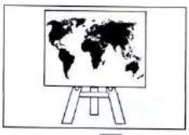 | 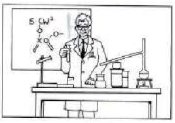
 | test4.5a.png | test4.5b.png | test4.5c.png
6. | What time is the dance class today?
 | 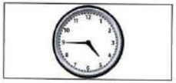 | 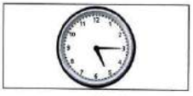 | 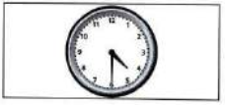
 | test4.6a.png | test4.6b.png | test4.6c.png
7. | Which vegetables do they decide to put in the curry?
 | 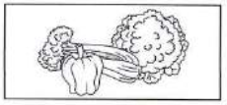 | 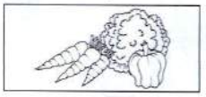 | 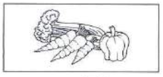
 | test4.7a.png | test4.7b.png | test4.7c.png

TEST 35
Part 1
Listen and choose the correct picture.AMTHANH\Test 5 part 1.mp3
Example: | Which sports did the girl watch on TV last night?
 | 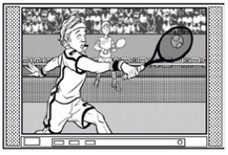 | 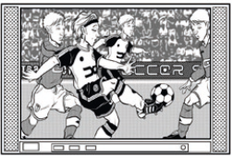 | 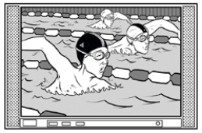
 | test5.vidua.png | test5.vidub.png | test5.viduc.png
1. | What time did the taxi arrive?
 | 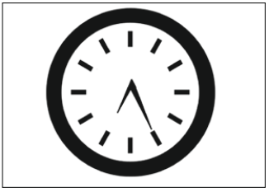 | 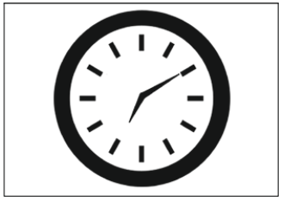 | 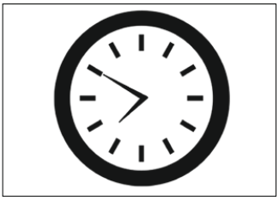
 | test5.1a.png | test5.1b.png | test5.1c.png
2. | What will they buy first?
2. | 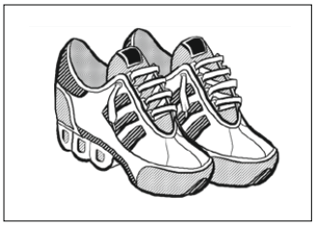 | 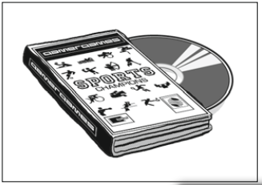 | 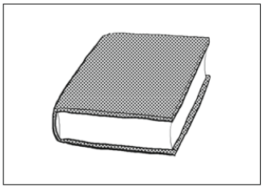
2. | test5.2a.png | test5.2b.png | test5.2c.png
3. | Which is the girl’s bag?
3. | 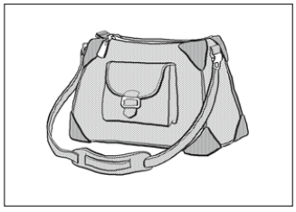 | 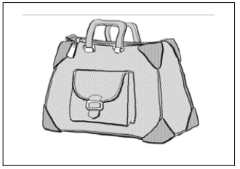 | 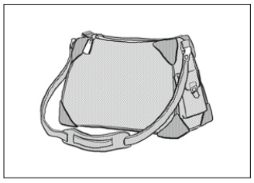
3. | test5.3a.png | test5.3b.png | test5.3c.png
4. | How will the boy contact his mother?
4. | 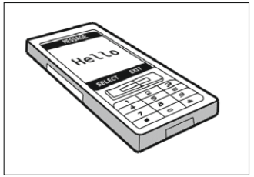 | 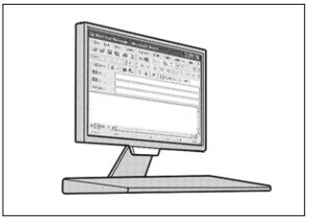 | 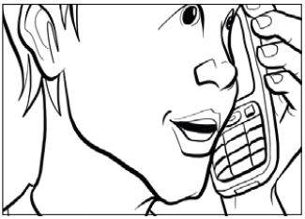
 | test5.4a.png | test5.4b.png | test5.4c.png
5. | What should Jessie bring to the picnic?
 | 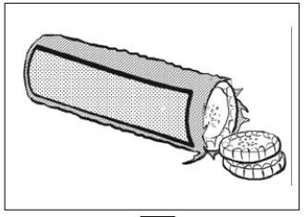 | 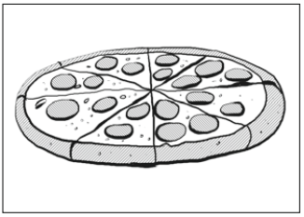 | 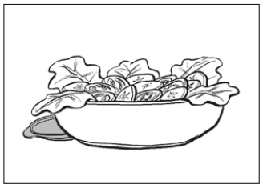
 | test5.5a.png | test5.5b.png | test5.5c.png
6. | What did the man buy?
 | 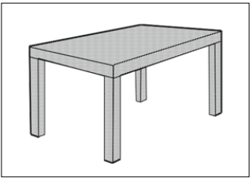 | 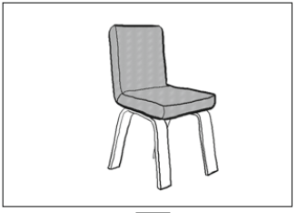 | 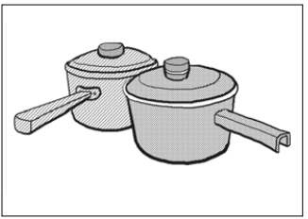
 | test5.6a.png | test5.6b.png | test5.6c.png
7. | Which bus will the girl catch?
 | 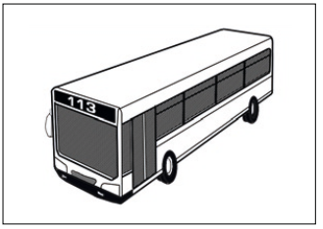 | 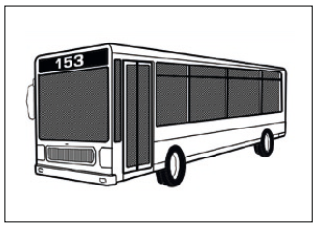 | 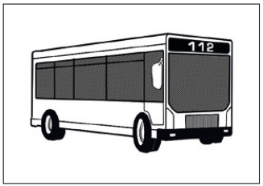
 | test5.7a.png | test5.7b.png | test5.7c.png

