Step to develop a spring mvc project.

Step 1 : Crete Mavent project and import spring dependencies:

<project xmlns=*"http://maven.apache.org/POM/4.0.0"*

xmlns:xsi=*"http://www.w3.org/2001/XMLSchema-instance"*

xsi:schemaLocation=*"http://maven.apache.org/POM/4.0.0 http://maven.apache.org/maven-v4_0_0.xsd"*>

<modelVersion>4.0.0</modelVersion>

<groupId>com.fpt.edu</groupId>

<artifactId>swd</artifactId>

<packaging>war</packaging>

<version>0.0.1-SNAPSHOT</version>

<name>swd Maven Webapp</name>

<url>http://maven.apache.org</url>

<dependencies>

<!-- spring-context which provides core functionality -->

<dependency>

<groupId>org.springframework</groupId>

<artifactId>spring-context</artifactId>

<version>4.1.6.RELEASE</version>

</dependency>

<!-- The spring-aop module provides an AOP Alliance-compliant aspect-oriented

programming implementation allowing you to define -->

<dependency>

<groupId>org.springframework</groupId>

<artifactId>spring-aop</artifactId>

<version>4.1.6.RELEASE</version>

</dependency>

<!-- The spring-webmvc module (also known as the Web-Servlet module) contains

Spring’s model-view-controller (MVC) and REST Web Services implementation

for web applications -->

<dependency>

<groupId>org.springframework</groupId>

<artifactId>spring-webmvc</artifactId>

<version>4.1.6.RELEASE</version>

</dependency>

<!-- The spring-web module provides basic web-oriented integration features

such as multipart file upload functionality and the initialization of the

IoC container using Servlet listeners and a web-oriented application context -->

<dependency>

<groupId>org.springframework</groupId>

<artifactId>spring-web</artifactId>

<version>4.1.6.RELEASE</version>

</dependency>

<dependency>

<groupId>org.springframework.data</groupId>

<artifactId>spring-data-jpa</artifactId>

<version>2.0.8.RELEASE</version>

</dependency>

</dependencies>

<build>

<finalName>swd</finalName>

</build>

</project>

Note that if you using the JPS you must install jstl lib :

<dependency>

<groupId>javax.servlet</groupId>

<artifactId>jstl</artifactId>

<version>1.2</version>

</dependency>

Step 2 : denine Root context and servlet context:

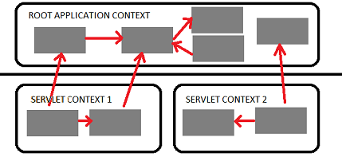

Create Context File (define bean , or define component to scan).