- BASIC FAT32 FILE SYSTEM CONCEPTS –
-DOBRA DARIUS-

1. Overview In Week 1, we established that the USB is a warehouse of "Sectors" and "Clusters". For Week 2, we need to understand the "Map" of that warehouse. This map is the FAT32 File System.
Without understanding FAT32, our tool can read the USB size, but it cannot find files or calculate free space accurately.
2. The USB Memory Map (Structure Diagram) To understand how the USB is organized, view the storage space as a linear timeline, starting from the very first byte (Sector 0) to the end.
Here is a simplified structural diagram of a standard USB formatted with FAT32:
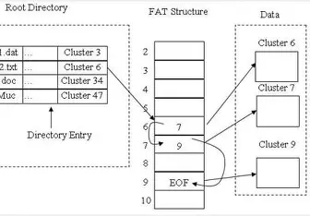

3. region 1: The Boot Sector (Reserved Region)
- Location: The very first sector of the partition (Sector 0).
- What it contains: The BIOS Parameter Block (BPB).
- Relevance to Developer (Rares): This is the most critical sector to read first. It contains the configuration numbers for the whole drive:
  - Bytes Per Sector (usually 512).
  - Sectors Per Cluster (usually 8, 16, or 64).
  - Reserved Sector Count (tells us where the FAT Region starts).
4. Region 2: The FAT (File Allocation Table)
- Location: Immediately follows the Reserved Region.
- What it is: A literal table of numbers. There are usually two copies (FAT1 and FAT2) for backup.
- How it works: It maps every single Cluster in the Data Region.
  - If an entry is 0x00000000, that cluster is FREE.
  - If an entry has a number, it points to the NEXT cluster in the file chain.
  - If an entry is 0x0FFFFFFF, it means End of File (EOF).
- Relevance to Project: To calculate "Free Space" (Week 2 Goal), we do not need to scan the whole drive. We only need to scan this table and count the Zeros.
5. Region 3: The Data Region (Root Directory & Files)
- Location: Takes up the vast majority of the USB drive (after the FATs).
- The Root Directory: In FAT32, the Root Directory is just a standard file chain stored here. It contains the list of files (Filename, Size, Date, Starting Cluster).
- Relevance: In Week 3 (File Listing), we will read the Root Directory to get file names. In Week 2, we just need to know that this is where the actual content lives.
6. Summary for the Team
- Read Sector 0 to get the dimensions (Sector/Cluster size).
- Read the FAT to calculate used vs. free space.
- Ignore the Data Region until we need to list specific file names in Week 3.

