|  |  |  |  |  |  |  |  |  |  |  |  |  |  |  |  |  |  |  |  |
| --- | --- | --- | --- | --- | --- | --- | --- | --- | --- | --- | --- | --- | --- | --- | --- | --- | --- | --- | --- |
|  |  | | |  | | | |  |  |  | | | | | |  | |  |  |
|  |  | | | | | ${platnum} | | |  |  | ${vehicleType} | | | | |  | | ${usage} |  |
|  | | | | | | | | | | | | | | | | | | | |
|  |  | | ${SYXZ} | | | | | |  |  | | ${DLYSZH} | | | | | | | |
|  | | | | | | | | | | | | | | | | | | | |
|  |  | | | | ${CLCCRQ} | | | |  |  | | ${CCDJRQ} | | |  |  | ${JYRQ} | | |
|  |  | | |  | | | | |  |  | |  | | | |  | |  | |
|  |  | | |  | | | | |  |  | |  | | | |  | | ${SFSQ} | |
|  |  |  | | | | |  | |  |  | |  | |  | |  | |  | |
|  |  | | | ${ZXZSL} | | |  | |  |  | |  | ${ZCZD} |  | |  | | ${KQXG} | |

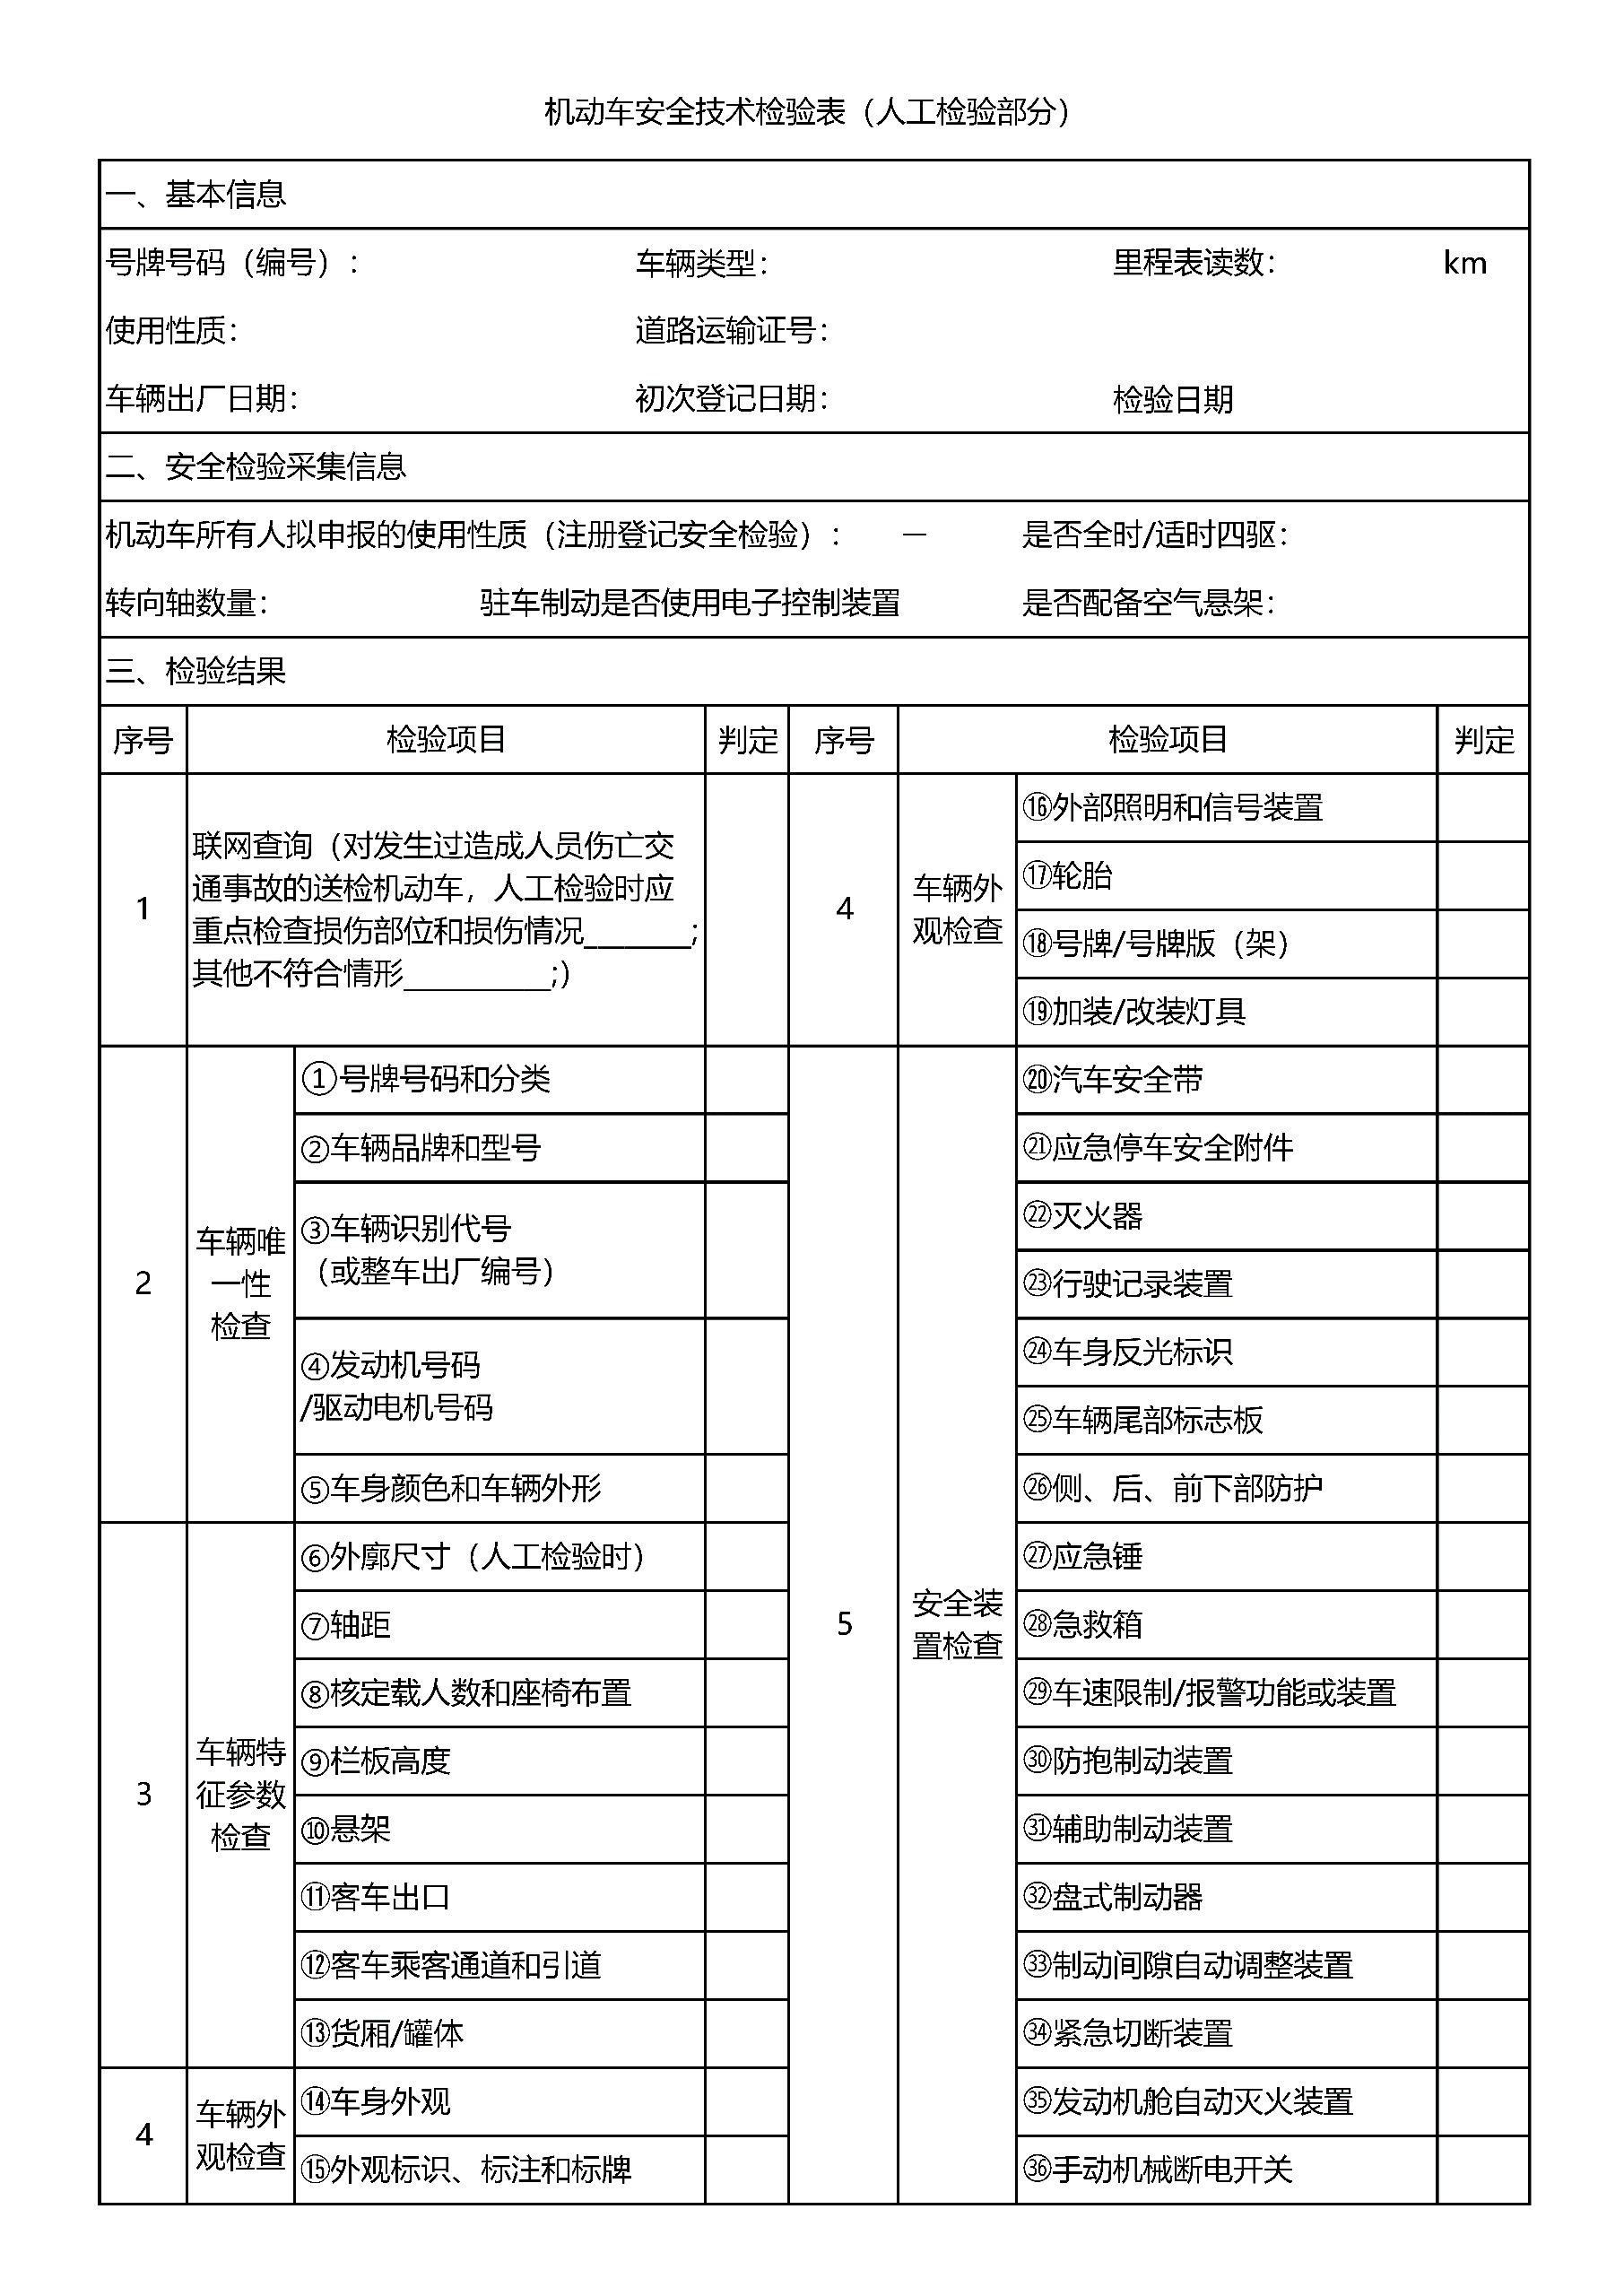

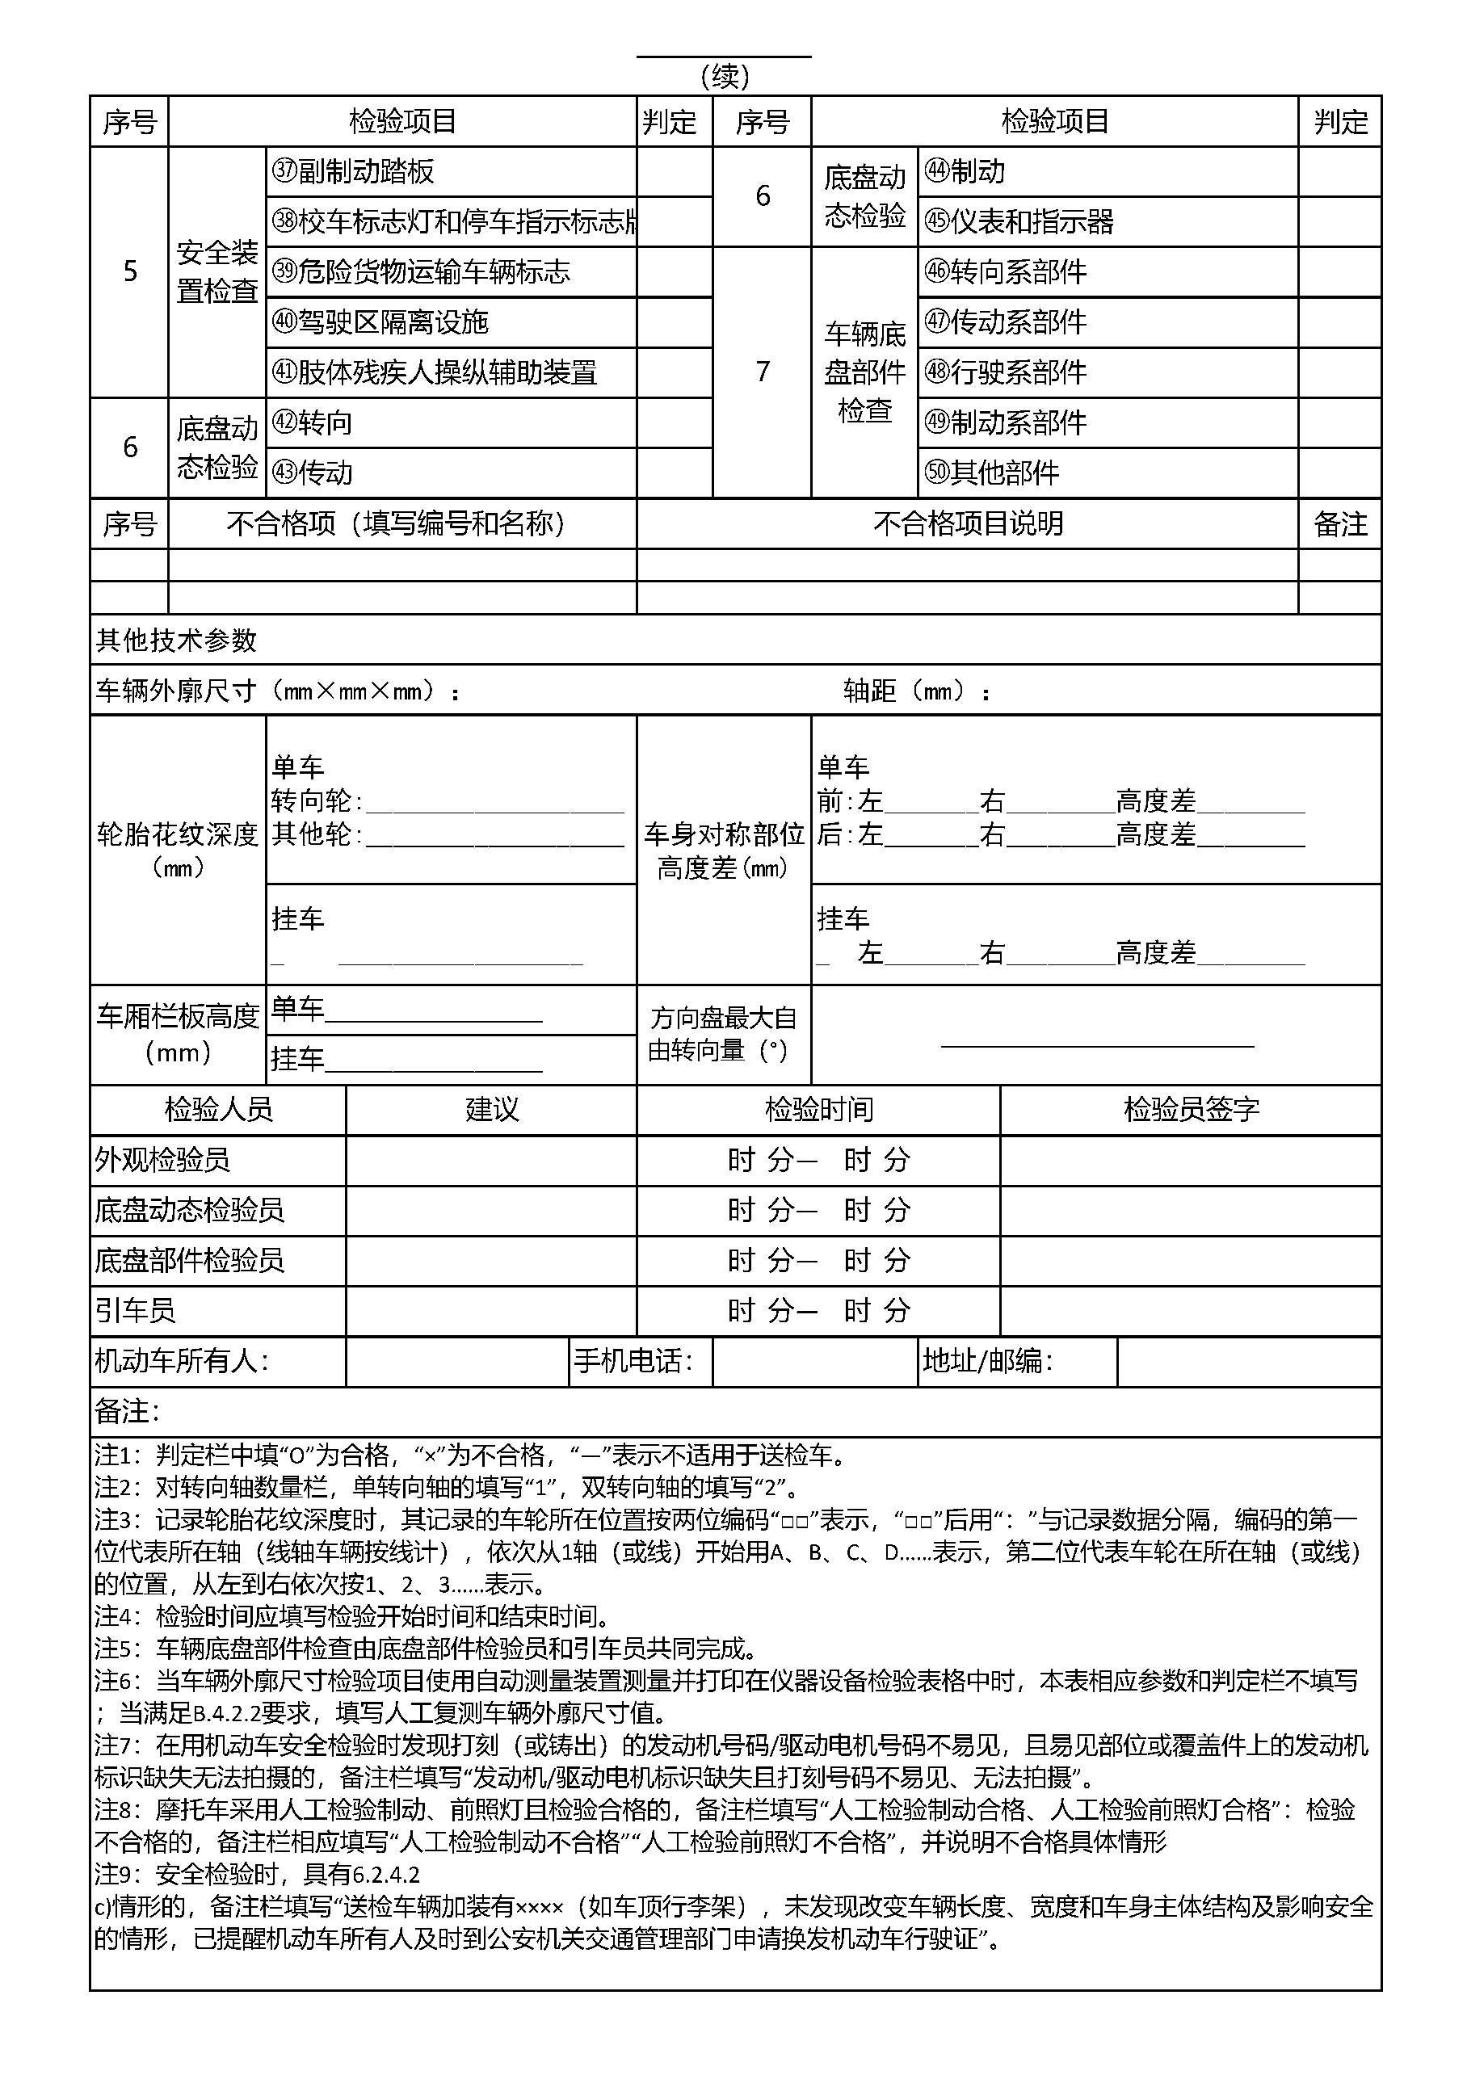

|  |  |  |  |  |  |  |  |
| --- | --- | --- | --- | --- | --- | --- | --- |
|  |  | ${owner} |  | ${tel} | |  | ${postcode} |
|  |  | |  | |  | |  |
|  |  | |  | |  | |  |