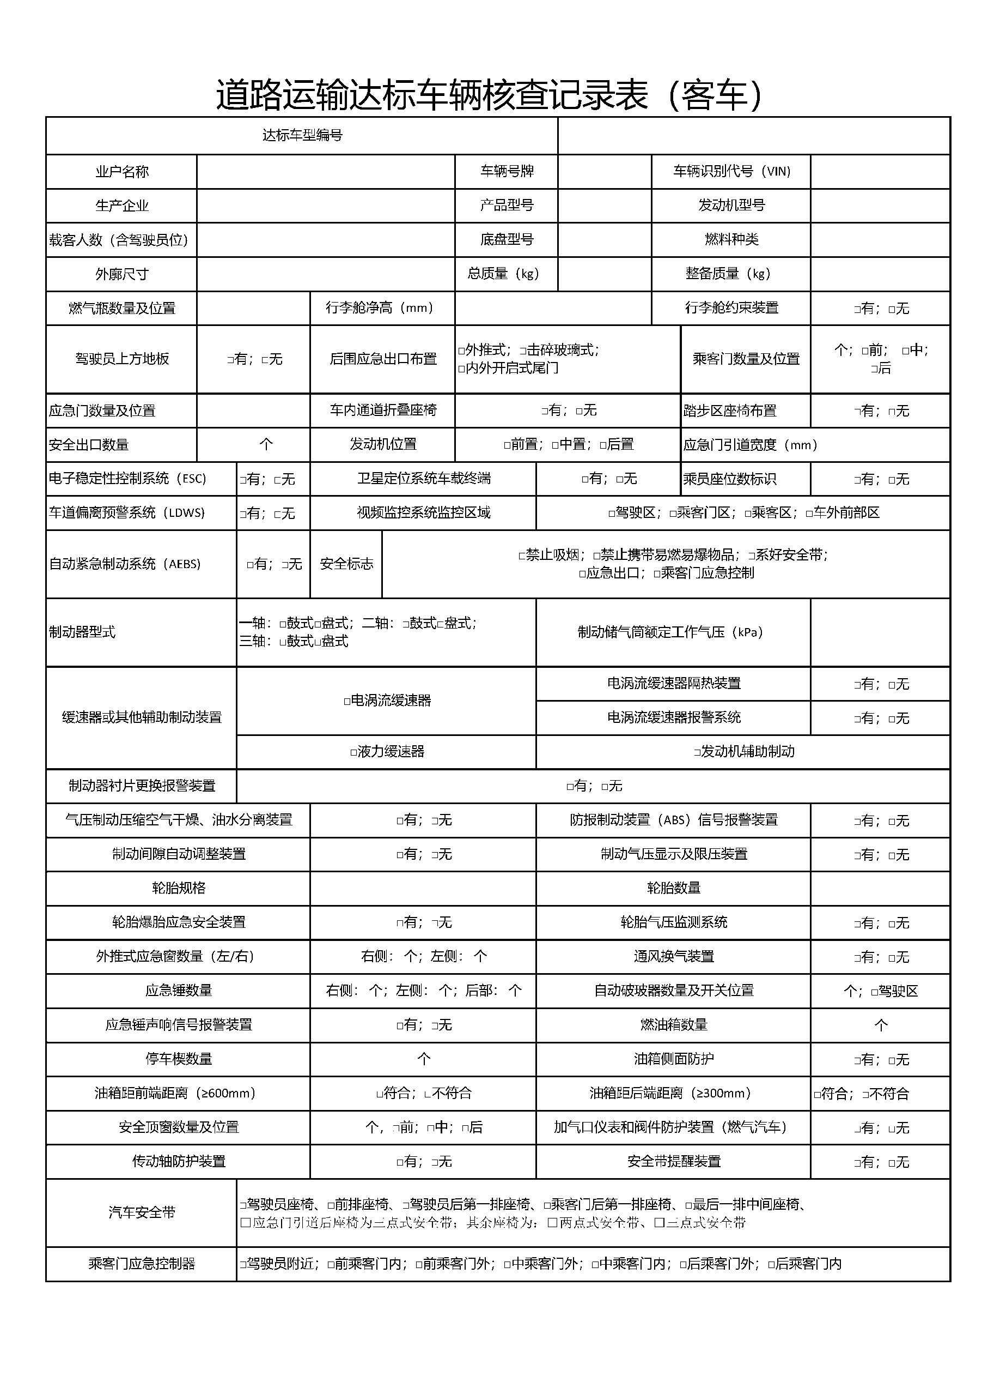

|  |  |  |  |  |  |  |  |  |  |
| --- | --- | --- | --- | --- | --- | --- | --- | --- | --- |
|  |  |  |  |  |  |  |  |  |  |
|  | ${owner} | | | |  | ${platnum} |  | ${vin} |  |
|  | ${factoryName} | | | |  | ${XH} |  | ${engineModel} |  |
|  | ${ZKRS} | | | |  |  |  | ${fuelType} |  |
|  |  |  |  |  |  |  |  |  |  |
|  | ${WXCC} | | | |  | ${crosght} |  | ${ZBZL} |  |
|  |  |  |  |  |  |  |  |  |  |

