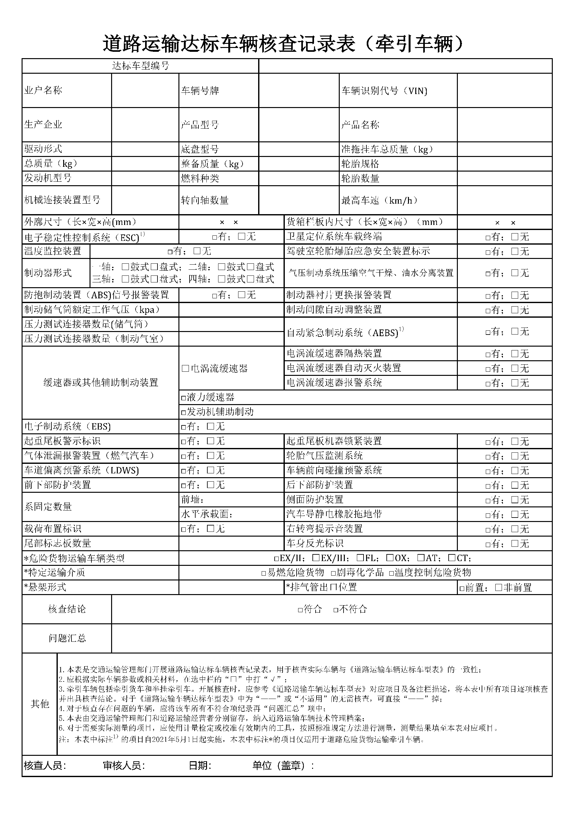

|  |  |  |  |  |  |  |  |  |  |  |  |  |  |  |  |  |
| --- | --- | --- | --- | --- | --- | --- | --- | --- | --- | --- | --- | --- | --- | --- | --- | --- |
|  |  |  |  |  |  | | | |  | |  |  | | |  | |
|  | ${owner} |  |  |  | ${platnum} | | | |  | |  | ${vin} | | |  | |
|  |  |  |  |  |  | | | |  | |  |  | | |  | |
|  | ${factoryName} |  |  |  | ${CPXH} | | | |  | |  | ${vehicleType} | | |  | |
|  |  |  |  |  |  | | | |  | |  |  | | |  | |
|  | ${QDXS} |  |  |  | ${DPXH} | | | |  | |  | ${LTGG} | | |  | |
|  | ${ZZL} |  |  |  | ${ZBZL} | | | |  | |  | ${LTSL} | | |  | |
|  | ${FDJXH} |  |  |  | ${RLZL} | | | |  | |  | ${ZGCS} | | |  | |
|  |  |  |  |  |  | | | |  | |  |  | | |  | |
|  | ${JXLJZZXH} |  |  |  | ${ZXZSL} | | | |  | |  | ${ZGCS} | | |  | |
|  |  |  |  |  |  | | | |  | |  |  | | |  | |
|  |  | ${WKCC} | | | |  |  |  | |  | | | ${HXLBCKG} |  | |
|  |  |  | | | | | |  | | | | | |  | |
|  |  |  | | | | | |  | |  | | |  |  | |