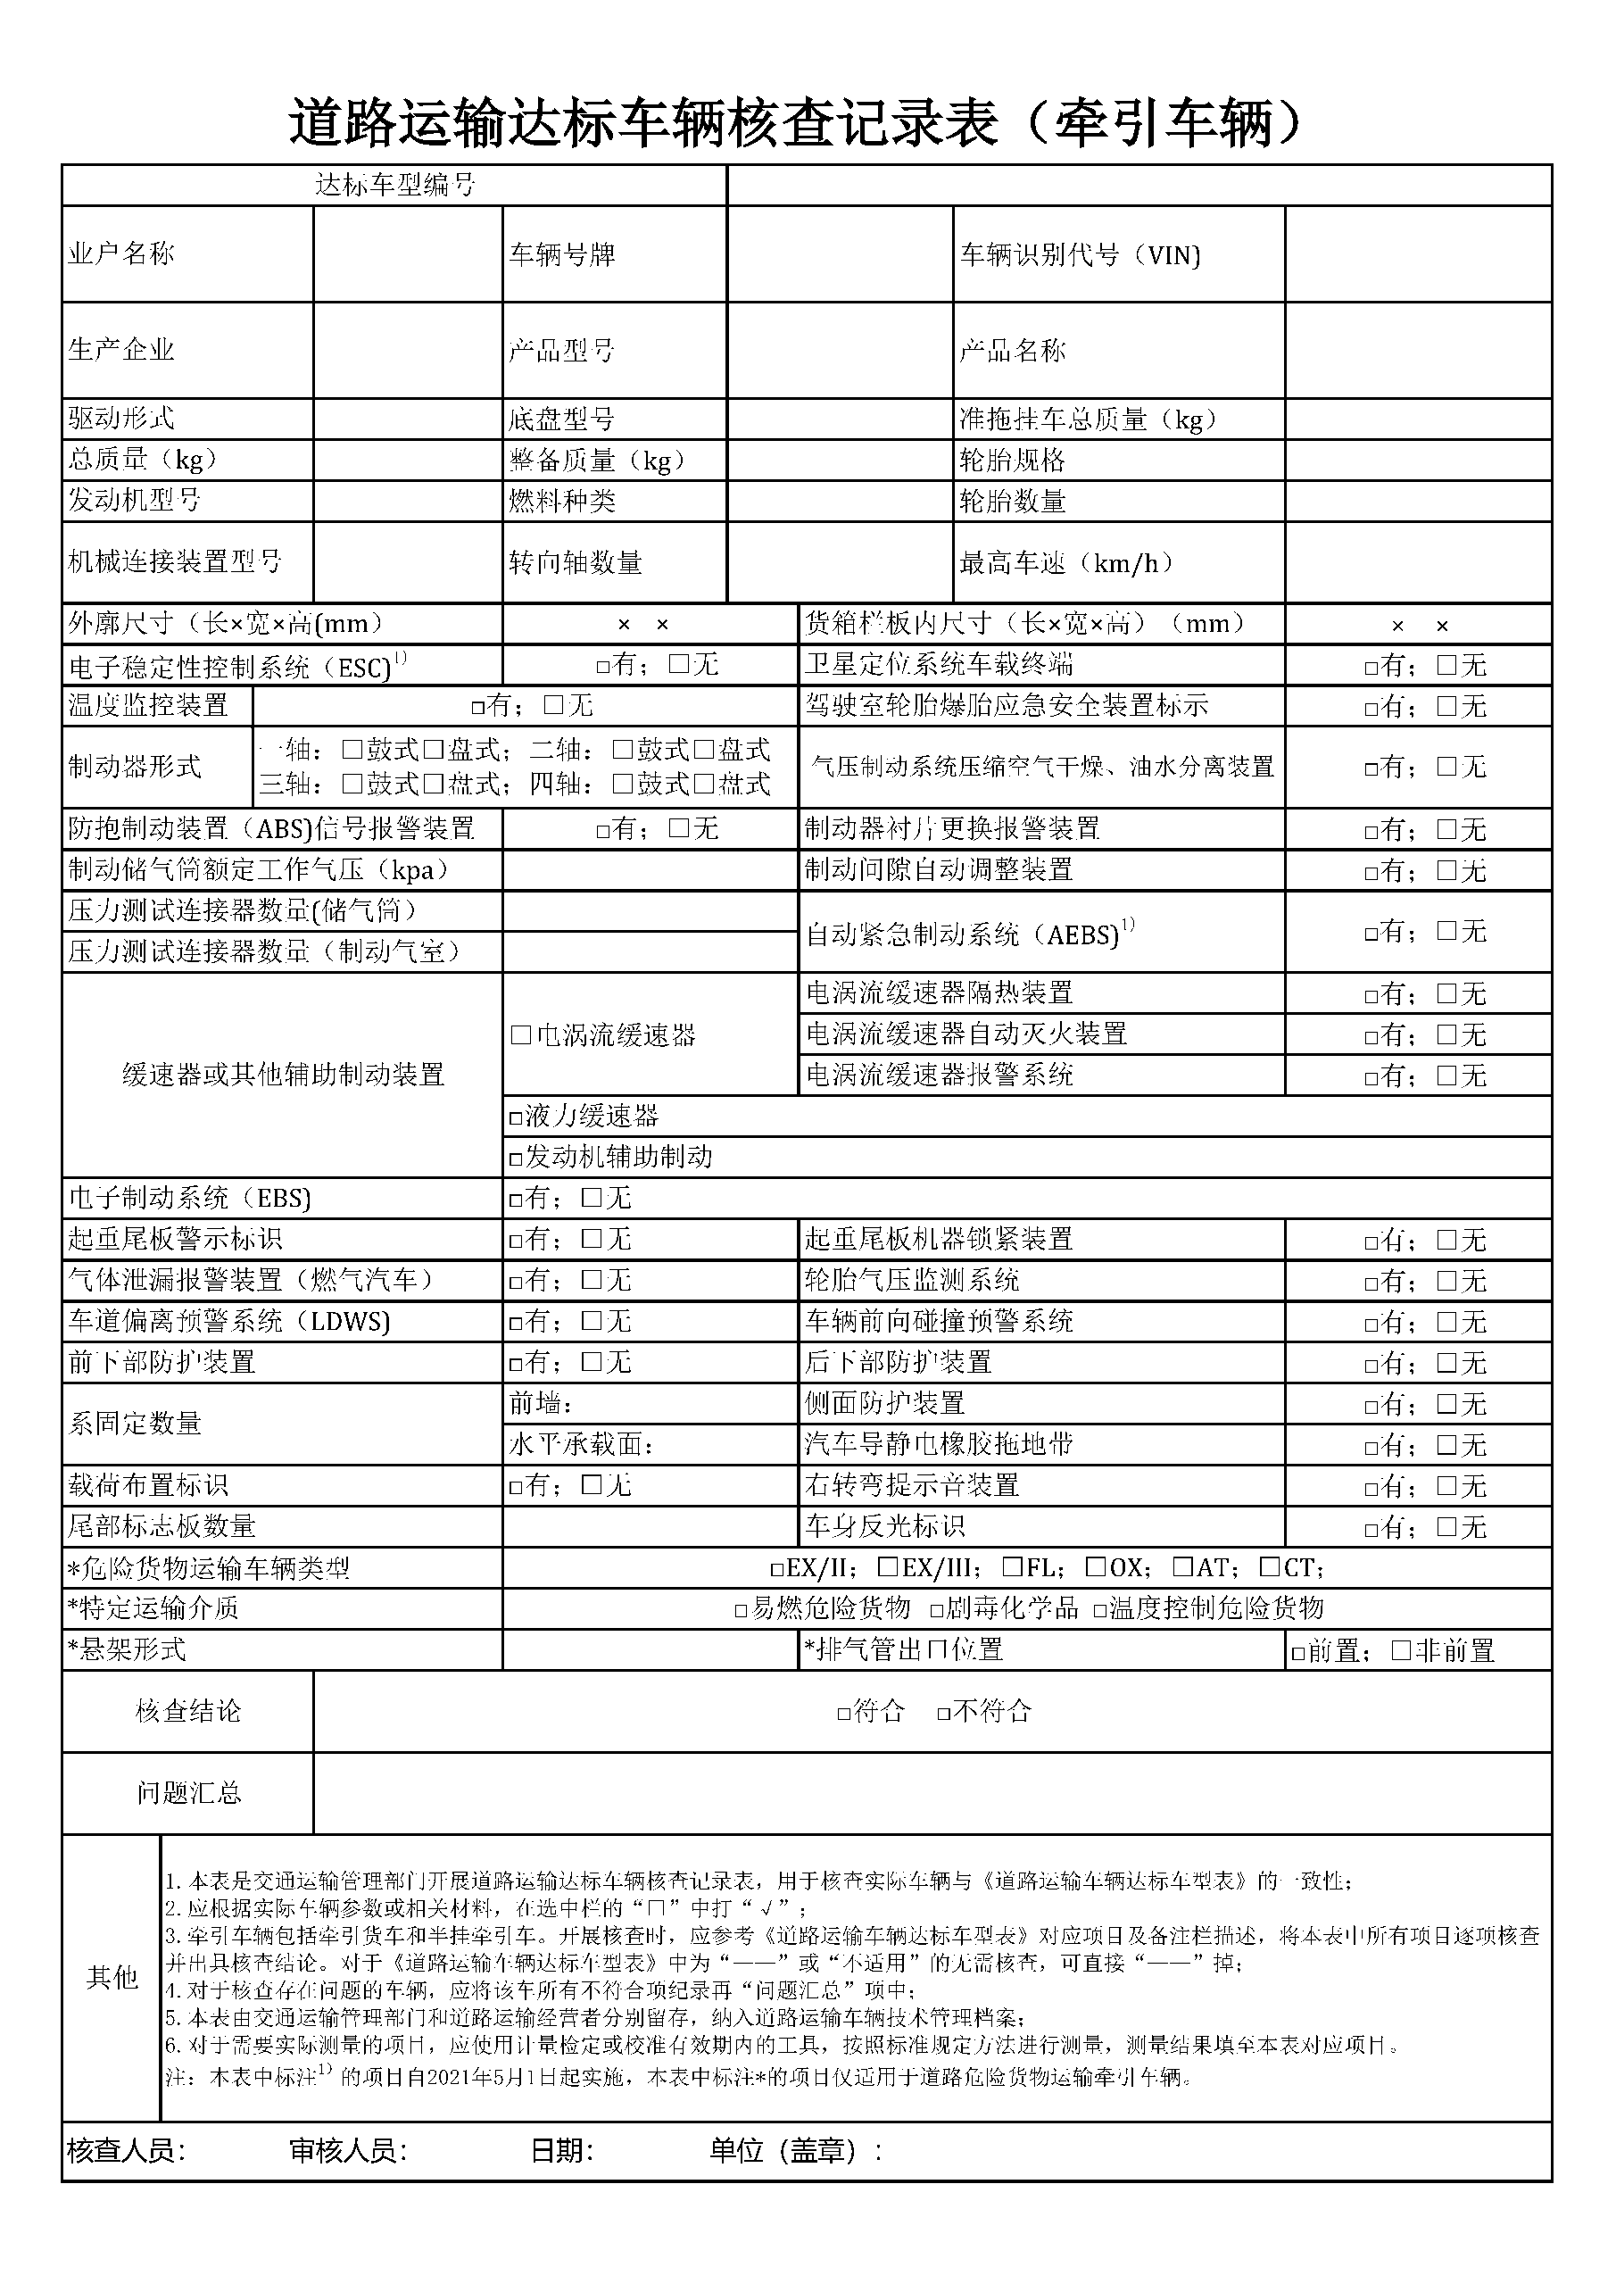

|  |  |  |  |  |  |  |  |  |  |  |  |  |  |  |  |  |
| --- | --- | --- | --- | --- | --- | --- | --- | --- | --- | --- | --- | --- | --- | --- | --- | --- |
|  |  |  |  |  |  | | | |  | |  | |  | |  | |
|  | ${owner} |  |  |  | ${platnum} | | | |  | |  | | ${vin} | |  | |
|  |  |  |  |  |  | | | |  | |  | |  | |  | |
|  | ${factoryName} |  |  |  | ${XH} | | | |  | |  | | ${vehicleType} | |  | |
|  |  |  |  |  |  | | | |  | |  | |  | |  | |
|  | ${posite} |  |  |  |  | | | |  | |  | |  | |  | |
|  | ${crosght} |  |  |  | ${ZBZL} | | | |  | |  | | ${LTGG} | |  | |
|  | ${engineModel} |  |  |  | ${fuelType} | | | |  | |  | | ${LTSL} | |  | |
|  |  |  |  |  |  | | | |  | |  | |  | |  | |
|  | ${JXLJZZXH} |  |  |  | ${ZXZSL} | | | |  | |  | | ${ZGCS} | |  | |
|  |  |  |  |  |  | | | |  | |  | |  | |  | |
|  |  | ${WXCC} | | | |  |  |  | |  | | ${HXLBNCC} | |  | |
|  |  |  | | | | | |  | | | | | |  | |
|  |  |  | | | | | |  | |  | |  | |  | |