|  |  |  |  |  |  |  |  |  |  |  |  |  |  |  |  |  |  |  |  |
| --- | --- | --- | --- | --- | --- | --- | --- | --- | --- | --- | --- | --- | --- | --- | --- | --- | --- | --- | --- |
|  |  | | |  | | | |  |  |  | | | | | |  | |  |  |
|  |  | | | | | 晋D | | |  |  | CA4256P1K2T1E5A80 | | | | |  | | 3000 |  |
|  | | | | | | | | | | | | | | | | | | | |
|  |  | | F | | | | | |  |  | | 14048109468 | | | | | | | |
|  | | | | | | | | | | | | | | | | | | | |
|  |  | | | | 2018 年 2 月 26 日 | | | |  |  | | 2018 年 3 月 5 日 | | |  |  | 2021年2月3日 | | |
|  |  | | |  | | | | |  |  | |  | | | |  | |  | |
|  |  | | |  | | | | |  |  | |  | | | |  | | 否 | |
|  |  |  | | | | |  | |  |  | |  | |  | |  | |  | |
|  |  | | | 1 | | |  | |  |  | |  | 否 |  | |  | | 否 | |

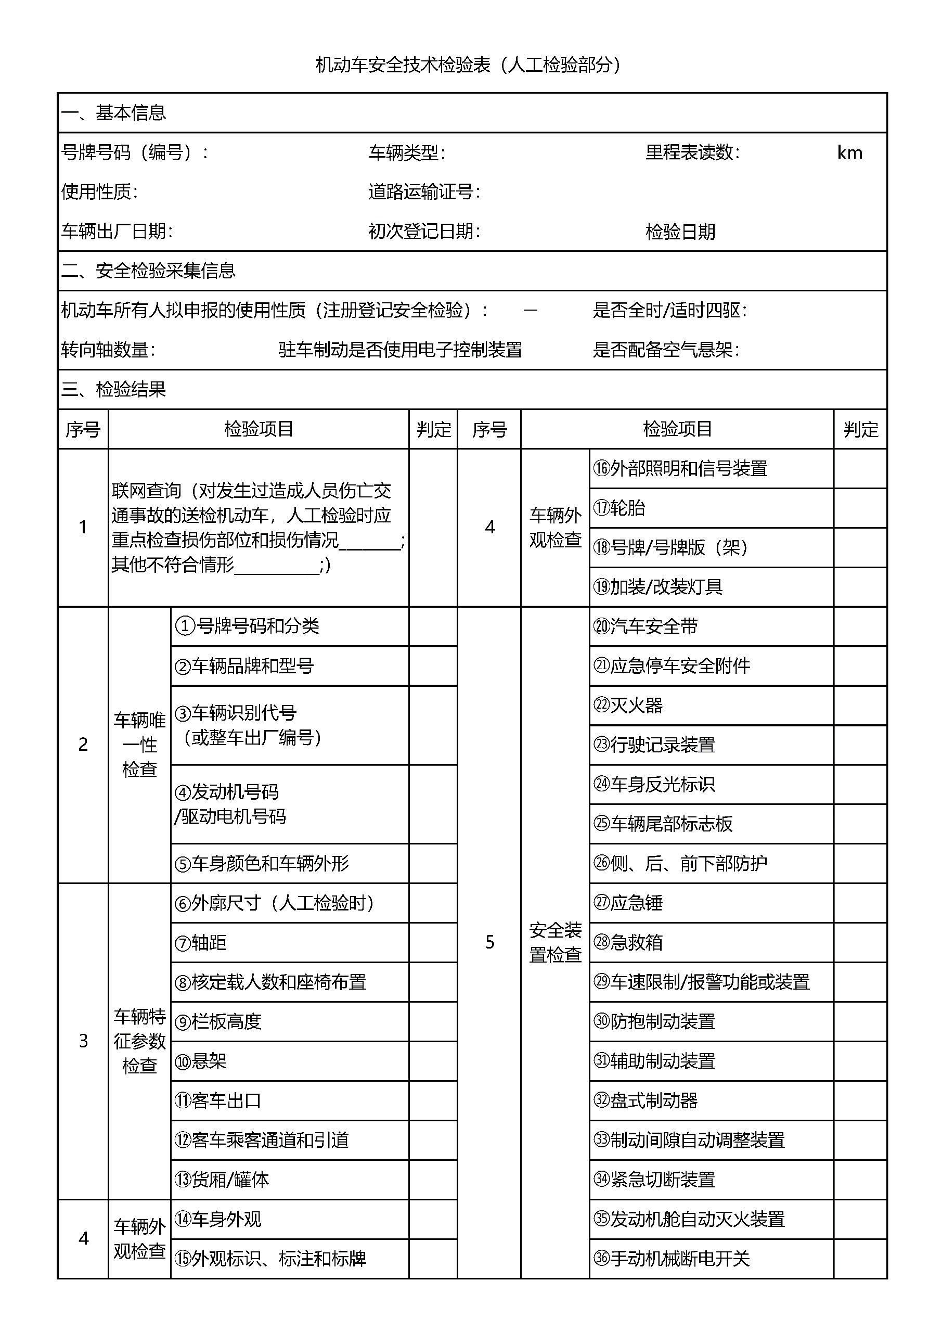

|  |  |  |  |  |  |  |  |
| --- | --- | --- | --- | --- | --- | --- | --- |
|  |  | 潞城市承昌通商贸有限公司 |  | 139 | |  | 047500 |
|  |  | |  | |  | |  |
|  |  | |  | |  | |  |

