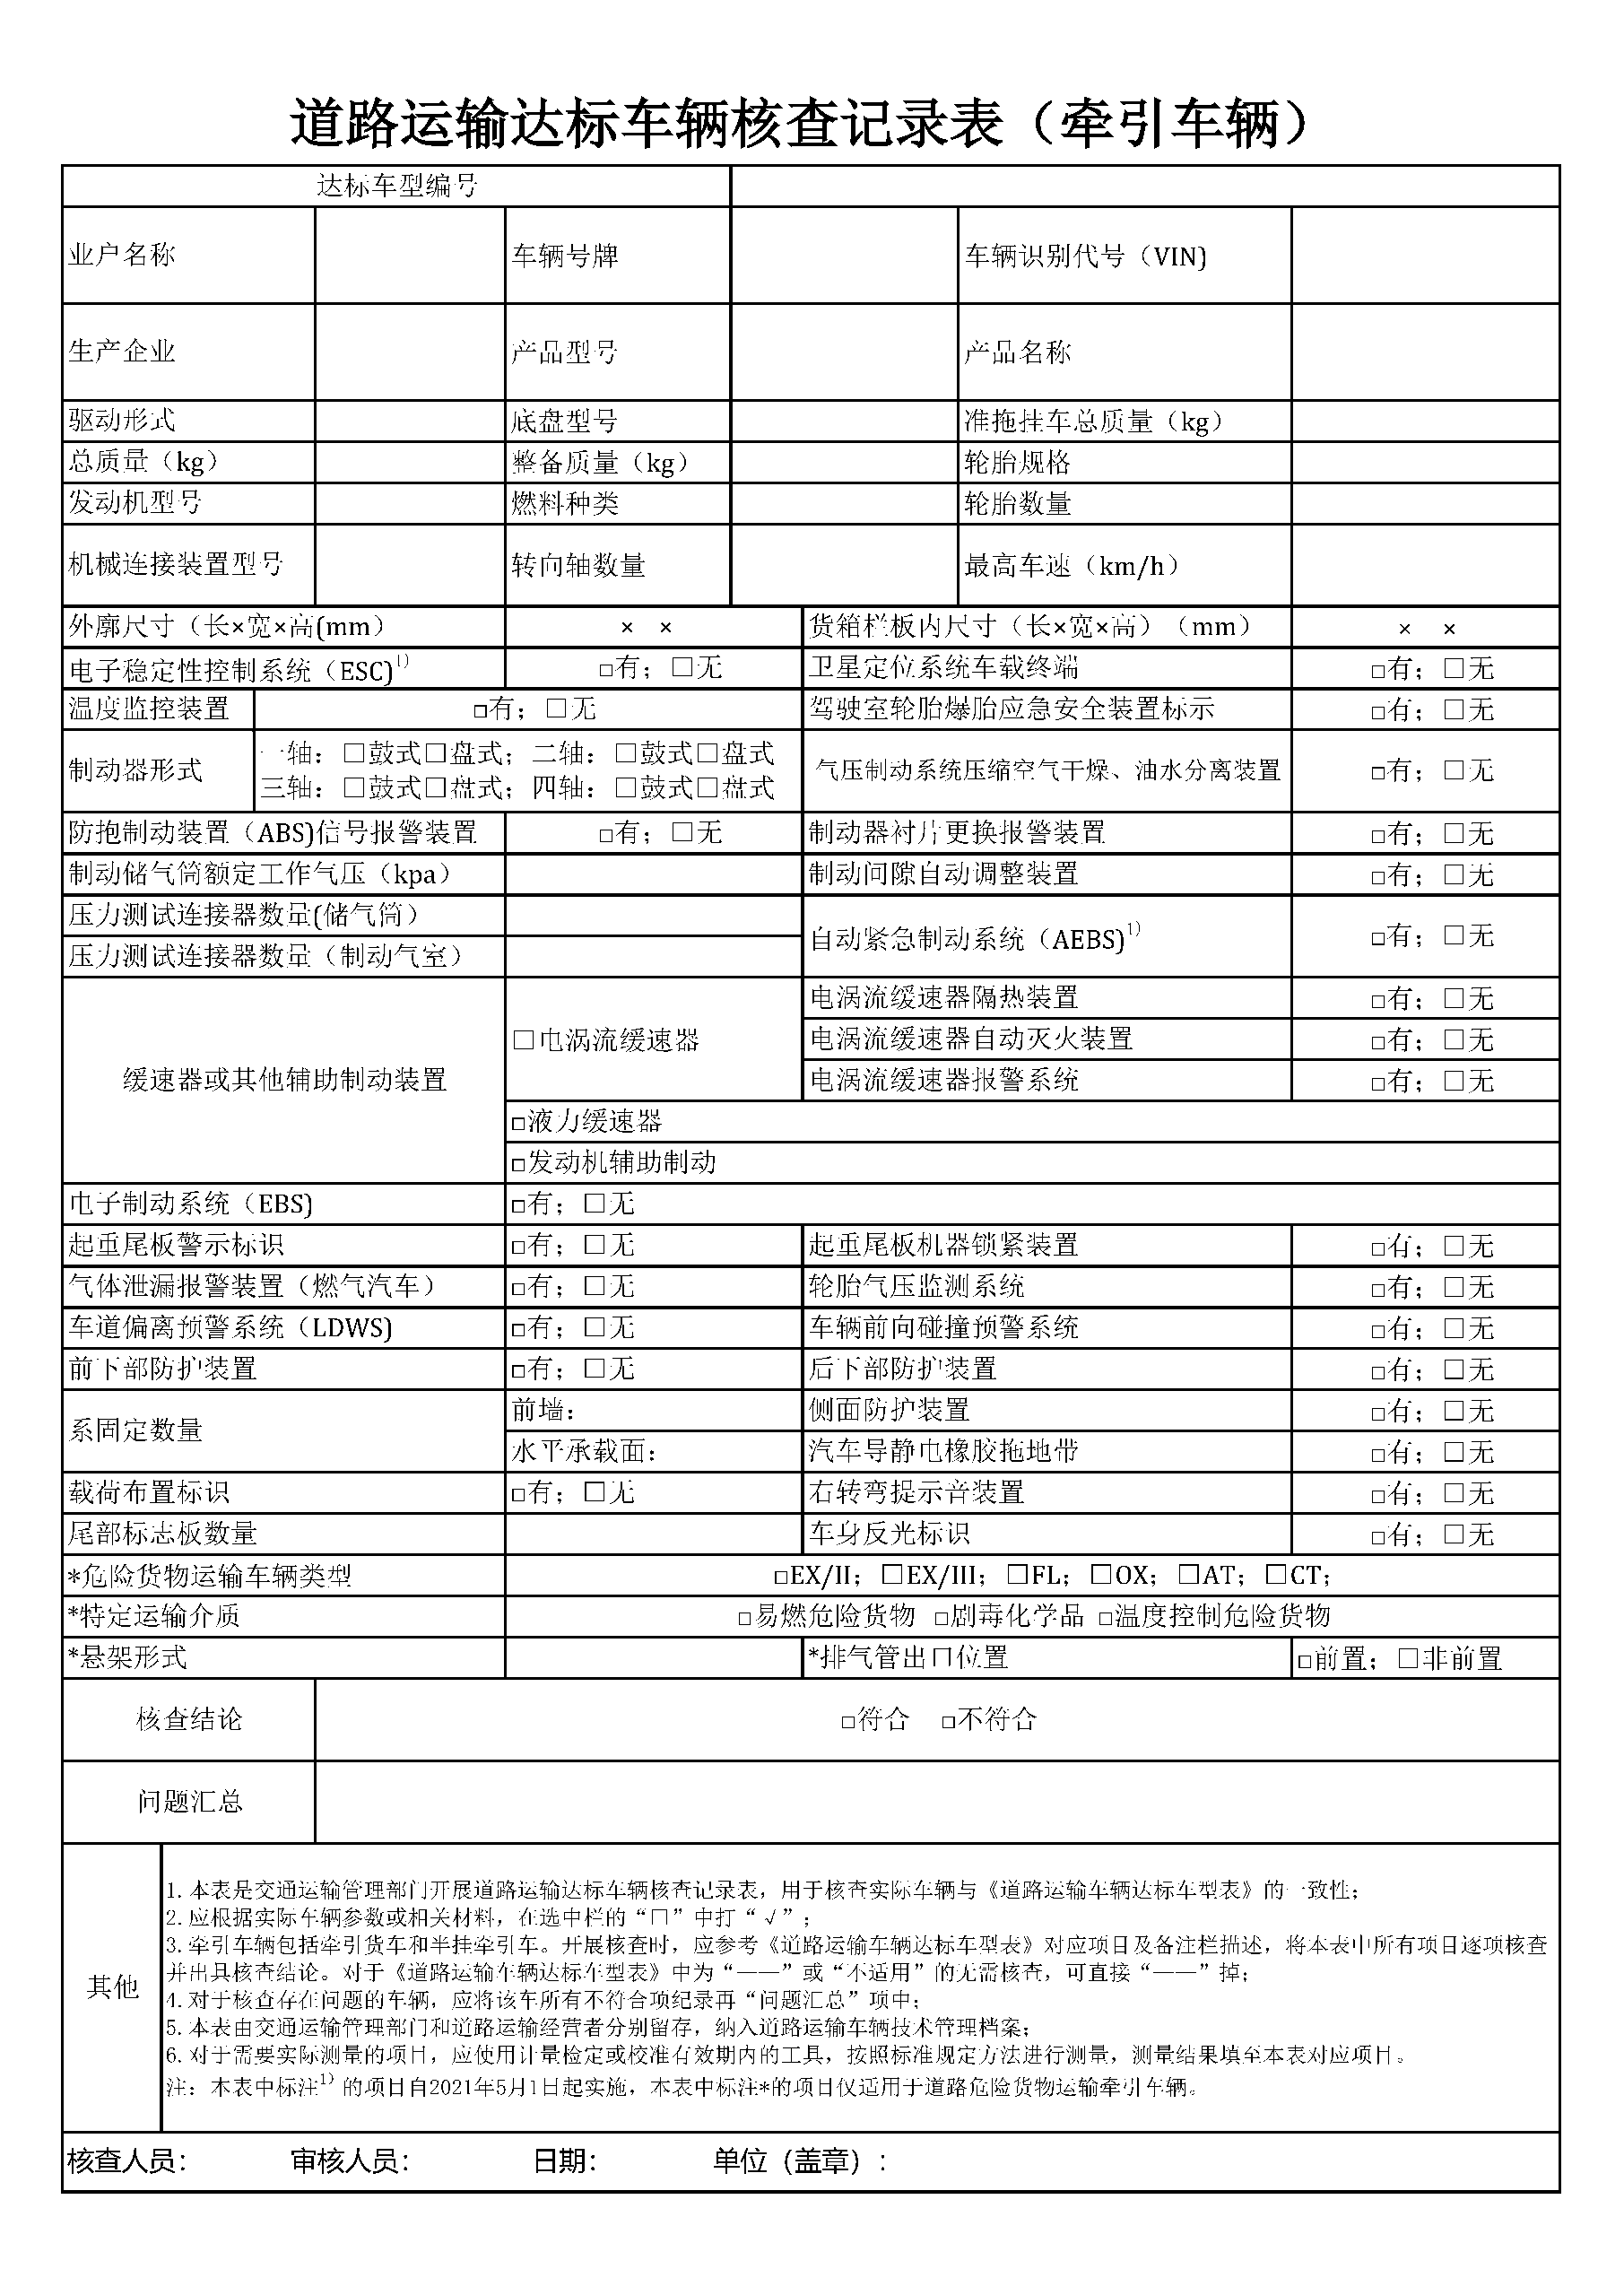

|  |  |  |  |  |  |  |  |  |  |  |  |  |  |  |  |  |
| --- | --- | --- | --- | --- | --- | --- | --- | --- | --- | --- | --- | --- | --- | --- | --- | --- |
|  |  |  |  |  |  | | | |  | |  | |  | |  | |
|  | 潞城市承昌通商贸有限公司 |  |  |  | 晋D | | | |  | |  | | ABLKSDJOIR798156748 | |  | |
|  |  |  |  |  |  | | | |  | |  | |  | |  | |
|  | 中国第一汽车集团公司 |  |  |  | CA4256P1K2T1E5A80 | | | |  | |  | | CA4256P1K2T1E5A80 | |  | |
|  |  |  |  |  |  | | | |  | |  | |  | |  | |
|  | 2,3 |  |  |  |  | | | |  | |  | |  | |  | |
|  | 25000 |  |  |  | 8415 | | | |  | |  | |  | |  | |
|  | WP10H400E50 |  |  |  | 柴油 | | | |  | |  | | 2/2 | |  | |
|  |  |  |  |  |  | | | |  | |  | |  | |  | |
|  |  |  |  |  | 1 | | | |  | |  | | 250 | |  | |
|  |  |  |  |  |  | | | |  | |  | |  | |  | |
|  |  | 6675 × 2490 × 3290 | | | |  |  |  | |  | | 1000 × 1000 × 1000 | |  | |
|  |  |  | | | | | |  | | | | | |  | |
|  |  |  | | | | | |  | |  | |  | |  | |