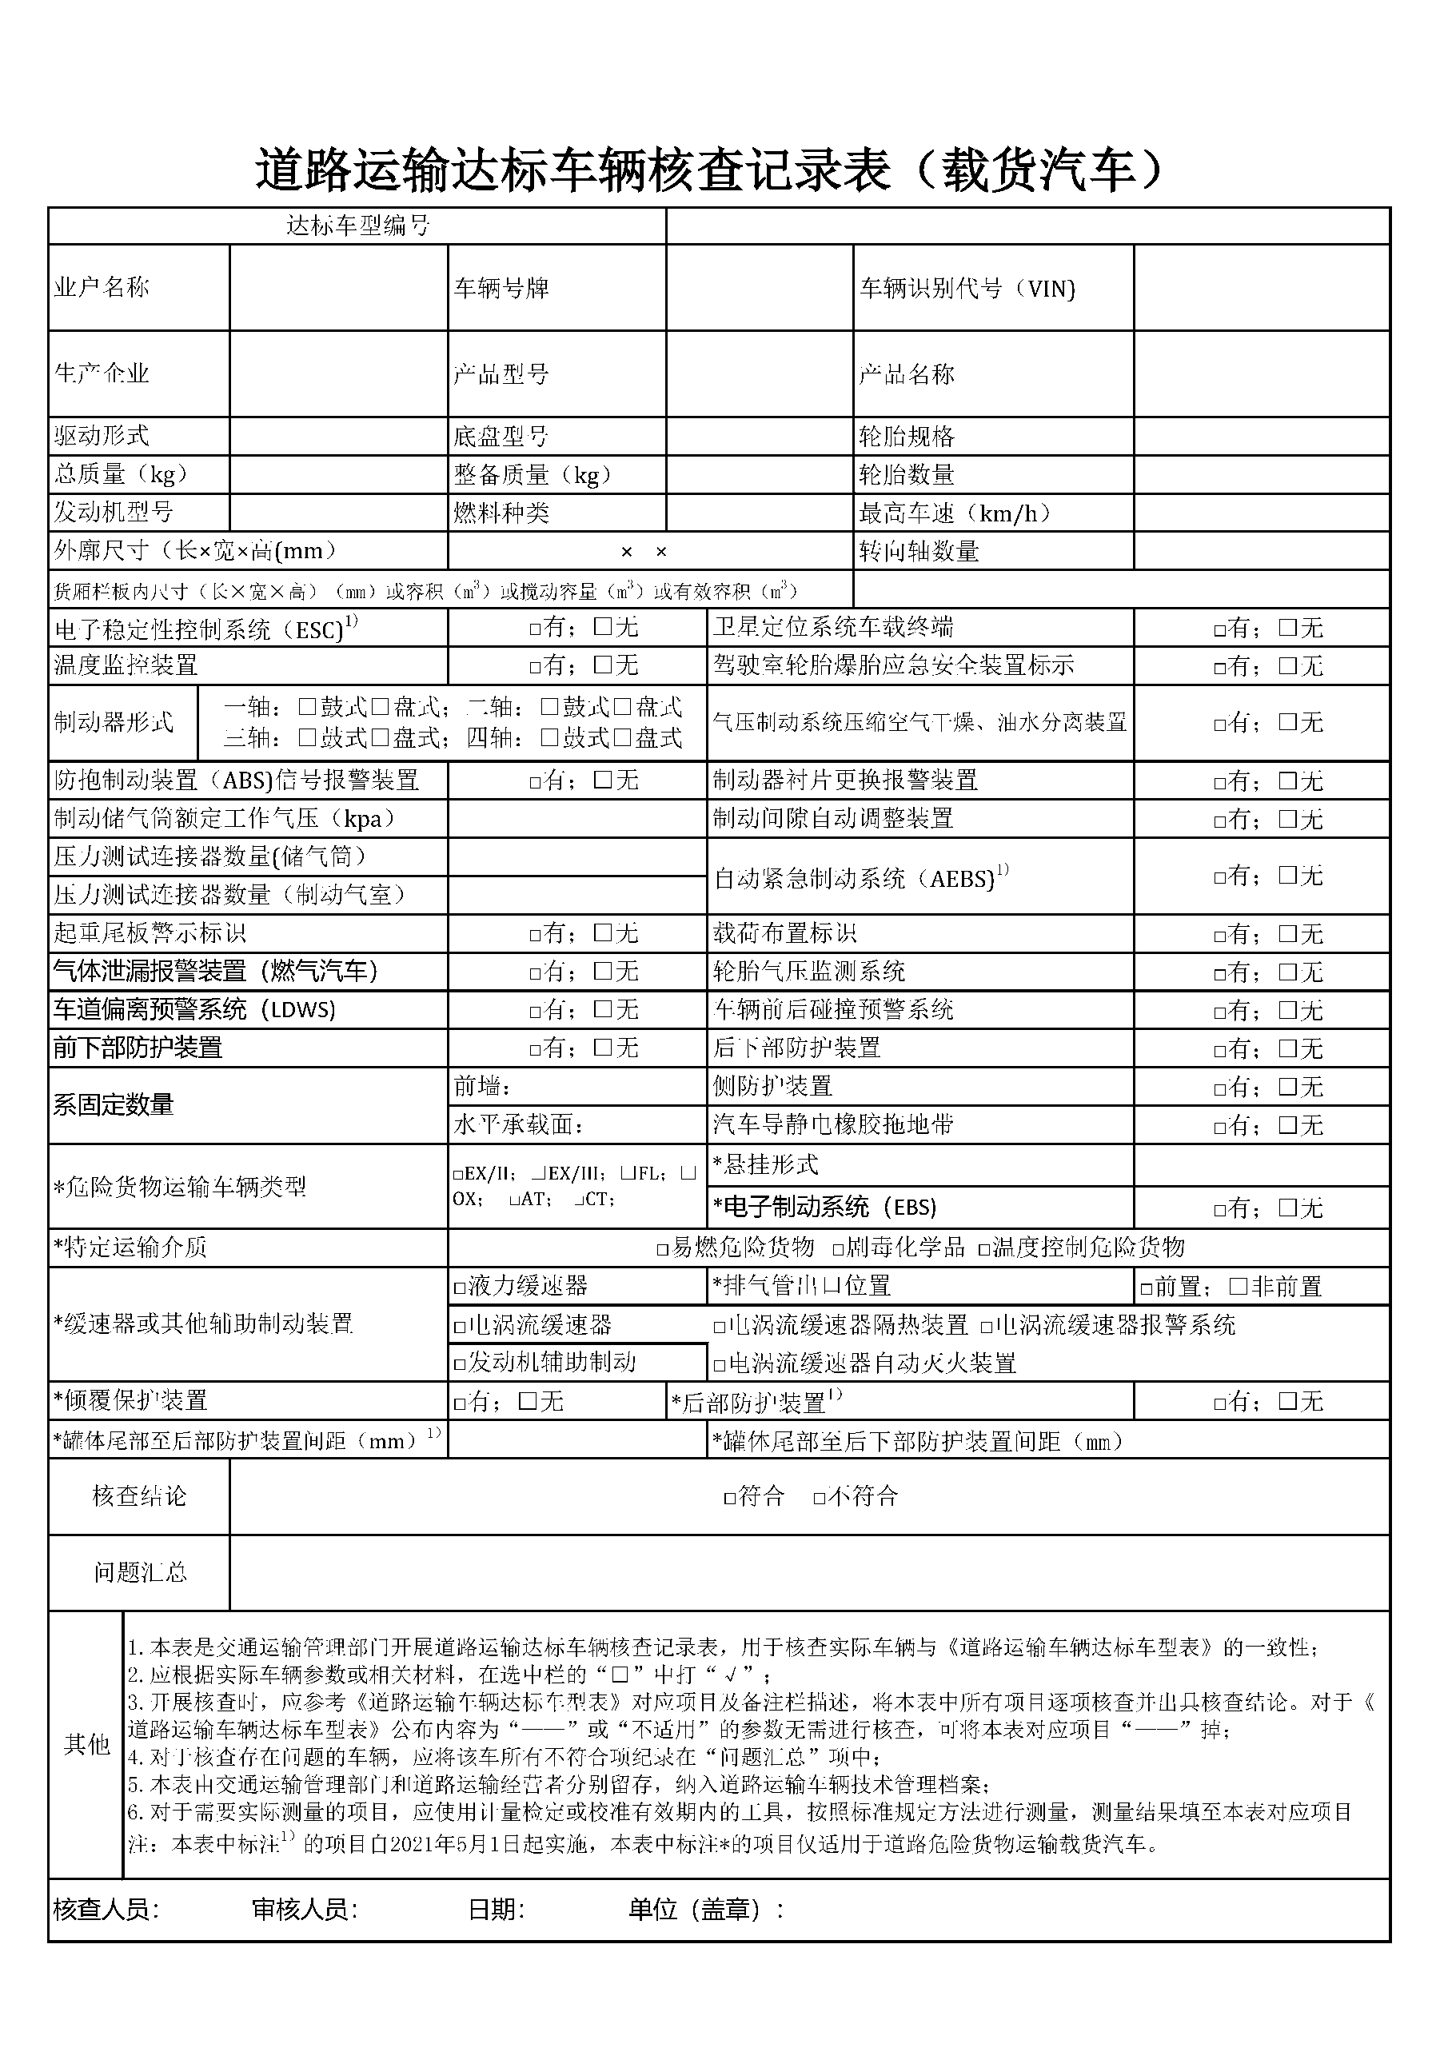

|  |  |  |  |  |  |  |  |  |  |
| --- | --- | --- | --- | --- | --- | --- | --- | --- | --- |
|  |  |  |  |  |  |  |  |  |  |
|  | 李璐君 |  |  |  | 晋DLQ718 |  |  | ggd1343423435 |  |
|  |  |  |  |  |  |  |  |  |  |
|  | 奔驰生产 |  |  |  | 大型车 |  |  | 大型车 |  |
|  |  |  |  |  |  |  |  |  |  |
|  | 大型车 |  |  |  | 大型车 |  |  | 大型车 |  |
|  | 大型车 |  |  |  | 大型车 |  |  | 大型车 |  |
|  | 大型车 |  |  |  | 大型车 |  |  | 大型车 |  |
|  |  | 大型车 | | | |  |  | 大型车 |  |
|  |  |  | | | | 大型车 | | |  |
|  |  |  | | | |  |  |  |  |