[WORKING COPY — auto-generated from the 27-01-2026 master. Newly INSERTED content (new §2.4, Table X, Fig. 6 caption, references 24–26, AI-disclosure) is highlighted. INLINE replacements (abstract/intro/§2.3 software wording, PDA/PH framing, §4.5 future work) are not highlighted; see CHANGELOG_working_docx.md. Re-key Eq. 13–15 as native Word equations.]
An integrated model for simulation of neonatal physiology

THE Cardiovascular system

Antonius TAJ, van Meurs WL, Westerhof BE, de Boode WP

TA, Dec 11, 2025

Target journal: Pediatric Research.

ABSTRACT

The physiology of critically ill neonates is complex and frequently only partially understood. Diagnostic reasoning, clinical decision making, and communication between members of the healthcare team often take place under time pressure. Explanatory models: interactive, animated visualizations of models of human physiology hold promise to assist clinicians in these challenging cognitive tasks. Here we describe the conceptual and mathematical underpinnings of an integrated model, focusing on the cardiovascular system for neonatal physiology. The core of the proposed model, called “EXPLAIN” is a pulsatile, lumped-parameter representation of the neonatal heart and vascular system that accommodates multiple neonatal-specific features (e.g. foramen ovale and ductus arteriosus). To instantiate the model for an individual patient, EXPLAIN is parameterized by an AI-assisted, closed-loop pipeline in which a large language model interprets the available clinical targets and a deterministic calibrator fits the mechanistic model to within clinician-meaningful tolerances; this pipeline was used to generate the patient-specific configurations validated here. We demonstrate the model’s ability to replicate both normal neonatal hemodynamics and pathological conditions such as a patent ductus arteriosus and acute pulmonary hypertension using published literature as target data. Simulation results show close agreement with measured values for hemodynamic quantities as cardiac output, blood pressures and ductal Doppler flow patterns under various shunt magnitudes. An EXPLAIN user environment, running the model in real time, is freely available online (https://explain-user.com) and annotated source code is available for researchers, ensuring transparency and extensibility.

- Introduction
Critically ill neonates exhibit complex and dynamically shifting physiology. Diagnostic reasoning and communication among healthcare professionals occur under time pressure, often with only partial information about the cardiorespiratory status. Explanatory models: visual, animated, interactive representations of underlying physiology, combined with interventions and clinical monitors can help bridge these gaps [1]. A new explanatory model for NICU clinicians and researchers (EXPLAIN) should allow for investigation of the norm scenarios:
- Apnea of prematurity
- Cardiogenic shock
- Congenital diaphragmatic hernia
- Infant respiratory distress syndrome
- Meconium aspiration syndrome
- Patent ductus arteriosus (PDA)*
- Acute pulmonary hypertension (aPH)*
- Septic shock
- Severe bradycardia and cardiac arrest
- Tension pneumothorax
- Hypoplastic left heart syndrome with and without closing or restricting shunts
“Investigation” includes exploring physiological mechanisms and pathologies, assessing the impact of therapeutic interventions, and facilitating case discussion and hypothesis testing. EXPLAIN requires an integrated mathematical model of neonatal cardiorespiratory physiology. Existing models do not meet these ambitious objectives [2-9]. A new integrated cardiorespiratory model is based on the principles outlined by van Meurs [10]. In this paper the controlled cardiovascular model for the term neonate is introduced. It is validated at baseline, and for the PDA and aPH conditions. A second contribution is a method for patient-specific parameterization of the model: an AI-assisted, closed-loop calibration pipeline that maps a small set of measured clinical targets onto the model’s parameters, and which we use to construct the validation cases presented below. The neonatal respiratory model, encompassing breathing, ventilation, gas exchange, gas transport, and metabolism, will be described in a separate paper. The acid–base model is was presented separately [11]. The model is for a full-term neonate but can be scaled to reflect premature born neonates. Degrees of prematurity do not require a change in model structure, but can be simulated by modifying selected model parameters and state variables. Visual interactive EXPLAIN can be run in real time from the web page https://explain-user.com. The complete source code is available upon request.

- Methods

2.1 Conceptual model

Figure 1 shows the main models and causal relationships underlying EXPLAIN. Overall inputs and outputs of the integrated model, such as the fraction of inspired oxygen and ECG, are not represented in this figure.

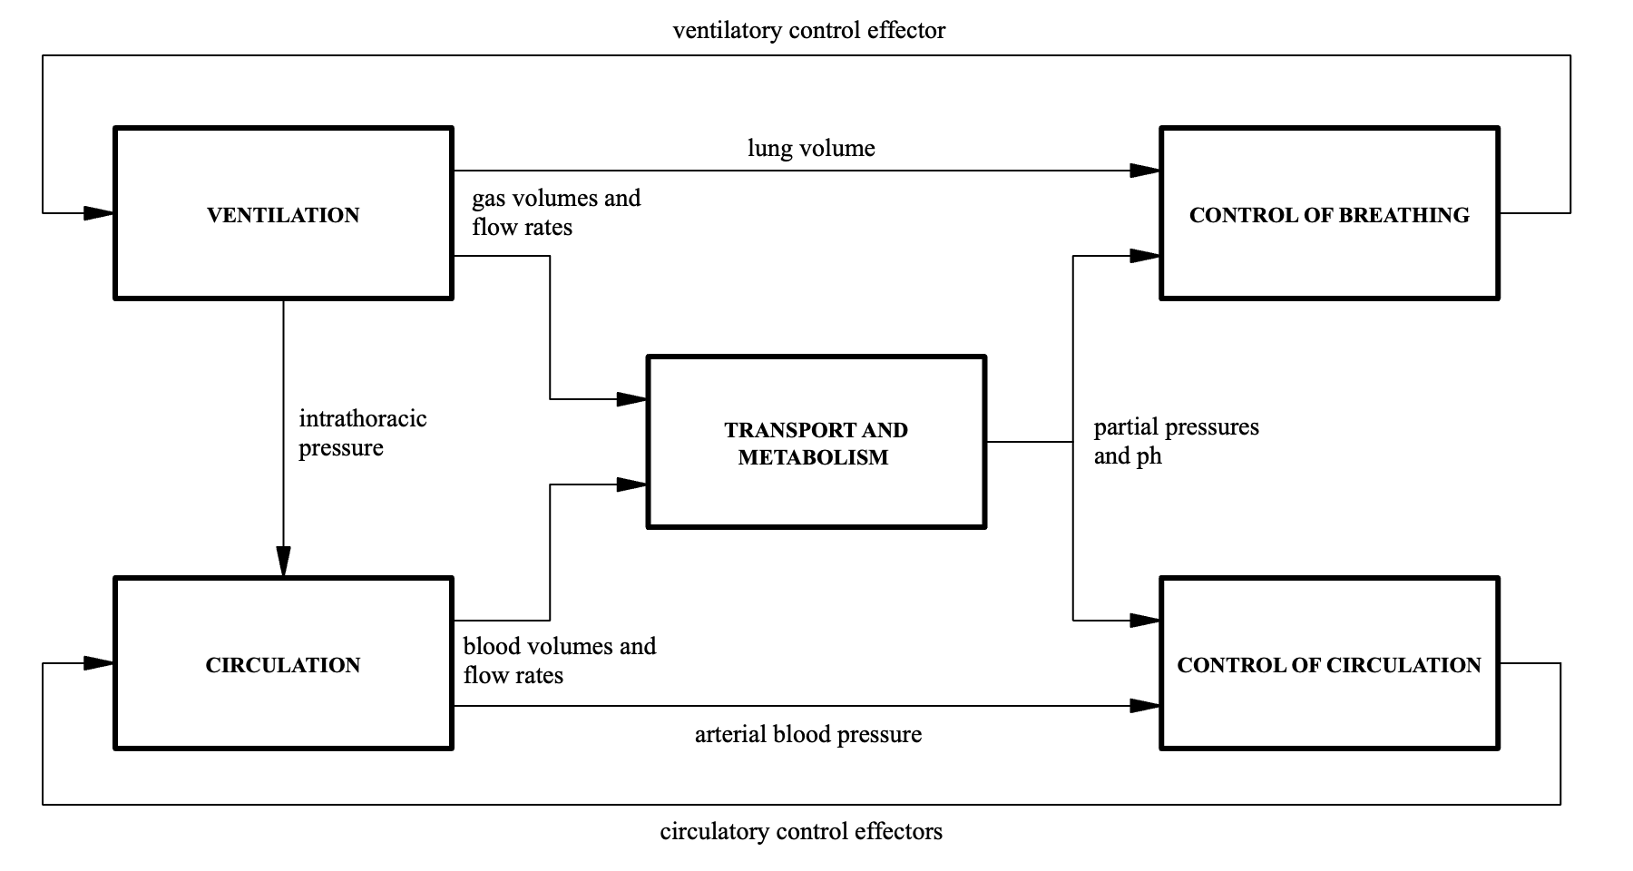
Fig. 1. Block diagram of the integrated cardiorespiratory model, adapted from van Meurs [10]

The two bottom blocks of this diagram reflect blood flow and control of circulation, and the two top blocks reflect gas flow and control of breathing. Oxygen delivery, cellular metabolism, and carbon dioxide elimination, part of the central block, rely on both gas flow and blood flow. From left to right, the blocks reflect the causally connected processes: fluid mechanics (liquids and gases), carried respiratory gases, and signals generated by the autonomic nervous system (ANS), respectively. Control effectors will be described in detail below. This article describes the model of the neonatal cardiovascular system: the two bottom blocks in Figure 1, a software implementation of this model, and selected cardiovascular simulation results and model validation.
A cardiac rhythm sub model is part of the circulation model. It responds to the circulatory control effector heart rate from the control of circulation model and generates heart chamber activation functions. These are sent to the hemodynamics model described below. The underlying time-varying elastance model and the four heart chamber activation functions will be explained in the mathematical model section. The function of the SA and AV nodes is implicit in the modeled time functions. The variable heart rate determines the firing rate of the SA node. Dysrhythmias can be simulated by ad-hoc changes to the parameters of the cardiac rhythm model.
The other sub model of the circulation model is the hemodynamics model, which reflects cardiac and vascular blood volumes, pressures, and flow rates. It responds to activation functions from the cardiac rhythm model, intrathoracic pressure generated by the ventilation model, and circulatory control effectors, including contractility, arteriolar resistance and elastance, and venous unstressed volume. Arterial blood pressure is an output variable from the hemodynamics model to the control of circulation model, and various circulatory volumes and flow rates are outputs to the transport and metabolism model. Figure 2 gives a hydraulic circuit representation of the neonatal hemodynamics model. The basis for this model is the one given by Beneken [12], also see Goodwin et al. [13], expanded by the specific tissue groups and neonatal shunts that are needed to simulate the neonatal conditions mentioned in the introduction.

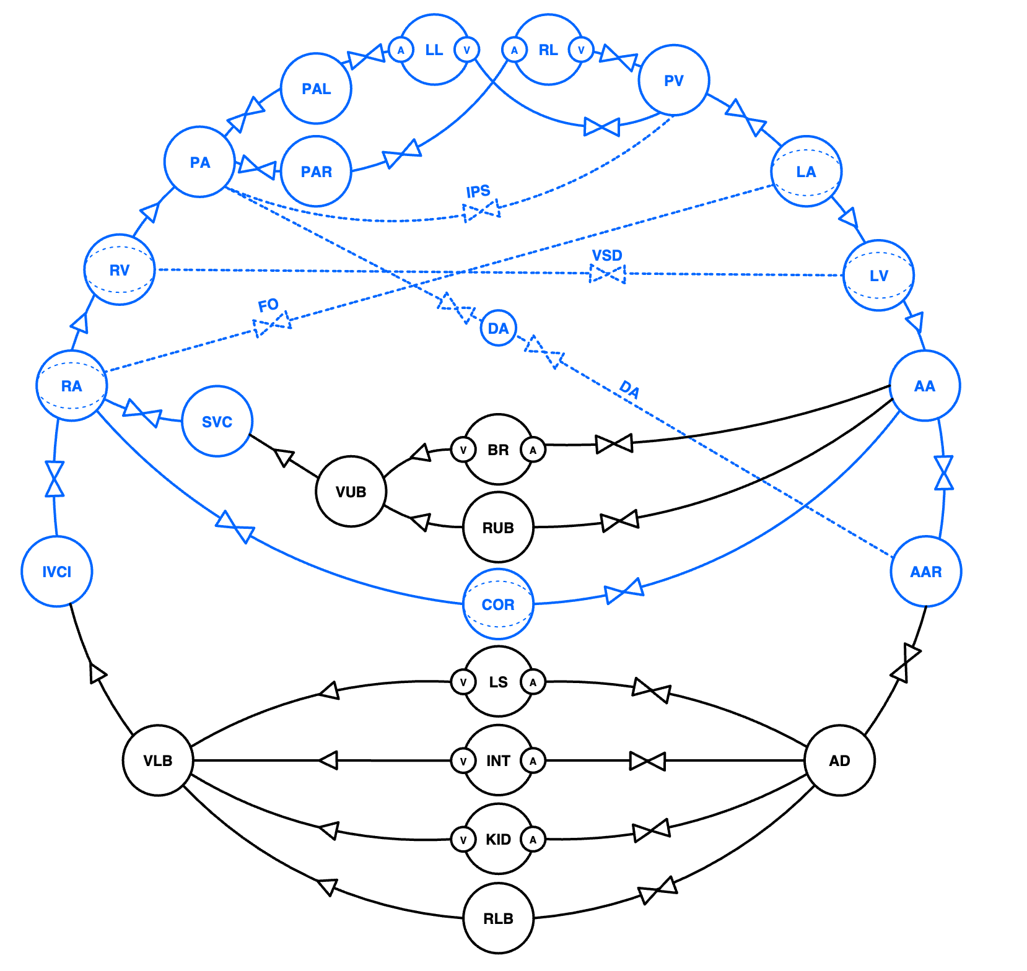
Fig 2. Hydraulic circuit representation of neonatal hemodynamics. See Table 1 for used symbols and their mathematical description. Intra-thoracic components are indicated in blue and extra-thoracic components in black. Components located inside the pericardium have a light grey background. Dashed lines represent shunts that are exclusive to the neonate, or more significant than in a typical adult. Time-varying elastances: LA: left atrium, LV: left ventricle, RA: right atrium, RV: right ventricle, COR: coronaries. Capacitances: AA: ascending aorta, AAR: aortic arch and intrathoracic descending aorta, AD: extrathoracic descending aorta, BR: brain, RUB: remainder of the upper body, VUB: veins of the upper body, SVC: superior vena cava, LS: liver and spleen, INT: intestines, KID: kidneys, RLB: remainder of the lower body, VLB: veins of the lower body, IVCI: intrathoracic inferior vena cava, PA: pulmonary artery, LL: left lung, RL: right lung, PV: pulmonary veins. All organ capacitances have an associated arteriole (A) and venule (V) connected with a resistor (not represented) to the capacitance. Shunts: DA: ductus arteriosus, FO: foramen ovale, IPS: intrapulmonary shunt, VSD: ventricular septal defect

The heart chamber activation functions, which are normalized to an amplitude of 1 (dimensionless), are multiplied by contractility from the control of circulation model and then drive the heart chambers. In the hemodynamics model, capacitances, indicated by circles, contain time varying blood volumes. The transport and metabolism model described in the a separate paper has compartments with time varying blood gas contents. The cardiac chambers: left atrium (LA), left ventricle (LV), right atrium (RA) and right ventricle (RV) were already part of the Beneken model [12], as were the pulmonary artery (PA) and pulmonary veins (PV). The intrathoracic systemic arterial compartment of the Beneken model is divided into ascending aorta (AA) and aortic arch and intrathoracic descending aorta (AAR), so that blood with shunt dependent different oxygen contents can flow to the coronaries, and to the brain and lower body. This is required to enable the representation of many neonatal conditions where the shunt across the ductus arteriosus is important. A separate coronary (COR) circulation is included to realistically simulate oxygen delivery to the myocardium. The ventricular activation function is also applied to the elastance of the coronary capacitance, which reproduces the characteristic coronary flow pattern dominated by diastolic blood flow. The central chemoreceptors require the simulation of a separate brain (BR) capacitance. Cerebral autoregulation is currently not included in the model, but to enable that in the future, a separate remainder of the upper body (RUB), which is not subject to autoregulation, is already included. The veins of the upper body (VUB) and superior vena cava (SVC) act as the downstream compartment to the upper body circulation, where the SVC is located inside the thoracic compartment. The intestines (INT) play an important role in redistribution of blood flow. Albeit not strictly required for the cardiorespiratory model, liver and spleen (LS) and kidneys (KID) compartments are necessary for differential metabolism in pharmacokinetic models. Other organs in the lower body are lumped together in the remainder of lower body (RLB) compartment. All organs consist of three capacitances connected by resistors representing the arteriole (A), capillary bed and venule (V) of that organ system. This configuration allows for an improved representation of the hemodynamic response to autonomic control. Separate left and right lung circulations and compartments are required for the simulation of unilateral phenomena in tension pneumothorax and congenital diaphragmatic hernia (CDH). The intrapulmonary shunt (IPS) is included to allow for simulation of heterogenous pulmonary perfusion states and atelectasis. The foramen ovale (FO) and ductus arteriosus (DA) are necessary for the representation of, for example, persistence of a patent ductus arteriosus, hypoplastic left heart syndrome, and congenital diaphragmatic hernia. The distinction between intra and extra-thoracic venous compartments IVCI and VLB, allows for simulation of the effects of intrathoracic pressure on the circulation. Intrathoracic pressure is modulated by spontaneous breathing, mechanical ventilation, and chest compressions. The pericardium, not shown in Figure 2, is modelled as an elastic structure with a low compliance above its unstressed volume, limiting the sum of heart chamber volumes.
The control of circulation by the autonomic nervous system (ANS) is based on the model described by van Meurs [10]. In this model, the main regulated cardiovascular variable, arterial pressure, is represented by an afferent activation function (Fig. 4). This function has a defined setpoint around which it operates and minimum and maximum activation levels. This model is expanded as follows: the afferent signal is used to determine the sympatho-vagal balance (SVB). Mean arterial pressure below the set point produces a positive SVB, corresponding to sympathetic dominance and cardiovascular stimulation. Pressure above the set point results in a negative SVB, indicating parasympathetic (vagal) dominance and cardiovascular depression. The magnitude of this response is defined by a baroreflex gain that determines the sensitivity of SVB to changes in arterial pressure. The resulting SVB controls the efferent cardiovascular effectors, including heart rate, myocardial contractility, systemic vascular resistance, and venous tone. Each effector responds to SVB according to its specific gain and is constrained to physiological limits. The model represents a closed loop baroreflex system in which arterial blood pressure is sensed, transformed into a unified autonomic control signal (SVB), and used to adjust cardiovascular function to restore and maintain pressure homeostasis. A further expansion of the van Meurs model is the inclusion of a time constant that determines how quickly it responds to changes in the controlled variable. The SVB based model can easily be expanded to include additional cardiorespiratory receptors.

2.2 Mathematical model

Cardiac cycle time is denoted by n = 1, 2, 3, ... (dimensionless). Continuous time is denoted by t (sec). The heart model is based on the time-varying elastance model first described by Beneken [12], and validated in dogs by Suga et al. [14]. Figure 3 shows the elastances for the neonatal left heart.

Fig. 3. Time-varying elastances for the left heart.

Contractions are simulated via rising heart chamber elastances, resulting in physiologic pressure and flow patterns in the hemodynamics model. The atria are activated by a half sinusoid over the duration of the atrium systole in seconds ($T_{as})$. This duration is defined by the PQ time in seconds.
$$a_{a}\left(t\right)=sin\left[π\left(\frac{t}{T_{as}}\right)\right]$$ | Eq. 1

The ventricles and coronary capacitances are activated by a delayed and slightly skewed half sinusoid over the duration of ventricular systole. The elastance waveforms displayed in Figure 3 have chamber specific baselines and amplitudes.
$$a_{v}\left(t\right)=\frac{t-\left(T_{as}+T_{av}\right)}{K_{n}t_{vs}(n)}sin\left[π\left(\frac{t-\left(T_{as}+T_{av}\right)}{t_{vs}(n)}\right)\right]$$ | Eq. 2

K_{n} is a normalization constant resulting in a maximum of 1 of the time function. The duration of the ventricular systole ($t_{vs}(n))$ is calculated by Bazett's formula using the QT interval [15].
$$t_{vs}\left(n\right)=QT\sqrt{\frac{60}{hr(n)}}$$ | Eq. 3

Name | Symbol | Relationship | Mathematical description
Resistor  Eq. 4 | 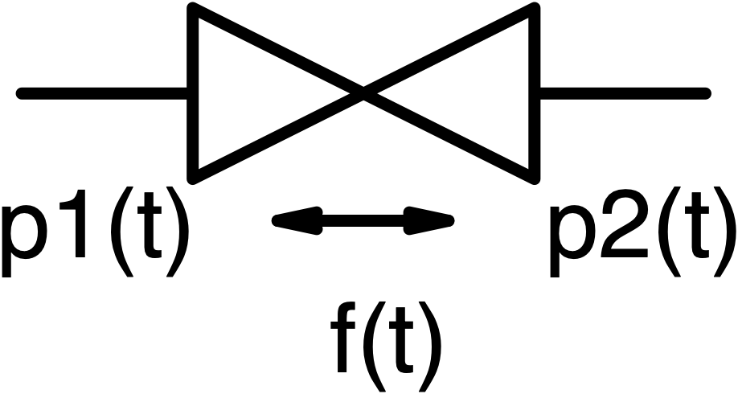 | 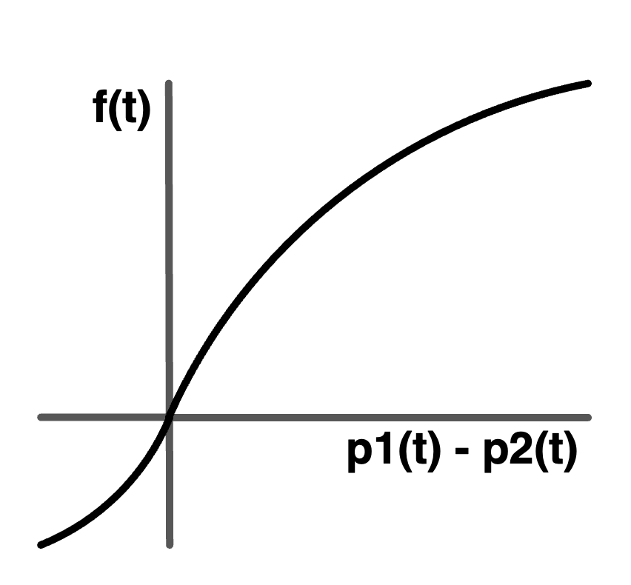 | $$\left\{\begin{aligned}p1\left(t\right)-p2\left(t\right)≥0 \\ K_{1}{f\left(t\right)}^{2}+R_{f}f\left(t\right)=p_{1}\left(t\right)-p_{2}\left(t\right) \\ \\ p1\left(t\right)-p2\left(t\right)<0 \\ {-K}_{1}{f\left(t\right)}^{2}+R_{r}f\left(t\right)=p_{1}\left(t\right)-p_{2}\left(t\right)\end{aligned}\right.$$
Valve  Eq. 5 | 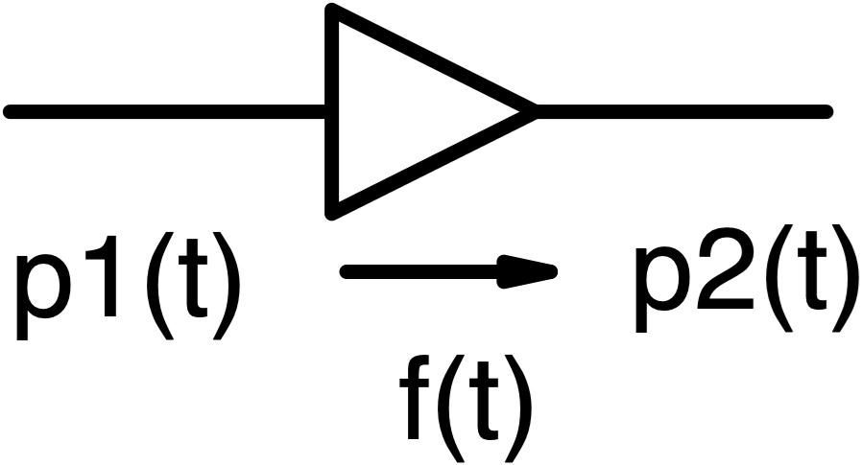 | 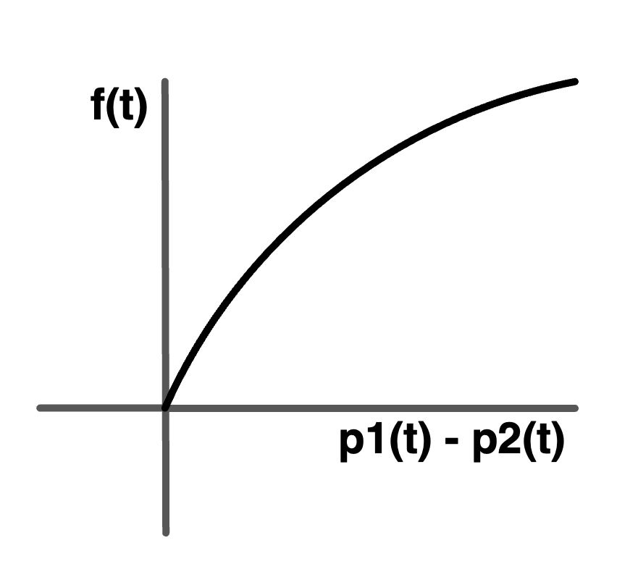 | $$\left\{\begin{aligned}p1\left(t\right)-p2\left(t\right)≥0 \\ K_{1}{f\left(t\right)}^{2}+R_{f}f\left(t\right)=p_{1}\left(t\right)-p_{2}\left(t\right) \\ \\ p1\left(t\right)-p2\left(t\right)<0 \\ f\left(t\right)=0, (R_{b}=∞)\end{aligned}\right.$$
Capacitance  Eq. 6 | 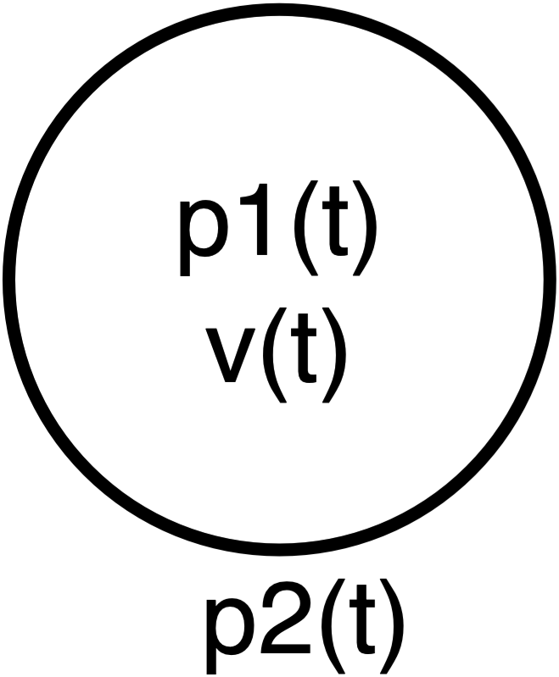 | 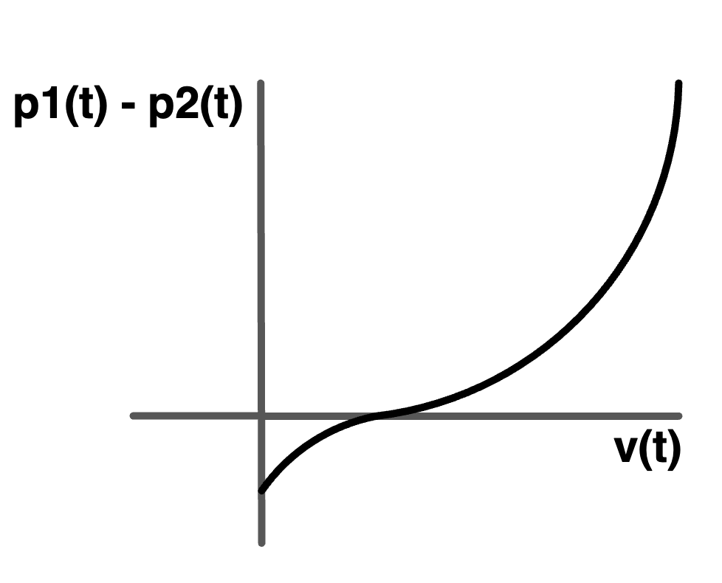 | $$\left\{\begin{aligned}v\left(t\right)≥UV \\ p_{1}\left(t\right)=K_{2}{\left[v\left(t\right)-UV\right]}^{2}+E\left[v\left(t\right)-UV\right]+p2(t) \\ \\ v\left(t\right)<UV<0 \\ p_{1}\left(t\right)={-K}_{2}{\left[v\left(t\right)-UV\right]}^{2}+E\left[v\left(t\right)-UV\right]+p2(t)\end{aligned}\right.$$
Container  Eq. 7 | 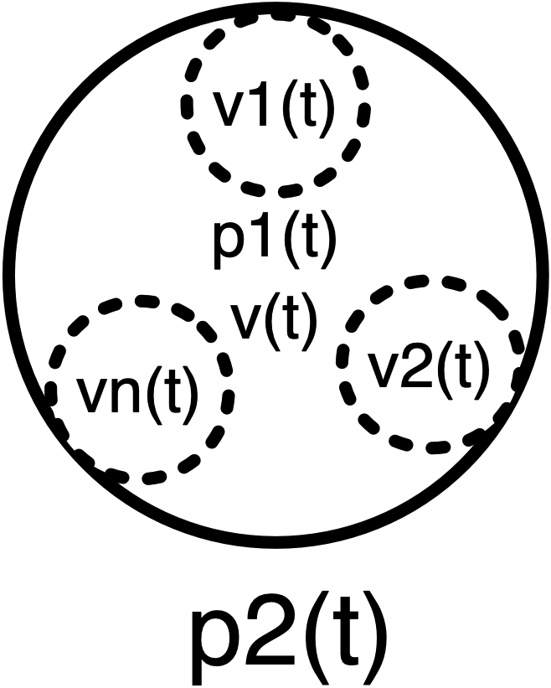 |  | $$\left\{\begin{aligned}v\left(t\right)=\sum{v_{n}(t)} \\ v\left(t\right)≥UV \\ p_{1}\left(t\right)=K_{2}{[v\left(t\right)-UV]}^{2}+E\left[v\left(t\right)-UV\right]+p2(t) \\ \\ v\left(t\right)<UV<0 \\ p_{1}\left(t\right)={-K}_{2}{[v\left(t\right)-UV]}^{2}+E\left[v\left(t\right)-UV\right]+p2(t)\end{aligned}\right.$$
Time-varying elastance  Eq. 8 | 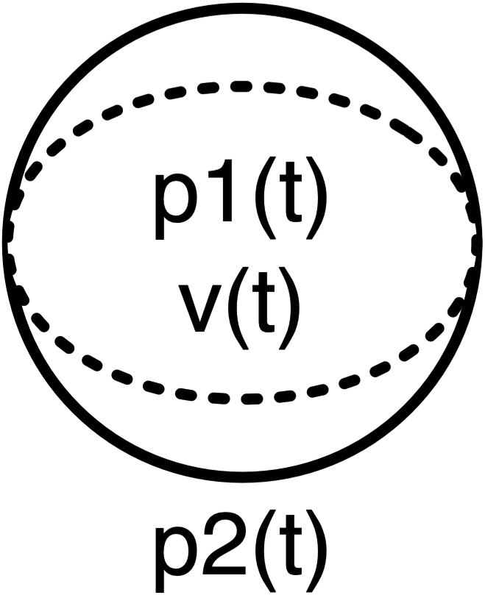 | 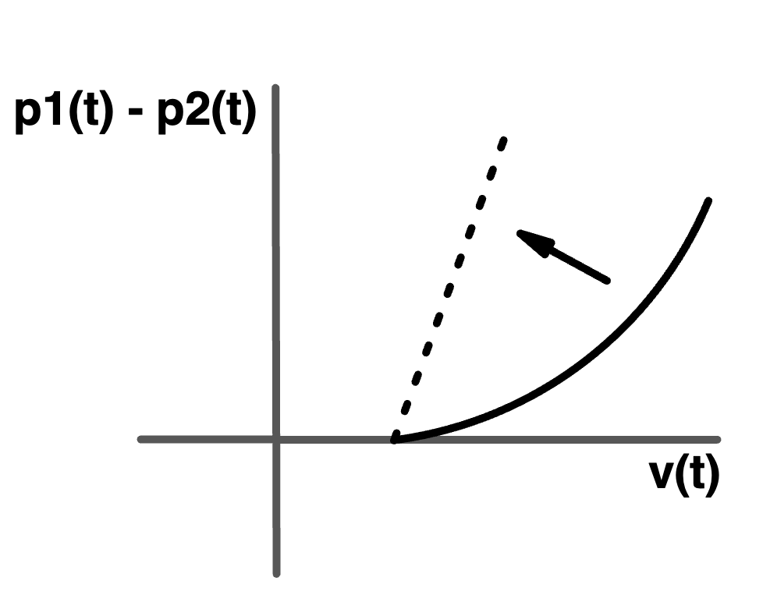 | $$\left\{\begin{aligned}v\left(t\right)≥UV \\ p_{ed}\left(t\right)=K_{2}{[v\left(t\right)-UV]}^{2}+E_{min}\left[v\left(t\right)-UV\right] \\ p_{ms}\left(t\right)=e_{max}\left(n\right)\left[v\left(t\right)-UV\right] \\ p_{1}\left(t\right)=\left[p_{ms}\left(t\right)-p_{ed}\left(t\right)\right]a\left(t\right)+p_{ed}\left(t\right)+p2\left(t\right) \\ \\ v\left(t\right)<UV \\ p1\left(t\right)=p2(t)\end{aligned}\right.$$
Table 1. Fluid circuit elements. Volume v(t), pressure p(t), and flow rate f(t). Symbols for parameters are presented in the main text. Units: volumes(v, UV) in liters, elastances(e, E) in mmHg*L⁻¹, pressures (p) in mmHg, flows (f) in l/s, resistances (r) in mmHg*s*L⁻¹ .K₁ in mmHg*L²*s⁻². K₂ in mmHg*L⁻².

Resistance can be different for forward: R_{f} and reverse: R_{r} flow. The constant K₁ (see Table 1) governs non-linear behavior. For K₁ > 0 the flow rate for higher pressure differences is reduced as compared to the linear case. K₁ is assumed to be identical for forward and reverse flow rates. Capacitance characteristics are represented by a piece-wise continuous relationship between volume v(t) and transmural pressure p₁(t) - p₂(t). This relationship is governed by the parameters elastance E (inverse compliance), unstressed volume UV, and the parameter K₂, governing non-linear behavior. A correctly functioning valve is a resistor with infinite reverse flow resistance. Strictly speaking, for mathematical reasons, this element could be replaced by a resistance, but it was chosen not to do so to enable future work on heart valve pathologies. Time-varying elastances during diastole resemble a capacitance with a minimum elastance E = E_{min}. For the atria and coronary circulation K₂ = 0, assuming linear behavior over the range of volumes of interest. For the ventricles K₂ is non-zero, so that the diastolic ventricular elastances saturate for higher volumes. For maximum contraction, a linear characteristic is applied. The maximum elastance emax(n) of the left ventricle is an input variable to the hemodynamics model from the control of circulation model. It affects all four heart chambers, as well as the coronary circulation, with a fixed proportionality factor per chamber. The transition between end diastole (ed) and maximum systole (ms) of the ventricles is governed by Equation 8 which takes the ventricular activation function (a(t)) as an input [16]. Using the equations in Table 1, pressures in all capacitances of Figure 2 are computed based on the volumes at time t and relevant parameters.
The control of circulation is expressed as a set of coupled mathematical functions describing the afferent activation, sympatho-vagal balance (SVB), and efferent control effects.

Afferent receptor activation function
Receptor activation is modeled as an activation function centered around its setpoint of the controlled variable $cv$ where ${af}_{cv}=0$ at $cv=CV_{sp}$.

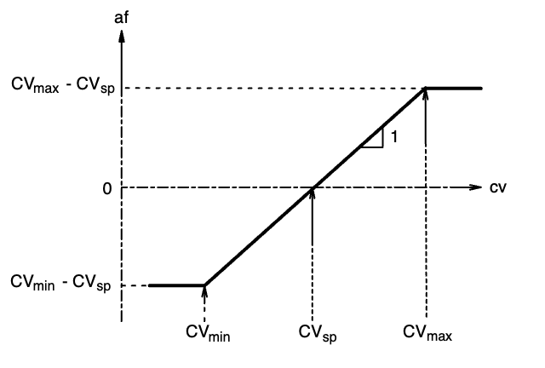
Fig. 4. Activation function adapted from van Meurs [10].

$$\left\{\begin{aligned}af={CV}_{max}-{CV}_{sp} cv≥{CV}_{max} \\ af=cv-CV_{sp} { CV}_{min}<cv<{CV}_{max} \\ af={CV}_{min}-{CV}_{sp} cv≤{CV}_{min}\end{aligned}\right.$$ | Eq. 9
where:
- $af$ = receptor activation
- $CV_{sp}$ = setpoint of the controlled variable
- $CV_{max}$ = maximum value of the controlled variable
- $CV_{min}$ = minimum value of the controlled variable
To represent the finite adaptation time of the receptor, the activation is low-pass filtered using a discrete-time first-order filter with receptor time constant $τ_{Cv}$ resulting in a filtered activation $a$.

The sympatho-vagal-balance is:
$$svb(t)=G_{{svb}/{map}}*a$$ | Eq. 10
where $G_{svb/map}$ defines the contribution of mean arterial pressure to the autonomic output.

Efferent control of cardiovascular effectors
Each effector is modulated as a relative change from its baseline reference value, scaled by its sensitivity to SVB:

$$ef\left(svb\right)=\left(1+G\frac{ef}{svb}*svb(t)\right)*ef_{ref}$$ | Eq. 11

where $G_{ef/svb}$is the gain relating SVB to the specific effector, and $ef_{ref}$ is its reference value.

2.3 Software implementation and code verification

The main target audience of EXPLAIN consists of clinical researchers in neonatal intensive care. The user can explore effects of therapeutic interventions and different clinical conditions including the validation experiments of this paper. The free software is accessible using standard browsers via https://explain-user.com. An important additional objective of the present work is to enable model developers to understand, use, and modify the model and corresponding code. The EXPLAIN source code is available upon request. The source code is extensively annotated. Developers with undergraduate level software engineering experience, should, after a few days of familiarization with the environment, be able to:

- run the described integrated model, and plot graphs of variables of interest, for example, right ventricular pressures and volumes,
- modify patient profiles via initial state variables and parameters, for example, create a hypotensive patient,
- modify model structure, for example, remove separate tissue capacitances and compartments to create a simpler model or to create an anatomical variant of the normal circulation.

With a little more time, developers should be able to:

- modify properties of model components, for example, create a regurgitating cardiac valve,
- add models, for example, liver metabolism,
- optimize numerical integration methods and simulation run-time,
- use the models in other applications, for example, in clinical decision support.

EXPLAIN is implemented as a framework-agnostic simulation engine written in JavaScript/TypeScript. The engine runs inside a Web Worker — a background execution thread separate from the user interface — and communicates with the application through a simple message-passing protocol, so that the physics loop advances independently of rendering and user interaction and the model can run in real time in a standard web browser. Each physiological component is a small, self-contained module that implements the equations of Section 2.2; complete scenarios (baseline anatomy, parameters and initial state) are defined declaratively as JSON model definitions, which makes patient profiles and structural variants straightforward to inspect, share and modify. The interactive application, built on the Vue framework, presents the animated model, parameter editors and clinical monitors, and is freely available at https://explain-user.com. The engine source code is extensively annotated and available upon request.

2.4 AI-assisted patient-specific parameterization
A recurring difficulty with lumped-parameter cardiovascular models is that they expose many free parameters (elastances, resistances, unstressed volumes, shunt geometry) while the clinic provides only a handful of directly measured targets — typically heart rate (HR), mean arterial pressure (MAP), central venous pressure (CVP), mean pulmonary artery pressure (PAP), cardiac output (CO), arterial oxygen saturation (SpO₂) and an arterial blood gas. To instantiate EXPLAIN for an individual patient we combine a large language model (LLM), which interprets the clinical inputs, with a deterministic closed-loop calibrator, which fits the mechanistic model to the resulting targets. The two roles are strictly separated: the LLM never edits equations or state directly, and the calibrator performs no interpretation.
Interpretation layer. An LLM agent (Claude, Anthropic; driven through the Claude Agent SDK) reads the case description — free text, monitor values, or an attached report (PDF/CSV) — and emits a structured build specification: a baseline scenario plus a set of target values and named pathophysiological modifiers. All model-facing actions are expressed as validated commands drawn from a fixed allowlist, checked against the same parameter schema, unit conversions and physiological bounds used by the interactive editor. An automatically generated command therefore behaves exactly like a vetted manual edit, and the agent cannot reach a parameter the interface itself would refuse.
Calibration layer. Given the targets, the calibrator assigns one physiologically interpretable lever to each measured quantity (Table X) and drives that quantity to its target with a per-target one-dimensional root-finder. The lever value l is updated from the measured value x toward the target x*. Before two samples exist the update is a proportional seed (Eq. 13); once two samples are available the calibrator switches to the secant method (Eq. 14), in which the local sensitivity of the measurement to the lever is estimated from the two most recent samples. Each lever is bounded to a physiological interval. The levers are run together inside one loop: the model is advanced to steady state (settle), every measured quantity is read as a beat-averaged mean over a short window, each lever is nudged, and the model is advanced again (warm) before re-measuring. Iteration stops when no lever moves — i.e. when every target satisfies the convergence criterion (Eq. 15) — after which a final undisturbed interval bakes the equilibrium state.
[re-key as native equation] Eq. 13 l(k+1) = clamp( l(k) + s·g·(x* − x(k)) , l_lo , l_hi )
[re-key as native equation] Eq. 14 m(k) = (x(k) − x(k−1)) / (l(k) − l(k−1)) , l(k+1) = clamp( l(k) + (x* − x(k)) / m(k) , l_lo , l_hi )
[re-key as native equation] Eq. 15 | x* − x(k) | ≤ τ
Here s = ±1 is the sign of the lever→measurement relationship, g a seed gain, m(k) the locally estimated sensitivity, and τ a clinician-meaningful tolerance band per quantity (MAP ±3 mmHg, CVP ±1.5 mmHg, mean PAP ±3 mmHg, HR ±6 min⁻¹, CO ±0.05 L·min⁻¹, SpO₂ ±2 %, PO₂ ±6 mmHg, PCO₂ ±4 mmHg, pH ±0.03, base excess ±1.5 mmol·L⁻¹).
Levers. For the cardiovascular targets each lever acts on a parameter already defined in Sections 2.1–2.2: MAP is driven by systemic (arteriolar) resistance; CO by ventricular maximum elastance (contractility, E_max); HR by the heart-rate reference of the cardiac-rhythm model; CVP by systemic venous unstressed volume; and mean PAP by pulmonary vascular resistance. Blood-gas targets are handled by the corresponding respiratory and acid–base levers (alveolar O₂ diffusion for PO₂/SpO₂; central ventilatory drive for PCO₂; Stewart unmeasured strong-ion difference for base excess and pH) and are described with those models in the companion papers.
Table X. Calibration levers. Each measured cardiovascular target is driven to its value by a single physiologically interpretable lever (parameters defined in Sections 2.1–2.2). Sign indicates the direction of the lever→target relationship.
Target | Lever | Sign
Mean arterial pressure (MAP) | systemic (arteriolar) resistance | +
Cardiac output (CO) | ventricular contractility, E_max | +
Heart rate (HR) | heart-rate reference (SA-node rate) | +
Central venous pressure (CVP) | systemic venous unstressed volume | −
Mean pulmonary artery pressure (PAP) | pulmonary vascular resistance | +
PO₂ / SpO₂ | alveolar O₂ diffusion | +
PCO₂ | central ventilatory drive | −
Base excess / pH | Stewart unmeasured anions | −
Body size and initial guess. Body-size differences are handled first, once, by allometric scaling of blood volumes, elastances and resistances to the target weight. For preterm patients a gestational-age–indexed seed sets the starting lever values (and structural features such as reduced contractility, stiffer diastole, lung immaturity and ductal patency) so that calibration begins close to convergence. Crucially, the baroreflex arterial-pressure set-point is aligned to the requested MAP, so that the autonomic control loop of Sections 2.1–2.2 defends — rather than opposes — the calibrated operating point.
Two entry points. The same calibrator serves (i) offline patient construction, which builds and bakes a new, fully calibrated scenario that the application loads immediately, and (ii) live in-place tuning, which drives an already-running simulation to new targets without a reload. The live path deliberately uses composable, persistent multiplier levers so that a tuning step stacks on top of any body-size or pathophysiological scaling already baked into the loaded patient rather than overwriting it. Because the levers interact through the shared circulation (for example blood volume, venous tone and MAP, or contractility and CO), convergence of the joint problem is not guaranteed for arbitrary target combinations; in practice the physiological seeds and set-point alignment of the construction path keep the joint problem well conditioned.
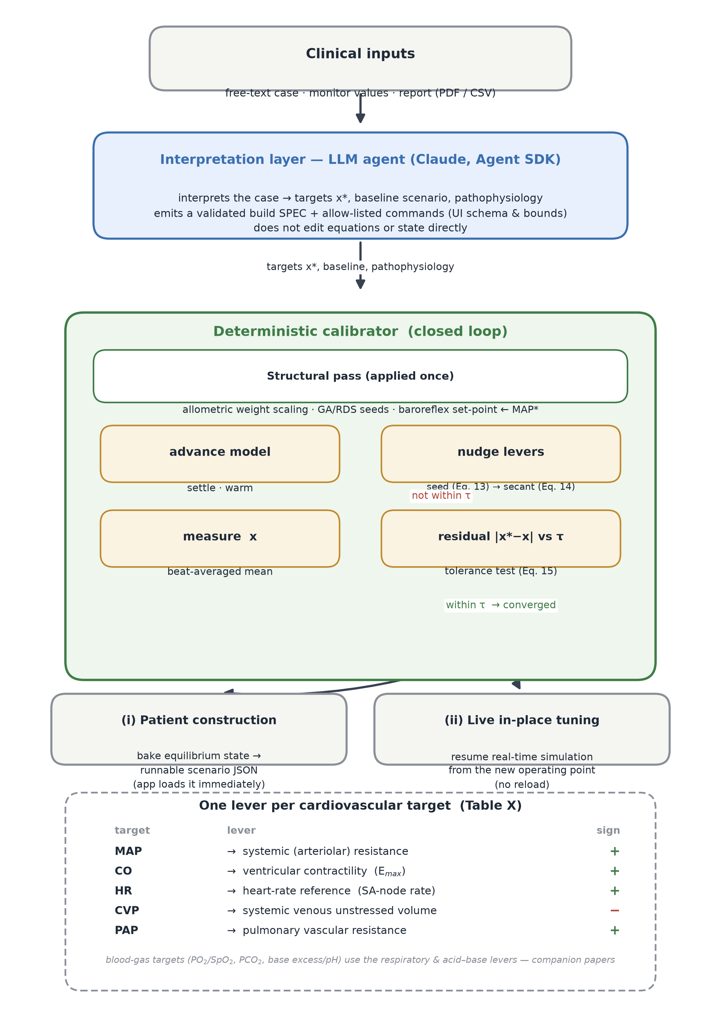
Fig. 6. AI-assisted patient-specific parameterization. An LLM agent interprets the available clinical targets and emits a validated specification and allowlisted commands; a deterministic calibrator then fits the mechanistic model (structural scaling and baroreflex set-point alignment, then one lever per target nudged by a proportional seed and the secant method) until every residual falls within its clinician-meaningful tolerance. The same loop supports offline construction of a new calibrated patient and live retuning of a running simulation.
Use of AI in this study. A large language model (Claude, Anthropic) was used as an integral component of the parameter-estimation method described in this section: it interpreted the clinical target data and generated the validated build specifications that drive the deterministic calibrator. The language model did not generate, analyse, or interpret the scientific content, results, or text of this manuscript, and it is not accorded authorship; all model outputs were reviewed and verified by the authors.
- RESULTS

3.1 Simulation experiments and model validation

3.1.1 Baseline hemodynamics

To validate the hemodynamic baseline state of the model we used published hemodynamic data of Jhaveri [17], Groves [18], Kluckow [19], and Zadelhoff [20]. These papers provide relevant hemodynamic data of normal full-term neonates and are in acceptable agreement with each other. Table 2 lists the reported hemodynamic data and the simulated results. Reported simulation results are end-expiratory, at an intrathoracic pressure of -3.5 mm Hg.

 | Target data |  |  |  | Simulation results
 | Jhaveri [17] | Groves [18] | Kluckow [19] | Zadelhoff [20] | EXPLAIN
HR | 100.3 +/- 9.8 | 142 +/- 17.1 |  | - | 118
LVEDV | 2.5 +/- 0.3 | 2.51 +/- 0.40 |  | - | 2.6
LVESV | 0.9 +/- 0.2 | 0.78 +/- 0.21 |  | - | 1.0
LVSV | 1.6 +/- 0.1 | 1.73 +/- 0.28 |  | - | 1.6
LVO | 177 +/- 25 | 245 +/- 47.1 |  | - | 181
RVEDV | 3.1 +/- 0.3 | - |  | - | 3.2
RVESV | 1.5 +/- 0.2 | - |  | - | 1.6
RVSV | 1.6 +/- 0.2 | - |  | - | 1.6
RVO | 181 +/- 30 | - |  | - | 181
fSVC |  | 95 +/- 27.0 | 76 (34-143) | - | 76
ABPs |  |  |  | 67 | 70
ABPd |  |  |  | 42 | 45
Table 2. Target data and simulation results for a normal term born neonate of 3.3 kg at an age of 24 hours. HR: heartrate, LVEDV: left ventricular end diastolic volume, LVESV: left ventricular end systolic volume, LVSV: left ventricular stroke volume, LVO: left ventricular output, RVEVD: right ventricular end diastolic volume, RVESV: right ventricular end systolic volume, RVSV: right ventricular stroke volume, fSVC: superior vena cava flow, ABPs: systolic arterial blood pressure, ABPd: diastolic arterial blood pressure. Volumes in mL, flow rates in mL/min/kg and pressures in mmHg.

There is a close match of simulation results to target data coming from different sources which measured the parameters using different techniques (echocardiography and MRI). Normal values of the resulting blood pressure are reported by many articles, and we used a recent study to validate our data as they report blood pressure over a range of gestational and postnatal ages.

3.1.2 Persistent ductus arteriosus (PDA)

One of the target clinical scenarios is persistent patent ductus arteriosus (PDA). Bischoff et al. [21] provide detailed neonatal hemodynamic data, making PDA a suitable validation case. Table 3 summarizes the effects of absent, bidirectional, and significant left-to-right shunting on left ventricular output (LVO), right ventricular output (RVO), superior vena cava flow (SVCF), and the LVO/RVO ratio. The baseline premature-infant configuration reported by Bischoff et al. was produced with the AI-assisted closed-loop parameterization pipeline of Section 2.4: blood volumes, unstressed volumes, elastances and resistances were first scaled allometrically to the reported weight, after which the iterative levers (Table X) calibrated the model to the reported baseline hemodynamic targets. A bidirectional shunt (≥10% right-to-left time) was obtained by modifying pulmonary vascular resistance and elastance at a ductus diameter of 2.2 mm. A hemodynamically significant left-to-right shunt (100% left-to-right) was created by lowering pulmonary vascular resistance to achieve an LVO/RVO ratio of 1.55. Simulations used active circulatory control, a small foramen ovale, and end-expiratory conditions at −3.5 mmHg intrathoracic pressure. For a more qualitative validation of model waveform output, Doppler flow velocity target data for non-restrictive and restrictive LtR transductal blood flow, and for bi-directional transductal blood flow are obtained from van Laere et al. [22]. Simulated instantaneous PDA flow rate f_{DA}(t) in L/s, Fig. 2, is transformed into to a Doppler flow pattern with a velocity v_{DA}(t) in m/s, averaged over the ductus velocity profile:

$$v_{DA}\left(t\right)=1000\frac{f_{DA}(t)}{π{\left({D_{PDA}}/2\right)}^{2}}$$ | Eq. 12

 | Target data |  |  | Simulation results
 | no PDA | bi-directional shunt | PDA | no PDA | bi-directional shunt | PDA
LVO | 169.7 +/- 43.7 | 140.4 +/- 30.3 | 250.1 +/- 45.7 | 179 | 157 | 261
RVO | 170.3 +/- 39.1 | 120.5 +/- 42.2 | 161.1 +/- 37 | 179 | 138 | 154
LVO/RVO | 0.996 | 1.165 | 1.552 | 1.0 | 1.14 | 1.57
SVCF | 73.4 +/- 29.4 | 69.7 +/- 24.7 | 65 ± 35.1 | 74 | 69 | 64.5
f_{LVO} | 1 | 0.83 | 1.47 | 1 | 0.88 | 1.39
f_{RVO} | 1 | 0.71 | 0.95 | 1 | 0.77 | 0.88
f_{LVO/RVO} | 1 | 1.17 | 1.56 | 1 | 1.14 | 1.57
f_{SVCF} | 1 | 0.95 | 0.89 | 1 | 0.93 | 0.89
Table 3. Target data from Bischoff et al. [21] and simulation results for a patient with three levels of PDA. Flow rates in (mL/min)/kg. Change reported as a fraction (f) of the "no PDA" baseline value. See main text for abbreviations.

The simulation results confirm the main conclusions of Bischoff et al. [10], namely that:

- Superior vena cava flow with and without transductal LtR shunt are comparable,
- Left ventricular output is higher with transductal LtR shunt,
- Ratio of left ventricular and right ventricular output is higher with transductal LtR shunt.

Simulated relative hemodynamic changes between absence and presence of transductal LtR shunt flow closely match the target data. Changes for the bidirectional shunt condition reproduce the correct direction and order of magnitude, though not the exact values. Notably, the model replicates the paradoxical reduction in LVO seen with bidirectional shunting, allowing further exploration of this finding. The model also generates Doppler and instantaneous flow patterns during ductal closure; Figure 5 compares simulation outputs with published transductal Doppler data.

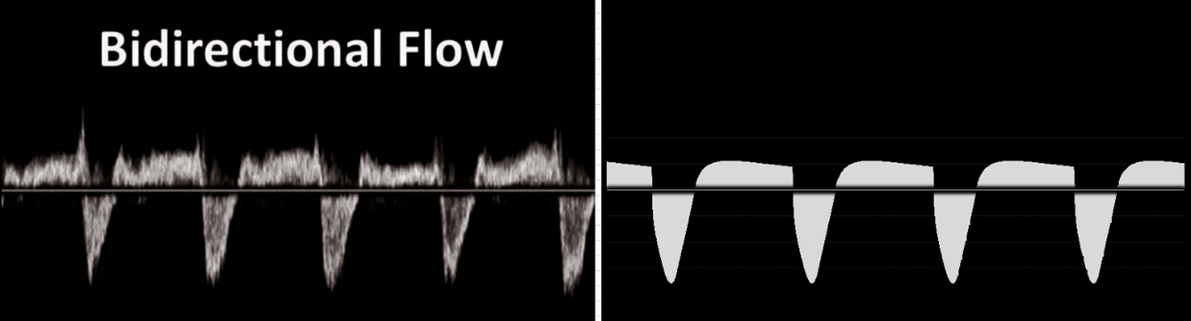

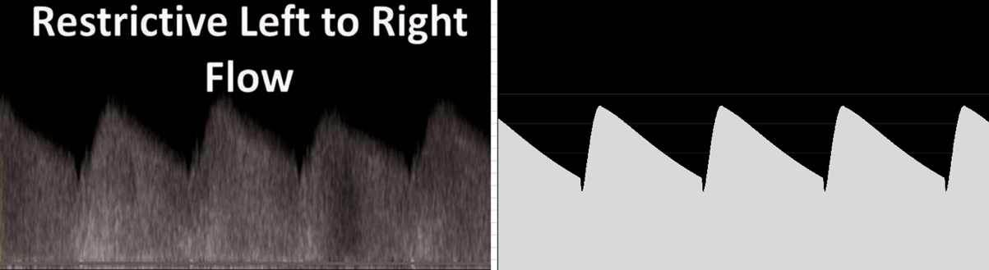

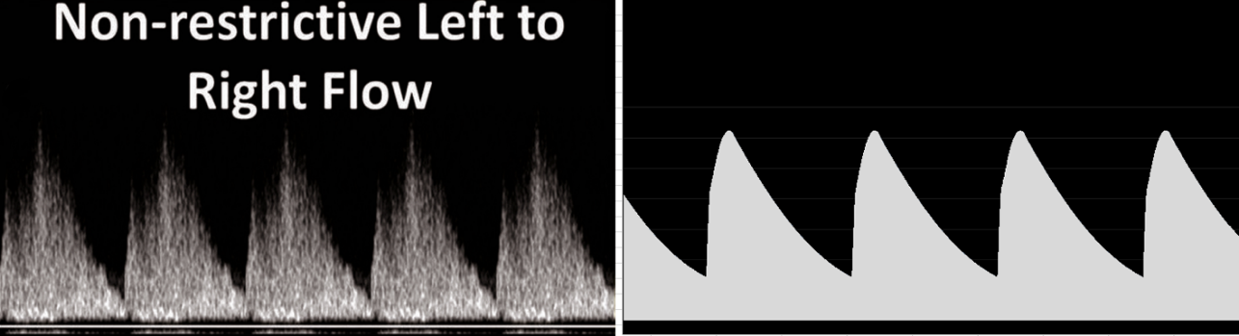
Fig. 5. Target PDA Doppler flow rate data from van Laere et al. [22] (left) and simulation results (right).

There is again a very close match of simulation results to target data. A somewhat minor, but very noteworthy observation in the target data: a very short early-systolic dip in Doppler velocity data for restrictive LtoR flow, is matched by model output.

3.1.3 Pulmonary hypertension (PH)
Pulmonary hypertension (PH) involves elevated pulmonary vascular resistance with right-to-left shunting through the ductus arteriosus and/or foramen ovale. Invasive neonatal hemodynamic data are scarce because cardiac catheterization is rarely performed; most clinical assessment relies on echocardiography. Jones et al. [23] report representative pressures, flows, and oxygen saturations across PH stages, reflecting current clinical understanding despite limited pooled data. In the EXPLAIN model, pulmonary hypertension is simulated by increasing the resistance in the pathways connecting the left and right pulmonary artery capacitance (PAAL, PAAR) to the left and right lung capacitance (LL, RL) and by modifying the baseline elastance of the pulmonary arteries capacitance to represent varying degrees of severity. As in the PDA case, the underlying patient baseline was established with the parameterization pipeline of Section 2.4; the pulmonary-resistance and pulmonary-artery-elastance changes representing each PH stage were then applied on top of that calibrated baseline.
 | Target data |  |  | Simulation results
 | Early PH | Severe PH  no PDA | Severe PPHN with PDA | Early PH | Severe PH  no PDA | Severe PH with PDA
Q_{p} | 176 | 126 | 101 | 179 | 132 | 105
Q_{s} | 176 | 132 | 176 | 179 | 143 | 178
Q_{p}/Q_{s} | 1.0 | 0.95 | 0.57 | 1.0 | 0.92 | 0.59
TPG | 34 | 48 | 36 | 35 | 47 | 37
PVR | 0.19 | 0.38 | 0.36 | 0.19 | 0.36 | 0.37
RVP | 58/7 | 70/8 | 60/7 | 55/7 | 68/7 | 63/8
LVP | 64/6 | 50/6 | 60/6 | 63/6 | 51/6 | 63/6
PAP | 58/28 | 70/38 | 60/30 | 60/30 | 72/39 | 63/32
ABP | 64/32 | 50/24 | 60/30 | 63/31 | 52/26 | 61/31
Table 4. Target data from Jones et al. [23] and simulation results for patienst with three levels of persistent pulmonary hypertension (PPHN). Target data was converted from L/min/m² to ml/kg/min using a body surface area of 0.221 m² (length=50 cm, weight = 3.515 kg). Q_{p}=pulmonary bloodflow (ml/kg/min), Q_{s}=systemic bloodflow (ml/kg/min), Q_{p}/Q_{s} = ratio between pulmonary and systemic blood flow. TPG=transpulmonary gradient (PAP-left atrial pressure) (mmHg), PVR=pulmonary vascular resistance (mmHg*min/ml), RVP=right ventricular pressure (mmHg), LVP=left ventricular pressure (mmHg), AAP=aortic pressure (mmHg), PAP=pulmonary arterial pressure (mmHg)

The target data are a reflection of current clinical understanding. The model closely matches the magnitude and direction of the changes in Q_{p}, Q_{s} and the ventricular and arterial pressures across the different states of PH.

- Discussion
Explanatory models are real-time, interactive, animated visualizations of human physiology that help acute care physicians carry out the challenging cognitive tasks they face in clinical practice and research. EXPLAIN is an explanatory model for neonatal intensive care. An integrated model of cardiorespiratory physiology underlies this tool. In this paper the cardiovascular model is presented. This model is validated – and its explanatory use illustrated – for the conditions persistent ductus arteriosus (PDA) and acute pulmonary hypertension (aPH). The model reproduces key baseline hemodynamic features for term neonates, as well as characteristic changes observed in PDA and PH. Reproducibility and use of simulation results and expansions of the cardiovascular model are enabled by making numerical values of model parameters, model source code, and the EXPLAIN user software available.
4.1 Model originality
The frequently used and well validated Beneken model for the adult and infant uncontrolled cardiovascular systems was expanded with specific tissue groups and shunts that are needed to simulate the neonatal conditions mentioned in the introduction. Non-linear characteristics of resistances and capacitances are given in the mathematical model section. The model of the baroreflex is an expansion of the well documented van Meurs model. The inclusion of an explicit variable for the sympatho-vagal balance results in a compact model with a high explanatory value. A simple model of the Doppler flow pattern is presented. A further element of originality is the parameterization method: rather than tuning parameters by hand, EXPLAIN is fitted to a patient by an AI-assisted closed-loop pipeline in which a large language model translates clinical targets into a validated specification and a deterministic secant-based calibrator drives the mechanistic model onto those targets. This makes patient-specific instantiation reproducible and keeps every automated adjustment within the same bounds as a manual edit.
4.2 Model validity
Validation consists of comparing model simulation results to target data from the literature. A close quantitative agreement for baseline term hemodynamics is observed. PDA states result in the expected relative changes in major flow ratios and Doppler wave morphology. The paradoxical reduction in LVO in bidirectional PDA, and the occurrence of the early systolic flow reduction in restrictive PDA, reported clinically but often under-represented in simplified cardiovascular models, emerged naturally from the interaction of shunt dynamics, pulmonary vascular tone and control responses. EXPLAIN allows for the visualization and manipulation of underlying variables and thereby contributes to the explanation and understanding of these phenomena. In PH, the model captures the direction and magnitude of major hemodynamic shifts and produces ductal Doppler patterns consistent with published wave forms.
4.3 Reproducibility of results and model expansion
A core aim was to create a tool which the authors and other investigators can use to reproduce the conditions used in validation and allows for the simulation of other conditions that are of educational and research value. EXPLAIN achieves this. The EXPLAIN aim favors an underlying cardiovascular model with a structure that has clear anatomical and physiological interpretations. This aspect also facilitates modification and expansion by qualified researchers and developers. This goal is further reinforced by making the model source code available.
4.4 Limitations
Quantitative neonatal hemodynamic data – particularly invasive measurements in PH patients – remain sparse and heterogeneous, thus some validation relies on representative clinical ranges, Doppler morphology, and expert consensus. Shunt diameter-resistance relationships assume idealized laminar/turbulent transitions, and geometric variability (ductal length, septal shape) is simplified. Despite these constraints, the model simulation results match published data. The model also provides a basis for further systematic refinement.
4.5 Future work
A major challenge of the present and related models is robust parameter estimation. Building on the AI-assisted parameterization pipeline described here (Section 2.4), future work will pursue a systematic sensitivity analysis to identify the most informative parameters, extend calibration from the current one-lever-per-target scheme to joint multi-target optimization for strongly coupled configurations, and undertake prospective validation of patient-specific model fits against clinical data. In addition, the coupled cardiorespiratory framework will be applied to study the physiological effects of ventilation strategies, pulmonary vasodilators, and mechanisms underlying transitional failure.
Conclusion
This paper presents original conceptual and mathematical models of the neonatal cardiovascular system for inclusion in an explanatory model for clinical researchers and educators. Simulation results match published target data in good approximation. The EXPLAIN educational software and model code are made available.

Acknowledgements and potential conflicts of interest. Supported in part by a grant from the Stichting Radboud universitair medisch centrum. Willem van Meurs is a paid consultant for Elevate Healthcare. None of the other authors have a potential conflict of interest to report

References

1. van Meurs, W.W.L. and T.A.J. Antonius, Explanatory models in neonatal intensive care: a tutorial. Adv Simul (Lond), 2018. 3: p. 27.
2. Allen, W.W., G.G. Power, and L.D. Longo, Fetal O2 changes in response to hypoxic stress: a mathematical model. J Appl Physiol Respir Environ Exerc Physiol, 1977. 42(2): p. 179–90.
3. Huikeshoven, F.J., et al., Mathematical model of fetal circulation and oxygen delivery. Am J Physiol, 1985. 249(2 Pt 2): p. R192–202.
4. van Willigen, B.G., et al., A review study of fetal circulatory models to develop a digital twin of a fetus in a perinatal life support system. Front Pediatr, 2022. 10: p. 915846.
5. Pennati, G., M. Bellotti, and R. Fumero, Mathematical modelling of the human foetal cardiovascular system based on Doppler ultrasound data. Med Eng Phys, 1997. 19(4): p. 327–35.
6. Sa Couto, C.D., et al., A model for educational simulation of neonatal cardiovascular pathophysiology. Simul Healthc, 2006. 1 Spec no.: p. 4–9.
7. Yigit, M.B., et al., Transition from fetal to neonatal circulation: Modeling the effect of umbilical cord clamping. J Biomech, 2015. 48(9): p. 1662–70.
8. Munneke, A.G., J. Lumens, and T. Delhaas, Cardiovascular fetal-to-neonatal transition: an in silico model. Pediatr Res, 2022. 91(1): p. 116–128.
9. May, R.W., et al., From fetus to neonate: A review of cardiovascular modeling in early life. WIREs Mech Dis, 2023. 15(4): p. e1608.
10. van Meurs, W.L., Modeling and Simulation in Biomedical Engineering: Applications in Cardiorespiratory Physiology. 2011: McGraw Hill LLC.
11. Antonius, T.A.J., et al., A white-box model for real-time simulation of acid-base balance in blood plasma. Adv Simul (Lond), 2023. 8(1): p. 16.
12. Beneken, J., A mathematical approach to cardiovascular function: the uncontrolled human system., in Medisch Fysisch Instituut TNO. 1965: Utrecht, The Netherlands.
13. Goodwin, J.A., et al., A model for educational simulation of infant cardiovascular physiology. Anesth Analg, 2004. 99(6): p. 1655–1664.
14. Suga, H., K. Sagawa, and A.A. Shoukas, Load independence of the instantaneous pressure-volume ratio of the canine left ventricle and effects of epinephrine and heart rate on the ratio. Circ Res, 1973. 32(3): p. 314–22.
15. Bazett, H., An analysis of the time-relations of electrocardiograms. Heart, 1920. 7: p. 353–70.
16. Burkhoff, D. and J.V. Tyberg, Why does pulmonary venous pressure rise after onset of LV dysfunction: a theoretical analysis. Am J Physiol, 1993. 265(5 Pt 2): p. H1819–28.
17. Jhaveri, S., et al., Normative ranges of biventricular volumes and function in healthy term newborns. J Cardiovasc Magn Reson, 2023. 25(1): p. 26.
18. Groves, A.M., et al., Functional cardiac MRI in preterm and term newborns. Arch Dis Child Fetal Neonatal Ed, 2011. 96(2): p. F86–91.
19. Kluckow, M.R. and N.J. Evans, Superior vena cava flow is a clinically valid measurement in the preterm newborn. J Am Soc Echocardiogr, 2014. 27(7): p. 794.
20. van Zadelhoff, A.C., et al., Age-dependent changes in arterial blood pressure in neonates during the first week of life: reference values and development of a model. Br J Anaesth, 2023. 130(5): p. 585–594.
21. Bischoff, A.R., et al., Assessment of superior vena cava flow and cardiac output in different patterns of patent ductus arteriosus shunt. Echocardiography, 2021. 38(9): p. 1524–1533.
22. van Laere, D., et al., Application of NPE in the assessment of a patent ductus arteriosus. Pediatr Res, 2018. 84(Suppl 1): p. 46–56.
23. Jones, C.B. and D.S. Crossland, The interplay between pressure, flow, and resistance in neonatal pulmonary hypertension. Semin Fetal Neonatal Med, 2022. 27(4): p. 101371.
24. Anthropic. Claude (Opus) [large language model]. Anthropic PBC; 2025. Available from: https://claude.com/product/overview.
25. Anthropic. Claude Agent SDK [software]. 2025. Available from: https://platform.claude.com/docs/en/api/agent-sdk.
26. Burden, R.L. and J.D. Faires, Numerical Analysis. 9th ed. 2011: Boston, Brooks/Cole, Cengage Learning.

