Unrestrictive left to right PDA

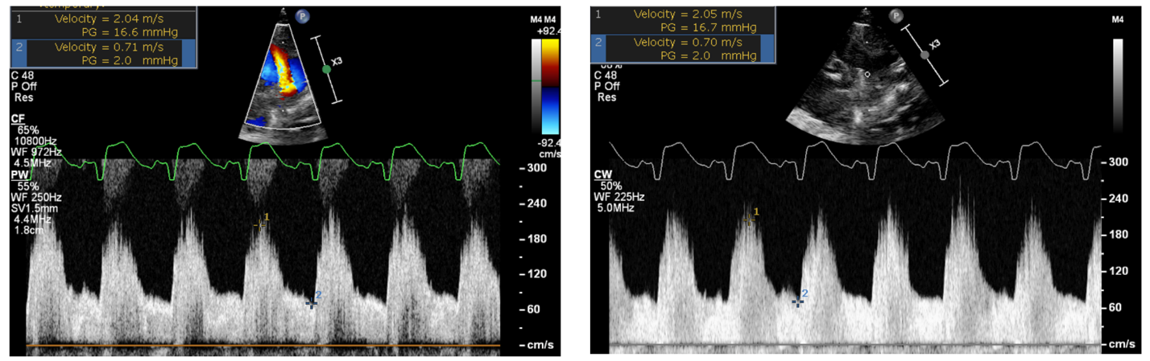
Pulse Wave Doppler (on the left) and Continuous Wave Doppler (on the right) outlining that the left to right shunt is pulsatile and unrestrictive (diastolic velocities that are low, outlining rapid equalization of pressure between the Aortic and Pulmonary end). This means that the ductus is transmitting flow to the pulmonary circulation and the systemic pressure into the pulmonary compartiment, by the fact that the 2 circulations are connected by a lesion that does not restrict flow/pressure transmission. The Peak systolic velocity is 17 mmHg (outlining that the systolic pulmonary arterialpressure is 17 mmhg below the systemic systolic blood pressure). The end Diastolic velocity is 2 mmHg, outlining that the diastolic pressure in the pulmonary artery is 2 mmHg below the diastolic pressure in the aorta (near systemic because of the pressure equalization via the ductus). Ratio of end diastolic to peak systolic velocity = 0.71/2.04 = 0.35

