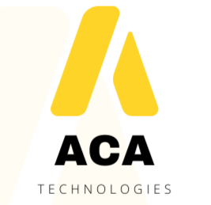 | Invoice

Trainer Name | MOHAMMED AFSAL
Purchase Order Reference
Technology / Subject

Invoice Details
Invoice Number |  | Invoice Date | 10/07/2026

# | Description of Service | Training Days (Qty) | Rate / Day | Amount
1 | Python Training (17th July, 18th July, 19th July) | 3 | 3500 | 11,500
2 | Python Training (23rd July, 24th July, 25th July) | 3 | 3500 | 11,500
Total Amount : 21000

Bank / Payment Details
Account Holder Name | SKILLMERIDIAN TRAINING AND SERVICES
Bank Name | federal bank
Account Number | 15210200006177
PAN Number | EQWPB2877Q
IFSC Code | FDRL0001521

Instructions
Please fill in all fields above accurately and completely, then return this invoice along with any supporting documents (bills/receipts for reimbursements, if applicable) to ACA Technologies for processing. Invoices may only be raised for completed training days, and must reference the Purchase Order shown above.

Trainer Signature & Date |  | For ACA Technologies — Received & Verified
This invoice must be accompanied by the corresponding Purchase Order. Payments are processed on a net 30 basis from date of approval.

