Gratis-DB:

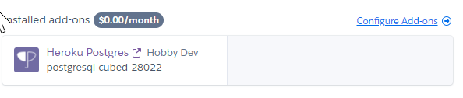

* Remote-Projekt auf postgre umstellen, DB-Daten angeben, migrate:fresh
* pgAdmin4 für Verwaltung

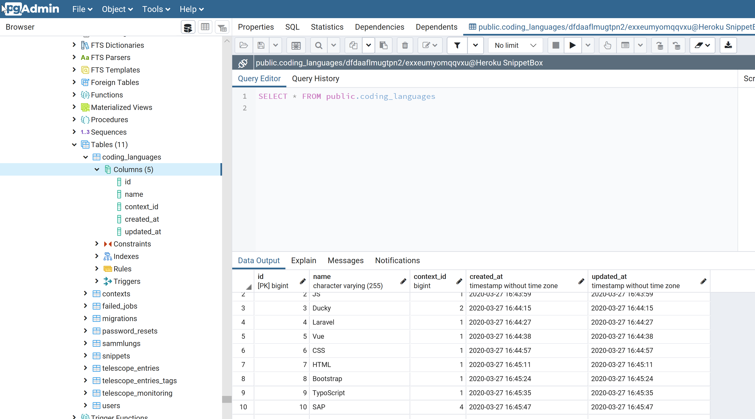

Heroku db

! data from another database with pg:copy

Created postgresql-cubed-28022 as DATABASE_URL

Use heroku addons:docs heroku-postgresql to view documentation

APP_KEY=base64:GRMLYH598su2yL1Uilq1P7lnenwrH2XQlfjIk0mgVDc=

Db user exxeumyomqqvxu  
Db pass 4e2d561955434e80098d87ba1d1d361f879154bb058d66ec5e0de277ee7930df  
Db Host ec2-46-137-84-173.eu-west-1.compute.amazonaws.com  
Db Port 5432  
Db DB dfdaaflmugtpn2