Air University
Generative AI Semester Project

MailOpsAI ? Multi-Agent AI System for Intelligent Email Operations

Name | Muhammad Irfan Cheema
Subject | Generative AI
University | Air University
Project Title | MailOpsAI ? Multi-Agent AI System for Intelligent Email Operations
Role | Generative AI Engineer

Abstract
MailOpsAI is a dual-implementation multi-agent email operations system. It analyzes customer email text, classifies intent and urgency, drafts a professional response, extracts tasks and follow-up actions, and combines all specialist outputs into a final orchestrated summary. The project is implemented once in Python/FastAPI and once in n8n, with Groq used as the primary LLM provider and Gemini documented as fallback.

Problem Statement
Email operations teams often receive urgent customer messages that require fast triage, consistent response quality, and clear follow-up ownership. Manual handling can delay escalation and cause inconsistent communication. MailOpsAI addresses this by automating classification, response drafting, task extraction, and final summarization through specialist agents.

Objectives
- Build a working Python FastAPI implementation with REST endpoints and a backend-served frontend.
- Build a real importable n8n workflow with Webhook, HTTP Request, Code, and Respond to Webhook nodes.
- Use at least three specialist agents with distinct agentic design patterns.
- Use Groq as the primary LLM provider and provide Gemini fallback documentation.
- Return structured JSON and display individual agent outputs plus a final orchestrator summary.

Proposed Solution
The solution uses a multi-agent architecture. Each specialist agent focuses on one part of email operations, and an orchestrator combines outputs into a final action plan. The Python implementation serves the frontend at http://127.0.0.1:8000 and mounts static assets under /static. The n8n implementation uses HTTP Request nodes to call Groq directly and Code nodes to normalize and merge structured outputs.

Agentic System Architecture
Component | Pattern | Python Implementation | n8n Implementation
Classification Agent | ReAct Pattern | agents/classification_agent.py | Classification Agent HTTP Request + parser Code node
Response Drafting Agent | Planner / Chain Pattern | agents/response_agent.py | Response Drafting Agent HTTP Request + parser Code node
Task & Follow-up Agent | Reflection Pattern | agents/task_followup_agent.py | Task and Follow-up Agent HTTP Request + parser Code node
Orchestrator | Supervisor / Router | orchestrator.py | Orchestrator / Merge / Code node

Specialist Agents and Design Patterns
- Classification Agent uses the ReAct Pattern.
- Response Drafting Agent uses the Planner / Chain Pattern.
- Task & Follow-up Agent uses the Reflection Pattern.
- The Orchestrator uses a Supervisor / Router pattern to dispatch, collect, and synthesize outputs.

Python Implementation
The Python deliverable is a FastAPI backend with REST endpoints POST /analyze-email and GET /health. FastAPI serves the frontend at http://127.0.0.1:8000, with CSS and JavaScript loaded from /static/style.css and /static/app.js. The frontend submits email_text to the backend and renders the Classification Agent, Response Drafting Agent, Task & Follow-up Agent, and Final Orchestrator Summary cards using real backend responses, not mock data.
- Backend start command: uvicorn main:app --reload
- Frontend served URL verified: http://127.0.0.1:8000
- StaticFiles mount verified at /static
- Primary provider: Groq llama-3.3-70b-versatile
- Final Python test returned provider_used = groq for specialist agents and final summary.

n8n Implementation
The n8n deliverable is a real importable workflow at n8n_implementation/workflow/mailopsai_n8n_workflow.json. It uses Webhook Trigger, Groq HTTP Request nodes, parser Code nodes, an Orchestrator / Merge / Code node, and Respond to Webhook. The workflow accepts POST JSON with email_text and returns structured JSON containing input_email, classification_agent, response_agent, task_followup_agent, final_summary, provider_used, and provider_trace.
- Webhook URL tested: http://localhost:5678/webhook/mailopsai
- Groq key is referenced through $vars.GROQ_API_KEY and is not hardcoded.
- Gemini fallback is included as an optional disabled branch and documented.
- Final n8n webhook test returned provider_used = groq and provider_trace showing Groq for all three specialist agents.

User Interface Design
Both frontends provide an email input area, an Analyze Email action, loading/error states, and structured cards for each specialist agent and the final orchestrator summary. The Python screenshots in this report were captured from the FastAPI-served URL, not from a local file path.

Screenshots
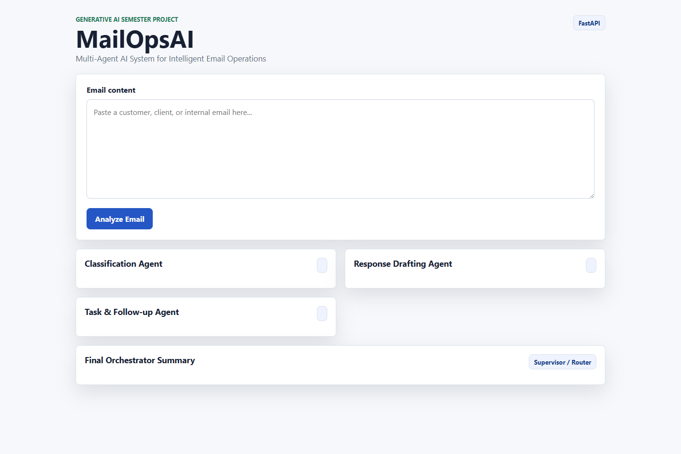
Figure 1: Python Frontend Homepage Served by FastAPI at http://127.0.0.1:8000
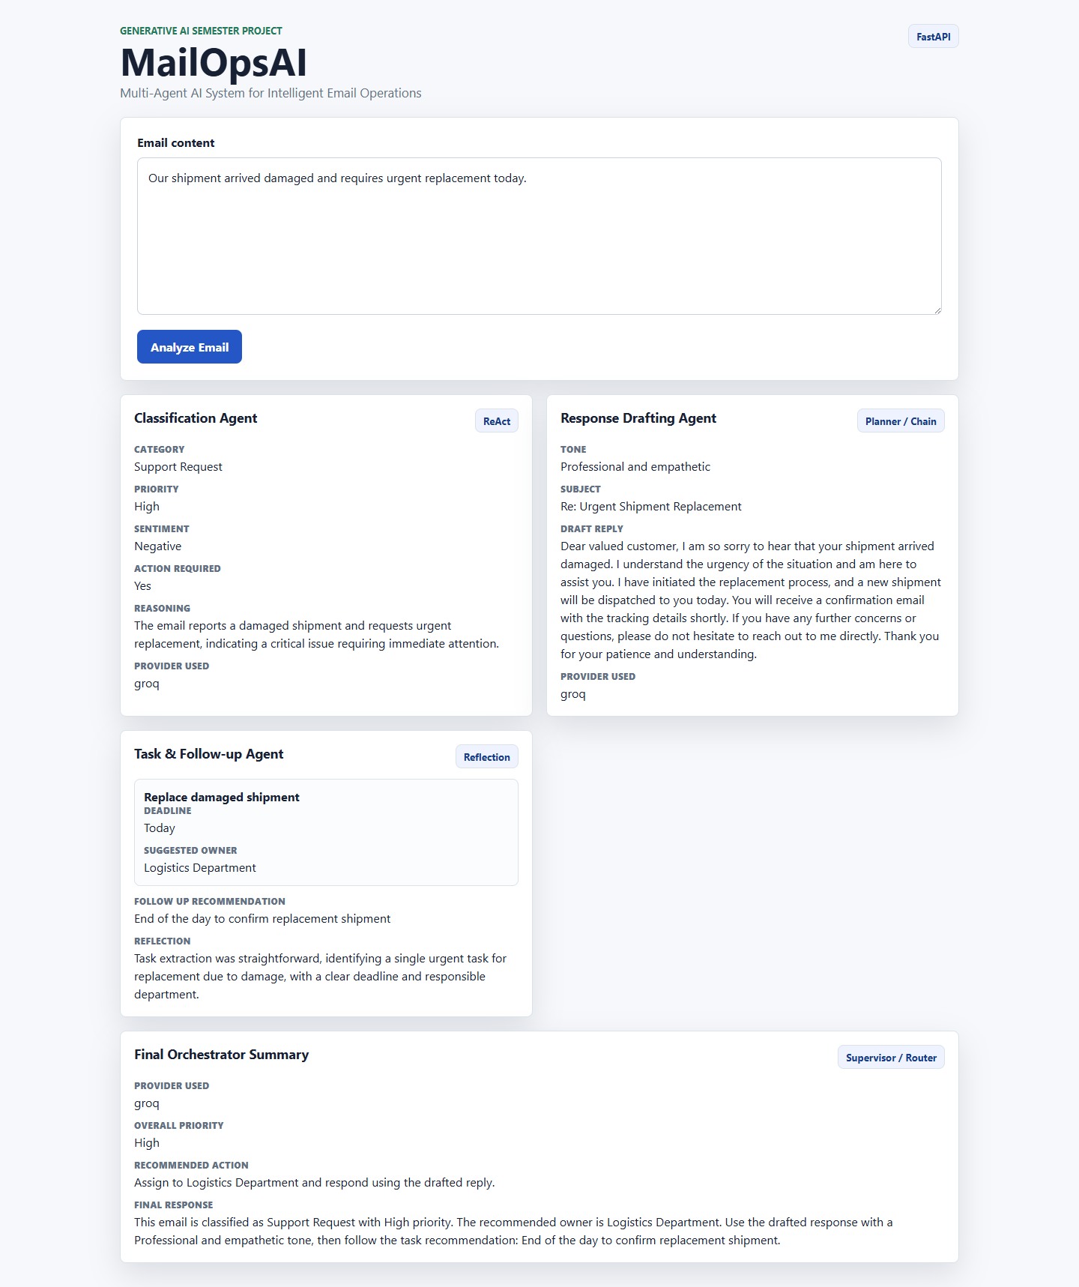
Figure 2: Python Email Analysis Result from FastAPI Backend
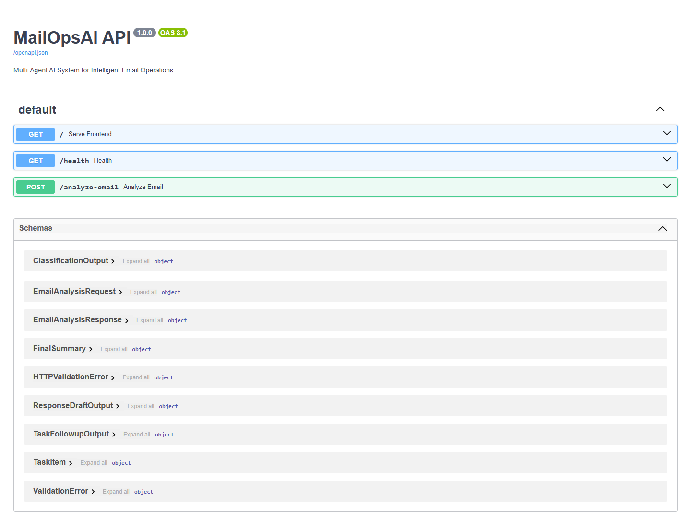
Figure 3: FastAPI Swagger Documentation
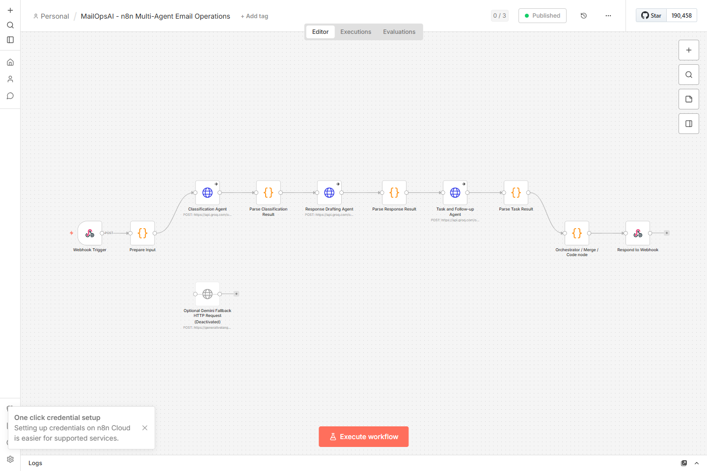
Figure 4: n8n Workflow Overview
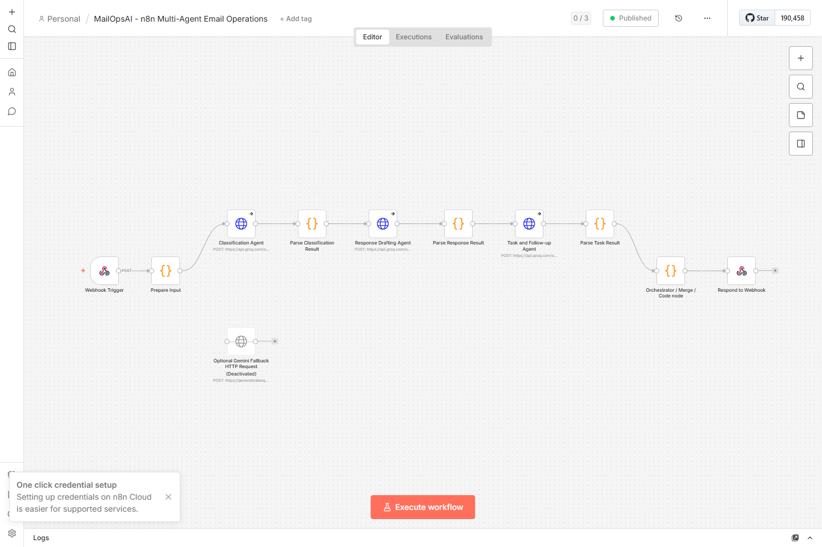
Figure 5: n8n Webhook Configuration
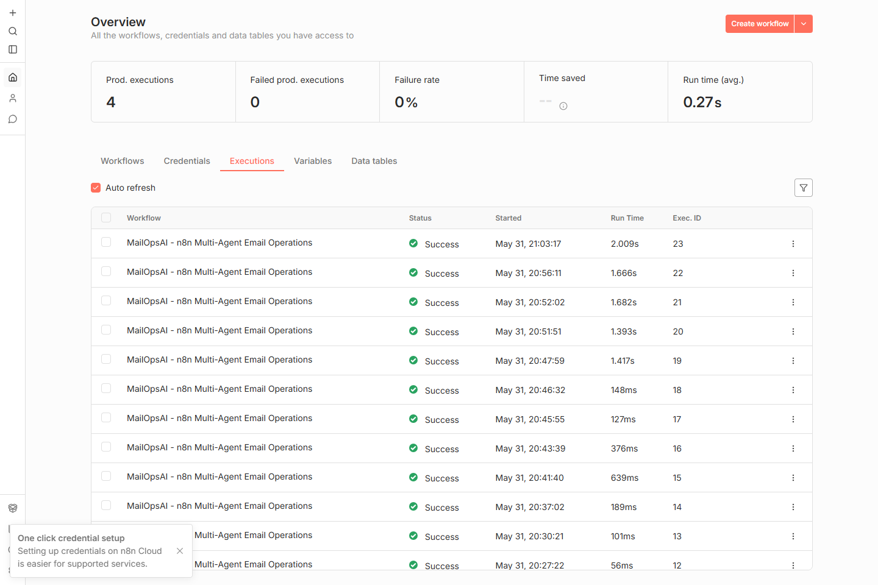
Figure 6: Successful n8n Workflow Execution
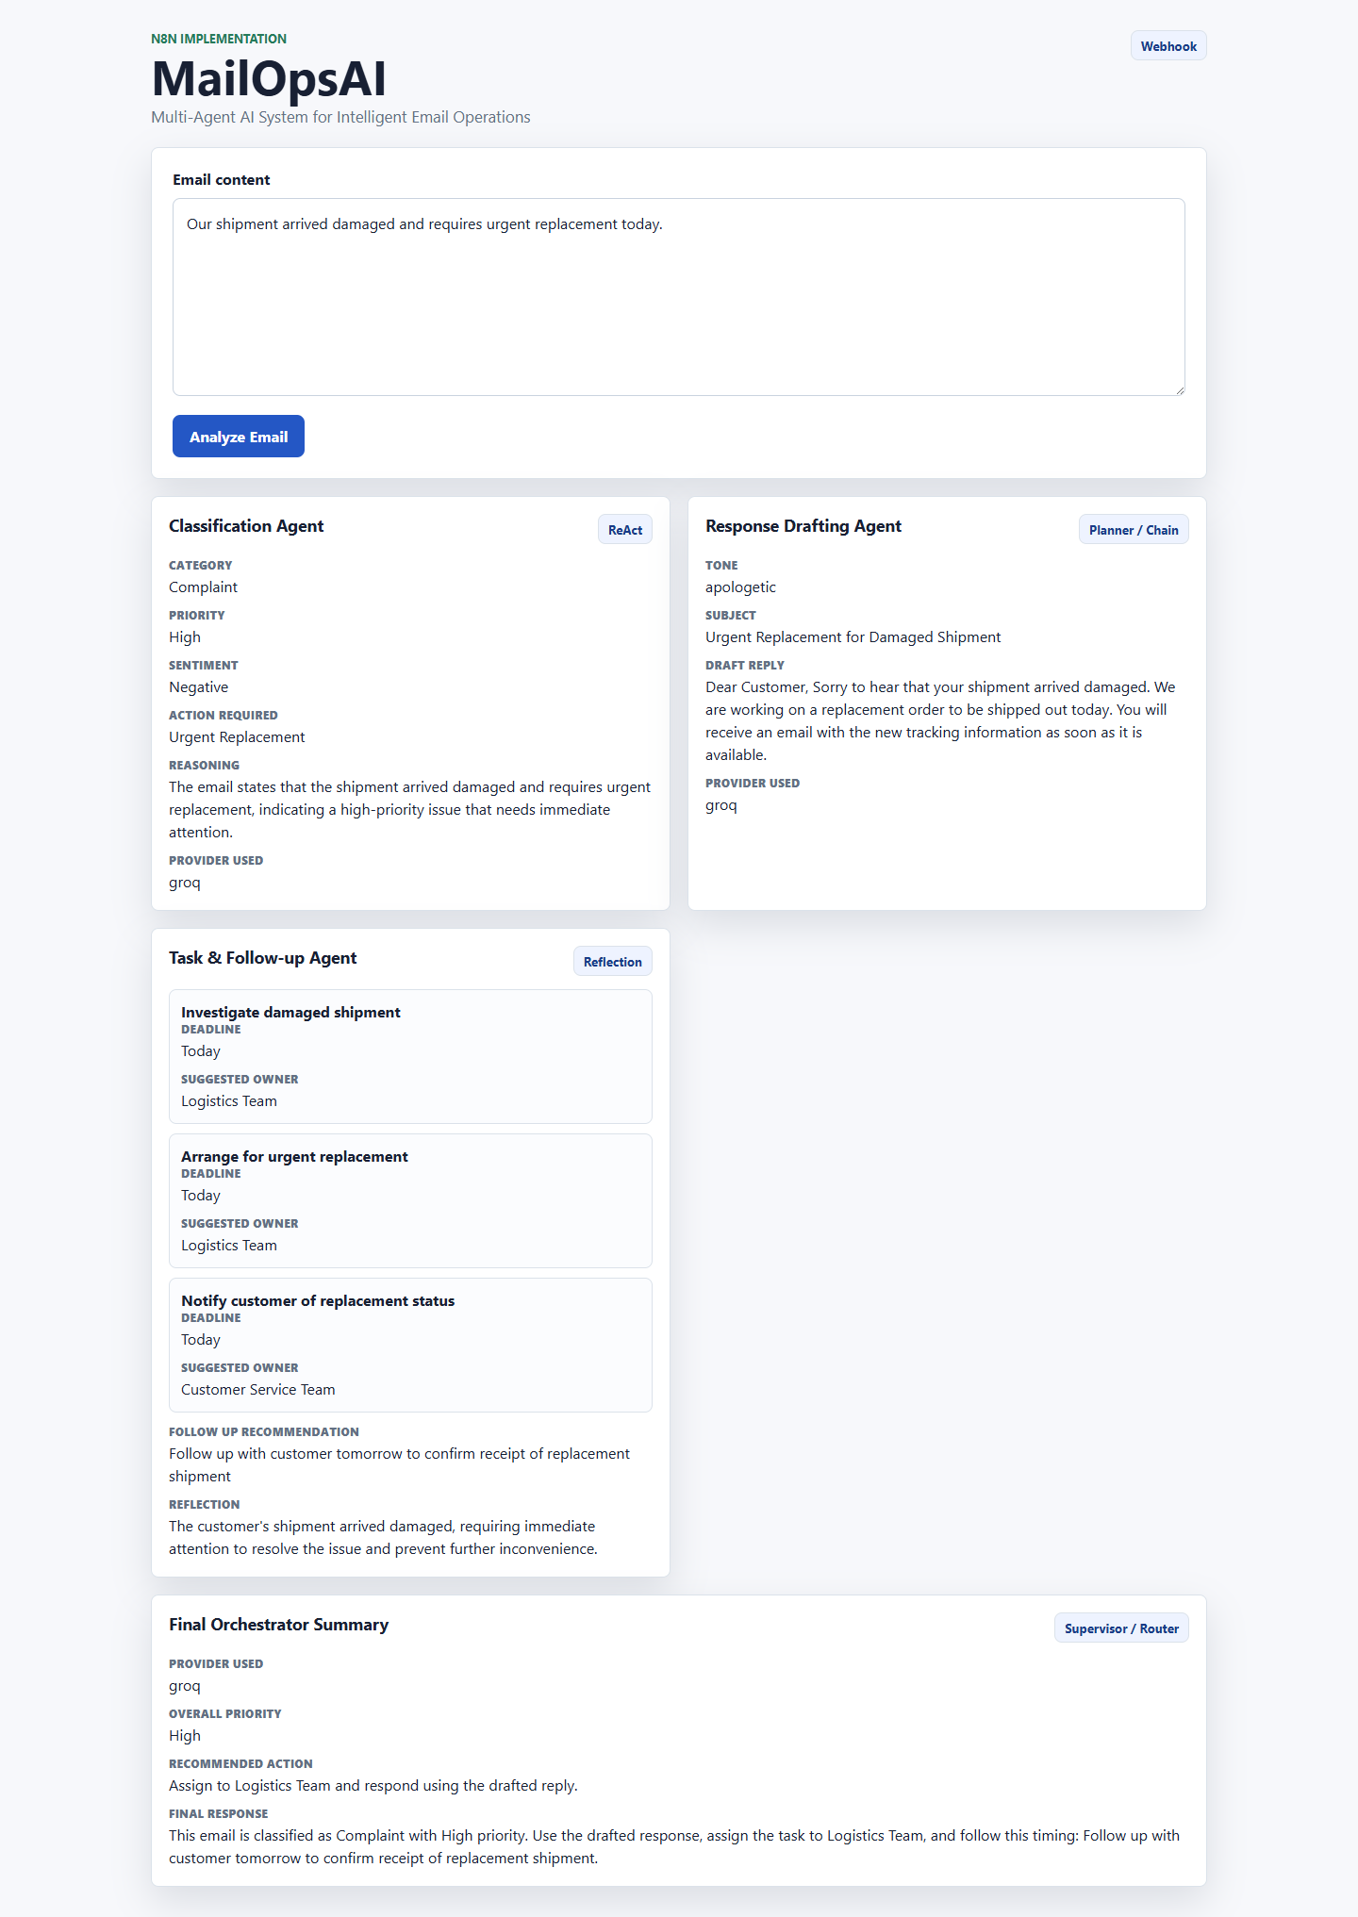
Figure 7: n8n Frontend Output

Testing and Results
- Python backend tested successfully through GET /health and POST /analyze-email.
- Python frontend tested successfully at http://127.0.0.1:8000 with CSS and JavaScript loading from FastAPI.
- Analyze Email button reached the FastAPI backend and rendered real response cards.
- n8n workflow imported and activated successfully.
- n8n webhook tested successfully at http://localhost:5678/webhook/mailopsai.
- Groq provider confirmed through provider_used: groq in Python and n8n responses.
- n8n frontend tested successfully and displayed structured results from the real webhook.
- Security scan found no real API keys hardcoded in source files, workflow JSON, README files, frontend JavaScript, or DOCX report.

Conclusion
MailOpsAI fully satisfies the semester project requirement for a dual implementation of an agentic Generative AI system. The Python/FastAPI and n8n implementations both provide three specialist agents, distinct design patterns, one orchestrator, real frontend integration, structured JSON output, and verified Groq provider usage.

References
- FastAPI documentation: https://fastapi.tiangolo.com/
- n8n documentation: https://docs.n8n.io/
- Groq API documentation: https://console.groq.com/docs
- Google Gemini API documentation: https://ai.google.dev/
- Python dotenv documentation: https://pypi.org/project/python-dotenv/

