TurnKey Mayan EDMS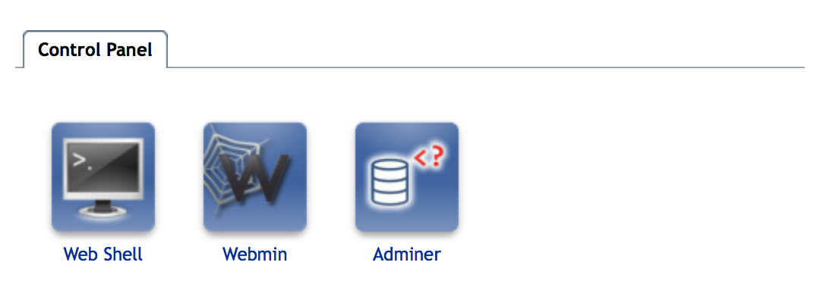

### Your TurnKey Mayan EDMS system has a few out of the box extras:

* Shell In a Box - Console access
  + - * Access by pointing your browser at: https://your-ip-address:12320
* Webmin - System administration
  + - * Access by pointing your browser at: https://your-ip-address:12321
* Adminer - Database administration (PostgreSQL)
  + - * Access by pointing your browser at: <https://your-ip-address:12322>

### SSL - Certificates

Your self generated certificate is located:

ssl_certificate /etc/ssl/private/cert.pem;

ssl_certificate_key /etc/ssl/private/cert.key;

You can swap this out with one purchased from an online CA, or an internal CA

Release notes for TurnKey Mayan EDMS:

https://www.turnkeylinux.org/mayan-edms