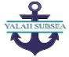
(DIVING AND MARINE SERVICES)

Dear Mr. Ola Olukoyede,

Chairman, Economic and Financial Crimes Commission (EFCC)
Plot 301/302, Institution and Research Cadastral District, Jabi, Abuja

We are excited to introduce Yalah Subsea Nigeria Limited, a leading provider of innovative subsea solutions. Our mission is to deliver exceptional services that exceed our clients' expectations and contribute to the growth of the industry.

With a team having 17 years of experience in diving and marine services, and Yalah Subsea Nigeria Limited being in operation since November 6th, 2017, we have established ourselves as a trusted partner in subsea operations. Our team is dedicated to providing high-quality services that meet the evolving needs of our clients.

We would be delighted to explore potential opportunities for collaboration and discuss how our solutions can benefit the EFCC's efforts in combating financial crimes. Please feel free to contact us at 08146690792 or yalahsubsea@gmail.com to learn more about our offerings.

Thank you for considering Yalah Subsea Nigeria Limited. We look forward to the possibility of working together.

Best regards,
Emmanuel Nanakeme Israel David Happiness ESQ
Counsel Director

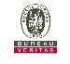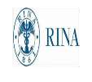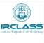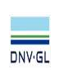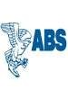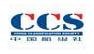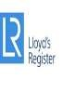
1

