LOAN AGREEMENT
This Loan Agreement is made and entered into on 1st of October 2025 by and between:
Lender's Details:
- Name: David Happiness
- Address: 22B OKE AMU STREET ZONEB WHITE HOUSE BUSTOP GOVERNORS ROAD
ALIMOSHO LAGOS STATE
- Phone Number: 08061579794
- Email: davidhappy3449@gmail.com
Borrower's Details:
- Name: [Borrower's Name]
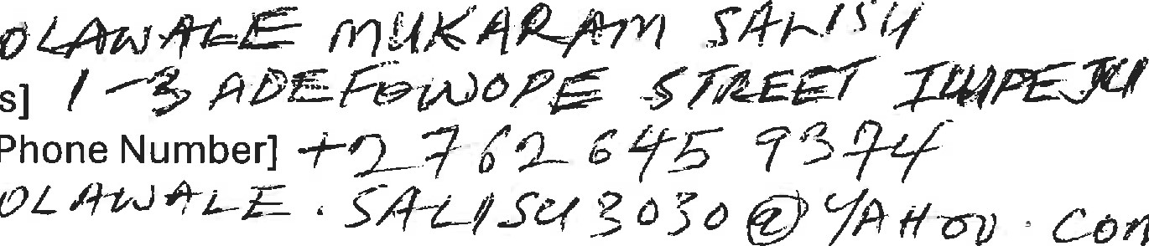
- Address: [Borrower's Address] /
CÖ?PI
- Phone Number: [Borrower's Phone Number]
- Email: [Borrower's Email] OL '4+0
LOAN TERMS
1 . _ Loan Amount:_ The Lender agrees to lend the Borrower the sum of 1,200,000 (One Million Two Hundred Thousand Naira).
- _ Repayment Amount:_ The Borrower agrees to repay the Lender the sum of 1,750,000 (One Million Seven Hundred and Fifty Thousand Naira) ("Repayment Amount") on or before 15th of November 2025.
- _ Payment Method:_ The Borrower shall make the repayment via:
- Ac no: 6509742705 Ac name: JESUSWORLD GLOBAL HOMES AND PROPERTIES
Moniepoint account
- or Ac no: 6151692924 Ac name: Handsome Oluwasemilore David Fidelity Bank.
4. Default: If the Borrower fails to repay the Repayment Amount on or before the 15th of November 2025, the Lender reserves the right to take legal action to recover the debt.
DEFAULT AND CONSEQUENCES_
If the Borrower fails to repay the loan as agreed, the Lender may take legal action, and the Borrower shall be liable for all costs and expenses incurred in recovering the debt, including legal fees. The Borrower also acknowledges that failure to repay the loan may result in damage to their credit score and potential legal consequences.
GOVERNING LAW
This Agreement shall be governed by and construed in accordance with the laws of Nigeria. Any disputes arising out of or in connection with this Agreement shall be resolved through the courts of law in Nigeria.
DISPUTE RESOLUTION
Any dispute or claim arising out of or in connection with this Agreement shall be resolved through arbitration in accordance with the Arbitration and Conciliation Act, Cap A. 18, Laws of the Federation of Nigeria 2004.
ENTIRE AGREEMENT
_
This Agreement constitutes the entire agreement between the parties and supersedes all prior negotiations, understandings, and agreements between the parties.
AMENDMENTS_
This Agreement may not be amended or modified except in writing signed by both parties.
ACKNOWLEDGMENT
_
By signing below, both parties acknowledge that they have read, understand, and agree to the terms and conditions of this Agreement.
SIGNATURES
David Happiness Signature: Date:_____________
__________________
Olawale Mukaram Salisu Signature: Date:_____________
__________________
Please review and ensure you understand the terms before signing

