

**IT 13L – IT PROFESSIONAL ELECTIVE 4**

**(3565)**

**PROPOSAL: REQUIREMENTS FOR CASHIERING AND INVENTORY SYSTEM FOR ALING NITA’S SARI-SARI STORE**

**CABE, FRANCIS MATTHEW**

**LATINA, KYLE GIAN**

**SAGA, REYNALD AL MARION**

**OCTOBER 2023**

**Table of Contents**

1. **Executive Summary**  3

2**. Development Team** 4

3. **Prototypes**

a. Main Form 5

b. Inventory Form 5

c. Sales History Form 6

d. Add Form 6

e. Update Form 7

f. Logs Form 9

g. Order Form 10

4. **Database Design**

a. Entity Relationship Diagram 10

b. Database Design 11

1. **Executive Summary**

Our group was assigned the responsibility of identifying various retail establishments and small enterprises for the purpose of conducting structured and confidential interviews pertaining to the current operational status of their businesses. The primary objective of these interviews was to assess the extent to which these businesses were utilizing automated systems or software in their operations.

It was observed that many of these businesses relied on manual record-keeping methods, such as logbooks. Our team was entrusted with the task of advocating for the adoption of an automated system offered by our organization. This system is designed to facilitate seamless business operations through the utilization of database management and automated transaction processing, thereby optimizing efficiency and offering a modern approach to record-keeping. Unfortunately, most of the businesses we approached declined our proposal. However, one of our team members succeeded in securing the cooperation of their interviewee. As a result, our proposal centers around a business model characterized by face-to-face transactions, commonly referred to as a "sari-sari" store. Our proposed system aims to accommodate the store's cashiering and inventory management requirements, thereby enhancing its operational effectiveness.

To go in more detail, the system we proposed is comprised of a cashiering system that is linked to an inventory system in which they both interact with each other depending on the situation/commands given by the user. Although our project targets Aling Nita’s Sari-sari store and other stores like hers; the usage is not limited to only sari-sari stores, as it is versatile enough to be used in most simple businesses that deals with trading goods for currency.

1. **Development Team**

The following individuals comprise the software development team. They are responsible for the analysis and development of the Cashiering and Inventory System for Aling Nita’s Sari-sari store.

|  |  |  |  |
| --- | --- | --- | --- |
| **Role** | **Tasks Assigned and Modules** |  | **Name** |
|  |  |  |  |
|  | Manages and provide support to |  |  |
| Team Leader/ | project team |  | Latina, Kyle Gian |
| Programmer | Develop the User Login form and |  |
|  | Main Solution template |  |  |
|  |  |  |  |
|  | Manages and provides support |  |  |
| Project Manager/ | to project team |  | Cabe, Francis Matthew |
| Programmer | Develop User and Audit Logs |  | Saga, Reynald Al Marion |
|  | form design |  |  |
|  |  |  |  |
| UI Designer/ | Designs the main template |  | Cabe, Francis Matthew |
| Programmer | Develop Product form design |  |  |
|  |  |  |  |
|  | Analyzes the project drafts and |  | Saga, Reynald Al Marion |
| System Analyst/ | provides optimizations to make |  |  |
| Programmer | the project streamlined and user- |  |  |
|  | friendly |  |  |
|  |  |  |  |
|  | Develops the main database to |  |  |
|  | be used in the project |  |  |
| Database Designer | Provides a database structure |  | Latina, Kyle Gian |
| /Programmer | that is most suited to the nature |  |  |
|  | of the project to ensure |  |  |
|  | efficiency |  |  |
|  |  |  |  |

1. **Prototypes**
2. Main Form

Our primary page when opening the system will look like this. Every button is shown with multiple buttons and textfields.

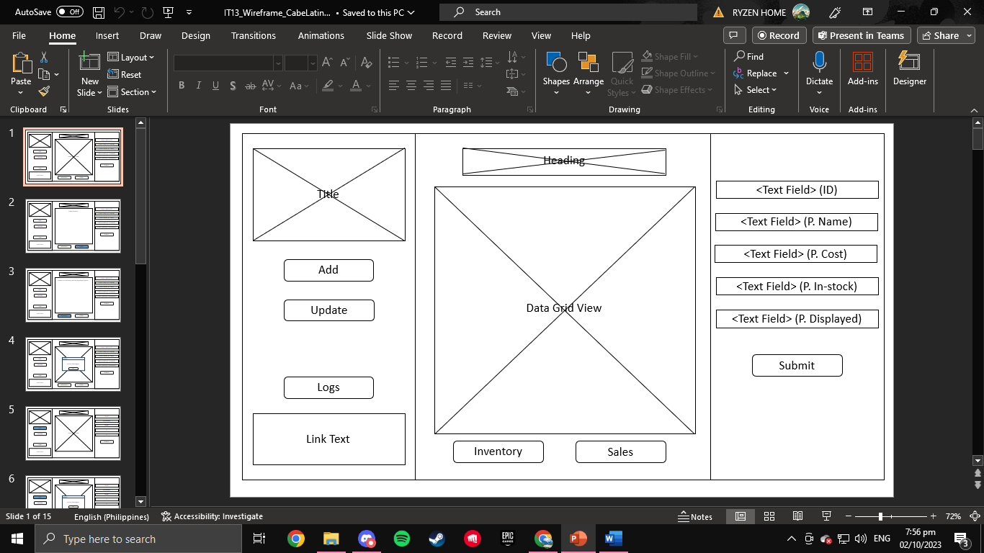

1. 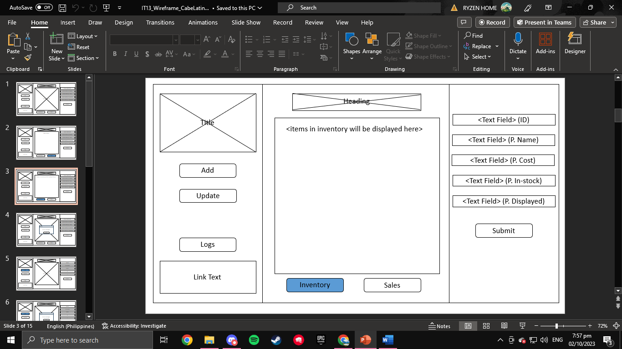Inventory Form

When the inventory button is clicked, the data grid view will change into inventory items. There will be no changes to the page other than the DGV when

1. Sales History Form-

Similar to the inventory button, only the data grid view will change while the other components will stay put on the page.

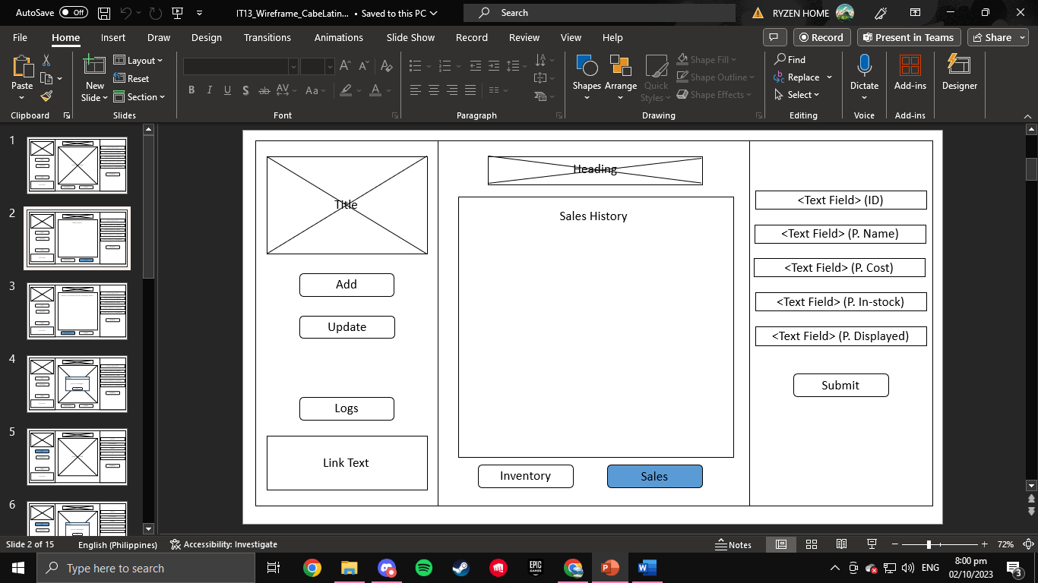

1. 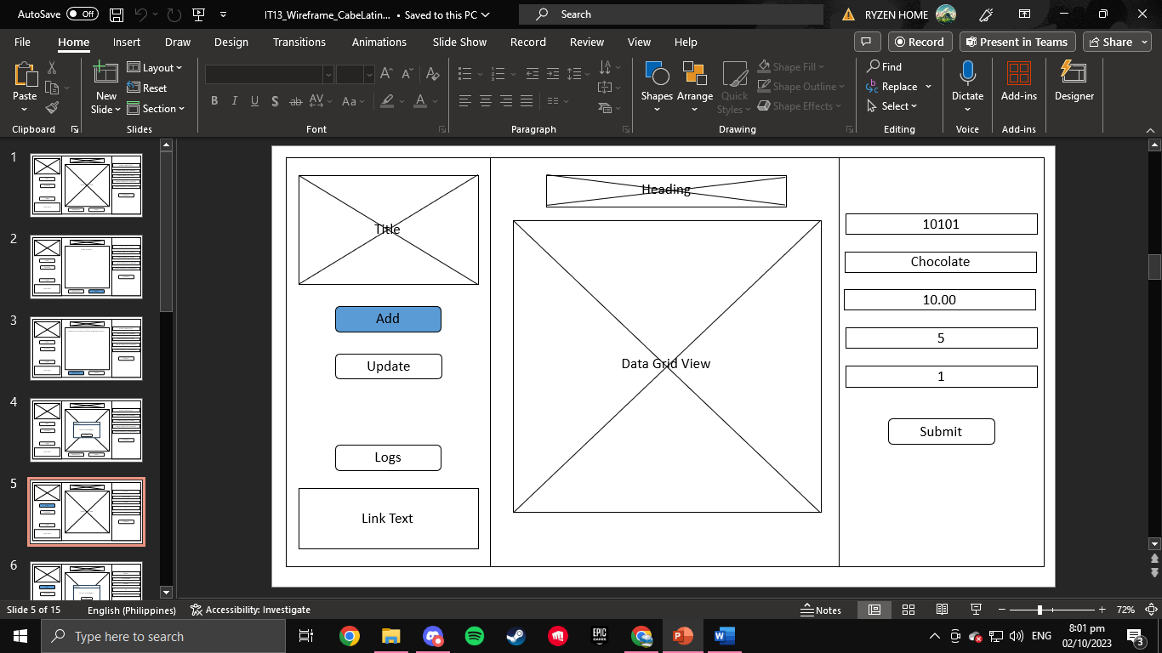Add Form

The Inventory button as well as the Sales button will disappear and the textfields will accept input from the user after you click the add button in order to add items.

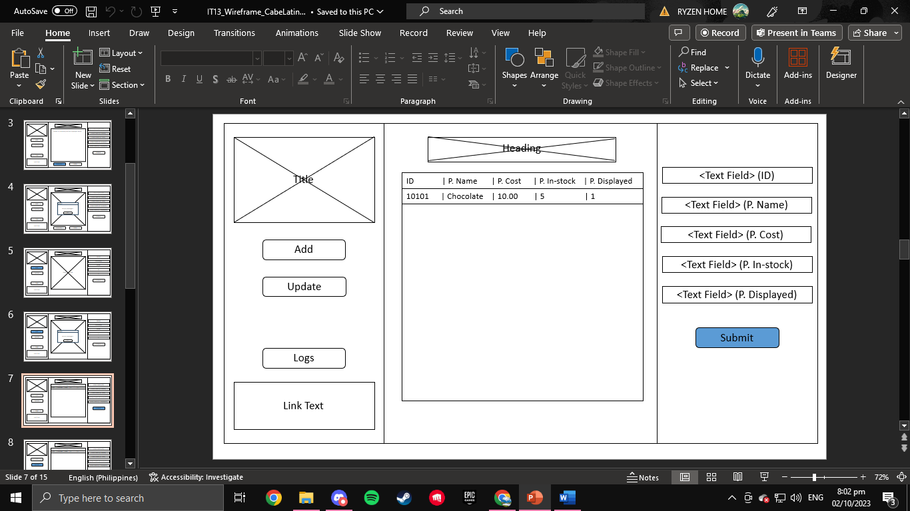

1. Update Form

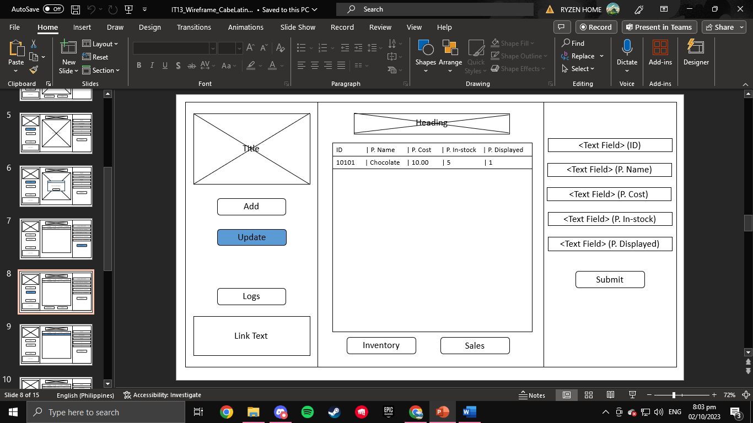

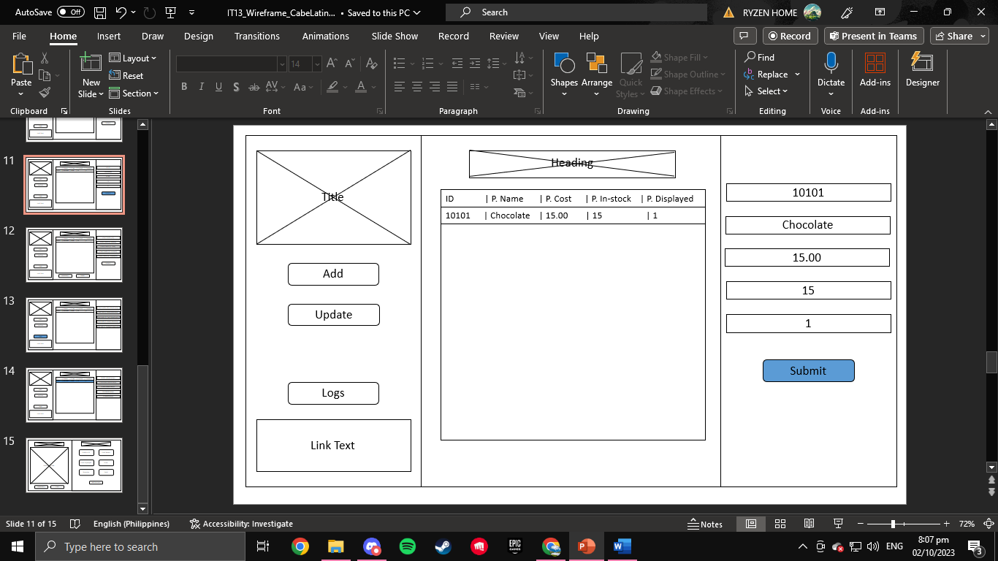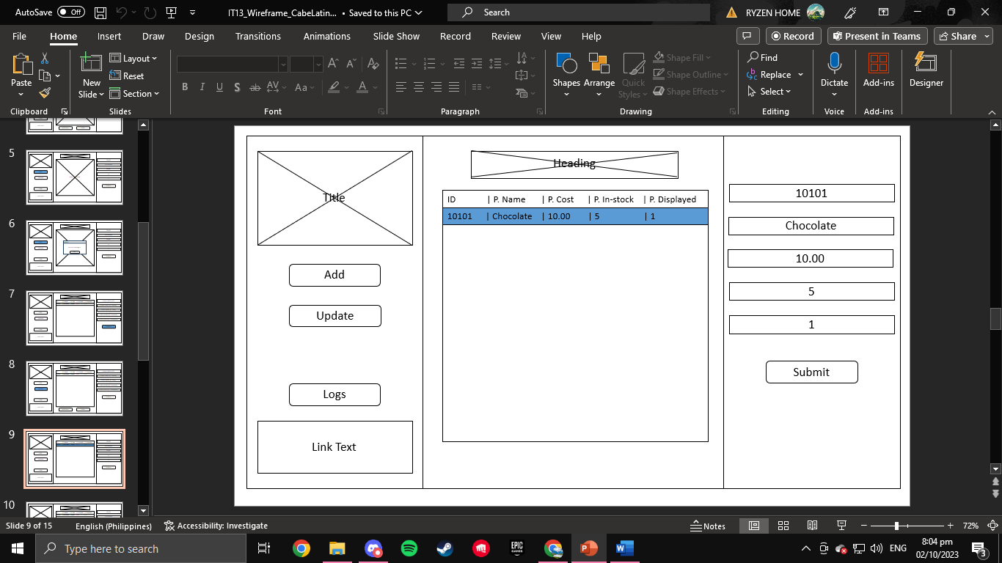

Similar to the add button, the update button will hide the inventory button as well as the sales button. The textfields on the right will accept user input in order to update data.

1. Logs Form (with sample log)

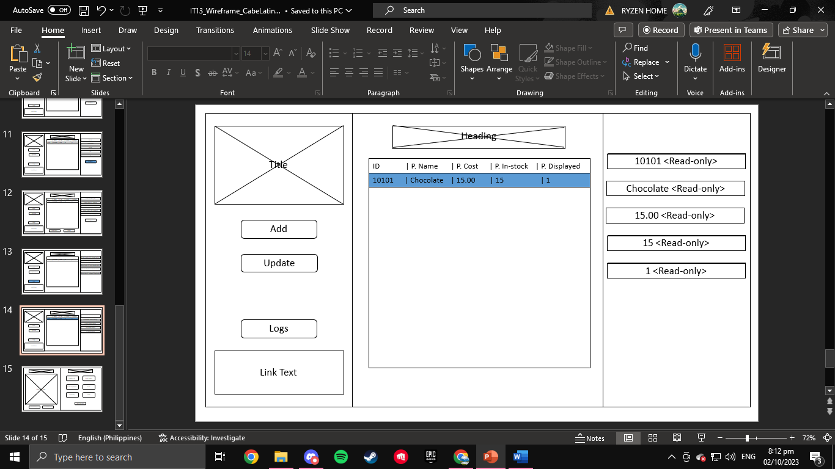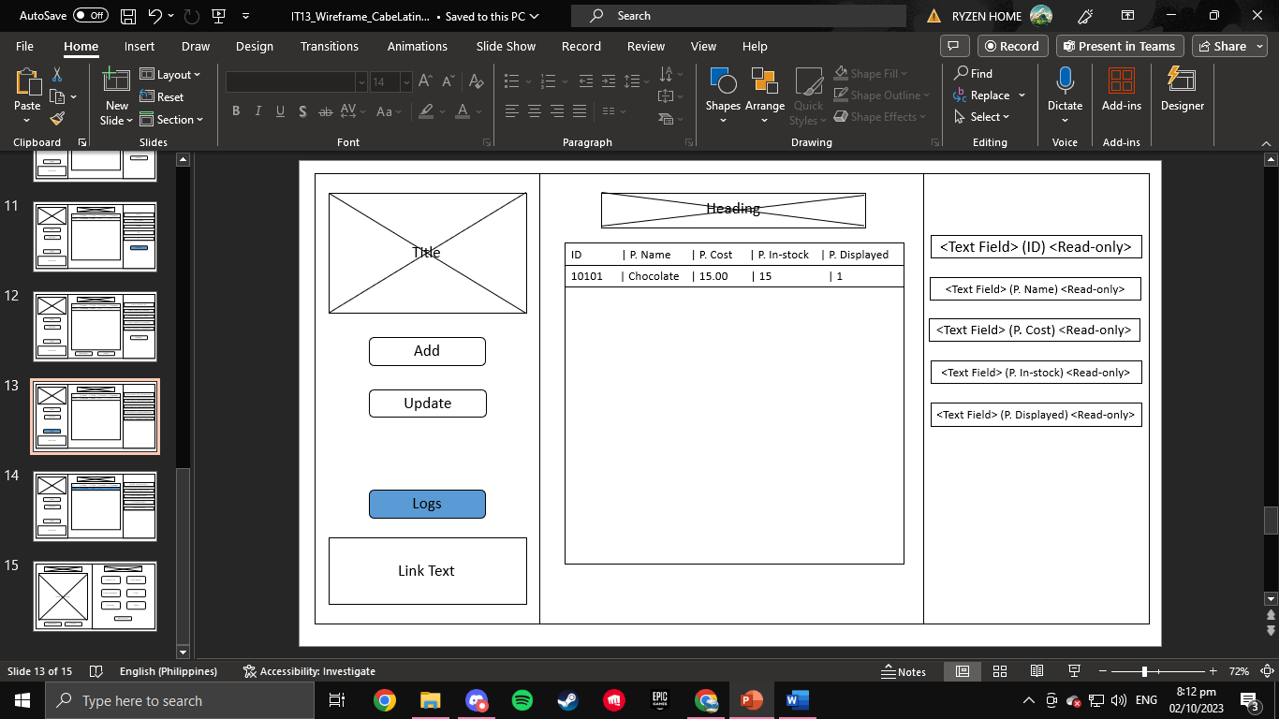

After clicking the logs button, the inventory button and sales button will disappear and every text field on the right will not accept any input from the user and will be set to read only and the submit button will also be hidden.

1. Order Form

After clicking the cashier button below the logs button, the user will be able to type in the text fields and input his/her order. The user can also access the submit button after his/her inputs.

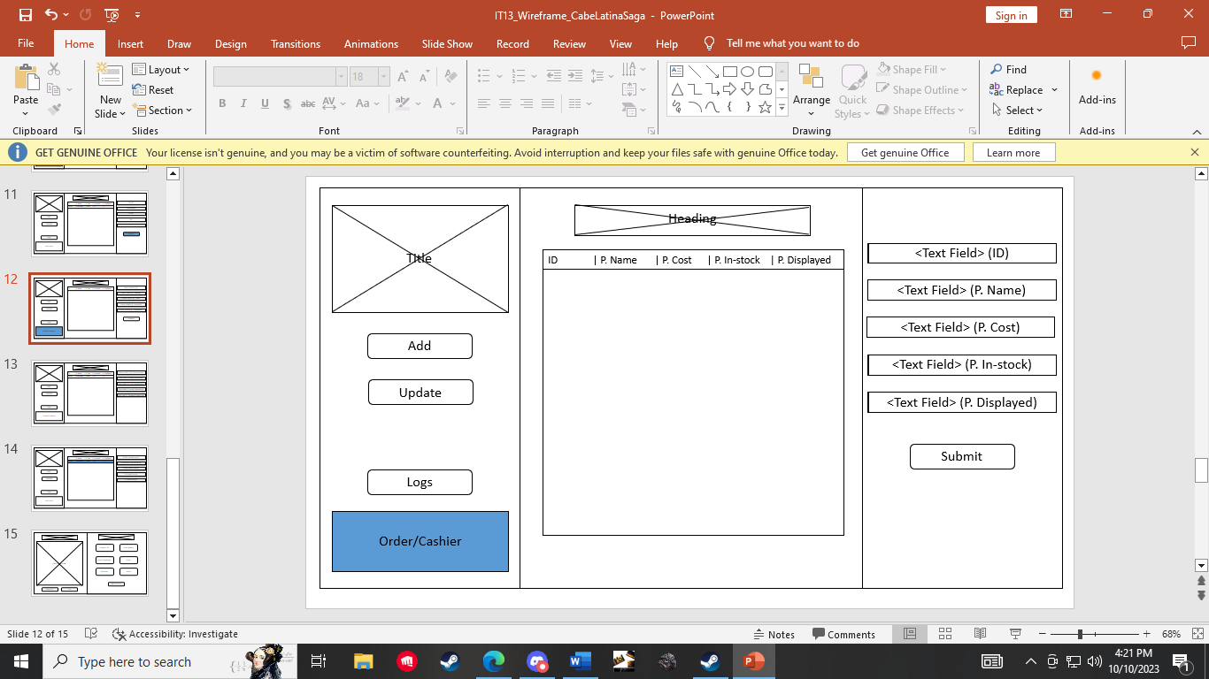

1. **Database Design**
2. Entity Relationship Diagram

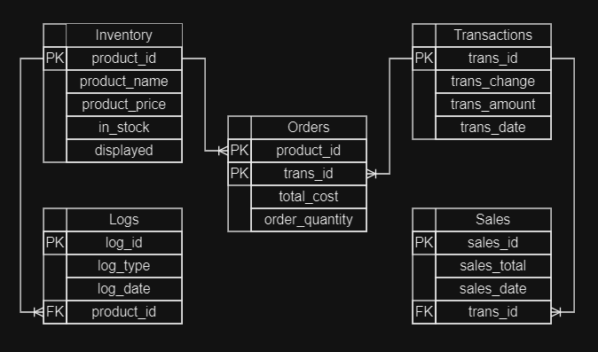

1. Data Dictionary

|  |  |  |  |  |  |  |
| --- | --- | --- | --- | --- | --- | --- |
| Inventory | | | | | | |
| **Field Name** | **Data Type** | **Unique** | **Primary Key** | **Foreign Key** | **Reference Table** | **Comment** |
| product_id | INTEGER | YES | YES | NO | N/A | Identifier of the product instance |
| product_name | TEXT | NO | NO | NO | N/A | Name of the product |
| product_price | REAL | NO | NO | NO | N/A | Price of the product |
| in_stock | INTEGER | NO | NO | NO | N/A | Number of products available |
| displayed | INTEGER | NO | NO | NO | N/A | Number of products displayed |

|  |  |  |  |  |  |  |
| --- | --- | --- | --- | --- | --- | --- |
| Logs | | | | | | |
| **Field Name** | **Data Type** | **Unique** | **Primary Key** | **Foreign Key** | **Reference Table** | **Comment** |
| log_id | INTEGER | YES | YES | NO | N/A | Identifier of the log instance |
| log_type | TEXT | NO | NO | NO | N/A | Short description of the log |
| log_date | TEXT | NO | NO | NO | N/A | Date the log instance was made |
| product_id | INTEGER | NO | NO | YES | INVENTORY | Identifier of the product instance affected |

|  |  |  |  |  |  |  |
| --- | --- | --- | --- | --- | --- | --- |
| Transactions | | | | | | |
| **Field Name** | **Data Type** | **Unique** | **Primary Key** | **Foreign Key** | **Reference Table** | **Comment** |
| trans_id | INTEGER | YES | YES | NO | N/A | Identifier of the transaction instance |
| trans_amount | REAL | NO | NO | NO | N/A | Payment of the customer |
| trans_date | TEXT | NO | NO | NO | N/A | Date the transaction instance was made |
| trans_change | REAL | NO | NO | NO | N/A | Customer’s change (default value is 0) |

|  |  |  |  |  |  |  |
| --- | --- | --- | --- | --- | --- | --- |
| Sales | | | | | | |
| **Field Name** | **Data Type** | **Unique** | **Primary Key** | **Foreign Key** | **Reference Table** | **Comment** |
| sales_id | INTEGER | YES | YES | NO | N/A | Identifier of the sales instance |
| sales_total | REAL | NO | NO | NO | N/A | Total profit from that instance |
| sales_date | TEXT | NO | NO | NO | N/A | Date the sales instance was made |
| trans_id | INTEGER | YES | NO | YES | Transactions | Identifier of the transaction instance affected |

|  |  |  |  |  |  |  |
| --- | --- | --- | --- | --- | --- | --- |
| Orders | | | | | | |
| **Field Name** | **Data Type** | **Unique** | **Primary Key** | **Foreign Key** | **Reference Table** | **Comment** |
| product_id | INTEGER | YES | YES | NO | Inventory | Identifier of the product instance  affected |
| trans_id | INTEGER | YES | NO | Transactions | Identifier of the transaction instance affected |
| total_cost | REAL | NO | NO | NO | N/A | Total cost of the order |
| order_quantity | INTEGER | NO | NO | NO | N/A | Total number of items bought |