README FOR: CLASS_59_66_CABVIEW_V01.zip and its archived files

to install:
1: unzip to a temp folder with "use folder names" on.

2: MAKE A FULL BACKUP OF THE LOCO YOU ARE GOING TO ADD THE CAB VIEW TO.

3: if the loco has a CABVIEW folder already then you should delete it or rename it, e.g. “CABVIEW.bak”

2: Go to the temp folder and copy & paste or drag & drop the folder “CABVIEW” to the folder of the loco you are going to use it with.

3: Open the .eng file of the loco that you are using and look for the “CabView” entry e.g. “CabView ( xxxxxxx.cvf )” .
This should be changed to “CabView ( JT42CWR.cvf )” .

4: you should now be able to use the cabview in MSTS, if you get any errors then if you followed step 2 you can just delete the modified locos folder and reinstate the unmodified backup folder, then retry or give up.

USEFULL NOTES:

This is my 1st cab view it was made for my JT42CWR #66609 (not finished yet).

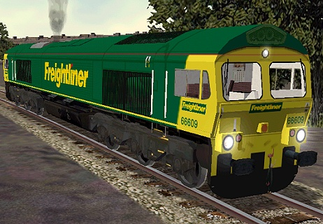

FUALTS:

No known faults at this time.

Copyright and Distribution:

This Microsoft Train Simulator CLASS_59_66_CABVIEW_V01.zip is released as Freeware. Copyright © Mark Todd 2001/2002. As freeware you are permitted to distribute this Archive subject to the following conditions,

1: The archive (CLASS_59_66_CABVIEW_V01.zip) must be distributed without modification to the Contents of the archive, redistributing this archive with any files Added, removed or modified is prohibited,

2: The inclusion of any individual file from this archive in another
Archive without the prior permission of the author is prohibited.

3: No charge (£, $, or other) may be made for this archive
Without the prior permission of the author.

4: The authors' rights and wishes concerning this archive must be
Respected.

You can email me at b101uk@btinternet.com

My web site http://www.btinternet.com/~marktod/ for MSTS & http://www.geocities.com/kg200_dart/ for other.

