Class 170 Cabview by Daniel Wilkie

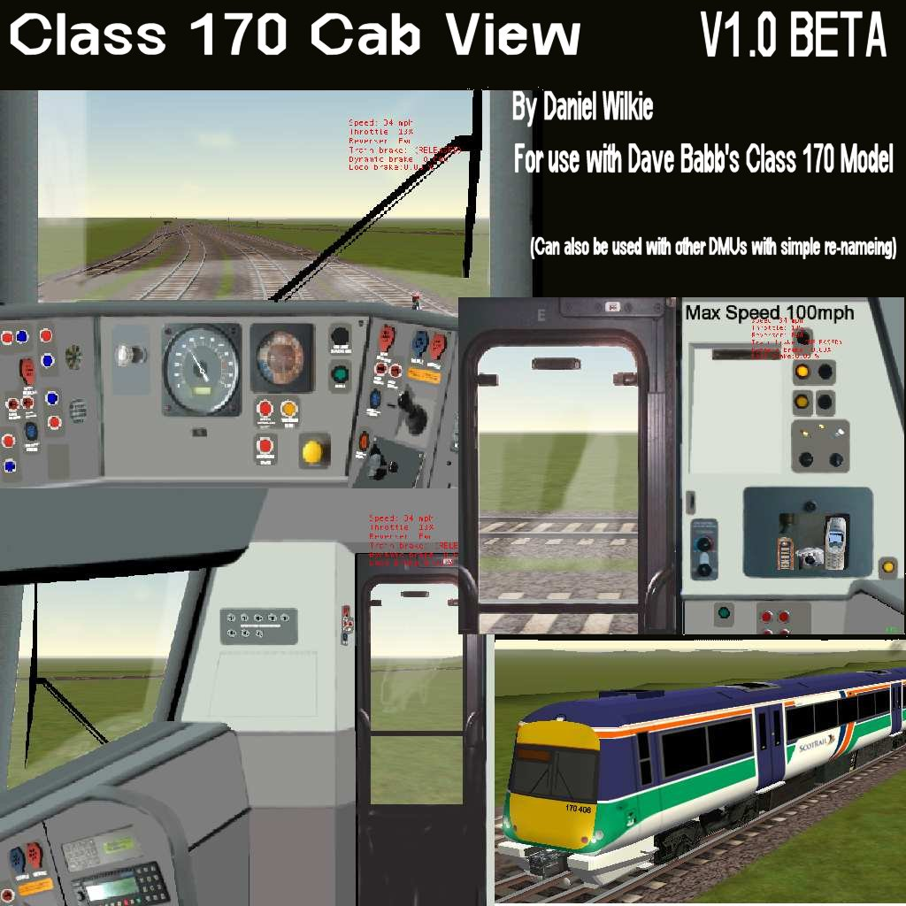

This is the Class 170 Cabview for use with Dave Babb’s Class 170’s. I have made this the best I can with the photos I have available to me.

This release is the first and there is a few things which still need done. I still have to animate the Horn and Wiper controller and sort out the Speedo so that it reads correct.

Installation…

Extract the Zip file to your root Train Sim Folder (Usualy C:\Program Files\Microsoft Games\Train Simulator)
Once done it will already have set up the cabviews for all available Class 170s (ScotRail, SPT, CT, SWT, Anglia, Poterbook versions)

This will also overwrite the Class170 Cabview

If you want to install this cabview in other trains simply copy the Class170.cvf file to the trains Cabview Directory and re-name it to the one used in that train and it will work. (This does not need any other files to be copied over, Only the CVF file)

Contact Info…

Email : Daniel.Wilkie@Btinternet.com
ICQ : 58923311
MSN : Danielwilkieuk@hotmail.com - Please only use this for EMAIL
Http : www.trainsim.tk
Http : www.uktrainsim.com

You can also find me in the Train Sim chatroom available via my website

Thanks
Daniel

