Operational crop acreage estimation at a national scale based on statistics and remote sensing

Xianfeng JIAO¹, Heather McNAIRN¹, Bangjie YANG² Jiali SHANG¹ Zhiyuan PEI²
1 Agriculture and Agri-Food Canada, Ottawa, Ontario, Canada K1A 0C6
2 Chinese Academy of Agricultural Engineering,
Ministry of Agriculture of China
41 Maizidian, Chaoyang District, Beijing China 100026;

Abstract: This paper provides an efficient and effective procedure for operational crop acreage estimation at a national scale. An innovated approach which incorporates both coarse and finer resolution satellite data into stratified sampling was presented. The crop planting area from MODIS data was defined as the sampling population. The population is divided into non-overlapping strata from which an independent sample is selected from each stratum. For selected samples that represent the population, a crop inventory was conducted using remote sensing imagery with finer resolution. At a certain confidence level, crop acreage could be estimated over the entire survey area. The method has been adopted by the Ministry of Agriculture of China for paddy rice inventory in northeast of China in 2005.

1 Introduction
Crop acreage is the determining factor in crop production. Monitoring and estimating crop acreage at a national scale is required in order to determine the national or regional food demand and supply balance, and to gauge social security. Whether during times of world food shortages, or during periods of surplus, monitoring and estimating crop acreage requires long-term efforts. Crop acreage estimation using remote sensing provides timely and reliable information. Since 1983, remote sensing has been considered the key technology for estimating crop acreage and China has made significant progress in the application of this technology. Initially, remote sensing monitoring over the important cropping regions within China was the primary approach for crop monitoring and estimating. Since 1999 The Chinese Academy of Agricultural Engineering (CAAE), Ministry of Agriculture of China (MOA), has delivered, operationally, crop area estimates over the main grain production regions using inputs of Earth observation (EO) data. Using this remote sensing approach, annual crop acreage estimates are provided across China for wheat, corn, soybean, cotton and rice. However, such an approach poses many challenges. Crop acreage estimated over these selected regions must be extrapolated to provide crop acreage information for the entire country.

This paper introduces a new sampling approach based on statistics and remote sensing and discusses progress to date on integrated SAR and optical imagery for crop classification and acreage estimation. The method was applied to paddy rice acreage estimation in the northeast of China.

2 Methodology
Monitoring and estimating crop acreage at a national scale presents specific problems with respect to data acquisition and method development.

- Data acquisition: It is impractical to acquire remote sensing imagery over all of China during the crop growing season. Processing such large quantities of imagery to support operational reported is not feasible. Adverse weather conditions during critical crop growing period limits the availability of remote sensing imagery. In particular, humid and rainy conditions during the growing season make the acquisition of optical remote sensing imagery problematic. For an operational monitoring approach, the availability of satellite data must be assured. Complementary crop information can be gained through integrating optical data and synthetic aperture radar (SAR) data from satellites such as ASAR and RADARSAT. These sensors offer the advantage of collecting information under cloudy sky conditions. Consequently a multi-sensor (optical and SAR) approach provides a practical solution for operational crop monitoring activities.

- Method development: Some approaches to estimate crop acreage are capable of achieving high accuracies using EO data. However, not all crops are always well classified. For example, winter wheat acreage estimation using NDVI from Landsat TM in Northern China has achieved high accuracies. But this method is not transferable to the crops of southern China, neither to other crops grown in northern China. On the other hand, some methods have been successfully applied for small area mapping, but achieved poor results or where not applicable at the national level. In China, crop planting and harvesting times are concentrated in the period from April to October each year. Before crops are harvested, reports on crop acreage must be submitted, making for tight timelines to process and analyze data. Thus the methods adopted for national crop estimation must be effective and efficient.

In this study, an innovative sampling approach was developed by incorporating coarse resolution MODIS and high resolution Landsat TM satellite data in a statistical stratified sampling. The method was developed to estimate paddy rice acreage in the northeast of China. In the northeast of China paddy rice acreage has fluctuated considerably during the past 10 years. Monitoring paddy rice acreage is meaningful for estimating grain production.

The paddy rice planting area in the current year was defined as the sampling population. Paddy rice mapping was conducted using MODIS data over the entire northern China to obtain an overview of the current year’s paddy rice planting. Because of the spatial resolution of MODIS data, the resulting information is coarse and does not satisfy the requirements of official annual crop reports. A further detailed crop inventory using high spatial resolution remote sensing imagery is needed. Standard 1:50,000-scale topographic maps were chosen as the sampling unit. At a 95% level of sampling accuracy, the population was divided into 6 strata according to the method of accumulated square root. The sample was then taken from each of these strata using proportionate allocation. For selected samples that represent the population, the crop inventory was conducted using Landsat TM and ENVISAT ASAR imageries. At a 95% confidence level, annual paddy rice acreage over the entire northeast of China was estimated.

3 stratified sampling design

3.1Population definition
In statistics, population refers to the total set of observations that can be made. In this study, the purpose of the implementation survey is to estimate paddy rice acreage across the whole northeast of China. The population was defined as the area of planted paddy rice. In northeast of China, paddy rice acreage fluctuates significantly every year, and paddy fields rotate frequently. Thus planting acreage is not available from historical databases. MODIS has a wide viewing swath and high-frequency revisits, making it an ideal instrument to provide an initial overview. Using MODIS Surface Reflectance 8-Day Global 250m data, the Normalized Difference Vegetation Index (NDVI), Vegetation Condition Index (VCI), Enhanced Vegetation Index (EVI) and Land Surface Water Index (LSWI) were calculated. These vegetation indices were used to capture the crop spectral characteristics. Through knowledge-base, a stepwise removal model was designed to automatically identify paddy rice. The resulting paddy rice planting area was defined as the population. The distribution rice paddies is shown in Figure 1.

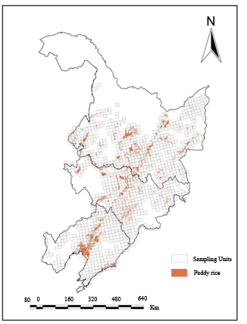
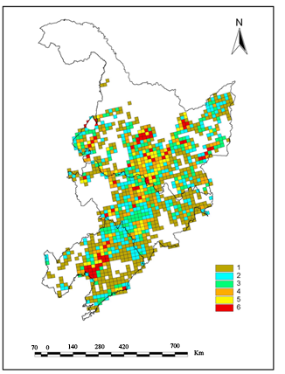
Figure2. The distribution of strata
Figure1. The population and sampling frame
Sampling unit
Rice Paddy

3.2 Sampling frame
The main characteristic of a crop acreage survey is that the sampling population is an area in which the sampling units are small parts of that area. When the population is finite, the frame may be defined by an explicit list of its elements. The sampling unit was considered as the area of a standard 1:50000-scale topographic map. This kind of sampling unit has certain advantages. A specific code is available for every unit and there is no area overlap, as compared with a sampling unit defined as a set area or satellite image frame. In this study, the population was defined as the current year’s paddy rice planting area. The sampling frame, which is the list of standard 1:50000-scale maps within the population, was easy to establish. The sampling frame consisted of 1197 sampling units as shown in Figure 1.

3.3 Stratification

The objective of a stratification design is to minimize the variance of the resulting estimates by creating homogeneous strata of sampling units. When a stratification design is used, the population is divided into several strata, and separate random samples are drawn from each stratum. As the number L of strata is concerned, Cochran (1977) developed a model representing the approximate reduction in the variance gained over simple random sampling by stratification, and deduced that there is little to be gained from having more than six strata.

In this study, the population was stratified into six strata. Once the sampling frame is established, the Cumulative Square Root of the Frequency (CSRF) was used. This is the preferred method to establish strata boundaries.

The cumulative root frequency procedure of stratum construction is carried out for the division of population into L strata as follow:
- Define the stratification variable X as paddy rice planting area within sampling unit;
- Arrange the stratification variable X in ascending order;
- Group the X into a number of classes, J;
- Determine the frequency for each class 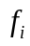 (i=1, 2, …J);
- Determine the square root of the frequencies in each class;
- Cumulate the square root of the frequencies 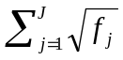
- Divide the sum of the square root of the frequencies by the number of strata;
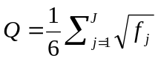
- Take the upper boundaries of each stratum to be the X values corresponding to
Q, 2Q, 3Q,……6Q

The statistics of each stratum are given in Table 1. Figure 2 shows the distribution of strata.

Table 1: The statistics of each stratum
Strata | boundary | Criterion (ha.) | the number of strata
1 | 68.92 | 0-550 | 482
2 | 137.84 | 550-1500 | 249
3 | 206.76 | 1500-2950 | 177
4 | 275.68 | 2950-5100 | 120
5 | 344.59 | 5100-8400 | 95
6 | 413.51 | >28800 | 74

3.4 Proportionate allocation
The precision and cost of a stratified design are influenced by the way that sample elements are allocated to strata. In this study, the method of proportionate allocation was adopted to determine the sampling fraction which is the proportion of a population to be included in a sample. With proportionate stratification, the sample size of each stratum is proportionate to the population size of the stratum. This means that each stratum has the same sampling fraction. Strata sampling sizes are determined by the following equation:
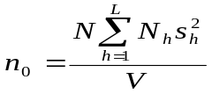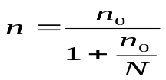
Sampling fraction,
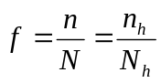The weight of stratum h, W_{h}
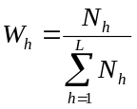

where：
V:The know variance of the population.
L: The number of strata in the population.
N: The number of observations in the population.
N_{h}: The number of observations in stratum h of the population ，h=1, 2, …. L
n: The number of observations in the sample.
n_{h}: The number of observations in stratum h of the sample ，h=1, 2, …. L
s_{h}: The sample estimate of the population variance in stratum h ,
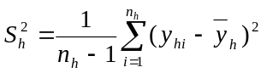

Assuming a 95% sampling accuracy level, from these equations the sampling fraction is 25%. The population consists of 1197 sampling units. The total sample is 300 standard 1:50000-scale topographic maps. According to the proportion of 25%, a simple random sample was drawn from each stratum. Table 2 shows the number of observations in the population and in the sample in each stratum and the weight of strata.

Table 2: the number of observation in the population and in the sample and the weight
stratum | the number of observation in the population | Fraction (%) | the number of observation in the sample | Weight (%)
1 | 482 | 25% | 121 | 40%
2 | 249 | 25% | 62 | 20%
3 | 177 | 25% | 44 | 14%
4 | 120 | 25% | 30 | 10%
5 | 95 | 25% | 24 | 7%
6 | 74 | 25% | 19 | 6%

4 Crop inventory
This stratified sampling scheme was implemented in a national crop acreage estimation system in 2005 for paddy rice acreage estimation in the northeast of China. Following the stratified sampling method, the total annual crop planting area was defined as the sampling population. At a 95% level of sampling accuracy, the population was divided into 6 strata according to the method of CSRF. The sample was then taken from each of these strata using proportionate allocation. For selected sample, a crop inventory was conducted using remote sensing imageries. For the most part, TM and SPOT4 images were used for the paddy rice inventory. Humid and rainy conditions during the growing season created problems for the acquisition of optical remote sensing imagery. The amount of available optical data was limited and thus the requirements of the number of samples determined by stratified sampling could not be met. Supplemental imagery can be acquired from SAR sensors such as ASAR and RADARSAT. These sensors offer the “all-weather” advantage. An optical-SAR approach provides a practical solution for crop acreage estimation at a national scale.

4.1 Data collection
Seven optical and two radar satellite images were collected during the 2005 growing season. Two alternating polarization mode precision images of ASAR with nominal resolutions of 25 m were collected. The alternating polarization was HH/VV, and the imaging modes were IS1 and IS6. SPOT-5 XS data have very high spatial resolution. These data were used to supplement ground data collection and for validation of the classification results. Sample images covering the study sites are shown in Figure 3.

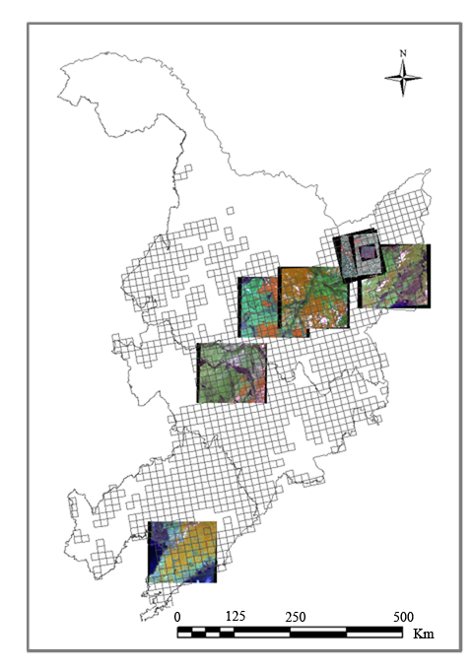

Figure 3: The location of remote sensing imagery

Ground truth data were collected to support the crop classification through on-site surveys. Each sample site covers an area of 500m by 500m and includes several fields with various crop types. Field boundaries were digitized using a Trimble DGPS. The recorded field observations included crop type and crop distribution.

4.2 Image pre-processing
All images were ortho-rectified and co-registered to the same map projection and pixel size (30 m). Cloud and heavy haze were masked out manually and were not included in the training and testing samples. For the purposes of crop classification, atmospheric correction does not positively affect the results (McNairn et al., 2007), thus the TM and SPOT imagery was used without atmospheric correction. The ASAR imagery was filtered using two passes of a 3 by 3 Gamma filter to reduce speckle effects.

4.3 Image classification
Ground truth data combined with visual interpretation from the August 9 SPOT-5 image were used as training and testing sets for supervised classification. For each crop, half of the fields were randomly selected for training the classifier and the second half were reserved for testing the classification accuracy. The training pixels and testing pixels were selected from different fields.
From an operational perspective, crop classification methods must be effective and efficient. The methods should be consistent and must be easily implemented. Some methods have high accuracies over local smaller sites, but costs and processing demands make them unattractive for larger regions. In this study, a decision tree (DT) classification method was used. A DT establishes a hierarchical system of rules to optimally separate classes based on linear discriminate functions estimated from the training data. The DT approach was developed by Agriculture and Agri-Food Canada (AAFC) based on the See5 software.
Independent samples were used to test crop classification accuracies. The accuracy of the classification was determined by comparing the test set with the classification results to generate producer’s, user’s and the overall accuracies.
At the individual class level, one encouraging observation is that using a single-date image, either optical or radar, a high classification accuracy can be achieved for the paddy rice class. Rice grows on flooded soils. During the rice transplanting period and the early part of the rice growing season, paddy fields are a mixture of green rice plants and water. This unique physical feature of paddy rice significantly contributes to paddy rice discrimination using remote sensing imagery. Most paddy rice in China grows in warm, humid environments where the region is always covered by heavy clouds and where significant rainfall occurs during the paddy rice growing season. Consequently the application of SAR data is attractive for monitoring paddy rice planting areas across China.

5 Estimation
For selected samples that represent the population, the crop inventory was conducted using remote sensing imagery. After the crop inventory, the crop acreage within each sample was acquired. At a certain confidence level, crop acreage of the entire survey region could be estimated.
In this study, the overall sample mean was used to estimate the population mean. To compute the overall sample mean, the following equation was used.
An unbiased estimator of the population mean and variance are,
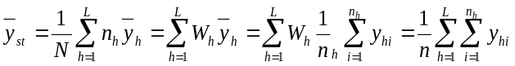

And

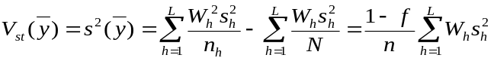

Where
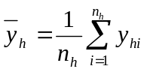

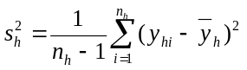

L: The number of strata in the population
n_{h :}The number of observations in stratum h of the sample ，h=1, 2, …. L，
_{yhi}: Paddy rice acreage in stratum h of the sample i
W_{h}: the stratum weight in acreage in stratum h

This stratified sampling was implemented in 2005 for paddy rice acreage estimation in northern China, with the integration of optical and SAR imagery. The result of this survey is an estimated 3.9% increase over last year’s paddy rice acreage.

6 Summary
The stratified sampling scheme proposed in this paper entails first defining the crop planting area from MODIS data as the sampling population and then establishing a sampling frame, choosing the area of a standard 1:50000-scale topographic map as the sampling unit. Finally, the population is divided into non-overlapping strata from which an independent sample is selected from each stratum. For selected samples that represent the population, a crop inventory was conducted using remote sensing imagery. At a certain confidence level, crop acreage could be estimated. The annual crop acreage at a national or regional scale can be obtained by implementing this stratified sampling. This study provides an efficient and effective procedure for operational crop acreage estimation at a national scale.

This study has demonstrated that integration of SAR data with optical imagery can support crop classification and can provide a practical means of acquiring enough imagery to satisfy the demands of a stratified sampling approach. SAR sensors, such as RADARSAT and ASAR, permit the collection of data under cloudy conditions and adds some additional information for differentiating specific crop types, in particular paddy rice.

According to sampling theory, a stratified sampling can provide greater precision than a simple random sample of the same size. Because it provides greater precision, stratified sampling often requires a smaller sample and requires fewer resources. In this study, not only was the stratified sampling investigated, but an innovated approach which incorporates both coarse and finer resolution satellite data into stratified sampling was presented. This procedure takes full advantage of the characteristics of sampling theory and remote sensing technology.

Acknowledgements: the authors would like to thank the team at Chinese Academy of Agricultural Engineering (CAAE), for collecting the ground truth data and processing the remote sensing data.

Reference:

- Alonso, F.G., Soria, S.L., & Cuevas Gozalo, J. (1991). Comparing two methodologies for crop area estimation in Spain using Landsat TM images and ground-gathered data. Remote Sensing of Environment, 35, 29-35
- Bezuidenhout, C.N., & Singels, A. (2007). Operational forecasting of South African sugarcane production: Part 2 - System evaluation. Agricultural Systems, 92, 39-51
- Chen, C., & McNairn, H. (2006). A neural network integrated approach for rice crop monitoring. International Journal of Remote Sensing, 27, 1367 - 1393
- Cochran, W.G. (1977). Sampling Techniques. New York: John Wiley & Sons, Inc
- Dawe, D., Frolking, S., & Li, C. (2004). Trends in rice-wheat area in China. Field Crops Research, 87, 89-95
- Gonzalez-Alonso, F., Cuevas, J.M., Arbiol, R., & Baulies, X. (1997). Remote sensing and agricultural statistics: crop area estimation in north-eastern Spain through diachronic Landsat TM and ground sample data. International Journal of Remote Sensing, 18, 467 - 470
- Jim Cotter, J.N. (1987). Area Frame Design for Agricultural Surveys. In. Washington, D.C.: National Agricultural Statistics Service, U.S. Department of Agriculture
- Lewis, J.E., Rowland, J., & Nadeau, A. (1998). Estimating maize production in Kenya using NDVI: some statistical considerations. International Journal of Remote Sensing, 19, 2609 - 2617
- Manjunath, K.R., Potdar, M.B., & Purohit, N.L. (2002). Large area operational wheat yield model development and validation based on spectral and meteorological data. International Journal of Remote Sensing, 23, 3023 - 3038
- McNairn, H., Champagne, C., & Shang, J. (2007). The value of SAR Multi-polarization data in delivering annual crop inventories. In C. Champagne (Ed.), Geoscience and Remote Sensing Symposium, 2007. IGARSS 2007. IEEE International (pp. 1397-1400)
- Murthy, C.S., Thiruvengadachari, S., Raju, P.V., & Jonna, S. (1996). Improved ground sampling and crop yield estimation using satellite data. International Journal of Remote Sensing, 17, 945 - 956
- Pradhan, S. (2001). Crop area estimation using GIS, remote sensing and area frame sampling. International Journal of Applied Earth Observation and Geoinformation, 3, 86-92
- Rembold, F., & Maselli, F. (2004). Estimating inter-annual crop area variation using multi-resolution satellite sensor images. International Journal of Remote Sensing, 25, 2641 - 2647
- Shao, Y., Fan, X., Liu, H., Xiao, J., Ross, S., Brisco, B., Brown, R., & Staples, G. (2001). Rice monitoring and production estimation using multitemporal RADARSAT. Remote Sensing of Environment, 76, 310-325
- Tsiligirides, T.A. (1998). Remote sensing as a tool for agricultural statistics: a case study of area frame sampling methodology in Hellas. Computers and Electronics in Agriculture, 20, 45-77
- Xiao, X., Boles, S., Liu, J., Zhuang, D., Frolking, S., Li, C., Salas, W., & Moore Iii, B. (2005). Mapping paddy rice agriculture in southern China using multi-temporal MODIS images. Remote Sensing of Environment, 95, 480-492
- Yichen, T., Bingfang, W., Wenbo, X., Jianxi Huang, A.J.H., & Wenting Xu, A.W.X. (2004). An effective field method of crop proportion survey in China based on GVG integrated system. In W. Bingfang (Ed.), Geoscience and Remote Sensing Symposium, 2004. IGARSS '04. Proceedings. 2004 IEEE International (pp. 4028-4030 vol.4026)

