

PNNL-13102

Calculation of Minimum Detectable Concentration Levels of Radioxenon Isotopes Using the PNNL ARSA System

JI McIntyre TW Bowyer PL Reeder

March 2006

Prepared for the U.S. Department of Energy under Contract DE-AC05-76RL01830

DISCLAIMER

This report was prepared as an account of work sponsored by an agency of the United States Government. Neither the United States Government nor any agency thereof, nor Battelle Memorial Institute, nor any of their employees, makes any warranty, express or implied, or assumes any legal liability or responsibility for the accuracy, completeness, or usefulness of any information, apparatus, product, or process disclosed, or represents that its use would not infringe privately owned rights. Reference herein to any specific commercial product, process, or service by trade name, trademark, manufacturer, or otherwise does not necessarily constitute or imply its endorsement, recommendation, or favoring by the United States Government or any agency thereof, or Battelle Memorial Institute. The views and opinions of authors expressed herein do not necessarily state or reflect those of the United States Government or any agency thereof.

PACIFIC NORTHWEST NATIONAL LABORATORY
operated by
BATTELLE
for the
UNITED STATES DEPARTMENT OF ENERGY
under Contract DE-AC05-76RL01830

Printed in the United States of America

Available to DOE and DOE contractors from the Office of Scientific and Technical Information,
P.O. Box 62, Oak Ridge, TN 37831-0062; ph: (865) 576-8401
fax: (865) 576-5728
email: reports@adonis.osti.gov

Available to the public from the National Technical Information Service,
U.S. Department of Commerce, 5285 Port Royal Rd., Springfield, VA 22161 ph: (800) 553-6847
fax: (703) 605-6900
email: orders@ntis.fedworld.gov
online ordering: http://www.ntis.gov/ordering.htm


This document was printed on recycled paper.

PNNL-13102

Calculation of Minimum Detectable Concentration Levels of Radioxenon Isotopes Using the PNNL ARSA System

JI McIntyre TW Bowyer PL Reeder

March 2006

Prepared for
the U.S. Department of Energy
under Contract DE-AC05-76RL01830

Pacific Northwest National Laboratory Richland, Washington 99352

Summary

Measurement of xenon fission product isotopes is a key element in the International Monitoring System (IMS), which is part of the Comprehensive Nuclear Test Ban Treaty organization. The Automated Radioxenon Sampler/Analyzer (ARSA) system, built by Pacific Northwest National Laboratory, can detect ^{131m}Xe, ^{133m}Xe, ¹³³Xe, and ¹³⁵Xe via a beta-gamma counting system. Due to the variable background and sources of these four radioxenon isotopes, it is important to have as sensitive a detection system as possible and to quantify the Minimum Detectable Concentrations (MDCs) that such a system will be able to detect to preclude false negative and false positive results. The calculations for each of the four radioxenon isotopes of interest are described, and recent MDC results from data obtained from a field test at the Insitut für Atmosphräische Radiaktivität (IAR) in Germany are presented. The MDC values for ¹³³Xe obtained from IAR were well below the 1 mBq/SCMA threshold as required by the Comprehensive Nuclear Test Ban Treaty organization (WGB TL-11 1999).

Contents
Summary iii
Introduction 1
Definition of MDC 1
Determination of σ₀ 3
Determination of the Background 3
Determination of the Radon Interference 4
¹³⁵Xe MDC Calculation 5
¹³³Xe^{81keV} MDC Calculations 6
30-keV Gamma Region MDC Calculations 7
^{131m}Xe^{30keV} Region MDC Calculation 7
^{133m}Xe^{30keV} Region MDC Calculation 8
¹³³Xe^{30keV} Region MDC Calculation 8
¹³³Xe MDC 9
Further MDC Calculations 9
Results Obtained from IAR Measurements 9
Conclusions 10
References 11
Figures
- The two-dimensional spectrum obtained from each sample 3
- The typical beta-gated gamma background spectrum 3
- High statistics gamma spectrum with radon 4
- The beta spectrum from ¹³³Xe and ¹³³Xe and radon daughters 6
- The 30-keV gamma-gated beta spectrum for pure ¹³³Xe divided into the three regions
to determine the ratios Ratio^{131mXe30} and Ratio^{133mXe30} 7
133Xe30 133Xe30
- Graph of the ¹³³Xe MDC values calculated for the field test at IAR 10

Introduction

The Automated Radioxenon Sampler/Analyzer (ARSA) system developed by Pacific Northwest National Laboratory (PNNL) separates xenon gas from air and determines the radioactivity in the xenon sample by use of a beta-gamma coincidence counting system (Reeder and Bower 1998). The counting system provides the number of counts associated with a particular xenon isotope during a specified counting interval, and routines are then applied to calculate radioxenon concentrations. This report describes the procedures used to determine the Minimum Detectable Concentration (MDC) levels of the specific isotopes from a given sample. These calculations require knowledge of the various background components in a given spectrum, as well as the same variables used in the quantity of xenon in the final sample; the detection efficiencies of the beta-gamma counting system for betas and gammas; and corrections for radioactive decay during the collection, processing, and counting of the gas sample.

Definition of MDC

The minimum detectable activity is a measure of the sensitivity of a particular detector system and for the ARSA system is defined as the lowest amount of activity that could be detected using the detector system given the daily fluctuations in radon gas interference, the background counts, and the memory effect of previous samples on subsequent samples and the detector operations. A good general explanation for the determination of detection limits can be found in Currie (1968), which explains a variety of different scenarios. The essential argument used for this report is taken from Currie’s paper as follows:
Let L_{C} be a critical limit that can be used to base the decision if an isotope is present or not,

Lc = k α σ 0

where kα is the abscissa of the standardized normal distribution for false positives which corresponds to
a detection confidence of 1 - α ( α = 5% for this report and thus gives a 95% confidence level for not
measuring a false positive) and σ₀ is the standard deviation for no isotope present in the measurement
(i.e., only the background and interference terms are present). It is now possible to define a detection limit (L_{D}) that is dependent on L_{C,} kβ , which is the abscissa of the standardized normal distribution for false negatives corresponding to a detection confidence of 1 - β ( β = 5% for this report and also gives a 95% confidence level for false negatives) and σ _{D} , the standard deviation when both an isotope and background are present.
LD = LC + kβ σD

Since α = β (i.e., the confidence level is the same for false negatives and false positives), L_{D} (in units of counts) is then simplified to:
LD = k ² + 2kσ

where k = 1.645 value and thus yields:

LD = 2.71 + 3.29σ₀

A careful accounting of the various backgrounds and interference terms is necessary to accurately
calculate the MDC values for a given radioxenon isotope. In general, σ₀ can be written in the following fashion:

σ0 =
BckCnt + σ²
BckCnt
+ InterferenceCnt + σ²
InterferenceCnt
+ MemoryCnt + σ²
MemoryCnt

The counts in the background is a constant, and is measured in the previous sample background (~8 hours). The variance of this quantity is assumed to be Poisson in nature and hence

2
σ
BckCnt
= BckCnts . The interference counts arise from two sources: 1) radioxenon itself for the 30-keV

region and 2) the two ²²²Rn daughters ²¹⁴Pb and ²¹⁴Bi for the 80-keV and 250-keV regions. These interference counts are further complicated because a ratio is required to effect the subtraction. These terms can be calculated generally in the following way:

InterferenceCnt = InterferenceRegionCnt * Ratio ^{InterferenceRegion} and
ROI

2
σ
InterferenceCnt

= InterferenceRegionCnt ² * σ ²
ROI
RatioInterferenceRegion

2
InterferenceRegionCnt
+ σ
* (Ratio InterferenceRegion )2

The actual measurements are reported as a concentration, milli-Bequeral/ Standard Cubic Meter of Air (mBq/SCMA) and so too are the MDC values. It is important to note that the standard deviation used in this case is dependent only on the counting statistics (assumed to be Poisson in nature) and not on errors associated with the gas volume or detector efficiency (i.e., systematic errors). The MDC equation is then:
ROI

MDC(mBq )=

2.71 + 4.65σ₀

λ² T_{C} *1000

where:
σ0

m³air

=
BckCnts + (σInterfences )
2
εγ εβ γ
BRβBR
(1 − exp(− λTC
))exp(− λTP
)(1 − exp(− λTA ))
VAir

εγ
εβ
γBR
βBR
= γ Efficiency
= β Efficiency
= γ Branching Ratio
= β Branching Ratio

λ = Ln(2)
t1 2

TC TP TA
VAir
= Xenon Collection Time
= Processing Time of Gas
= Acquisition Time of Counts
= cc of Xenon / 0.087 cc of Xenon per m³air

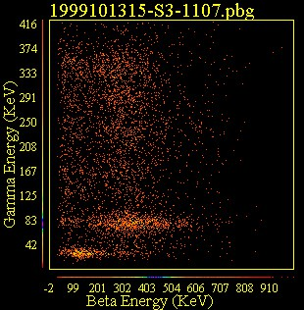
There are a number of half-life (t_{1/2}) dependent terms in the above equation to account for the radioactive decay that occurs during the collection, processing, and detection of the radioxenon sample. These terms can be quite substantial in the case of
214Pb
135Xe
133Xe

133Xe, 131mXe, 133mXe
¹³⁵Xe with its short half-life (t_{1/2} = 9.1 hours gives a
factor 4.42 increase in the calculated concentration and MDC values, which are calculated back to the beginning of the xenon collection time), but are small effects for the longer-lived radioxenons.

Determination of σ₀

There are five regions of interest (ROIs) in the two-dimensional gamma-beta spectrum (see Figure 1) obtained from each Xenon gas sample acquired by the ARSA system. There is also a two-dimensional gamma-beta spectrum taken before (and after) each xenon gas sample is injected into the detection

Figure 1. The two-dimensional spectrum obtained from each sample. The boxed regions indicate the five ROIs used for the calculation of the concentrations and the MDCs.

system and is used to measure the background. The calculation of the MDC value for each radioxenon isotope is different because of the distinct contributions and amount of the radon and radioxenon interference that are unique for each isotope. It is helpful to describe the background and radon interference contributions that are common to all ROIs before presenting the individual calculations for each isotope.
The following sections describe the MDC calculations used for the ARSA system to calculate the MDCs for each of the ROIs. For each radioxenon except ¹³³Xe, the calculation is fairly straightforward
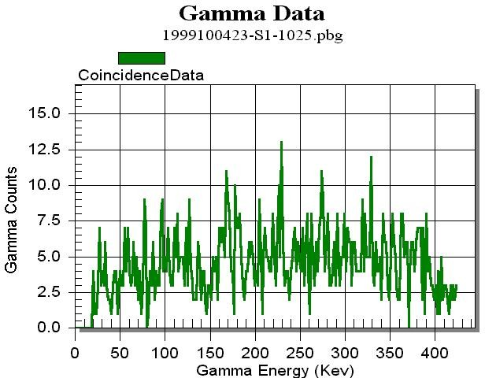
since the isotopes have only one ROI. ¹³³Xe has 2 ROIs that are combined to calculate the MDC for that isotope—and hence the total MDC is lower than either calculation separately.

Determination of the Background

Figure 2. The typical beta-gated gamma background spectrum (no radioactive sources present). Count time is 24 hours.
The non-source associated background (see Figure 2) is always present and most likely originates from cosmic rays and Compton scattering from high energy gamma-ray sources external to the detector. It is quantified when the detector is first brought to a new location and before any sources (radioactive gas) are injected into the beta cells. It can vary with location but is kept relatively small by shielding the detector with 5 cm of lead and an additional inner layer of 0.5-cm copper to attenuate

Pb x-rays (for data taken at the IAR, the background was 2.9 × 10⁻⁵ counts/sec/keV in the gamma spectrum). There is also an additional reduction of this background because the detector rejects coincidence events between any two (or more) beta cells and coincidence events between the two halves of the NaI(Tl) detector.

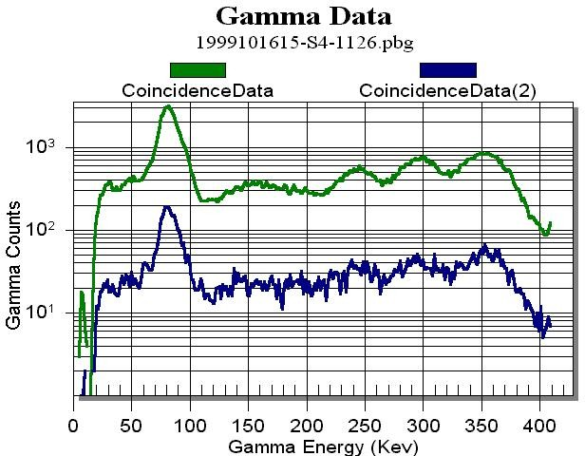
Determination of the Radon Interference

The radon gas does not directly cause the interference problems in the two-dimensional pulse height spectrum, it is the ²¹⁴Pb and ²¹⁴Bi daughters. ²¹⁴Pb has four dominate gamma-ray peaks in coincidence with betas at 79, 242, 295, and 352-keV (²¹⁴Bi also contributes to the
79-keV peak) (see Figure 3). Compton scattering from these gamma rays also affects all of the ROIs used for radioxenon measurements. The radon interference is accounted for by using a high statistics measurement made with only radon gas in the cell with the background subtracted out and determining the ratio of counts in the 352-keV gamma peak to the counts present in each of the ROIs (this is included in the prototype radioxenon data format [Biegalski 1999]). The

Figure 3. High statistics gamma spectrum with radon. The green (higher counts) line is a 24 hour count and the blue line (lower counts) is an 8 hour count taken subsequently and shows the 20% memory effect of radon.

¹³⁵Xe 250-keV ROI and the ¹³³Xe 81-keV ROI have the strongest interference with ²¹⁴Pb because of the 242-keV and 79-keV peaks, respectively. The 30-keV regions (¹³³Xe, ^{131m}Xe and ^{133m}Xe) are affected weakly from the Compton scattering from the higher energy gamma-rays.
The memory effect of radon (how much radon remains in the beta cell after the sample has been evacuated)^{(a)} is substantial (20%) and, coupled with its long half-life (3.83 days), can affect subsequent xenon samples measured in the beta cell for days. This memory effect is effectively removed because of the subtraction of the background count. The amount of radon interference determined from the background count is slightly higher than what would be measured in the sample due to radioactive decay. Therefore, the counts subtracted out will be higher than needed and hence the variance will be higher than appropriate. Assuming that all of the counts in the background originate from ²²²Rn, this amounts to a systematic 6% increase in the variance. If instead all of the count in the background originate from memory effects related to the radioxenon isotope, then the systematic increase for the radioxenon-specific variance becomes 73% for ¹³⁵Xe, 4.5% for ¹³³Xe, 10.9% for ^{133m}Xe, and 2% for ^{131m}Xe. The true situation for a given sample is a combination of radioxenon and ²²²Rn memory effects and thus becomes difficult to deconvolute, and would give a slightly higher MDC than those obtained with a more rigorous treatment of memory effect contributions. For this reason, the MDCs calculated in this work should be considered slightly pessimistic.

(a) The memory effect is highly dependent on the contact time of the radon or xenon gas with the counting cell. The memory effect numbers quoted here are for a 24-hour contact time.

¹³⁵Xe MDC Calculation
The ROI for ¹³⁵Xe is strongly affected by the interference of the 242-keV gamma ray of ²¹⁴Pb, which, as mentioned earlier, is either from the previous sample (memory) or injected into the beta cell, along with the xenon sample. The contribution from the memory effect associated with radioxenon can be accounted for by determining the standard deviation of the previous background count. The xenon gas has a memory effect of approximately 5%, and due to the short half-life of ¹³⁵Xe (9.1 hours) it is unlikely that this will ever be a substantial correction, and thus, for the purposes of this report, will not be considered.^{(a)} The equations below explain each of the components needed to determine the MDC value for ¹³⁵Xe for an arbitrary sample count.

135 Xe250

(mBq )=

2.71 + 3.29σ^{135Xe}
C
(λ135Xe )2

TC *1000

MDC m³air
ε_{γ} ε_{β} γ
BRβBR
(1 − exp(− λ^{135Xe}T
))exp(− λ^{135Xe}T
)(1 − exp(− λ^{135Xe}T ))
VAir

where
(σ
)
(
)
2 * (σ
135Xe
BckCnt
2
+
Ratio * σ
135Xe 214Pb
214Pb SamCnt
2
+
Ratio135 Xe
214 Pb
* SamCnts^{214Pb} )2
P
A

σ135Xe =

is the standard deviation of the background and ¹³⁵Xe signal when the ¹³⁵Xe signal is equal to zero,
Sample _ count _ time
Background _ count _ time
BckCnts^{135Xe}

135Xe
σ
BckCnt
= ,

is the standard deviation of the total counts in the ¹³⁵Xe ROI found in the previous background count and includes both the memory effect and the background contributions. Because of the 8-hour background count time vs. the 24-hour sample count time, it is necessary to normalize the background variance with
respect to the sample variance. The term, σ^{214Pb352} , is the variance of the total counts in the ²¹⁴Pb ROI found in the sample count that has had the previous background count removed,
SamCnt

214Pb
BckCnt2s14Pb352 +SamCnt2s14Pb352
σ
=
SamCnt

The amount of ²¹⁴Pb found in the ¹³⁵Xe ROI is found using a previously measured ratio, Ratio^{135Xe} , which
214Pb

has an uncertainty of σ

135 Xe
Ratio
214 Pb
(less than 2.0%).

As mentioned earlier, the correction to the MDC to account for the memory effect decay of ²¹⁴Pb during counting is small (<6%) because of its long (3.8-day) half-life. Furthermore, the memory effect associated with the ¹³⁵Xe from the previous sample is small (< 0.8%).

(a) For ¹³⁵Xe, 84% of a given sample will decay while it is being counted, the remaining 16% will be reduced to 0.8% when the beta cell is evacuated prior to a background count. Therefore, its contribution to subsequent samples is negligible except for very high ambient ¹³⁵Xe concentrations.

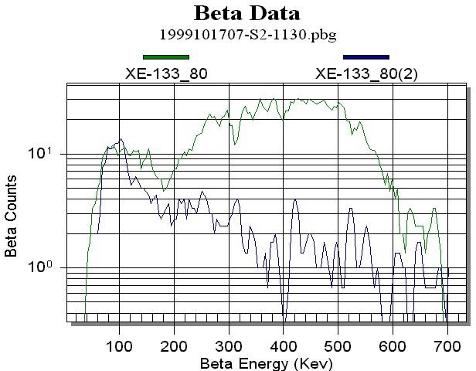
¹³³Xe^{81keV} MDC Calculations
133Xe
214Pb + 214Bi

In the two-dimensional beta-gamma spectrum ¹³³Xe has two ROIs, one at a gamma-ray energy of 30-keV and is actually a group of four closely spaced x-rays not resolved with NaI(Tl), and the other is a gamma-ray at 81-keV. Each of them have radon daughter interferences; the 81- keV line has a direct interference from the 79-keV ²¹⁴Pb and ²¹⁴Bi x-rays, and the 30-keV peak has an interference contribution from the Compton continuum from the higher energy gamma-rays. In addition, the 30-keV peak has the potential interference from ^{131m}Xe and ^{133m}Xe that may be present in the spectrum. The 81-keV region MDC is calculated in the same way as ¹³⁵Xe. Because the interference is particularly strong in this ROI (see Figure 3) it was decided to restrict the beta energy range to 0 to 200 keV rather then extending it out to the 0 to 346 keV range of the beta energy spectrum. This reduced

Figure 4. The beta spectrum from ¹³³Xe (blue line) and ¹³³Xe and radon daughters (green line). The red line indicates the reduce ROI used for the MDC calculations.

ROI decreases the Ratio^{133Xe81} by a factor of 5 while removing only ~30% of the ¹³³Xe 81 keV data (see
214Pb79
Figure 4). The ¹³³Xe^{80keV} MDC calculation is carried out in the same manner as the ¹³⁵Xe.

133 Xe81

(mBq )=

2.71 + 3.29σ^{133Xe81}
C

(λ133Xe )2

TC *1000

MDC
P
A

m³air
εγ εβ γ
BR βBR
(1 − exp(− λ^{133Xe}T
))exp(− λ^{133Xe} T
)(1 − exp(− λ^{133Xe} T ))

VAir

where
2 * (σ
133Xe81
BckCnt
) + (
2
Ratio
133Xe81 214Pb79
214Pb79 SamCnt
* σ
) + (
2
σ
Ratio133 Xe81
214 Pb 79
* SamCnts 214Pb79 )2

σ133Xe81 = ,

and

133Xe81
BckCnts133Xe81
σ =
,
BckCnt

is the standard deviation of the total counts in the ¹³³Xe^{81keV} ROI found in the previous background count and includes both the memory effect and the background contributions. The term,

214Pb79
BckCnts214Pb325 + SamCnts214Pb352
σ =
,
SamCnt

is the same error associated with the ²¹⁴Pb^{352keV} ROI, and Ratio^{133Xe81} is the ratio of the ²¹⁴Pb 79-keV ROI
214Pb79
to the ²¹⁴Pb 352-keV ROI, and has an equivalent error, σ , associated with it (less than 2.0%).
Ratio133Xe81
214 Pb 79

The previous background count is used to account for the residual ¹³³Xe and ²¹⁴Pb that remain in the beta cell from the memory effect, and as mentioned earlier, the variance of these values is, at most, 6% higher than the actual variances associated with the true residual contributions from the memory effect of radon of xenon.

30-keV Gamma Region MDC Calculations
The calculation of MDC levels for the ¹³³Xe 30-keV ROI requires two additional ratios to account for the two meta-stable radioxenon isotopes ^{131m}Xe and ^{133m}Xe. Both of these isotopes emit mono-energetic conversion electrons (129 keV for ^{131m}Xe and 199 keV for ^{133m}Xe), which are seen in the 30-keV gamma-gated beta spectrum as Gaussian peaks. The resolution of the beta cells is ~35%, and so there is some overlap in these peaks. To overcome this problem the beta spectrum gated on the 30-keV
x-rays is split into three distinct regions (Figure 5 shows the division of the 30-keV gamma ROI into three regions in the beta spectrum). Region I is the ROI for ¹³¹Xe, and region II is the ROI for

1000

100
Counts

10

30 keV Gamma-Gated Beta Energy Spectrum

0 50 100 150 200 250 300 350 400 450 500

131mXe133mXe
Region III
Region I
Region II
Region III
Beta Energy (keV)

^{133m}Xe. These two regions are reduced in size so that there is no possible overlap in counts in the region between them. Region III is composed of
Figure 5. 30-keV gamma-gated beta spectrum for pure ¹³³Xe divided into the three regions to determine
the ratios Ratio^{131mXe30} and Ratio^{133mXe30} .

two separate beta/gamma energy regions. The first region extends from ~20 to 40-keV in the
133Xe30
133Xe30

gamma energy region and from 0 to 100 keV in the beta energy region, and the second region covers the same gamma energy region but covers a beta energy region from 240 to 392-keV. This modified region excludes any possible inclusion of metastable contamination for the ¹³³Xe.
From these three regions it is possible to calculate the concentrations of ¹³³Xe, ^{131m}Xe, and ^{133m}Xe independently.

^{131m}Xe^{30keV} Region MDC Calculation
To determine the amount of ^{131m}Xe there is in any given spectrum a previously measured ratio using pure ¹³³Xe. The ratio, Ratio^{131mXe30} , is found by dividing the counts in region I by those in region III. This ratio then is used to determine the excess counts in region I (^{131m}Xe ROI) as follows:
133Xe30
SamCnts^{131mXe30} = Region I − Region III * Ratio^{131mXe30}
133Xe30

where the previous background count has been subtracted out from each region and included in the error calculations. For the MDC calculation only the potential interference from ¹³³Xe is important so that the error associated with this calculation is as follows:

σ131mXe30 =
2 * (σ
Region I
BckCnt
) + (
2
Ratio
131mXe30 Region III
133Xe30 SamCnt
* σ
) + (
2
σ
Ratio131mXe 30
133 Xe 30
* Region III
SamCnts
)2

where
SamCntsRegion III + BckCntsRegion III

Region I
σ =
BckCnt
Region III
SamCnt
BckCntsRegion I
and σ
= .

The MDC is then:

131m

30 ( mBq )

2.71 + 3.29σ^{131mXe30}
(λ131mXe )2

TC *1000

Xe =
MDC 3
C
P
A
m air
ε γ εβ γ

BR βBR
(1− exp(− λ^{131mXe} T
))exp(− λ131mXe T
)(1 − exp(− λ^{131mXe} T ))

VAir

^{133m}Xe^{30keV} Region MDC Calculation

A similar process is followed to determine the ^{133m}Xe MDC. The now becomes: Ratio^{133mXe30} , and is determined in the same way as before. The number of background subtracted counts in the ^{133m}Xe ROI is now:
133Xe30

SamCnts^{133mXe30} = Region II − Region III * Ratio^{133mXe30}
133Xe30

The error associated with this calculation is:
2 * (σ
Region II
BckCnt
) + (
2
Ratio
133mXe30 Region III
133Xe30 SamCnt
* σ
) + (
2
σ
Ratio133 mXe 30
133 Xe 30
* Region III
SamCnts
)2

σ131mXe30 =

where

Region II
BckCntsRegion II
σ =
BckCnt
and σ ^{Region} ^{III} was defined above.

The MDC becomes:
SamCnt

( )

2.71 + 3.29σ^{133mXe30}

(λ133mXe )2

T *1000
C

133m Xe30 mBq =
( ( )) ( )(
( ))

MDC m³air
C
P
A
εγεβγ
BRβBR
1 − exp − λ^{133mXe}T
exp − λ133mXeT
1 − exp − λ^{133mXe}T
VAir

¹³³Xe^{30keV} Region MDC Calculation
Because of the breakup of the 30-keV gamma energy region into the three distinct regions, it is now possible to determine the ¹³³Xe 30-keV region MDC easily.^{(a)}
The variance used in the MDC calculation is:

σ133Xe30 =
)
2 * (σ
133 Xe30
BckCnt
2

(a) From experience operating the ARSA system in North America and Europe, ¹³³Xe dominated the gamma-ray spectrum more than 90% of the time.

where

133Xe30
BckCnts133Xe30
σ =
,
BckCnt

and the MDC is:

2.71 + 3.29σ^{133Xe30}
( )

(λ133Xe )2

T *1000

133 30
Xe
MDC
C
P
A
mBq =
m³air
εγ εβ γ

BR βBR
(1 − exp(− λ^{133Xe} T
))exp(− λ^{133Xe} T
)(1 − exp(− λ^{133Xe} T ))
C .
VAir

This MDC does not account for decay of ^{133m}Xe to ¹³³Xe, which will confuse the issue of how much of the ¹³³Xe is from ^{133m}Xe and how much was produced in the initial process. Presumably this does not affect the MDC for ¹³³Xe; rather it affects the ratio between ^{133m}Xe and ¹³³Xe.

¹³³Xe MDC
The two MDC calculations made for ¹³³Xe can be combined to produce a single MDC for each spectrum. The equation,

133 Xe
mBq =
m³air
1
( Xe ) + ( Xe )
133
81keV
−2
133
30keV
−2
MDC
MDC
MDC ( )

is the weighted average of the errors and is dominated by the smaller of the two MDC calculations. It should be noted that the equation used above is not mathematically rigorous, but probably within 10% of the rigorous value.

Further MDC Calculations
Because the ARSA system measures three xenon samples a day, it is possible to obtain a lower MDC value for each radioxenon isotope in the following manner:

( ) ∑ iMDC
3
Xe

Daily MDC
3
Xe
mBq m³air
= ^{i=1} , where each i is one of three daily measures of a paticular xenon isotope.
3

Results Obtained from IAR Measurements
During recent field testing of the ARSA system in Freiburg Germany, at the Insitut für Atmosphräische Radiaktivität (IAR), we were able to determine concentrations for ¹³³Xe and ^{131m}Xe and calculate MDC values for the ¹³³Xe results. A total of 63 measurements were made during a three-week period and the concentrations of xenon were variable as well as the radon interference. Typical ¹³³Xe concentration values ranged from 0.0 ± 0.06 to 2.74 ± 0.24 mBq/SCMA. Figure 6 shows the MDC results, and most values over the 3-week period were less than 0.15 mBq/SCMA for an 8-hour xenon collection time (<0.09 mBq/SCMA for a 24-hour collection time), which is well below the
1.0 mBq/SCMA required by the Comprehensive Nuclear Test Ban Treaty (CTBT).

¹³³Xe MDC Values

0.60
MDC 30
MDC 80 MDC 133Xe
MDC (mbq/SCMA)
0.50
0.40
0.30
0.20
0.10
0.00

Cell - Run Number
S4-1080
S2-1085
S4-1089
S2-1097
S4-1101
S2-1105
S4-1109
S2-1113
S4-1118
S2-1122
S4-1126
S2-1130
S4-1134
S2-1138
S4-1142
S2-1146
S4-1150
S2-1154
S4-1158
S2-1162
S4-1166
S2-1170
S4-1174
S2-1178
S4-1182
S2-1186
Figure 6. Graph of the ¹³³Xe MDC values calculated for the field test at IAR. As expected, the 30-keV data (purple boxes) provides lower MDC values as there is little radon interference. The blue diamonds are the 81-keV data and the red triangles are the weighted average between the 30 and 81-keV data. Typical MDC values were 0.15 mBq/SCMA. The high point mid-graph resulted from excessive radon contamination after a change was made to the gas collection system—and thus would not be considered valid data during routine operation.

Conclusions

It is important that both ROIs be used for calculating the ¹³³Xe MDC for the ARSA system, because of the radon interference in the spectrum that occasionally significantly contaminates the 81-keV ROI. In fact, the 30-keV ROI is statistically as or more useful than the 81-keV ROI in more than 50% of the cases.
There are several effects that contribute to the MDCs for the ARSA system. These are radon interference, the memory effect, other radioxenon isotope interference, ambient background, and counting statistics. Counting statistics and radon interference usually dominate the MDC values for ¹³³Xe and ¹³⁵Xe. In parts of the world (especially close to reactors), ^{131m}Xe contamination to the ¹³³Xe signal can be significant (and vice versa) though near these locations, the MDC is not a useful measure of system performance, since it will require significant levels of ¹³³Xe to trigger International Data Center event bulletins. Likewise, the memory effect at these locations will be large, though unimportant compared to the daily levels and variations of the ¹³³Xe level. These considerations should be taken into account when doing site surveys for radioxenon equipment and for establishing the usefulness of the MDC value at some locations.

References

Biegalski KM. 1999. “Proposal for Release 3 Formats and Protocols: Full Incorporation of Noble gas Data into Pulse Height Data Messages,” Prototype International Data Centre, Rev. 10, October.
Currie LA. 1968. Analytical Chemistry, 40, 586.

Reeder PL and TW Bowyer. 1998. Nucl. Instr. Meth. Phys. Res. A408, 582.

WGB TL-11. 1999. Operational Manual for Radionuclide and the International Exchange of Radionuclide Data, Prepatory Commission for Comprehensive Nuclear Test Ban Treaty Organization, CTBT/WGB/TL-11/5/Rev. 4, Apr (1999).

