Wednesday, March 22, 2006

Note to Members of the Subcommittee on Valuation for National Rulemaking SAB Committee on Valuing the Protection of Ecological Systems and Services (C-VPESS)

Rick Freeman and Hal Mooney have asked me to begin our work together on the national rulemaking source example. Thanks especially to all who can participate in the face-to-face meeting planned for April 18-19, 2006 in Washington, DC. We hope that we can engage other subcommittee members who cannot attend through two pre-meeting teleconferences that we have scheduled for:

April 4, 2006 from 11 a.m. to 12 p.m., Eastern Time
Purpose: to discuss the goals and strategy for working together and preparing for a face-to-face meeting May 9-10, 2006.
Teleconference number: Call 866-299-3188, access code 343-9981 and press the # sign.

April 11, 2006 from 11:00 - 12:30 a.m. Eastern Time
Purpose: Subcommittee to discuss with Agency staff background questions about the Agency’s benefit assessments for the proposed and final aquaculture rules and about the process used for developing those assessments.
Teleconference number: Call 866-299-3188, access code 343-9981 and press the # sign.

Please RSVP (nugent.angela@epa.gov) by Wednesday March 22 to confirm your availability for the calls.

Please find attached background materials for subcommittee’s work and preliminary agendas for our face-to-face meeting and pre-meeting teleconferences. The draft face-to-face meeting agenda assumes that members who are not able to attend the face-to-face meeting will be contributing text and ideas to the discussion through email or teleconference participation.

Please read the background material described in the Aquaculture Overview and, at a minimum, the key sections of the final benefit assessment (identified on page 6 in the table “Key Sections of EPA Documents”--web links provided) before the first planning call, April 4, 2006.

Please let me know if I can be helpful as you begin work on the source example.

Angela

Table of Contents

Appendix 1: Aquaculture Overview 3
Appendix 2: Suggested Guidance 10
Appendix 3: Draft Agenda for Face-to-face Meeting April 18-19, 2006 15
Appendix 4: Draft Agenda for Planning Call April 4, 2006 18
Appendix 5: Draft Agenda for Planning Call April 18-19, 2006 19

.

Appendix 1: Aquaculture Overview
C-VPESS Subcommittee on Valuation for National Rulemaking: Aquaculture Rule Source Example: Overview of Aquatic Rule for C-VPESS Subcommittee

Valuation Issue: What are the benefits associated with the new regulations in the final rule? What were the benefits associated with options described in the proposed rule?

EPA Decision/Reason for Valuation:

On June 30 2004, EPA finalized a new rule establishing effluent limitations guidelines (ELGs) for concentrated aquatic animal production (CAAP), or aquaculture, facilities. The regulation applied to CAAP facilities that generate wastewater from their operations and discharge that wastewater directly into waters of the United States.

The scope of the rule is described in Attachment 1. Attachment 2 provides a table of technologies required by the final rule compared with other options considered by EPA

Authority for and Genesis of Rule

Title III of the Clean Water Act (CWA) gives EPA authority to issue effluent guidelines, national standards for wastewater discharges to surface waters and publicly owned treatment works (municipal sewage treatment plants). The standards are technology-based (i.e. they are based on the performance of treatment and control technologies). They are not based on risk or impacts upon receiving waters.

When EPA completed this regulation, it completed all the regulations required by a January 1992 settlement with the Natural Resources Defense Council and others, which established a schedule by which EPA would consider regulations for 19 industrial categories. Section 304(m) of the Clean Water Act governs how EPA works with the public in identifying identify industries for which effluent guidelines need to be revised or developed.

Requirements for and Use of Cost-benefit Analysis

The CWA includes no mandate for cost-benefit analysis. As a technology-based rule, decision-making centers on analysis of cost-effectiveness. The CWA, however, does not prevent EPA decision-makers from considering cost-benefit analysis as part of the entire technical analysis supporting a decision.

Under Executive Order 12866 the Agency must determine whether a regulatory action falls under the definition of a “significant regulatory action” which requires a cost-benefit analysis and OMB review. EPA generally conducts a cost-benefit analysis for rules that might meet this trigger.

Information in cost-benefit analysis is used by decision makers, especially for controversial issues. Analysts supplement formal monetized cost-benefit analysis with narrative description of non monetized benefits to explain benefits of different regulatory options. These narrative descriptions are often removed stripped from final assessments because of the time involved in developing them and negotiating final language with OMB.

Decision-maker who was to use analysis: Acting Administrator,

Other audiences for valuation information:

Other audiences include: OMB and interested and affected parties (e.g., regulated entities, trade associations, environmental groups, and the technical experts hired by these parties. In the case of some effluent guidelines (not the aquaculture guidelines) regulated parties may be interested in the valuation because they may have the ability to apply for waivers from site-specific permits because particular circumstances do not justify the cost-benefit standard established in the final economic assessment.

Status of Valuation Work and Chronology of Valuation Effort:

Final rule published | June 30, 2004 | http://www.epa.gov/fedrgstr/EPA-WATER/2004/August/Day-23/w15530.htm
Final benefit analysis published | June 2004. | http://www.epa.gov/waterscience/guide/aquaculture/EEBA/index.html
Due date for comments on proposed rule: | January 27, 2003.
Proposed rule published | September 12, 2002 | http://www.epa.gov/fedrgstr/EPA-WATER/2002/September/Day-12/w21673.htm
Proposed benefit analysis published | September 2002. | http://www.epa.gov/waterscience/guide/aquaculture/ea/ea.htm

The web page for the rule (http://www.epa.gov/waterscience/guide/aquaculture/)
contains a more complete chronology and links to relevant documents:
“Bottom-line” Costs and Benefits

In the final assessment, EPA described the costs and benefits of the final rule option in the following ways. The Agency provided “Estimated Pre-Tax Annualized Compliance Costs and Monetized Benefits” (2003 dollars) (see Table ES-4 in the final assessment)

Estimated Total Costs | $1,445,000
Estimated total Benefits | $66,000 to $99,000

“Monetized benefit categories are primarily in the areas of improved surface water quality (measured in terms of enhanced recreational value). EPA also identified a number of benefits categories that could not be monetized, including reductions in feed contaminants and spilled drugs and chemicals released to the environment, as well as better reporting of drug usage to permitting authorities.” (p. ES-12)

In the proposed assessment (see p. 10-1), EPA described the benefits in the following way:

“EPA has quantified and monetized a subset of the anticipated benefits of the proposed action listed above. The central basis for the quantitative benefits analysis is a water quality modeling assessment that estimates water quality responses to the pollutant loading reductions under technology options described earlier in this document. Specifically, the benefits that EPA has been able to quantify are (a) water quality improvements in stream reaches downstream of flow-through and recirculating systems, and (b) improvements in the recreational use value of these same reaches. Benefits that were not quantified include water quality and ecological responses to pollutant loading reductions at net pen systems and ecological and other water resource benefits from reductions in releases of non-native species, aquatic animal pathogens, and drugs and chemicals used at CAAP facilities. EPA did not quantify or monetize these potential benefits due to lack of readily available assessment modeling tools for such an analysis. Thus, the estimated monetized benefits of the proposed action are based only on a portion of the expected environmental benefits of the proposed regulation.”
Overview of EPA Valuation: Key Sections of EPA Documents

Identification of potentially important ecological changes | Final benefit assessment: Chapter 7 on Environmental Impacts from Aquaculture Facilities. | http://www.epa.gov/waterscience/guide/aquaculture/EEBA/EEBA%20-%20Chapter%207.pdf
Identification of potentially important ecological changes | Proposed benefit assessment: Chapter 9 on Environmental Impacts of the AAP Industry in the U.S | http://www.epa.gov/waterscience/guide/aquaculture/ea/ch9.pdf
Characterization and /or quantification of benefits (non-monetary terms and monetary terms) | Final benefit assessment: Chapter 8 on Environmental Benefits of Final Regulation, | http://www.epa.gov/waterscience/guide/aquaculture/EEBA/EEBA%20-%20Chapter%208.pdf
 | Proposed benefit assessment: Chapter 10 on Environmental Benefits of Proposed Regulation and Chapter 11., Section 1, Cost-Benefit Comparison | http://www.epa.gov/waterscience/guide/aquaculture/ea/ch10.pdf  http://www.epa.gov/waterscience/guide/aquaculture/ea/ch11.pdf
Characterization of uncertainty and data quality | Final benefit assessment: Chapter on Environmental Benefits of Final Regulation, Chapter 8, especially section 8.2.7, Source of Uncertainty | http://www.epa.gov/waterscience/guide/aquaculture/EEBA/EEBA%20-%20Chapter%208.pdf

Other Aspects of the Analytical Process

Data constraints:

The CWA provides direct authority for EPA to survey industries concerning technologies and costs related to effluent guidelines. OMB review of such surveys under the Paperwork Reduction Act does not impede development of regulations. There is no authority provided for data collection related to the benefit of such regulations.

Resource constraints:

The Office of Science and Technology prepared the final assessment with the support of Eastern Research Group, Incorporated and Tetra Tech.

Peer review:

The economic assessments were not peer reviewed nor were sections of the documents peer reviewed because they did not include novel methods or approaches.

Attachment 1: Scope of Final Rule

Excerpt from “Effluent Guidelines Aquatic Animal Production Industry Final Rule - Fact Sheet”
http://www.epa.gov/waterscience/guide/aquaculture/fs-final.htm#

The rule requires that all applicable facilities:

- Prevent discharge of drugs and pesticides that have been spilled and minimize discharges of excess feed.
- Regularly maintain production and wastewater treatment systems.
- Keep records on numbers and weights of animals, amounts of feed, and frequency of cleaning, inspections, maintenance, and repairs.
- Train staff to prevent and respond to spills and to properly operate and maintain production and wastewater treatment systems.
- Report the use of experimental animal drugs or drugs that are not used in accordance with label requirements.
- Report failure of or damage to a containment system.
- Develop, maintain, and certify a Best Management Practice plan that describes how the facility will meet the requirements.

The rule requires flow through and recirculating discharge facilities to minimize the discharge of solids such as uneaten feed, settled solids, and animal carcasses.

The rule requires open water system facilities to:

- Use active feed monitoring and management strategies to allow only the least possible uneaten feed to accumulate beneath the nets.
- Properly dispose of feed bags, packaging materials, waste rope, and netting.
- Limit as much as possible wastewater discharges resulting from the transport or harvest of the animals.
- Prevent the discharge of dead animals in the wastewater.

Attachment 2
Technologies Required by the Final Rule Compared with other options considered by EPA

Image below taken from final assessment, page 4-2

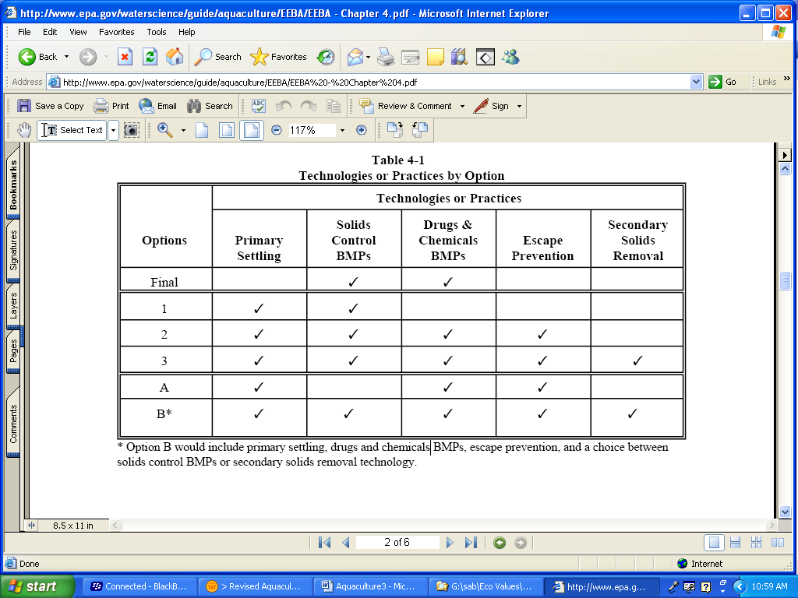

Appendix 2: Suggested Guidance
Suggested Guidance for C-VPESS Subcommittees Preparing Draft Text Relating to EPA Valuation “Source Examples” for the May 9-10, 2006 C-VPESS meeting

At the C-VPESS planning call on February 3, 2006, committee members agreed to work in March and April in three subcommittees focusing on three types of source examples of most apparent interest
- Valuation for national-level rule-making: Tentative focus: EPA Office of Water Aquaculture rule;
- Valuation for regional decision-making: Tentative focus: Green Infrastructure Mapping as a Decision-Support Tool
- Valuation for local decision-making: (tentative focus: Superfund Site(s) combined with Traditional versus Sustainable Redevelopment of Contaminated Properties)

C-VPESS members asked for guidance on the scope and general approach for the source example exercise. The suggested guidance below is offered to help subcommittees work in parallel to achieve the two major purposes of the source-example exercise:
- to help the C-VPESS develop its Applications Report, which will examine how EPA might conduct valuation studies in particular decision contexts (e.g., national rule-making, regional decisions, local decision-making) using a variety of methods.
- to help C-VPESS identify the extent to which the various methods included in the current draft SAB C-VPESS Methods Report might be used by EPA, to assess their strengths and weaknesses; and to shed additional light on a number of cross-cutting issues that have been identified for inclusion in that report.

This guidance suggests that subcommittees consider three major questions:
- How could EPA conduct ecological valuation as completely as possible in the specific context provided by the source example?
- How could EPA conduct ecological valuation in other contexts that are similar to the specific context provided by the source example but differ in some key aspect such as scale, data availability, scientific uncertainty, etc.? In other words, how can the source examples provide a starting point for a more general approach to ecological valuation that would be useful to EPA?
- Based on subcommittee discussions, how can the C-VPESS refine the discussion of cross-cutting issues currently in the October 18, 2005 draft of the Methods Report and address other cross-cutting issues identified at the December 2005 SAB Workshop, Science for Valuation of EPA's Ecological Protection Decisions and Programs?

More detail related to these questions can be found in the attachment to this guidance.

Subcommittee draft expanded narrative outline for the May 9-10 meeting should represent the consensus views of subcommittee members or the range of views held by them. Draft expanded narrative outlines should be approximately 15-25 pages in length, provided to the Designated Federal Officer by May 1, 2006 for distribution to the full committee.

Attachment: Additional Detail on Three Major Questions for
C-VPESS “Source Example Subcommittees”

- How could EPA conduct ecological valuation as completely as possible in the specific context provided by the source example?

As a guide to this effort, each subcommittee can refer to the process diagram discussed earlier by the committee (see figure 1) and ask:

  - how could you identify the potentially important ecological changes?
  - how could you determine what people care about, and hence what changes to focus on?
  - how can you quantify the ecological impacts in bio-physical terms?
  - how can you characterize and, if possible, quantify these impacts in human (but non-monetary) terms?
  - if necessary, how might you quantify these impacts in monetary terms?

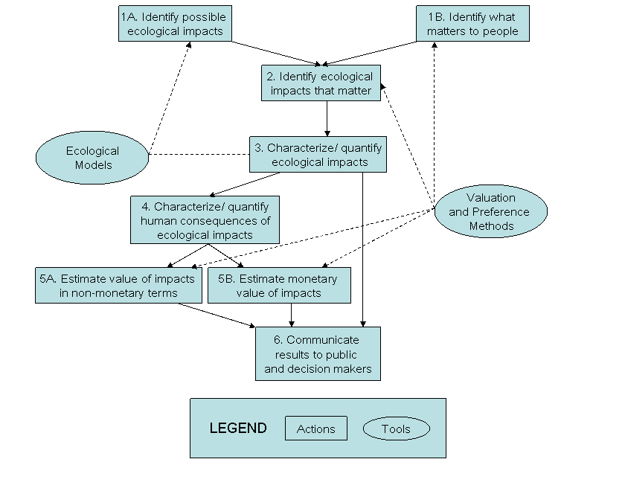
In the process of answering these questions, each subcommittee can identify the extent to which the various methods included in the current draft SAB C-VPESS Methods Report
(http://www.epa.gov/sab/pdf/c-vpess_oct_18_2005_draft_12_methods_report.pdf) might be used by EPA and assess their strengths and weaknesses.

In regard to question 3, each subcommittee can also consider whether they found the Boyd and Banzhaf approach (Boyd and Banzhaf 2006) to defining ecosystem services to be helpful? If not, why not?

- What questions should be asked related to this type of valuation that would make C-VPESS advice more generally useful to EPA? How can the subcommittee change aspects of the source example to illuminate potentially useful applications of analytical processes, methods and data sets?

- Subcommittees should ask:
  - Are there special features to this valuation exercise that analysts don’t generally encounter?
  - Are there regular features or issues associated with other valuation exercises that this source example doesn’t involve?

- Some suggestions from Committee Members:
  - Could the issue raise concerns about the value of “natural” vs. non-natural (e.g., genetically engineered, engineered, exotic species) components of the ecosystem and does EPA’s valuation approach address these concerns? Are there appropriate methods that could?
  - Could the valuation issue involve valuation issues regarding “bio-ecological” benefits (biodiversity, protection/restoration of native plant/animal species, “naturalness”) and some important aesthetic benefits that can be represented visually (e.g., natural beauty—which requires some specific piece of landscape to represent)? If so present and discuss the role that (non-economic) verbal and perceptual survey methods might play in such a decision making process

- Based on subcommittee discussions, how can the C-VPESS refine the discussion of cross-cutting issues currently in the October 18, 2005 draft of the Methods Report and address other cross-cutting issues identified at the December 2005 SAB Workshop, Science for Valuation of EPA's Ecological Protection Decisions and Programs?
  - Determination of who is appropriate to assign ecological values (e.g., experts, non-experts) and related issues of sampling and representativeness
  - Selecting the endpoint or target to be valued
  - Choice of spatial and temporal scale for the valuation
  - Selecting appropriate descriptions or expressions of the endpoint or target
  - Spatial data issues
  - Importance of quantifying and/or characterizing non-monetized benefits in a way that is scientifically based, defensible, verifiable (not just listing them and including as +B); standardization is key; metrics to use?
  - Data quality – general characterization of data quality, importance (or lack thereof) of response rates; use of knowledge networks; questions about reaction vs. introspection; tradeoffs between Type I and Type II errors; role of information (how informed)
  - Characterization of uncertainties
  - Potential for data sharing – making existing data (ecological, economic, survey) readily available; data, model, and parameter “banks”; making use of LTER, NEON; standardization of data

Appendix 3: Draft Agenda for Face-to-face Meeting April 18-19, 2006
Meeting of the Subcommittee on Valuation for National Rulemaking, SAB Committee on Valuing the Protection of
Ecological Systems and Services (C-VPESS) Draft Agenda
April 18-19, 2006

Science Advisory Board Conference Center, 1025 F Street, NW, Suite 3705, Washington, D.C. 20004

Purpose: Subcommittee to develop the Aquaculture Rule source example to develop draft text for full C-VPESS consideration on May 9-10, 2006 that will
• help the C-VPESS develop the national rule-making portion of the Applications Report rule-making, regional decisions, local decision-making) using a variety of methods.
• to help C-VPESS identify the extent to which the various methods included in the current draft SAB C-VPESS Methods Report might be used by EPA, to assess their strengths and weaknesses; and to shed additional light on a number of cross-cutting issues that have been identified for inclusion in that report.

Day 1

9:00 - 9:10 | Welcome | Dr. Angela Nugent, EPA, SABSO  Dr. Vanessa Vu, EPA, SABSO
9:10 - 9:20 | Review of agenda | Drs. A. Myrick Freeman and Harold Mooney, Co-Chairs
9:20 - 9:40 | Identification of ecological stressors associated with concentrated aquatic animal production (CAAP) | Dr. A. Myrick Freeman
9:40 - 10:30 | Identification of potentially important ecological changes | Dr. Robert Huggett  Dr. Harold Mooney
10:30 - 11:00 | Break
11:00 - 12:00 | Identification of related human values and ecological changes for what people care about, and the ecological changes to focus on | Dr. Douglas MacLean  Dr. William Ascher  Dr. Paul Slovic (not attending in person)
12:00 - 1:00 | Lunch
1:00 - 2:30 | Quantification of ecological impacts in bio-physical terms | Dr. Robert Huggett  Dr. Harold Mooney
2:30 – 3:30 | Characterization and quantification of impacts in human (but non-monetary) terms | Dr. Douglas MacLean  Dr. William Ascher  Dr. Paul Slovic (not attending in person)
3:30 - 3:45 | Lunch
3:45 - 4:45 | Quantification in monetary terms | Dr. A.Myrick Freeman  Dr. V. Kerry Smith (not attending in person)  Dr. Robert Stavins (not attending in person)
4:45 - 5:30 | Characterization of data quality and uncertainty | Dr. William Ascher  Dr. Robert Stavins (not attending in person)  -
5:30 | Adjourn

Day 2

8:30 - 8:35 | Opening of Meeting/Review of Agenda | Drs. A. Myrick Freeman and Harold Mooney
8:35 – 11:00 | Additional methodological issues to address of importance to valuation for rulemaking | All
11:00 – 2:45 | Working Lunch  Discussion of Cross-Cutting Issues | All, based on assignments
3:00 | Adjourn

Appendix 4: Draft Agenda for Planning Call April 4, 2006

Subcommittee on Valuation for National Rulemaking SAB Committee on Valuing the Protection of Ecological Systems and Services (C-VPESS) Draft Agenda Planning Teleconference #1: April 4, 11:00 - 12:00 a.m. Eastern Time
Teleconference number: 866-299-3188, access code 343-9981 #

Purpose: Subcommittee to discuss the goals and strategy for working together and preparing for a face-to-face meeting May 9-10, 2006.

Day 1

11:00 – 11:10 | Welcome and review of agenda | Dr. Angela Nugent, EPA, SABSO  Drs. A. Myrick Freeman and Harold Mooney, Co-Chairs
11:10 - 11:20 | Review of goals for subcommittee and review of materials sent to subcommittee members | Drs. A. Myrick Freeman and Harold Mooney
11:20 -11:30 | Discussion of pre-meeting teleconference (April 1?, 2006) with Agency  Purpose: to raise questions about the Agency’s benefit assessments for the proposed and final aquaculture rules and about the process used for developing those assessments | All
11:30 – 11:50 | Proposed agenda and assignments for April 18-19th face-to-face Subcommittee meeting | All
11:50 – 12:00 | Summary of Action Items | Drs. A. Myrick Freeman and Harold Mooney
12:00 | Adjourn

Appendix 5: Draft Agenda for Planning Call April 18-19, 2006

Subcommittee on Valuation for National Rulemaking SAB Committee on Valuing the Protection of Ecological Systems and Services (C-VPESS)
Draft Agenda
Planning Teleconference #2 April 11, 11:00 - 12:30 a.m. Eastern Time
Teleconference number: 866-299-3188, access code 343-9981 #

Purpose: Subcommittee to discuss with Agency staff background questions about the Agency’s benefit assessments for the proposed and final aquaculture rules and about the process used for developing those assessments.

11:00 – 11:10 | Welcome, introductions, and review of agenda | Dr. Angela Nugent, EPA, SABSO  Drs. A. Myrick Freeman and Harold Mooney, Co-Chairs
11:10 - 11:30 | Response from Agency Staff to questions provided in advance | Dr. Julie Hewitt
11:30 -12:15 | Discussion of additional questions | All
12:15 – 12:30 | Summary of Action Items | Drs. A. Myrick Freeman and Harold Mooney
12:30 | Adjourn

Economic and Environmental Benefits Analysis of the Final Effluent Limitations Guidelines and New Source Performance Standards for the Concentrated Aquatic Animal Production Industry Point Source Category (hereafter called “final assessment”), EPA-821-R-04-013
Economic and Environmental Impact Analysis of the Proposed Effluent Limitations Guidelines and Standards for the Concentrated Aquatic Animal Production Industry (hereafter called “proposed assessment”) EPA-821-R-02-015
More specifically, the source examples are intended: - to provide specifics about what should be done to characterize ecological values more fully, not to critique EPA efforts or provide detailed advice on specific cases - to provide context for a discussion of the practical issues that EPA is likely to face in doing valuations, not to provide EPA with analysis on specific valuations. - to provide a starting point for discussion of how varying details of the examples (e.g., changing scale, type of pollutant, data availability) might lead to use of different methods or approaches, so that C-VPESS can generate general principles with applicability beyond the specific details of the source examples. - to help the C-VPESS draft an Applications Report that would offer guidelines for conducting ecological valuation in different decision contexts with enough specificity to allow EPA analysts and decision makers to make better informed choices about how to conduct and use ecological valuations.
on the web at http://www.epa.gov/sab/pdf/c-vpess_oct_18_2005_draft_12_methods_report.pdf) ,
Boyd, J. and S. Banzhaf (2006). What are Ecosystem Services? The Need for Standardized Environmental Accounting Units. RFF Discussion Papers. Washington, DC, Resources for the Future. On the web at: http://www.rff.org/rff/News/Features/What-are-Ecosystem-Services.cfm
We could tag subcommittee members to come prepared to address the topics below and have them come with brief text - Determination of who is appropriate to assign ecological values and related issues of sampling and representativeness (Slovic-not attending in person, MacLean) - Selecting the endpoint or target to be valued (Huggett) - Choice of spatial and temporal scale for the valuation (Ascher) - Selecting appropriate descriptions or expressions of the endpoint or target (Slovic-not attending in person) - Spatial data issues (Smith-not attending in person) - Importance of quantifying and/or characterizing non-monetized benefits in a way that is scientifically based, defensible, verifiable (not just listing them and including as +B); standardization is key; metrics to use? (Ascher) - Data quality – general characterization of data quality, importance (or lack thereof) of response rates; use of knowledge networks; questions about reaction vs. introspection; tradeoffs between Type I and Type II errors; role of information (how informed) (Smith-not attending in person, Ascher) - Potential for data sharing – making existing data (ecological, economic, survey) readily available; data, model, and parameter “banks”; making use of LTER, NEON; standardization of data (Smith-not attending in person)

