The World Census of Agriculture 2010 Programme:
a Modular Approach

Jack Colwell
Hiek Som

Food and Agriculture Organization of the United Nations

FAO is now preparing the programme for the 2010 round of agricultural censuses, to be undertaken between 2006 and 2015. Previous agricultural census programmes have been successful, but countries have faced problems because of the increasing demands for data, the high costs of census taking, and the complexity of many census topics.

A new approach will be used for the 2010 round of agricultural censuses. Countries will undertake their agricultural censuses within the framework of an integrated agricultural census/survey programme, which will enhance the usefulness of data from different sources. A modular approach will be used. The core census module, based on complete enumeration, will provide a limited range of key data; and sample-based census supplementary modules will provide more in-depth data. This will reduce costs and allow countries to collect a wider range of data.

This paper outlines FAO’s proposals for the 2010 round of agricultural censuses. The census core and supplementary modules are discussed and changes from previous programmes are highlighted. The coordination of the agricultural and population censuses is also discussed.

1. Introduction

FAO is currently preparing for the 2010 round of agricultural censuses, which will cover the period 2006-2015. It will be the ninth in the decennial programme of agricultural censuses, which started in 1930. Well over 100 countries participated in the 2000 round of agricultural censuses.

In the past, agricultural censuses have focussed on the collection of data for agricultural holdings. An agricultural holding is defined as an economic unit of agricultural production under single management. This covers crop and livestock production activities. In most countries, agricultural holdings are predominantly in the household sector, but they may also be corporations, cooperatives or government institutions.

After its formation in 1946, FAO assumed responsibility for agricultural censuses and has promoted the 1950, 1960, 1970, 1980, 1990 and 2000 programmes. FAO’s role is to: issue standards and guidelines for taking agricultural censuses; provide technical assistance to countries in undertaking censuses; and summarize census data obtained from countries. FAO has published manuals for each round of agricultural censuses [FAO, 1967; FAO, 1976; FAO, 1986; FAO, 1995]. It has also published other technical material on agricultural census methodology [FAO, 1996a].

The 1930 and 1940 agricultural censuses aimed to provide comprehensive data on agricultural production activities, but were difficult for many countries to implement. From 1950, the content of agricultural censuses was limited to data on the structure of agricultural holdings, such as land use, farm size, area of crops grown, structure of livestock herds, farm machinery, and agricultural inputs. Over the years, the content has widened to include new areas of interest; the 2000 round included data on gender and the environment [FAO, 1995].

The 2010 round of agricultural censuses has been developed after a review of country experiences with the previous programme. Many countries are concerned about the costs of agricultural censuses, as well as the demands made on technical and other resources. Countries are finding it difficult to meet the increasing demand for often complex data on current issues, such as food security, agricultural practices, and the environment. Greater use is being made of sampling methods in agricultural censuses. Countries would also like to link agricultural and population census data. The need to better integrate the agricultural census into the ongoing system of agricultural statistics is also of concern to many countries.

2. Agricultural censuses in the framework of an integrated agricultural census/ survey programme

The new programme provides for agricultural censuses to be conducted as the central component of the system of agricultural sample surveys. Under this scenario, the agricultural census/survey programme can be viewed as having two related elements: (i) the agricultural census; and (ii) the series of agricultural sample surveys based on the agricultural census, called the thematic agricultural surveys. Each country is encouraged to develop its agricultural census within the overall framework of the system of agricultural surveys, and to plan the thematic agricultural surveys as a part of the agricultural census development.

The thematic agricultural surveys will be based on sampling frames obtained from the agricultural census. These surveys will provide more detailed data for agricultural census topics, such as crops and agricultural practices. They will also include new topics, such as time use and cost of production, as well as ongoing agricultural surveys such as crop and livestock production.

A schematic representation of agricultural censuses in the framework of an integrated agricultural census/survey programme is shown in Figure 1. It shows items under selected headings, such as land, irrigation, etc., according to their suitability for inclusion in the census core module, in a census supplementary module, or in a thematic agricultural survey.

3. Outline of the new agricultural census methodology
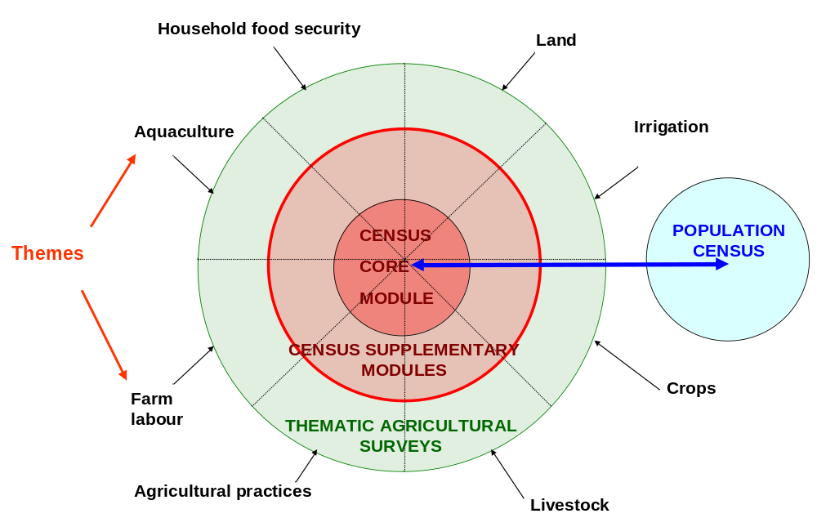

As in the past, the 2010 round of agricultural censuses will focus on the collection of structural data for agricultural holdings. However, two options to widen the scope of the agricultural census will be provided:
Figure 1: Agricultural censuses in the framework of an integrated agricultural census/survey programme
- In traditional agricultural censuses, units engaged in aquaculture production are included only if they also have some crop and livestock production activities. In view of the growing importance of aquaculture in many countries, the option will be provided to cover all aquaculture production units.

- Some countries may wish to expand their agricultural censuses to collect socio-economic data about other rural households that are not agricultural holdings, such as those containing farm labourers.

A modular approach will be used for agricultural censuses in the 2010 programme. A core census module, to be conducted on a complete enumeration or large sample basis, will provide a limited range of key data. One or more census supplementary modules will be conducted on a sample basis, using the core census module as a frame, to provide more in-depth data. This is essentially the short/long questionnaire approach already used by some countries.

A draft list of 16 items has been identified as being suitable for inclusion in the core census module. These items have been selected on the basis of: (i) their importance for national policy-making and for making inter-country comparisons; (ii) the need to establish sampling frames; and (iii) the importance of providing fine level data such as for low-level administrative units. The 16 items are:

- identification and location of agricultural holding
- type of agricultural holding
- sex of agricultural holder
- age of agricultural holder

- household size
- main purpose of production

- area of holding according to land use types
- total area of holding
- land tenure types
- presence of temporary crops by crop type
- presence of permanent crops by crop type and whether grown in a compact plantation
- number of animals by livestock type
- presence of aquaculture
- presence of forest and other wooded land
- other economic activities of the holding’s enterprise
- whether the holding is part of a household that is primarily a farming household

A further 80 items have been identified as suitable for enumeration by sample methods in the census supplementary modules. These items may be as important as the 16 recommended core items, but do not need to be collected on a complete enumeration basis because they are not needed for sampling frame purposes or because data are not required for low-level administrative units. The 80 items are classified under 12 headings, representing possible topics for census supplementary modules:

- land (7 items)
- irrigation and water management (6 items)
- crops (10 items)
- livestock (10 items)
- agricultural practices (8 items)
- agricultural services (10 items)
- demographic and social characteristics (6 items)
- economic activity of household members (4 items)
- household food security (6 items)
- aquaculture (5 items)
- forestry (4 items)
- management of the holding (4 items)

The modular approach can be illustrated using aquaculture as an example. One aquaculture item, presence of aquaculture, is recommended for inclusion in the core census module to provide data on the number of holdings with aquaculture and to help establish a sampling frame. The following five items are recommended for enumeration by sampling methods in a census supplementary module:

- area of aquaculture by type of site
- area of aquaculture by type of production facility
- area of aquaculture by type of water
- sources of water for aquaculture
- type of aquaculture organism cultivated

The number of items in the 2010 round of agricultural censuses is larger than in previous programmes. This is because limiting the core census module to just a few key data items and collecting more in-depth data using sampling methods will result in considerable cost savings, enabling the census to cover much more data than would be possible in a single census operation.

In developing their core census modules, countries will be encouraged to include all 16 recommended core items, plus other items required to meet national data needs or to help establish sampling frames. For example, an item on fertilizer use might be included in the core census module for sampling frame purposes if an agricultural inputs supplementary module was required. The core census module should cover fewer items than in agricultural censuses in the past.

A country will not collect all 80 recommended supplementary items, but will select topics for supplementary modules according to national policy priorities and data needs. It is expected that countries will carry out one or two census supplementary modules in association with the core census module. Usually, a supplementary module will include data from several headings. For example, a household food security module could include data from the land, crops, and agricultural practices categories, as well as household food security items.

4. Community-level data

The 2010 round of agricultural censuses will provide for the collection of infrastructure and other socio-economic data at the community level, an important need in many countries. Community-level data are of interest in their own right, as well as for analysis of relationships with agricultural holding data. Examples of community-level data under consideration are: whether the community is prone to natural disasters; availability of services such as roads, electricity, health facilities and schools; presence of agricultural produce market and agricultural input suppliers; economic activities in the community; and existence of farmers’ organizations.

5. Changes from previous agricultural census programmes

Most items included in previous programmes will also be included in the 2010 programme, although some data are recommended for collection by sample methods. Some items are included for the first time:

- Land: soil degradation.
- Water: irrigation by crop type; method of irrigation; sources of irrigation; payment terms for irrigation; other water management.
- Crops: fertilizer use by crop type; source of seed; area of nurseries.
- Livestock: milking animals; livestock population dynamics; type of feed.
- Agricultural practices: pesticide types; good agricultural practices; organic farming; genetically modified crops.
- Agricultural services: credit; source of agricultural information; extension services; access to food markets; use of veterinary services.
- Demographic and social characteristics: relationship to head; educational attainment; national/ethnic group.
- Economic activity of household members: time worked.
- Household food security: a new topic altogether.
- Aquaculture: type of site; production facility; type of water; sources of water; type of organism.
- Forestry: function of forest; agro-forestry.
- Community-level data.

Some items in the 2000 programme have been omitted; namely, presence of a hired manager, area with irrigation potential, soil type/colour/depth, non-residential buildings, and value of forestry/fishery sales.

Other important changes in concepts and definitions are:

- The concept of an agricultural holding has been reviewed to ensure consistency with national accounting standards [UN et al, 1993; FAO, 1996b; UN, 2004].

- Concepts relating to activity status and employment have been changed to better reflect the structure of employment in rural areas and to be consistent with ILO standards [FAO, 1997a; ILO, 2000].

- The concept of forest land has been modified to bring it into line with international standards.

- The concepts of agri-aqua holding and aquaculture holding have been introduced to cover aquaculture production in the agricultural census. An agri-aqua holding is an agricultural holding that is also engaged in aquaculture, whereas an aquaculture holding is a unit engaged in aquaculture but not agricultural production [FAO, 1997b].

- Two new concepts, the sub-holding and the sub-holder, have been introduced to better understand the role of household members, especially women, in the management of a holding. A sub-holding is a part of a holding managed by a particular person in the household. A sub-holder is the person managing the sub-holding on behalf of the holder [FAO, 1999].

- The definition of irrigation has been clarified to reflect the “controlled” supply of water. The concept of water management has also been introduced to cover such things as flood recession cultivation and spate irrigation.

- The concept of fertilizer has been clarified to reflect the variety of materials used to enhance plant growth.

- The notion of legal ownership has been introduced into the land tenure concept to describe land rights that provide security of tenure. This covers not only land held under a land title system, but also other forms of owner-like possession that are recognized by the state.

- The land use classification has been simplified to clarify the land use terminology.
Structured classifications will also be provided for crop type, as in previous agricultural censuses, as well as, for the first time, livestock type and type of machinery.
A feature of the 2010 round of agricultural censuses is the linkage between the agricultural census and the population census. Countries will be encouraged to explore opportunities for coordinating the two census activities. Issues to consider are: the use of common concepts and definitions; sharing field materials; using the population census as a frame for the agricultural census; collecting additional data in the population census; and coordinating the two data collection operations [UN, 1998].

As in the past, the 2010 programme will provide flexibility for countries to design agricultural censuses to meet their own specific requirements.

6. Agricultural census/survey publications to be issued

As in the past, FAO will issue a series of technical publications presenting the 2010 agricultural census/survey programme. The first publication will provide guidelines for countries on the methodology, data items, concepts, definitions and tabulations for the agricultural census. The publication is expected to be issued in late 2005 in all official FAO languages.

Over the coming years, FAO will issue a series of other publications on specific aspects of the agricultural census/survey programme.

7. References

FAO (1967), Programme for the 1970 World Census of Agriculture, Rome.

FAO (1976), Programme for the 1980 World Census of Agriculture, Rome.

FAO (1986), Programme for the 1990 World Census of Agriculture, Rome.

FAO (1995), Programme for the World Census of Agriculture 2000, Rome.

FAO (1996a), Conducting Agricultural Censuses and Surveys, Rome.

FAO (1996b), A System of Economic Accounts for Food and Agriculture, Rome.

FAO (1997a), Guidelines on Employment: Supplement to the Programme for the World Census of Agriculture 2000, Rome.

FAO (1997b), Guidelines on the Collection of Structural Aquaculture Statistics: Supplement to the Programme for the World Census of Agriculture 2000, Rome.

FAO (1999), Agricultural Censuses and Gender Considerations: Concepts and Methodology, Rome.

ILO (2000), Current International Recommendations on Labor Statistics, Geneva.

UN, OECD, World Bank, Eurostat (1993), System of National Accounts 1993 (SNA), Brussels, New York, Paris, Washington.

UN (1998), Principles and Recommendations for Population and Housing Censuses, Revision 1, New York.

UN (2004), International Standard Industrial Classification of all Economic Activities (ISIC), Revision 3.1, New York.

