A Review of State Sea Grant Plans & Relevant State Ocean, Coastal and Great Lakes Priorities – A Snapshot of a “Bottom-Up” Planning Landscape

I. Background
In response to a National Research Council review, the National Sea Grant College Program formed a Response Integration Team (RIT) with three subcommittees: strategic planning, performance evaluation and operations. Each subcommittee was asked to formulate recommendations and produce a report. The Strategic Planning Subcommittee’s report suggested the formation of a Strategic Planning Steering Committee which would begin implementation of a revised strategic planning process both at the national and state level. Further, they suggested that the Steering Committee begin with a synthesis of existing programs from both a 'top-down' and 'bottom-up' approach. With respect to the bottom-up approach the subcommittee stated:

Many state Sea Grant programs conduct outstanding, nationally relevant programs of great importance to the National Sea Grant College Program. These activities represent a great source of innovation and learning that could be of use to revisit and regularly revise the National Sea Grant College Program's Strategic Plan. A bottom up synthesis of the thematic and functional priorities of state Sea Grant plans is one of the most important background summaries needed to determine national Sea Grant priorities. Such a bottom up synthesis would be valuable to NOAA as the agency works to capture the priorities of stakeholders and to revise its priorities in the future. It is also recommended that regional syntheses of state strategic plans be conducted as well as syntheses of relevant state ocean, coastal, and Great Lakes priorities, given the new emphasis on regional planning by both Sea Grant and NOAA.

This report presents the “bottom-up” planning landscape by providing information from two perspectives – thematic and programmatic. Sea Grant’s thematic priorities have, for many years, served to define the program as Sea Grant's mission statement, strategic planning processes, and program evaluation processes are all organized thematically. The first part of this report presents that perspective via an overview of all state Sea Grant strategic plans based upon Sea Grant’s thematic areas, and current Regional Research and Information planning information.

The Sea Grant program can also be described functionally - as research, extension, education and communication networks. The functional or programmatic perspective is reflected in the organization of each state program with portfolios and personnel assigned to the various functional components. Thus, this report also provides a bottom-up snapshot of Sea Grant’s functional priorities, via a review of objectives developed by the Sea Grant Educators Network, pertinent information from Sea Grant extension and communication surveys, and partnership information from the 2006 state Sea Grant annual reports. Note that the snapshots of the programmatic components may only represent a particular issue or topic relevant to that network. In particular, there are no current operational or evaluative processes in place for the research network, which is unfortunate given the relative importance of that component.

II. A Bottom-up Snapshot of Sea Grant’s Thematic Priorities
A. Background Information on Sea Grant’s Thematic Areas
A “thematic area” is a core area of emphasis and expertise in Sea Grant’s purview. Ideas for themes could have come from anywhere within the Sea Grant enterprise. The Sea Grant Association’s (SGA) Program Mission Committee (PMC) coordinated this information for eventual presentation to SGA’s Board of Directors. After discussion with the SGA membership, the Board of Directors then worked with the Nation Sea Grant College Program Office to establish priorities for thematic areas.

The 11 thematic areas, which include: Aquatic Invasive Species, Aquaculture, Biotechnology, Coastal Communities & Economies, Coastal Natural Hazards, Digital Ocean, Ecosystems & Habitats, Fisheries, Marine & Aquatic Science Literacy, Seafood Science & Technology, and Urban Coasts, were vetted through the Sea Grant College Program Network, and each one explores pressing issues related to the health and sustained well-being of our coasts and coastal economies. All state Sea Grant strategic plan objectives and all Sea Grant projects generally fall into at least one of the 11 thematic areas.

B. Overview of the conditions and challenges and Sea Grant’s niche within each (based upon Sea Grant’s thematic area)
Thematic Area #1: AQUACULTURE
Issue: Marine aquaculture is an important and rapidly emerging multimillion-dollar industry within the United States. While the U.S. currently imports more than 60 percent of consumable fish and shellfish (a trend which has resulted in a seafood trade deficit of roughly $9 billion annually), within the next 20 years marine aquaculture has the potential to supply upwards of 25 percent of all seafood consumed domestically, replenish certain fisheries, and relieve fishing pressure on wild stocks, particularly in coral reef habitats. In addition to providing more sustainable seafood management, marine aquaculture could also offset the negative effects the collapse of several of the nation’s major fishery industries has had on coastal communities by providing employment for many otherwise out-of-work fishermen and seafood processors.

Sea Grant’s Niche: The National Sea Grant College Program is well positioned to develop the nation’s marine aquaculture industry, based on its experience with marine resources conservation and broad network of multidisciplinary research, education, and extension teams located in universities throughout the country. Sea Grant programs in the coastal and Great Lakes states have a particular advantage in producing socially and environmentally responsible and effective aquaculture research and development.

Thematic Area #2: INVASIVE SPECIES
Issue: Aquatic invasive species have been identified as one of and perhaps the greatest threat to coastal ecosystems, economies, and human health. The pervasiveness of the problem, affecting all four coastal regions—East, West, Gulf and Great Lakes—as well as many interior states led Congress to pass the Non-indigenous Aquatic Nuisance Prevention and Control Act (NANPCA) in 1990 followed by the National Invasive Species Act in 1996, and most recently, the National Aquatic Invasive Species Act in 2003. Despite such attention, new invaders continue to infiltrate coastal areas.

Sea Grant’s Niche: The scale and scope of the invasive species problem requires the broad organizational capacity and expertise that Sea Grant provides. Operational in every coastal state, the Sea Grant program is best suited to address such problems and has become a leader in invasive species research, education, and outreach for both public and private institutions, businesses, and individuals. Sea Grant’s strengths in education and outreach are particularly important, as research alone will not solve the invasive species problem.

Thematic Area #3: BIOTECHNOLOGY
Issue: The rapidly growing field of biotechnology has created new opportunities for research and economic development. While biological technology as it relates the marine environment is still in its infancy, marine plants, animals, and microorganisms produce unique biochemicals, which have demonstrated potential to treat diseases such as cancer and inflammatory disorders and may one day prove effective against HIV. Marine biochemicals have other commercial applications as well, such as in the emerging field of nanofabrication. While the application of marine products in biotechnology has substantial economic potential, such uses may also provide many environmental benefits such as the generation of new technology for monitoring biological processes, remediation of pollutants, and conversion of wastes.

Sea Grant’s Niche: Sea Grant has a long and successful history of involvement in marine biotechnology. The program has been actively involved in the development of many new, highly marketable biochemicals including Pseudopterosin, an anti-inflammatory agent isolated from a marine gorgonian with a market value of $3 million to $4 million each year. In addition to human health benefits, such products have also served to enhance environmental remediation and even improve fisheries management through the use of DNA fingerprints.

Thematic Area #4: COASTAL COMMUNITIES AND ECONOMIES
Issue: Healthy ecosystems are essential to the economic survival of coastal communities. Unfortunately, population growth, increasing tourism, and development can jeopardize the sustainability of coastal ecosystems. As coastal ecosystems and economies are integrally linked, economic growth must complement environmental conservation in a sustainable way, that is, in a manner that meets present needs without compromising future generations’ quality of life.

Sea Grant’s Niche: While the diversity of needs and interests among coastal stakeholders presents unique challenges, such disparities must be overcome if coastal communities are to develop economically and environmentally sustainable environments. To bridge this gap, Sea Grant has a distinct advantage, providing coastal communities with the best available science-based information for long-term sustainable community development and decision-making, coupled with the knowledge, experience and tools needed to bring diverse coastal interests together. The knowledge, programs and approaches developed by Sea Grant has broad applicability and can be applied from state to state throughout the national network.

Thematic Area #5: COASTAL HAZARDS
Issue: The winds, waves, and floods generated by hurricanes and other major storms, as well as earthquakes and tsunamis all pose a serious threat to coastal development and human welfare. Property losses from coastal disasters have increased dramatically over the past few decades, amounting to upwards of $150 billion in the 1990s alone. Such risks will only intensify with rising sea levels, land subsidence, expanding coastal populations (often unfamiliar with coastal hazards), and rapidly increasing investments in valuable but vulnerable coastal property. Such conditions necessitate a coordinated national effort to reduce the economic, social, and environmental costs of natural hazards.

Sea Grant’s Niche: Research and outreach programs are an essential to increased coastal hazard awareness and preparedness. Sea Grant and its network of universities, laboratories, and outreach programs contribute considerable expertise and capability to the national coastal natural hazards mitigation effort. Sea Grant is particularly well suited to take the lead in the development of new remediation and disaster prevention technologies, risk assessment, habitat restoration, and information generation, distribution, and transfer.

Thematic Area #6: DIGITAL OCEAN
Issue: The Digital Ocean Project has become a promising tool for marine resource management. By developing methods to create extensive digital models of ocean resources and phenomena or extreme events such as hurricanes, the project will build on previous Sea Grant technology to facilitate the translation and dissemination of chemical, biological and physical data into tools to better manage marine resources. Technology developed under the project will benefit a wide array of coastal stakeholders, from fisheries managers to regional authorities.

Sea Grant’s Niche: The mission of Sea Grant’s Digital Ocean is to build on work pioneered by Sea Grant to develop methods for creating digital representations, or models, of ocean resources and phenomena. By gathering, analyzing and making data widely available, we can help provide essential tools for ensuring the health and sustainability of our marine resources and economy.

Thematic Area #7: ECOSYSTEMS AND HABITATS
Issue: The U.S. economy depends on healthy coastal ecosystems. The United States’ 95,000-miles of coastal areas provide essential habitat for fish and shellfish that make up 75 percent of U.S. commercial landings. Coastal zones also provide habitat for numerous species of recreational fishes, waterfowl, migratory birds, marine mammals and sea turtles. Rapid population growth and urbanization in coastal areas, however, has destroyed large swaths of coastal wetlands, degraded coastal water quality, and placed substantial strain on coastal ecosystems. Indeed, nearly half of the nation’s coastal wetlands have been lost—exceeding 90 percent in some states. Beaches, dunes, seagrasses, coral reefs, oyster reefs and other valuable habitats face similar pressures. Loss and deterioration of coastal habitats has dramatically affected U.S. fishery stocks as landings and genetic diversity decline.

Sea Grant’s Niche: Drawing on extensive experience in marine resource management education, research and technical assistance, Sea Grant focuses on minimizing the negative impacts of anthropogenic changes to coastal ecosystems and on developing and implementing methods of restoring damaged coastal habitats. Sea Grant provides vital information on critical or vulnerable habitats and species and engages private and public entities. While empowering coastal communities to undertake well-planned coastal development that preserves and helps restore coastal habitats. In addition, Sea Grant has been a leader in research and outreach regarding public health and economic impacts many harmful algal blooms (HABs) caused by excessive inputs of nutrients and toxic pollutants, and subsequent wetland loss and over-fertilization of coastal waters.

Thematic Area #8: FISHERIES
Issue: America’s fisheries are under extreme stress from many sources and new management approaches must be found to cope with the difficult challenges. To make the best decisions, fishery managers must have a reasonable idea of how many fish comprise each population, the rates at which they grow, reproduce, and die, and how many can be harvested under various scenarios of regulatory measures and fishing pressure. It is also important that fisheries managers know how their decisions might affect people who depend on fishery resources. When changes affect people, it is equally important to help them cope.

Sea Grant’s Niche: With myriad relationships among university, government and industry researchers, Sea Grant is uniquely situated to promote cooperative research on subjects critical to decisions being made by fisheries managers. Topics include stock assessment, habitat and ecosystem health, environmental contamination, area management strategies, fish biology and behavior, climate change, management institutions, conflict resolution and others. Sea Grant’s outreach specialists translate and transfer useful research findings to stakeholders. Located in coastal communities, Sea Grant extension personnel enjoy cooperative working relationships with recreational, commercial and subsistence fishing interests. This unique front-line presence will allow Sea Grant to facilitate local problem solving and guide experiments in community-based management.

Thematic Area #9: MARINE AND AQUATIC SCIENCE LITERACY
Issue: The challenges to marine and aquatic science education in this country are profound. Fifty-two million pre-college students are being taught science by 1.9 million elementary and 186,000 middle and high-school teachers. Of these educators, 37% in high school, 83% in middle school, and practically all teaching science at the elementary level lack science degrees (NSTA 2000). To compound this problem, too few of the teachers who do have science degrees have studied marine and aquatic science. In fact, these content areas are barely mentioned in the National Science Education Standards, an influential report released by the National Research Council in 1996.

Sea Grant’s Niche: As a national network, Sea Grant has the inherent strengths necessary to be a key player in the development of that critical national education base. Sea Grant’s innovative and effective marine and aquatic education programs have been a cornerstone of the Sea Grant program and they have produced a record of successes that span three decades. With more than 30 years of sustained funding, strong regional infrastructures and a commitment to education, Sea Grant is capable of making the long-term investments and providing the continuity needed to ensure meaningful education outcomes. The program has established and supports a network of Sea Grant educators that provides valuable leadership in marine and aquatic science education activities at the local, regional and national levels throughout this country, offering a wide array of experiential internships, fellowships, team-based research courses, interdisciplinary courses and programs, and traditional research assistantships that broaden the experiences of undergraduate and graduate students alike.

Thematic Area #10: SUSTAINABLE SEAFOOD TECHNOLOGY
Issue: The U.S. seafood industry an increasingly competitive global marketplace, complex trade policies, stricter safety regulations, rising energy costs, food security concerns and an increasingly limited seafood supply. Changes brings new opportunities to expand markets, form strategic alliances and encourage innovations to lower production costs, create new products, add value to existing ones, increase safety and reduce waste. In this new seafood era, science and education are cornerstones for maintaining the vitality of the nation’s $27 billion seafood industry ($55 billion including consumer expenditures) and its 250,000 member workforce. To remain competitive, the industry must control the costs of catching, transporting, processing, storing and distributing seafood. The U.S. seafood industry recognizes the benefits of innovation, but it is comprised of mostly small and medium-sized, independent enterprises that simply cannot afford research and development programs.

Sea Grant’s Niche: Through its unique capabilities in research and technology transfer, the national Sea Grant network is poised to help the industry increase quality and safety, add value, lower costs and expand seafood supplies and markets. While the Sea Grant seafood science and technology community is uniquely positioned to advance the global competitiveness of the nation’s seafood industry, meeting this goal will require a continuous commitment by Sea Grant’s many partners and additional funding as well.

Thematic Area #11: URBAN COASTS
Issue: More than half of the U.S. population is concentrated in coastal areas accounting for only 10 percent of the nation’s land mass. Economic growth since World War II has increased the urbanization of coastal areas—with corresponding rises in pollution and environmental degradation. In an urban setting, a shoreline has significant appeal, shown in the demand for recreational, business and residential developments near the water. Communities and states must decide how to balance economic and environmental values, manage the impacts of runoff and waste disposal, and consider transportation, recreation and commerce needs—all while maintaining the integrity of coastal ecosystems that provide critical habitat and nurseries for countless species.

Sea Grant’s Niche: Sea Grant leads the nation in solving problems and recognizing opportunities along our urban coasts. For example, Sea Grant has extensive experience in assessing the risks of contaminants in dredged materials and the identification of disposal options. In addition, Sea Grant’s federal-state partnership combines multidisciplinary scientific research with public education and outreach, which endows it with a unique capability to provide policymakers, managers, users and the public with understandable scientific explanations of coastal processes and the value and risks involved in coastal activities and change.

III. Sea Grant’s Current Leadership and Activities within the Thematic Areas

A. A Review of State Sea Grant Strategic Plans
In the current National Sea Grant College Program Strategic Plan, there are sub-priorities listed under each thematic area. Since all programs participate in thematic areas, the National Office linked the objectives from the state program’s strategic plans to the National Sea Grant College Program’s thematic areas. The National Office then aggregated the state Sea Grant program information into Sea Grant’s current ten regions: Alaska, California Current (combining the Pacific NW and SW regions) Caribbean, Great Lakes, Gulf of Maine, Gulf of Mexico, Insular Pacific, Mid-Atlantic, New York Bight, and South Atlantic Region to see where each region participates the most in Sea Grant’s current eleven thematic areas.

In reviewing the state Sea Grant Strategic Plans, efforts were made to: (1) place state Sea Grant planning priorities in appropriate theme areas in those cases where the state's theme area title was inconsistent with the National Sea Grant Strategic Plan (Theme Team Areas); (2) keep the priorities in the theme areas as reported by the State, unless the priority clearly belonged in a different theme area; and (3) report priorities at the 'objective' level.

Information was pulled solely from the strategic plans. Implementation plans were not reviewed for additional information in cases where strategic plans lacked detail. The purpose of this comparison was to compare strategic plans, and not ancillary documents.

The regional comparisons match each state's strategic plan priority element to the NOAA Sea Grant Strategic Priority Element by Theme Area. If more than one item from the state's strategic plan fit under the NOAA Sea Grant Element, it was combined into one. If a state's item could fit under more than one NOAA Sea Grant Element, it was applied to all possible elements, generously.

1. Participation of Sea Grant Priorities on a National Scale
The following bar chart is the national average of participation for each thematic area based upon State Sea Grant program objectives that fall under one or more of the NOAA Sea Grant sub-priority area of each thematic/priority area.

2. Sea Grant Priorities on a Regional Scale
New York Bight Region
The New York Bight region consists of Connecticut, Massachusetts (MIT & WHOI), New Jersey, New York, Rhode Island and Pennsylvania Sea Grant Programs. Based upon this region’s State Strategic Plans, the areas of highest participation include Coastal Communities and Economies, Ecosystems & Habitats, Marine & Aquatic Science Literacy, and Aquaculture.

Theme | Participation
Coastal Communities & Economies | 75%
Ecosystem & Habitats | 67%
Marine Aquatic Science Literacy | 67%
Aquaculture | 60%
Urban Coasts | 56%
Fisheries | 47%
Coastal Hazards | 46%
Aquatic Invasive Species | 43%
Biotechnology | 27%
Seafood Science & Technology | 21%
Digital Ocean | 17%

The Gulf Region
The Gulf region consists of the Florida, Louisiana, Mississippi/Alabama and Texas Sea Grant Programs. The state strategic plans submitted for this region reveal high levels of program participation in Aquaculture, Coastal Communities & Economies, Ecosystem & Habitats, and Marine and Aquatic Science Literacy. Even though Fisheries is not among the top four priority areas for this region, all four programs participate in the sub-priorities of Improve Fisheries Management and Caring for People. Similarly, all programs are involved in the Reduce Loss of Life and Property sub-priority within Coastal Hazards.
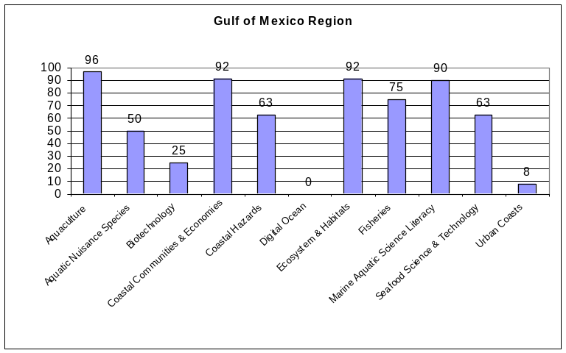
Theme | Participation
Aquaculture | 96%
Coastal Communities & Economies | 92%
Ecosystem & Habitats | 92%
Marine Aquatic Science Literacy | 90%
Fisheries | 75%
Coastal Hazards | 63%
Seafood Science & Technology | 63%
Aquatic Invasive Species | 50%
Biotechnology | 21%
Urban Coasts | 8%
Digital Ocean | 0%

The California Current Region (Pacific NW & SW)
The California Current region is comprised of the California, Oregon, Southern California, and Washington Sea Grant programs. State strategic plans for California Current programs indicate that Coastal Communities & Economies, Coastal Hazards, Ecosystem & Habitats, and Aquatic Invasive Species are all top priority areas for the region. While Fisheries is not among the top four priority areas, all of the California Current programs participate in the sub-priorities of Improve Fisheries Management and Caring for People. All programs also participate in the Create and Sustain Effective Marine and Aquatic Science-based Educational Programs and Cultivate Sea Grant Leadership sub-priorities under Marine Aquatic Science Literacy. In addition, all states are engaged in the Digital Ocean sub-priority, Focusing on Coastal Areas and the Seafood Science & Technology sub-priority, Ensuring Food Safety.

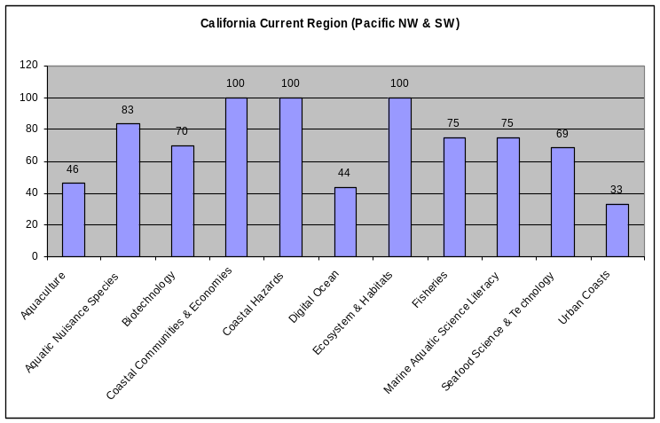
Theme | Participation
Coastal Communities & Economies | 100%
Coastal Hazards | 100%
Ecosystem & Habitats | 100%
Aquatic Nuisance Species | 83%
Fisheries | 75%
Marine Aquatic Science Literacy | 75%
Biotechnology | 70%
Seafood Science & Technology | 69%
Aquaculture | 46%
Digital Ocean | 44%
Urban Coasts | 33%

The South Atlantic Region
The South Atlantic region includes Florida, Georgia, North Carolina, and South Carolina Sea Grant programs. Participation levels in this region are highest in the areas of Ecosystem & Habitats, Coastal Communities & Economies, Aquaculture, and Marine Aquatic Science Literacy. In addition, while Fisheries is not a top priority for the region, all four programs participate in the sub-priority of Better Understanding of Fish Biology and Behavior.

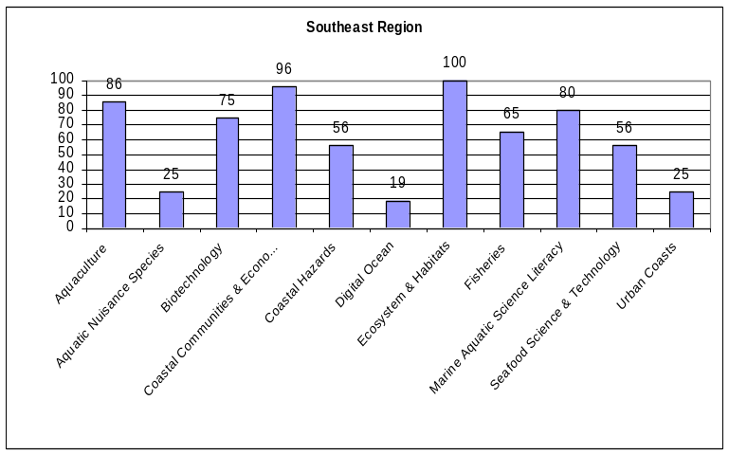
Theme | Participation
Ecosystem & Habitats | 100%
Coastal Communities & Economies | 96%
Aquaculture | 86%
Marine Aquatic Science Literacy | 80%
Biotechnology | 75%
Fisheries | 65%
Coastal Hazards | 56%
Seafood Science & Technology | 56%
Aquatic Invasive Species | 25%
Urban Coasts | 25%
Digital Ocean | 19%

The Mid-Atlantic Region
The Mid-Atlantic region includes Sea Grant programs in Delaware, Maryland, New Jersey, and Virginia. These four programs indicate priorities in Coastal Communities & Economies, Ecosystem & Habitats, Marine Aquatic Science & Technology, and Urban Coasts.

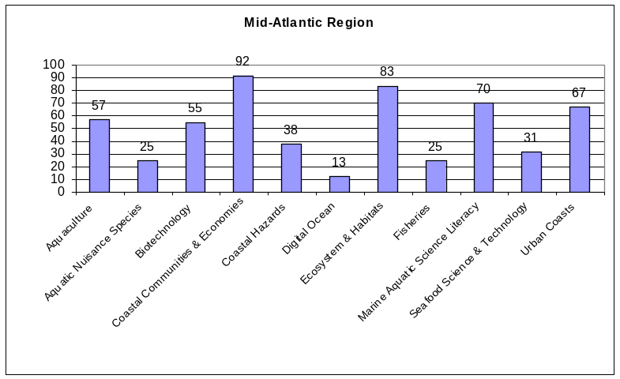
Theme | Participation
Coastal Communities & Economies | 92%
Ecosystem & Habitats | 83%
Marine Aquatic Science Literacy | 70%
Urban Coasts | 67%
Aquaculture | 57%
Biotechnology | 55%
Coastal Hazards | 38%
Seafood Science & Technology | 31%
Aquatic Invasive Species | 25%
Fisheries | 25%
Digital Ocean | 13%

The Great Lakes Region
The Great Lakes region includes the Illinois/Indiana, Michigan, Minnesota, New York, Ohio, Pennsylvania, and Wisconsin Sea Grant Programs. Top priority areas, as indicated in the state strategic plans include Aquatic Invasive Species, Ecosystem & Habitats, Coastal Communities & Economies, and Urban Coasts. While Seafood Science & Technology is not among the top four priority areas for the Great Lakes region, all programs participate in the sub-priority of Ensuring Seafood Safety.
Theme | Participation
Aquatic Invasive Species | 100%
Ecosystem & Habitats | 100%
Coastal Communities & Economies | 83%
Urban Coasts | 81%
Marine Aquatic Science Literacy | 71%
Aquaculture | 61%
Fisheries | 60%
Seafood Science & Technology | 50%
Coastal Hazards | 43%
Biotechnology | 34%
Digital Ocean | 32%
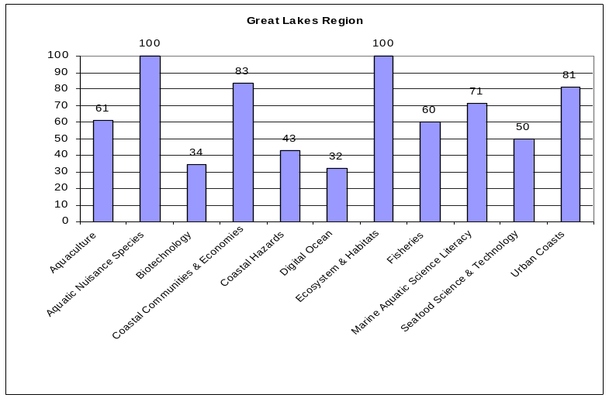

The Gulf of Maine Region
The Northeast region includes Sea Grant programs in Connecticut, Maine, Massachusetts (MIT and WHOI), New Hampshire, New York, and Rhode Island. Within the region, participation was highest in the areas of Coastal Communities & Economies, Aquaculture, Fisheries, and Ecosystem & Habitats. While not one of the four priorities areas, all programs participate in Marine Aquatic Science Literacy sub-priorities, Create and Sustain Effective Marine and Aquatic Science-based Educational Programs and Cultivate Sea Grant Leadership.
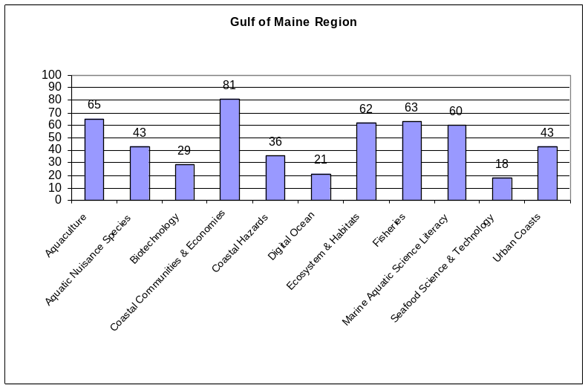
Theme | Participation
Coastal Communities & Economies | 81%
Aquaculture | 65%
Fisheries | 63%
Ecosystem & Habitats | 62%
Marine Aquatic Science Literacy | 60%
Aquatic Nuisance Species | 43%
Urban Coasts | 43%
Coastal Hazards | 36%
Biotechnology | 29%
Digital Ocean | 21%
Seafood Science & Technology | 18%

The remaining three regions, Caribbean, Insular Pacific and Alaska currently constitute a single state Sea Grant program thus the regional and state syntheses are identical.

The Caribbean Region
Top Priorities
- Aquaculture
- Aquatic Invasive Species
- Coastal Communities and Economies
- Coastal Hazards
- Ecosystem & Habitat
The Caribbean region is comprised of the Puerto Rico Sea Grant program, which has identified priorities in Aquaculture, Aquatic Invasive Species, Coastal Communities & Economies, Coastal Hazards, and Ecosystem & Habitats areas.

The Insular Pacific Region
Top Priorities
- Aquaculture
- Aquatic Invasive Species
- Biotechnology
- Coastal Communities & Economies
- Coastal Hazards, and Ecosystem & Habitat
The Insular Pacific Region consists of the Hawaii Sea Grant program. As indicated in the Hawaii Sea Grant strategic report, top priorities for the region are Aquaculture, Aquatic Invasive Species, Biotechnology, Coastal Communities & Economies, Coastal Hazards, and Ecosystem & Habitat.

The Alaska Region
Top Priorities
- Coastal Communities & Economies
- Ecosystem & Habitats
- Fisheries
- Seafood Science & Technology
The Alaska region Sea Grant program has highlighted a number of priority areas, which include Coastal Communities & Economies, Ecosystem & Habitats, Fisheries, and Seafood Science & Technology.

B. Sea Grant Regional Planning Effort Information
Eight regional planning efforts were initiated in FY06: Alaska, Pacific Northwest and Southwest, Insular Pacific, Great Lakes, Gulf of Mexico, South Atlantic, and Gulf of Maine. The Mid-Atlantic, Caribbean, and New York Bight regional planning efforts will begin by the end of this fiscal year. The charge for each of the regional teams is to develop a Regional Research and Information Plan by the end of FY08. There is a common framework for the planning efforts across all the regions, but each of the regional teams is implementing that framework in the manner most suited to their particular region. The general framework is as follows:
- Establish a regional coordination group to oversee the planning and implementation of the research and information plan;
- Conduct a bottom-up needs assessment with broad user and stakeholder input from all levels of government, academia, industry, non-governmental organizations, and the public;
- Identify research and information gaps;
- Develop a research and information plan for the region (not for Sea Grant or for a particular agency) that ranks priorities according to management-critical needs;
- Develop coordination mechanisms to ensure the transfer of technology and information to the appropriate end users; and
- Provide an ongoing platform for coordination, collaboration, and resource sharing among participants.

Since the regional initiative has just begun and since different regions are using slightly different approaches on different timeframes the current snapshot of regional efforts is limited to a subset of all defined regions.

Through the regional workshop held in Silver Spring last month, three regions (Gulf of Mexico, Gulf of Maine, and the Pacific NW and SW) shared preliminary results of regional priorities from their planning efforts, which are listed below.

(1) Gulf of Mexico – Preliminary Results from Regional Planning Exercise, looking at how the Gulf of Mexico plans link to the ORPP Themes.
Ocean Research Priorities Plan  Theme | Percent of  goals/priorities in GOM plans  with link to theme
Improving Ecosystem Health | 36.1%
Stewardship of Natural and Cultural Resources | 32.8%
Enhancing Human Health | 9.3%
Enabling Marine Operations | 8.2%
Increase Resilience to Natural Hazards | 7.5%
The Ocean's Role in Climate | 6.1%

(2) Gulf of Maine – Preliminary Results
Thematic Priority Areas…
    - Effects of Climate Change
    - Conservation & Sustainability
    - Oceans & Human Health
    - Management & Governance
Focused Opportunities
    - Use of New Technologies
    - Modeling Ecosystem Impacts
    - Address Issues of Scale

(3) Pacific NW & SW - Preliminary Results
Areas Seven Themes have emerged repeatedly in national and regional programs and Sea Grant; working on identifying the broad elements that fall with in each of these themes; they are almost all encompassing. Each of the collaborating Sea Grant Programs focuses on different areas within these themes:
- Social and Economic Vitality of Coastal Communities
- Coastal Natural Hazards
- Human Health
- Ecosystem Dynamics, Quality and Connectivity
- Ocean’s Role in Climate Variability
- Marine Transportation and Security
- Ocean Education and Environmental Literacy

IV. A Bottom-up Snapshot of Sea Grant’s Functional Strengths and Priorities
A. Sea Grant College Program Background
Sea Grant is a NOAA partnership program that engages the nation's universities in conducting scientific research, education and extension projects designed to help us better understand and use our ocean, coastal and Great Lakes resources. As a national network of over 30 Sea Grant programs, located in all coastal and Great Lakes states and Puerto Rico, there are more than 300 participating institutions involving over 3,000 scientists, engineers, outreach experts, educators and students. Sea Grant is also a matching program; a non-federal matching requirement results in substantial leveraging of additional effort.

What Does Sea Grant Do?
- Research to tackle priority problems and opportunities identified by coastal residents and businesses and local, regional, state and federal agencies
- Technology transfer to user groups such as natural resource managers, coastal planners, NGOs and businesses people,
- Science-based information transfer about marine and coastal issues through extension and communications projects, serving as an “honest broker” among a wide range of groups, and
- Training and curriculum development for K-12 educators to bring the sciences into the classroom as well as for undergraduate and graduate students to be mentored by senior researchers.

What Advantages Does Sea Grant Offer?
- Local, university-based on-site project management
- An established network of constituents and stakeholders at the local and state level
- Integration of research projects with outreach capabilities
- Leverage through matching funds

As noted in the introduction, a bottom-up snapshot of the Sea Grant program from a functional perspective relies on a number of 'photographs' of various sub-network initiatives rather than a comprehensive attempt to evaluate or organize the national program functionally.

B. Sea Grant Educators Network’s (SGEN) Strategic Plan 2004-2009
Early in its history, Sea Grant provided an emphasis on K-12 education by developing marine and aquatic sciences education curricula and professional development programs for pre-college teachers. Current SGEN efforts continue to provide pre-college teachers with enhanced science content knowledge, instructional skills, and high-quality curricula for teaching their students about the relevance of watersheds, coastal processes, and marine and aquatic sciences.

The following goal and objectives are taken from the SGEN Strategic Plan (2004-09). The SGEN will accomplish this goal by facilitating communication and interaction among Sea Grant educators and establishing partnerships with others involved in marine and aquatic sciences education.

Goal: To effectively deliver to constituent groups marine and aquatic sciences-based information, programs, and resources that enhance environmental literacy.

- Objective 1: Create and sustain effective marine and aquatic sciences-based educational programs.
- Objective 2: Cultivate and expand SGEN leadership and membership in marine and aquatic sciences education communities.
- Objective 3: Support the use of marine and aquatic sciences content and examples in teaching of science, mathematics, social studies, and language arts, as mandated by Federal initiatives, such as the No Child Left Behind Act (2002).
- Objective 4: Support the use of marine and aquatic sciences examples in standardized testing.
- Objective 5: Expand professional development opportunities for all educators.
- Objective 6: Engage underrepresented populations in SGEN efforts.

C. Sea Grant Extension Survey Results (2004)
According to the Sea Grant Extension Leaders, the top three priority hires include:
- Fisheries
- Water Quality/Watershed Management
- Education Specialist, Coastal Communities and Economies
- Coastal Hazards, Natural Resource Economist/Coastal Bus

When asked what the number one top priority hire is, the extension leaders answered in the following way:
- Water Quality/Watershed Management, Education Specialists
- Habitat Restoration, Fisheries, Coastal Communities and Economies, Natural Resource Economist/Coastal Business Specialists
- Climate Change, Coastal Hazards, Outdoor/Coastal Recreation
- Aquaculture, Clean Marina, Ports and Harbors, Fisheries Acoustician, Biotechnology

D. Sea Grant Communication Survey Results
The Communicators network is comprised of more than 110 individuals, accounting for 90 FTE. Within that community, expertise varies from print media to radio to web and a variety of other areas. When asked for their top three areas of emphasis if we were able to hire additional communications specialists, responses varied throughout the network, but the three most common answers were: web expert, graphic designer, and writer.

V. Critical Alliances
Finally, as requested by the Strategic Planning Steering Committee, it is useful, from a bottom-up perspective, to examine Sea Grant's most productive alliances and partnerships.

The following partnership information was gathered from Sea Grant Programs’ 2006 Annual Reports. Partnerships that seemed to occur most often within most programs were chosen.

Federal

- National Oceanic & Atmospheric Administration
- U.S. Fish and Wildlife Services
- Environmental Protection Agency
- U.S. Geological Survey
- U.S. National Park Services
- U.S. Department of Agriculture
- U.S. Food and Drug Administration
- U.S. Coast Guard
- U.S. Army Corps of Engineers
- NOAA’s Office of Ocean and Coastal Resource Management’s (OCRM)
- Aquatic Nuisance Species (ANS) Taskforce

Non-Governmental Organizations

- National Marine Educators Association (NMEA)
- Consortium for Oceanographic Research and Education (CORE)
- Centers for Ocean Sciences Education Excellence (COSEE)
- National Research Council
- Seafood HACCP Alliance
- National Fish and Wildlife Federation
- National Fisheries Institute
- National Geographic Society
- American Zoo and Aquarium Association
- National Council for Geographic Education
- National Council for the Social Studies
- North American Association of Environmental Educators
- National Non-Point Education for Municipal Officials (NEMO) Network
- Association of Science-Technology Centers
- American Association for the Advancement of Science
- American Society for Limnology and Oceanography
- Estuarine Federation Society and affiliated chapters
- National Association of Marine Laboratories and affiliated chapters

International

- Canada Department of Fisheries and Oceans
- Environment Canada
- Ontario Ministry of Natural Resources

Appendix A
Sea Grant Strategic Plan’s Priorities and Sub-Priorities

Sea Grant Theme Area #1: AQUACULTURE
Priorities for NOAA Sea Grant action include:
1. Culture system technology development
2. Nutrition and feeds
3. Genetics of cultured species
4. Health and disease
5. Stock enhancement
6. Public policy and law
7. Socioeconomic issues

Sea Grant Theme Area #2: BIOTECHNOLOGY
Priorities for NOAA Sea Grant action include:
1. Marine natural products
2. Biomolecular process discovery
3. Marine environmental biotechnology
4. Marine resource management
5. Seafood safety and processing

Sea Grant Theme Area #3: COASTAL COMMUNITIES & ECONOMIES
Priorities for NOAA Sea Grant action include:
1. Strengthening coastal planning
2. Resource valuation
3. Constructing indicators of sustainable development
4. Educating coastal planners
5. Building leadership
6. Developing decision support systems
7. Revitalizing communities

Sea Grant Theme Area #4: COASTAL NATURAL HAZARDS
Priorities for NOAA Sea Grant action include:
1. Reducing the loss of life and property
2. Weather-related hazards
3. Earthquakes and tsunamis
4. Shoreline change

Sea Grant Theme Area #5: DIGITAL OCEAN
Priorities for NOAA Sea Grant action include:
1. Focusing on coastal areas
2. Preparing for extreme events
3. Passive acoustics in fisheries
4. Supporting offshore industry

Sea Grant Theme Area #6: ECOSYSTEMS AND HABITATS
Priorities for NOAA Sea Grant action include:
1. Reducing stresses on coastal ecosystems
2. Coastal watersheds
3. Conserving and restoring coastal habitats

Sea Grant Theme Area #7: FISHERIES
Priorities for NOAA Sea Grant action include:
1. Partnering with constituents to improve fisheries management
2. Caring for people by helping them adapt to changes in fishery resources and by interjecting socio-economic dimensions into fisheries management decisions
3. Better understanding fish biology and behavior
4. Balancing needs of fishermen and managers with technological improvements to reduce bycatch, develop new value-added products, and reduce waste
5. Predicting effects of climate and ecosystem change and other perturbations to aquatic systems

Sea Grant Theme Area #8: MARINE AND AQUATIC SCIENCE LITERACY
Priorities for NOAA Sea Grant action include:
1. Create and sustain effective marine and aquatic science-based educational programs
2. Cultivate Sea Grant leadership in marine and aquatic sciences education communities
3. Support the use of marine and aquatic sciences content and examples in science and mathematics teaching and standardized testing
4. Expand professional development opportunities for all educators
5. Engage underrepresented populations in science efforts

Sea Grant Theme Area #9: SEAFOOD SCIENCE & TECHNOLOGY
Priorities for NOAA Sea Grant action include:
1. Ensuring seafood safety
2. Ensuring seafood quality
3. Improving processing technology
4. Expanding supplies and markets

Sea Grant Theme Area #10: URBAN COASTS
Priorities for NOAA Sea Grant action include:
1. Reducing nonpoint-source pollution
2. Enhancing port and harbor operations
3. Managing coastal resources

Sea Grant Theme Area #11: INVASIVE SPECIES
Priorities for NOAA Sea Grant action include:
1. Reducing ballast water introductions
2. Reducing intentional and accidental releases of aquaculture species
3. Responding with integrated, multi-state programs of research, outreach and education

The SGA's Program Mission Committee has continued to discuss the current relevance of the 11 theme areas and has suggested, but not adopted, combining some of the areas, forming a smaller set of 'meta themes'.
The theme team information below was taken from Sea Grant’s theme team one-pagers or booklets, all of which were vetted through the entire Sea Grant Network.
Some State Sea Grant Programs participate in more than one regional effort; those programs were placed in each region in which they participate.

