RTI Project Number
0208665.001

Influenza Vaccine Overview: Summary And Assessment

Issue Brief

October 2005

Prepared for

Amy Nevel, MPH
Senior Public Health Policy Analyst
Office of Science and Data Policy
Assistant Secretary for Planning and Evaluation
Department of Health and Human Services
Mail Stop 445F
200 Independence Ave., SW
Washington DC 20201

Prepared by

Lucia Rojas Smith, DrPH, MPH
Christine Layton, PhD, MPH
Tara Robinson, BA
RTI International*
Health, Social, and Economics Research
Research Triangle Park, NC 27709

*RTI International is a trade name of Research Triangle Institute.

Contents
Page
1. Introduction 2
2. Stakeholders in the Influenza Vaccination System 2
3. Overview of Influenza Vaccine Manufacturing and Supply Issues 2
4. Overview of Influenza Purchase and Distribution Issues 2
5. Case Study of the Influenza Seasons from 1999 through 2005 2
5.1 Prevailing Strains and Vaccine Composition 2
5.2 Manufacturing and Distribution 2
5.3 Changing Advisory Committee on Immunization Practices (ACIP) Recommendations 2
5.4 Impact of Bioterrorism Preparedness on Influenza Awareness and Planning 2
6. Summary and Conclusions 2
References 2

List of Figures
Number Page
1. Vaccine Manufacturing Timeline 2
2. Influenza Vaccine Distribution Pathways 2
3. Influenza Vaccine Doses Produced and Distributed for the U.S. Market 1999–2004 2
4. Public Health Poster from 1911 2

List of Tables
Number Page
1. Stakeholder Involvement in Influenza Vaccines 2
2. Influenza Vaccines, Manufacturers, and Seasons during which each Vaccine Was Sold 2
3. Major Buyers of Influenza Vaccine 2
4. VRBPAC Recommended Vaccine Compositions 1999–2005 2
5. Summary of 1999–2005 Influenza Seasons 2
6. Tiered Approach to Allot Inactivated Influenza Vaccine During a Shortage 2

This issue brief is one of five produced for the Assistant Secretary for Planning and Evaluation (ASPE) by RTI International. The contents of these briefs is based on research involving a review of literature including peer-reviewed journals, media reports, and other nonreferenced sources (including those identified using the World Wide Web search engine Google) as well as confidential interviews with 30 key informants representing influenza vaccine manufacturers, wholesalers, community immunizers, state and local public health officials, and other experts. The other briefs in the series are
- Influenza Vaccine Economics
- Influenza Vaccine: Who Buys It and Who Sells It
- Influenza Vaccine Manufacturing
- Influenza Vaccine Demand: The Chicken and the Egg
This issue brief was written by Lucia Rojas Smith, DrPH, MPH, Christine Layton, PhD, MPH, and Tara Robinson, BA.

Influenza Vaccine Overview: Summary and Assessment

1. Introduction
Immunization tops the list of the 10 great public health achievements during the last century (Centers for Disease Control and Prevention [CDC], 1999a). Despite this achievement, each year less than half of those who are at highest risk for influenza-related complications are vaccinated. Meanwhile, influenza is the leading cause of mortality due to infectious disease (CDC, 2005a), causing an average of 36,000 deaths (Thompson et al., 2003) and 226,000 hospitalizations annually (Thompson et al., 2004).
The capacity of the health care delivery system to accommodate the demand for influenza vaccine depends largely on a combination of factors that shift from year to year, including the virulence of the circulating influenza strains, the ability of manufacturers to match a vaccine to these strains, and the timeliness of vaccine distribution. Moreover, influenza immunization is unique when compared to other types of immunizations for several reasons:
- The influenza vaccine is reformulated each year in an attempt to match the strain(s) of the virus anticipated to circulate in the coming season.
- Because it is reformulated annually, the influenza vaccine has a limited shelf life.
- The influenza vaccine is typically administered prior to the start of the influenza season (approximately October to early December).
- Various factors related to the marketplace and supply chain affect the timely and efficient distribution of influenza vaccines.
The unique characteristics of the influenza vaccine and the complexity of the market forces that determine its supply and demand present policymakers and public health officials a dynamic set of challenges each influenza season. Thus, there is no “normal” influenza season, although the epidemic usually peaks in the United States between January and March (Harper, Fukuda, Uyeki, Cox & Bridges, 2005). To respond rapidly and effectively to an unpredictable and dynamic set of circumstances requires public health systems to be nimble, flexible, and creative in their approach to managing annual influenza outbreaks.
In 2004, the Office of the Assistant Secretary for Planning and Evaluation (ASPE) contracted RTI International to produce a series of five briefs on subjects related to the dynamics of influenza vaccine supply and demand between 1999 and 2005. These issue briefs are based on information gathered from confidential interviews conducted with 30 key informants from federal, state, and local health agencies; vaccine manufacturers and wholesalers; community immunizers; and other experts and on information available in peer-reviewed journals, reports, media, and other relevant sources.
An in-depth examination of the factors explored in these key informant discussions can be found in the other four issue briefs. Influenza Vaccine Economics describes the characteristics of the influenza vaccine market, industry regulatory requirements for vaccine production, and factors affecting the profitability of vaccine production compared to producing other biologic products or pharmaceuticals. It also considers factors affecting the decisions of individual suppliers about how much vaccine to produce in a given year and possible policy approaches to prevent future shortages of influenza vaccine. Influenza Vaccine: Who Buys It and Who Sells It describes the vaccine supply chain as well as potential means for facilitating vaccine purchase and distribution. Influenza Vaccine Manufacturing describes the unique characteristics of the influenza vaccine and discusses the structure of the vaccine manufacturing industry, the nature of the market, decisions about the amount of vaccine produced each year, investments in new technologies to produce vaccine, the implications of relying on global manufacturers for the U.S. domestic vaccine supply, and the factors that influence manufacturers’ decisions to enter or exit the market. Influenza Vaccine Demand: The Chicken and the Egg examines the factors that impact the demand for influenza vaccine and how they can affect supply.
This brief, Influenza Vaccine Overview: Summary and Assessment, summarizes the key points of the other issue briefs and is organized into six sections, including this Introduction. Section 2 describes the roles and responsibilities of the various influenza vaccine stakeholders. Section 3 discusses key issues relevant to influenza vaccine manufacturing and supply. Section 4 discusses factors impacting purchasing and distribution of influenza vaccine. Section 5 presents a case study of the influenza seasons from 1999 through 2005 and highlights the important challenges that arose during each season. We also discuss the impact of bioterrorism preparedness planning on influenza planning during that period. In Section 6, we conclude with a brief review of key issues to consider in developing influenza vaccine policy.

2. Stakeholders in the Influenza Vaccination System
Given its complexity, the influenza vaccination system has a number of stakeholders, with corresponding roles and responsibilities. To outline these stakeholders and the areas in which they are involved, we adapted a list of stakeholders in the U.S. influenza vaccine system created by the former director of CDC’s National Immunization Program, Walter Orenstein, and colleagues (see Table 1):
Table 1. Stakeholder Involvement in Influenza Vaccines
 | Stakeholders
Areas | Federal Government | State/ Local Government | Academia | Health Care Providers | Community Immunizers | Health Insurance Companies | Vaccine Industry | Wholesalers | Professional Societies | Consumers
Health burden determination | ● | ● | ●
Vaccine discovery | ● |  | ● |  |  |  | ●
Vaccine development | ● |  | ● |  |  |  | ●
Vaccine production¹ | ● |  |  |  |  |  | ●
Vaccine distribution |  | ● |  |  |  |  |  | ●
Regulation | ●
Vaccine policy | ● | ● |  |  |  | ● |  |  | ●
Vaccine recommendations | ●
Vaccine financing | ● | ● |  |  |  | ● |  |  |  | ●
Vaccine administration |  | ● |  | ● | ●
Monitoring vaccine use | ● | ● |  |  |  |  | ●
Monitoring vaccine effectiveness | ● | ● |  |  |  |  | ●
Monitoring vaccine safety | ● |  |  |  |  |  | ●
Vaccine injury compensation and liability | ● |  |  |  |  |  | ●
¹Although the primary responsibility for influenza vaccine production falls to the vaccine industry, CDC prepares reference strains of influenza virus for the FDA to distribute to influenza vaccine manufacturers.
Adapted from Orenstein, Douglas, Rodewald, & Hinman (2005).
The complexity of the influenza vaccine system cannot be grasped fully without appreciating the variety of stakeholders that develop, produce, distribute, administer, and finance influenza vaccine and vaccination programs and the fact that the roles and responsibilities of these stakeholders often overlap and at times, some would argue, conflict with one another. The federal government (through the National Institutes of Health, CDC, and U.S. Food and Drug Administration [FDA]), academic researchers, and vaccine manufacturers are all involved in some aspect of vaccine discovery and development, although production is the primary responsibility of the manufacturers. The stakeholders mainly responsible for the administration of vaccine to individuals include state and local governments, health care providers, and community immunizers. However, vaccine regulation and policy development remain the primary responsibility of policymakers and the federal government, although they often seek the input of other stakeholders, such as academic researchers and vaccine industry officials. Moreover, financers such as health insurers can institute policies that are capable of creating de facto regulations among their health care providers. For example, insurers can link provider reimbursement to immunization rates of their patients.

3. Overview of Influenza Vaccine Manufacturing and Supply Issues
Unlike other commodities, the annual supply of influenza vaccine is largely immune to demand pressures. Because of the time required for production, manufacturers must estimate at least 6 months in advance how much vaccine to produce for the upcoming season. The complexities of producing influenza vaccine, coupled with the small number of influenza vaccine manufacturers, make it nearly impossible to produce more vaccine than originally planned in advance. Therefore, one manufacturer cannot make up another’s shortfall when vaccine is lost or delayed. Figure 1 summarizes the vaccine production process and its timeline.
Typically, firms operating in an industry with only a few producers base their output decisions in part on their beliefs about their competitors’ output decisions. However, for producers of influenza vaccines, competitors’ output levels are likely to be difficult to predict, because changes in the virus strains from year to year necessitate changes in the production process. As a result, influenza manufacturers calculate the amount to be produced each year based on a process known as prebooking, in which buyers reserve what they intend to purchase.
Moreover, influenza vaccine manufacturers rarely worry about the threat of competition from new firms because the industry tends to be characterized by significant barriers to entry including significant government regulation, large capital expenses, and the long time period required to produce each year’s supply of influenza vaccine. Moreover, the influenza manufacturing industry assumes significant financial risk due to the fragility of the production process and the volatility of the demand for the product. As a result, a number of manufacturers have dropped out of the influenza vaccine market in recent years, including Parkedale in 2000 and Wyeth in 2002. Financial and other issues reduced the number of influenza vaccine
Figure 1. Vaccine Manufacturing Timeline
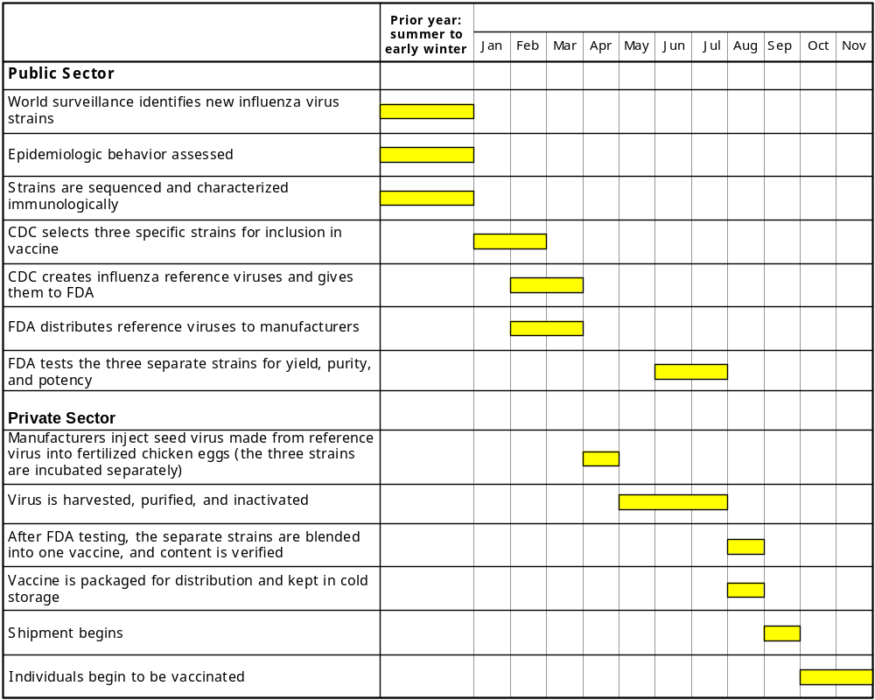

manufacturers licensed in the United States from four during the 1998–1999 influenza season to two in the 2004–2005 influenza season. Table 2 illustrates how the number of manufacturers has changed from 1993 to 2005.
Table 2. Influenza Vaccines, Manufacturers, and Seasons during which each Vaccine Was Sold
 |  |  | Influenza Season^{a,b}
Vaccine Trade Name |  | Manufacturer | 1993–94 | 1994–95 | 1995–96 | 1996–97 | 1997–98 | 1998–99 | 1999–00 | 2000–01 | 2001–02 | 2002–03 | 2003–04 | 2004–05 | 2005–06
Fluarix |  | GlaxoSmithKline (GSK) |  |  |  |  |  |  |  |  |  |  |  |  | •
FluMist^{c} |  | MedImmune Vaccines, Inc. |  |  |  |  |  |  |  |  |  |  | • | • | •
Fluogen |  | Parkedale Pharmaceuticals Inc.^{d} |  |  |  |  |  | •
 |  | Parke-Davis | • | • | • | •
FluShield^{e} |  | Wyeth Laboratories, Inc. | • | • | • | • | • | • | • | • | • | • | •
Fluvirin^{f} |  | Chiron Corporation |  |  |  |  |  |  |  |  |  |  |  | ^{g} | •
 |  | Evans Vaccines Ltd. |  |  |  |  |  |  |  |  |  |  | •
 |  | PowderJect Pharmaceuticals plc |  |  |  |  |  |  |  |  | • | •
 |  | Medeva Pharma Ltd. |  | • | • | • | • | • | • | •
Fluzone |  | Sanofi-Pasteur Inc.^{h} |  |  |  |  |  |  |  | • | • | • | • | • | •
 |  | Connaught  Laboratories | • | • | • | • | • | • | •
Flu-Imune |  | Lederle Laboratories | •
ª Vaccine Adverse Event Reporting System (VAERS) data used in this table includes manufacturer and trade name information taken only from specific incidence reports of vaccine adverse reactions. Data that did not specify specific influenza seasons were not used.
^{b} Influenza seasons 1993–1994 through 2000–2001 (CDC, 1993, 1994, 1995, 1996, 1997, 1998, 1999, 2000). Influenza seasons 2001–2002 through 2004–2005 (FDA, 2005).
^{c} Wyeth and MedImmune had a collaboration for the commercialization of FluMist for the 2003-2004 influenza season. The companies announced the dissolution of their collaboration in April 2004.
^{d} Parkedale Phamaceuticals, Inc., was ordered to discontinue production of influenza vaccine following a 2000 FDA inspection.
^{e} 1993–1994 trade name not available. Wyeth left the market after losing $50 million over the prior three influenza seasons; 2001–2002 was the worst season, during which the company lost $30 million and had 7 million doses of the vaccine that never sold (Ferguson, 2004).
^{f} In 2003, Chiron acquired PowderJect as a wholly owned subsidiary. In 2001, PowderJect acquired Medeva—which had previously acquired Evans Medical Ltd.—and restored the Evans name to Evans Vaccines Ltd, a wholly owned subsidiary of PowderJect. Prior to this, Evans Medical Ltd. had acquired the vaccine business of Wellcome. For more information on company acquisitions and mergers, see Vaccine Identification Standards Initiative: Manufacturer Abbreviations (CDC, 2003d).
^{g} On October 5, 2004, Chiron’s influenza vaccine plant was forced to cease production by government regulators due to contamination issues.
^{h} In 1999, Aventis Pasteur, Inc., obtained FluZone vaccine ownership from Connaught Laboratories, Inc. In 2004, Sanofi merged with Aventis Pasteur to create the Sanofi Aventis Group. The vaccine division of the Sanofi Aventis Group changed its name to Sanofi Pasteur.

4. Overview of Influenza Purchase and Distribution Issues
The process by which influenza vaccine is bought and sold is unlike that of other vaccines, which lack seasonality. The process involves numerous entities and different channels, many of which are little understood outside the vaccine industry. The major buyers of vaccine are presented in Table 3.
Table 3. Major Buyers of Influenza Vaccine
Wholesale Distributors | Providers | State/Federal Government
- Medical supply distributors  - Pharmaceutical distributors  - Pharmaceutical redistributors | - Private physicians  - Managed care organizations  - Hospitals  - Long-term care/nursing home facilities  - Work and retail-based community immunizers  - Local public health departments | - State health departments  - U.S. Department of Health and Human Services  - U.S. Department of Defense  - U.S. Department of Veterans Affairs

The distribution of influenza vaccine reflects the complex network of private and public components that constitute the U.S. health system (Figure 2). In the simplest case scenario, a private physician may buy vaccine directly from a manufacturer to administer to his/her patients. More typically, vaccine will have passed through multiple intermediaries before reaching the individual consumer. Health care providers of various sorts (physicians, community immunizers, state health departments, local public health departments) may buy vaccine from a distributor who bought it directly from a manufacturer. Alternatively, health care providers may obtain their vaccine through a state or federal vaccine program that bought it through a distributor or directly from a manufacturer. For example, CDC contracts with manufacturers for influenza vaccines. States buy vaccine through these contracts using their own funds or other government funds. The vaccine is then distributed to health care providers (including state and local health departments) through a variety of mechanisms.
As with the manufacturing sector, the buying and selling of influenza vaccine is rife with financial risk. The primary challenge to the entire system of purchase and distribution is balancing the potential financial liability of unused (and thus unpaid for) vaccine with the desire to provide influenza vaccine to those who need it. Like manufacturers, many distributors are so
Figure 2. Influenza Vaccine Distribution Pathways
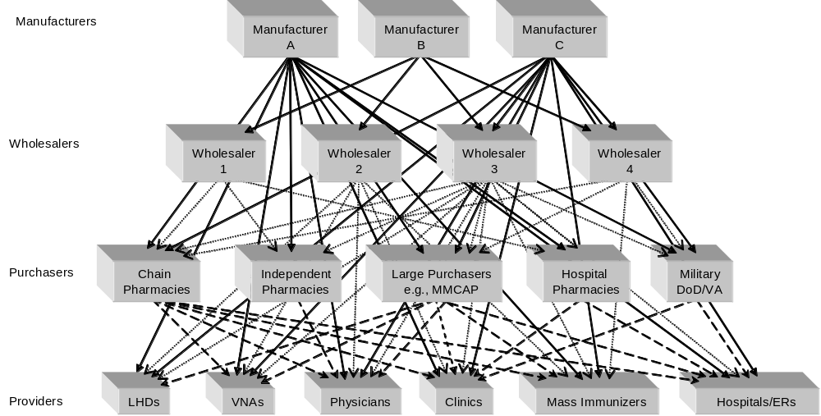
DoD = U.S. Department of Defense; ERs = emergency rooms; LHDs = local health departments;
MMCAP = Minnesota Multi-State Contracting Alliance for Pharmacy; VA = U.S. Department of Veterans Affairs; VNAs = Visiting Nurse Associations
concerned about the problems created by a fluctuating and unreliable influenza vaccine supply that they question their continued role in influenza vaccine distribution.

5. Case Study of the Influenza Seasons from 1999 through 2005
In examining the features of the influenza seasons from 1999 through 2005, one key finding is clear: there are no predictable factors that characterize a “normal” influenza season. Year to year, the strain and virulence of the virus varies, and it is difficult with any degree of certainty to forecast which strain will predominate 6 months in advance of the influenza season, when manufacturing decisions are made. Problems with manufacturing and distribution are difficult to predict, and rarely does the same problem arise more than once. Recommendations for who should receive vaccine also change according to scientific discoveries and the available supply of vaccine.

5.1 Prevailing Strains and Vaccine Composition
Each year, the influenza vaccines produced include two influenza A strains and one influenza B strain. In four of the last six influenza seasons from 1999 to 2005, A(H3N2) was the prevailing influenza A strain, but A(H1N1) and A(H1) were the prevailing strains in 2000–2001 and 2002–2003, respectively. During this period, the FDA Vaccines and Related Biologic Products Advisory Committee (VRBPAC) recommended, and manufacturers subsequently produced, 11 different vaccine compositions for the U.S. market. Only two of the 11 compositions, A/Caledonia/20/99(H1N1) and A/Moscow/10/99 (H3N2), were produced for three or more influenza seasons. In five of the last six influenza seasons, the recommended vaccine compositions matched the prevailing strains. However, in 2003–2004 the prevailing strain (H3N2) was more closely matched to a drift variant of A/Fujiian/411/2002/(H3N2), not the recommended vaccine composition for that year, A/Moscow/10/99 like (H3N2) (Table 4). Such alternative strains are used in situations in which the prevailing strain has a history of poor growth and/or poor yield during vaccine production.
Table 4. VRBPAC Recommended Vaccine Compositions 1999–2005
VRBPAC Recommended Vaccine Composition | Influenza Season
VRBPAC Recommended Vaccine Composition | 1999–2000 | 2000–2001 | 2001–2002 | 2002–2003 | 2003–2004 | 2004–2005
A/Beijing/262/95 (H1N1) | ▲
A/Fujian/411/2002 like (H3N2) |  |  |  |  |  | ▲
A/New Caledonia/20/99 like (H1N1) |  | ▲ | ▲ | ▲ | ▲ | ▲
A/Moscow/10/99 like (H3N2)ª |  |  | ▲ | ▲ | ▲
A/Panama/2007/99 like (H3N2) |  | ▲
A/Sydney/5/97/(H3N2) | ▲
B/Hong Kong/330/2001 |  |  |  | ▲ | ▲
B/Beijing/184/93 | ▲
B/Sichuan/379/99 |  |  | ▲
B/Shanghai/361/200 like |  |  |  |  |  | ▲
B/Yamanashi |  | ▲
ªA/Moscow could be used in lieu of A/Panama.
Sources: CDC, 1999b; CDC, 2000a; CDC, 2001a; CDC, 2001c; CDC, 2002a; CDC, 2002b; CDC, 2003a; CDC, 2003c; CDC, 2004a; CDC, 2004c; CDC, 2004d; CDC, 2005b.

5.2 Manufacturing and Distribution
From 1999 to 2004, annual influenza vaccine production rose steadily from 77.2 million to 99.5 million doses. A similar trend was seen for the number of doses distributed (Figure 3). Despite the progress made toward increasing production of influenza vaccine for U.S. distribution, it remains well below the 183.3 million doses recommended by the Advisory Committee on Immunization Practices (ACIP) to immunize all people in all target groups.
Figure 3. Influenza Vaccine Doses Produced and Distributed for the U.S. Market 1999–2004
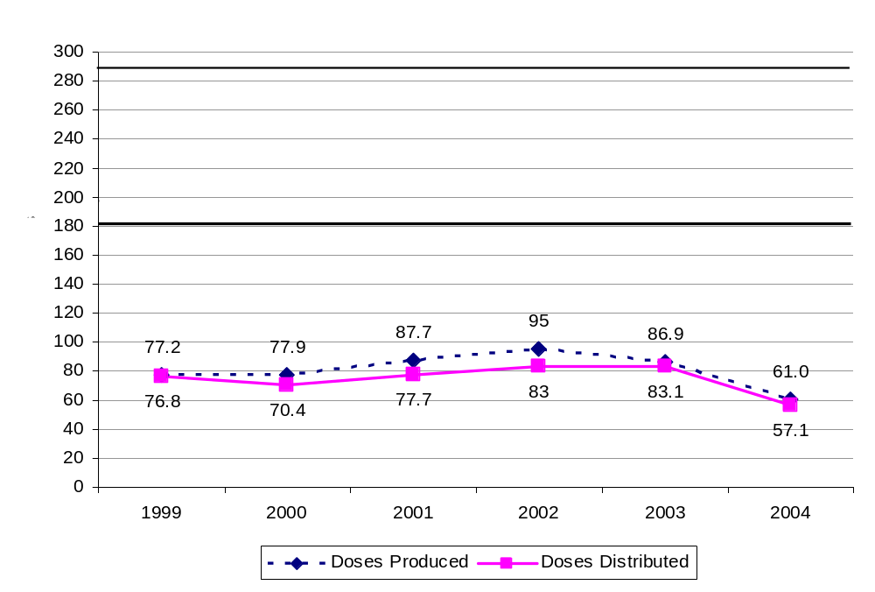
ª Targeted population includes persons 65 years of age or older, those with defined chronic diseases, pregnant women, children 6 to 23 months of age, household contacts of those previously mentioned, health care personnel, and healthy persons 50 to 64 years of age.
Sources: CDC, 2005c; Santoli, 2005.
Manufacturing problems arose in two of the last six influenza seasons. In 2000–2001, manufacturing problems at two companies resulted in lower than expected yields, causing delays in delivery of vaccine that created de facto shortages (Layton, Honeycutt, Levy, Kessler, & Liao, 2001). In 2001–2002, spot shortages were reported in some areas early in the season (CDC, 2001c) and were more widespread in 2003–2004 (Mitka, 2005). In 2004–2005, U.K. regulators suspended production at Chiron after the company failed to resolve ongoing production problems, resulting in the widely publicized loss of nearly half the U.S. vaccine supply for that season. This was the only season in which rationing occurred (CDC, 2004b). Table 5 summarizes some of the key issues occurring during these six influenza seasons.
Table 5. Summary of 1999–2005 Influenza Seasons
Event | Influenza Season
Event | 1999–2000 | 2000–2001 | 2001–2002 | 2002–2003 | 2003–2004 | 2004–2005
Prevailing influenza strain | A(H3N2) | A(H1N1) | A(H3N2) | A(H1) | A(H3N2) | A(H3N2)
Production problems | No | Yes | No | No | No | Yes
Delays in delivery | No | Yes | Yes | No | No | Yes
Spot shortages | No | Yes | Yes | No | Yes | Yes
Vaccine rationing | No | No | No | No | No | Yes
ACIP broadens identified target groups | No | Yes | No | No | No | Yes
ACIP updated recommendations | No | No | Yes | Yes | Yes | Yes
Sources: CDC, 1999b; CDC, 2000b; CDC, 2001a; CDC, 2001c; CDC, 2002a; CDC, 2002b; CDC, 2002c;
CDC, 2003a; CDC, 2003b; CDC, 2004a; CDC, 2004c; CDC, 2004d; CDC, 2004f; CDC, 2005b; FDA, 2001.

5.3 Changing Advisory Committee on Immunization Practices (ACIP) Recommendations
ACIP is a 15-member panel of experts on immunization from the fields of medicine, immunology, and public health. ACIP advises CDC and the U.S. Department of Health and Human Services and develops written recommendations for routine vaccine administration. In three of the last six influenza seasons, ACIP has revised its recommendations for influenza administration. Recommendations to broaden target groups have reflected evolving science, which has shown benefits associated with immunizing increasing proportions of the public. In 2000, ACIP broadened its initial target group—persons 65 years of age or older and persons with health conditions that would place them at particular risk for influenza-related complications—to include all persons 50 years of age or older regardless of health status (CDC, 2001b). In 2004, the recommendations broadened again to include young children 6 to 23 months of age (CDC, 2004a).
Although ACIP recommends that all individuals who wish to avoid influenza be immunized, ACIP’s identified target groups are those who are especially vulnerable to influenza-associated complications. These groups are generally the very young, elderly, chronically ill, and immunocompromised. Recommendations to prioritize target groups or otherwise “ration” influenza vaccine in times of shortage have been the subject of considerable debate. Due to problems in previous influenza seasons, in 2003, ACIP began to recommend that those at highest risk for influenza complications receive immunizations in September and October, but others should wait until November (CDC, 2001b). Although ACIP recognizes the need for coherent and consistent recommendations, it also wants to assure the means to target specific priority groups in times of vaccine shortage. Thus, in 2005, ACIP recommended a tiered use of inactivated influenza in the case of vaccine shortage (CDC, 2005d). Such a tiered approach is outlined in Table 6. However, it should be noted that, among the key informants, there was no agreement regarding how a shortage should be defined.
Table 6. Tiered Approach to Allot Inactivated Influenza Vaccine During a Shortage
 | Priority Groups
Tier 1 | A  Persons 65+ years of age with comorbid conditions  Residents of long-term care facilities | B  Persons 2 to 64 years of age with comorbid conditions  Persons 65+ years of age without comorbid conditions  Children 6 to 23 months of age  Pregnant women | C  Health care personnel  Household contacts and out-of-home care givers of children < 6 months of age
Tier 2 | Household contacts of children and adults at increased risk for influenza-related complications  Healthy persons 50 to 64 years of age
Tier 3 | Persons 2 to 49 years of age without comorbid conditions

5.4 Impact of Bioterrorism Preparedness on Influenza Awareness and Planning
The terrorist attacks in the U.S. during the fall of 2001 increased awareness of the potential for infectious agents to be used for bioterrorism. As one key informant noted, “The big targets are going to be what you eat, breathe, and drink … and that’s public health infrastructure, which is already strapped. I’d think you’d want to eliminate an additional threat if you could.” Since fiscal year (FY) 2002, states have expended an estimated $2 billion in bioterrorism funds to develop preparedness for a range of natural and terrorist disasters and other public health emergencies, including pandemic influenza (U.S. Government Accounting Office, 2005).
In general, those with whom we spoke viewed bioterrorism preparedness within a broader context of public health preparedness. Most key informants were positive about the impact of preparedness planning on influenza planning and vice versa. At the state level, funding for bioterrorism preparedness has established mechanisms for coordination and communication to deal with man-made and naturally occurring public health crises.
States used the challenges arising during the influenza seasons of 2002–2003 and 2003–2004, in particular, to initiate and “test” their emergency preparedness plans—activating their command incident centers and using their Health Alert Network to determine which providers had influenza vaccine and how much. Also, states have had to increase their capacity to distribute many more doses of vaccine than in previous years. During the 2003–2004 season, one state conducted a 1-day mass immunization event to assess whether they had the capacity to conduct such an effort (they did, in fact, successfully administer an estimated 53,000 doses in 1 day).
During periods of vaccine shortages, states have also, by necessity, taken on new roles as brokers—finding new vaccine storage facilities, reaching out to a range of new providers—to ensure that scarce vaccine is distributed to those most in need. For community immunizers, the experience of the 2003–2004 influenza season prompted the establishment of explicit procedures for crowd control and planning of mass immunization events.
A positive effect of bioterrorism preparedness, mentioned by nearly all of our key informants, is enhanced communication. State health officials reported better communication with their stakeholders both within and outside the health department. Federal health officials cited better communication between state entities and CDC, and manufacturers and distributors noted better communication with CDC and greater private/public partnering. One community immunizer explained,
What I’ve been seeing from the past year or so, there’ve been some great public-private partnerships that I think have shown a lot of people what we need to do for pandemic planning and bioterrorism planning. I know that’s a big thing going on. But at the same time, there are still locations [that] really don’t have a realistic plan on what to do if something happened … there really needs to be multiple levels of involvement and plans put far enough in advance.
Despite enhanced communication among stakeholders at all levels and a greater understanding of state capability for mass immunization, a few informants noted that the merits of bioterrorism preparedness have yet to be fully realized. As one informant noted, states need “a dose of reality;” some of the preparedness plans in place simply are not realistic because they ignore the inability of the manufacturing and distribution sectors to produce more vaccine in a short period of time. Moreover, while the willingness to “band together and get things done” is commendable, some stakeholders are still very unclear as to how they should respond in an emergency. Following the 2004–2005 season, one community immunizer said,
In case of emergency—a vaccine shortage—there has to be a plan in place already and something that can be easily adjusted within a matter of a day or two because we lost 2 or 3 weeks of getting vaccine out to the right people. I think that’s one of the big reasons why there was vaccine wasted.
There is also uncertainty among federal officials about how their own agencies would respond in a crisis. For example, during the 2003–2004 season, CDC repositioned and reassigned staff to new duties in ways that were unclear to personnel. While CDC management clearly felt the need to keep staffing flexible and fluid during a crisis, some of our informants argued that the process isolated and disregarded the expertise of key staff; in their view, this resulted in poor decision making. Thus, it would seem that in the absence of any concrete “crisis plan” that is understood and agreed to by all key personnel a priori, the potential exists for miscommunication, inefficiency, and the loss of important knowledge and expertise when it is needed most.
Thinking about influenza immunization in the broader sphere of public health, some key informants addressed the roles of various stakeholders and emphasized the importance of defining the roles and responsibilities of all involved. This is particularly important as various components of the influenza immunization infrastructure are privatized. One community immunizer from a for-profit firm explained,
… The scenario now is that private companies really don’t want to spend a lot of time doing [preparedness planning] because it’s all pie-in-the-sky stuff. There’s no funding. Unfortunately, private companies have to make a living in order to help anybody. As long as we’re in America.
Another community immunizer asserted,
The government needs to take a more serious stand in taking the risk away and incentivizing manufacturers to make influenza vaccine to stabilize demand and supply issues so that providers—very much including community immunizers—stay in the business because in the case of an emergency scenario—whether it’s influenza or other needs which require vaccine or mass distribution of medication—you want those community immunizers to already have an infrastructure to work closely … with public health because I just don’t see how public health agencies can take that on their own.
On the other hand, another key informant, an expert in the field of immunization, felt not only that all immunization was fundamentally a job for the public sector, but that it ought to be a primary concern:
I tend to view vaccination as a matter of national health security. If you use as a paradigm national security, which is a responsibility of the department of defense … We don’t leave national defense to the private sector. … It is idiotic, idiotic for us to regard vaccine-preventable diseases as anything other than health security—particularly when we’re concerned about influenza and a threat of a pandemic. To think that this is something that can be led in a market-oriented way by profit-seeking companies and essentially holding national health hostage to what corporations do and do not want to do is ludicrous.

6. Summary and Conclusions
The issues and challenges raised here are intended to inform policies affecting the production, distribution, and administration of influenza vaccine. While these issues are difficult and evolving quickly over time, four features remain fundamental to an understanding of the influenza vaccine market in the U.S.:
- The complexity of influenza vaccine demand, supply, and distribution. The production and distribution of influenza vaccine is unique and cannot be compared to any other vaccines or pharmaceuticals. The complexity of the system is borne out of the time-consuming technologies used to produce influenza vaccine, the immense unpredictability of the demand for the vaccine, and the public reaction to supply shortages or surpluses.
- The high level of financial risk incumbent on vaccine manufacturers and wholesalers. Manufacturers carry a financial risk producing influenza vaccines with complicated technology for an unpredictable market that can leave them with tens of thousands or even millions of unused or, as in the case of Chiron, unusable doses. This risk is transferred to the wholesalers once vaccine supplies are booked and sold to other distributors or immunization providers. Additional protections from the public sector (e.g., commitments to purchase surplus vaccine) may be needed to reduce the risk that manufacturers and distributors face in a marketplace with relatively low profit margins compared to other pharmaceuticals.
- The fundamental need to better educate the public. A more informed public can increase demand for vaccine, which in turn could solve many of the vaccine supply, demand, and distribution issues in and of itself. Greater demand and therefore a greater supply would in turn alleviate the prebooking requirements that can generate shortages.
- The complexity of the problem, which requires multifaceted strategies. Solutions that will improve vaccination supply and distribution cannot be achieved solely by any single participant, be they manufacturers, health care providers, or distributors. The production system needs greater creativity and innovation that will foster new technologies to manufacture the vaccine more quickly and efficiently.
Former CDC National Immunization Program Director, Walter Orenstein, has called influenza “the most significant vaccine-preventable disease.” Despite this, many people still think of influenza as a mild illness—even though it kills more people annually than prostate or cervical cancer. Nevertheless, the approach to influenza’s prevention has not been proportionate to the threat it poses. It is clear that in order to effectively provide annual influenza immunization to targeted groups that the various components of the vaccine immunization infrastructure must work toward this goal in a coordinated and collaborative fashion. Examples of the efforts required by various groups are described in the recent report written by members of the National Vaccine Advisory Committee (NVAC), Strengthening the Nation’s Influenza Vaccination System (Helms et al., 2005). Such collaboration is depicted in a 1911 public health poster (Figure 4). The public’s health is protected by infrastructure composed of many components. All of these components are not sufficient on their own, but together they create a means to assure the public’s health—the essential form of national security.
Figure 4. Public Health Poster from 1911
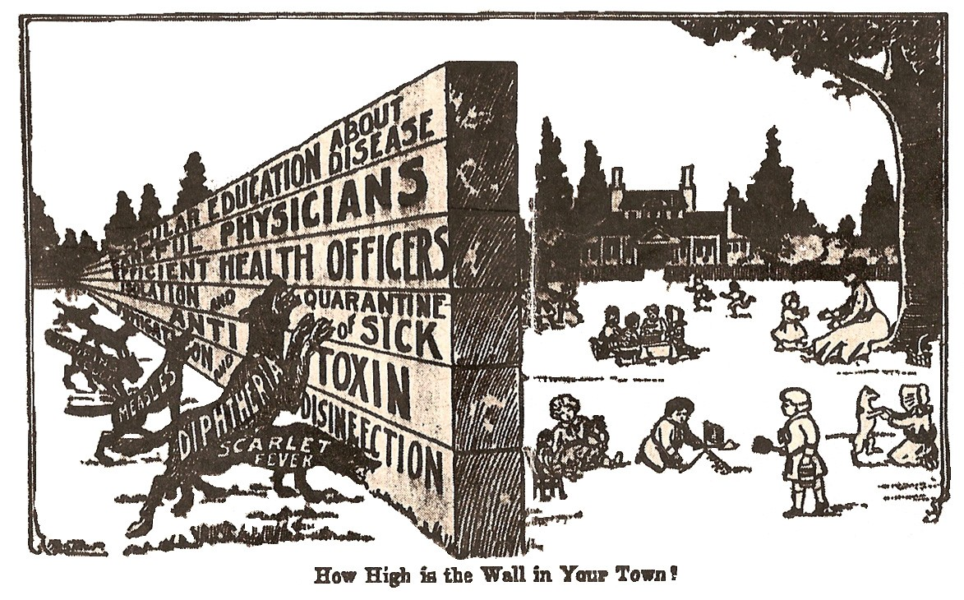
Source: Ehrenreich and English (1973).

References
Centers for Disease Control and Prevention (CDC) (1993, 1994, 1995, 1996, 1997, 1998, 1999, 2000). Vaccine Adverse Event Reporting System (VAERS) Data. Retrieved October 19, 2005 from http://vaers.hhs.gov/info.htm
Centers for Disease Control and Prevention (CDC) (1999a, April 2). Ten Great Public Health Achievements–United States, 1900–1999. Morbidity and Mortality Weekly Report, 48(12), 241–243. Retrieved October 20, 2005, from http://www.cdc.gov/mmwr/preview/mmwrhtml/00056796.htm
Centers for Disease Control and Prevention (CDC) (1999b, May 14). Update: Influenza activity–United States and worldwide, 1998–99 season and composition of the 1999–2000 influenza vaccine. Morbidity and Mortality Weekly Report, 48(18), 374–378. Retrieved October 20, 2005, from http://www.cdc.gov/mmwr/preview/mmwrhtml/mm4818a2.htm
Centers for Disease Control and Prevention (CDC) (2000a, May 5). Update: influenza activity–United States and worldwide, 1999–2000 season and composition of the 2000–01 influenza vaccine. Morbidity and Mortality Weekly Report, 49(17), 375–381. Retrieved October 20, 2005, from http://www.cdc.gov/mmwr/preview/mmwrhtml/mm4917a5.htm
Centers for Disease Control and Prevention (CDC) (2000b, October 6). Notice to readers: Updated recommendations from the Advisory Committee on Immunization Practices in response to delays in supply of influenza vaccine for the 2000–01 season [see also erratum]. Morbidity and Mortality Weekly Report, 49(39), 888–892. Retrieved October 20, 2005, from http://www.cdc.gov/mmwr/preview/mmwrhtml/mm4939a3.htm
Centers for Disease Control and Prevention (CDC) (2001a, June 8). Update: influenza activity–United States and worldwide, 2000–01 season and composition of the 2001–02 influenza vaccine. Morbidity and Mortality Weekly Report, 50(22), 466–470. Retrieved October 20, 2005, from http://www.cdc.gov/mmwr/preview/mmwrhtml/mm5022a4.htm
Centers for Disease Control and Prevention (CDC) (2001b, July 13). Notice to readers: Delayed influenza vaccine availability for 2001–2002 season and supplemental recommendations of the Advisory Committee on Immunization Practices. Morbidity and Mortality Weekly Report, 50(27), 582–585. Retrieved October 20, 2005, from http://www.cdc.gov/mmwr/preview/mmwrhtml/mm5027a3.htm
Centers for Disease Control and Prevention (CDC) (2001c, October 19). Influenza vaccine bulletin #9. Flu season 2001–2002. Retrieved October 20, 2005, from http://www.cdc.gov/flu/professionals/bulletin/2001-02/bulletin9_101901.htm
Centers for Disease Control and Prevention (CDC). (2002a, June 14). Update: Influenza activity–United States and worldwide, 2001–02 season and composition of the 2002–03 influenza vaccine. Morbidity and Mortality Weekly Report, 51(23), 503–506. Retrieved October 20, 2005, from http://www.cdc.gov/mmwr/preview/mmwrhtml/mm5123a3.htm
Centers for Disease Control and Prevention (CDC) (2002b, October 9). Influenza vaccine bulletin #5. Flu season 2002–2003. Retrieved October 20, 2005, from http://www.cdc.gov/flu/professionals/bulletin/2002-03/bulletin5_100902.htm
Centers for Disease Control and Prevention (CDC) (2002c, October 25). Surveillance for influenza–United States, 1997–98, 1998–99, and 1999–00 seasons. Morbidity and Mortality Weekly Report, 51(SS07), 1–10. Retrieved October 20, 2005, from http://www.cdc.gov/mmwr/preview/mmwrhtml/ss5107a1.htm
Centers for Disease Control and Prevention (CDC) (2003a, June 6). Update: Influenza activity–United States and worldwide, 2002–03 season and composition of the 2003–04 influenza vaccine. Morbidity and Mortality Weekly Report, 52(22), 516–521. Retrieved October 20, 2005, from http://www.cdc.gov/mmwr/preview/mmwrhtml/mm5222a2.htm
Centers for Disease Control and Prevention (CDC) (2003b, August 22). Notice to readers: Supplemental recommendations about the timing of influenza vaccination, 2003–04 Season. Morbidity and Mortality Weekly Report, 52(33), 796–797. Retrieved October 20, 2005, from http://www.cdc.gov/mmwr/preview/mmwrhtml/mm5233a6.htm
Centers for Disease Control and Prevention (CDC) (2003c, September 11). Influenza Vaccine Bulletin #3. Flu Season 2003–2004. Retrieved October 20, 2005, from http://www.cdc.gov/flu/professionals/bulletin/2003-04/bulletin3_091103.htm
Centers for Disease Control and Prevention (CDC) (2003d, October 31). Vaccine Identification Standards Initiative: Manufacturer Abbreviations. Retrieved October 19, 2005, from http://www.cdc.gov/nip/visi/prototypes/mfgnames.htm
Centers for Disease Control and Prevention (CDC) (2004a, July 2). Update: Influenza activity–United States and worldwide, 2003–04 season, and composition of the 2004–05 influenza vaccine. Morbidity and Mortality Weekly Report, 53(25), 547–552. Retrieved October 20, 2005, from http://www.cdc.gov/mmwr/preview/mmwrhtml/mm5325a1.htm
Centers for Disease Control and Prevention (CDC) (2004b, October 5). Interim influenza vaccination recommendations, 2004–05 (Press Release). Retrieved October 20, 2005, from http://www.cdc.gov/od/oc/media/pressrel/r041005.htm
Centers for Disease Control and Prevention (CDC) (2004c, October 8). Interim influenza vaccination recommendations, 2004–05 influenza season. Morbidity and Mortality Weekly Report, 53(39), 923–924. Retrieved October 20, 2005, from http://www.cdc.gov/mmwr/preview/mmwrhtml/mm5339a6.htm
Centers for Disease Control and Prevention (CDC) (2004d, November 5). Influenza vaccination and self-reported reasons for not receiving influenza vaccination among Medicare beneficiaries aged >65 years—United States, 1991–2002. Morbidity and Mortality Weekly Report, 53(43), 1012–1015. Retrieved October 20, 2005, from http://www.cdc.gov/mmwr/preview/mmwrhtml/mm5343a3.htm
Centers for Disease Control and Prevention (CDC) (2004e, November 24). National Program of Cancer Registries: Data Collection and Surveillance. 2001 Appendix D1–Case counts by primary site. Retrieved October 20, 2005 from http://apps.nccd.cdc.gov/uscs/TableV.asp?group=da&Year=2001&Gender=MAL&TableType=MORT
Centers for Disease Control and Prevention (CDC) (2004f, December 24). Updated interim influenza vaccination recommendations—2004–05 influenza season. Morbidity and Mortality Weekly Report, 53(50), 1183–1184. Retrieved October 20, 2005, from http://www.cdc.gov/mmwr/preview/mmwrhtml/mm5350a7.htm
Centers for Disease Control and Prevention (CDC) (2005a, March 7). Table E. Deaths and percentage of total deaths for the 10 leading causes of death, by race: United States, 2002. National Vital Statistics Reports, 53(17), 9. Retrieved October 20, 2005, from http://www.cdc.gov/nchs/data/dvs/nvsr53_17tableE2002.pdf
Centers for Disease Control and Prevention (CDC) (2005b, April 8). Update: Influenza activity–United States, 2004–05 season. Morbidity and Mortality Weekly Report, 54(13), 328–331. Retrieved October 20, 2005, from http://www.cdc.gov/mmwr/preview/mmwrhtml/mm5413a2.htm
Centers for Disease Control and Prevention (CDC) (2005c, July 28). Interim estimates of populations targeted for influenza vaccination from 2003 National Health Interview Survey data and estimates for 2004 based on influenza vaccine shortage priority groups. Retrieved September 20, 2005 from http://www.cdc.gov/flu/professionals/vaccination/pdf/targetpopchart.pdf
Centers for Disease Control and Prevention. (2005d, August 5). Tiered use of inactivated influenza vaccine in the event of a vaccine shortage. Morbidity and Mortality Weekly Report, 54(30), 749–750. Retrieved October 21, 2005, from http://www.cdc.gov/mmwr/preview/mmwrhtml/mm5430a4.htm
Ehrenreich, B., & English, D. (1973). Complaints and disorders; the sexual politics of sickness (Glass Mountain Pamphlet No. 2). Old Westbury, NY: The Feminist Press.
Ferguson, B. (2004, October 29). Flu shot debacle: The flu vaccine crisis was produced by the very policies favoured by those who seek to reform the entire pharmaceutical industry. Any lesson here? (Atlantic Institute for Market Studies). Retrieved October 19, 2005, from http://www.aims.ca/aimslibrary.asp?cmPageID=192&ft=4&id=1034
Harper, S.A., Fukuda, K., Uyeki, T.M., Cox, N.J., & Bridges, C.B. (2005, July 29). Prevention and control of influenza: Recommendations of the Advisory Committee on Immunization Practices (ACIP) (see erratum). Morbidity and Mortality Weekly Report, 54(RR08), 1-40. http://www.cdc.gov/mmwr/preview/mmwrhtml/rr5408a1.htm
Helms, C.M., Guerra, F.A., Klein, J.O., Schaffner, W., Arvin, A.M., & Peter, G. (2005). Strengthening the nation's influenza vaccination system: A National Vaccine Advisory Committee assessment. American Journal of Preventive Medicine, 29(3), 221–226.
Layton, C., Honeycutt, A., Levy, J., Kessler, A., & Liao, W. (2001). Annual influenza vaccine distribution process. Report prepared for the U.S. Department of Health and Human Services, Office of the Assistant Secretary of Planning and Evaluation, under Contract No. HHS-100-97-0014, Task 11.
Mitka, M. (2005). Medical news & perspectives: Health officials brace for flu season. Journal of the American Medical Association, 292(14), 1670–1671.
Orenstein, W.A., Douglas, R.G., Rodewald, L.E., & Hinman, A.R. (2005). Immunizations in the United States: Success, structure, and stress. Health Affairs 24(3), 599–610.
Santoli, J.M. (2005). The 2004–05 influenza season: What can we take away from this experience? Presentation at the 2005 NACCHO-ASTHO Joint Conference in Boston, July 12-15. Retrieved October 20, 2005, from http://www.astho.org/pubs/santoli2005.ppt
Thompson, W.W., Shay, D.K., Weintraub, E., Brammer, L., Bridges, C.B., Cox, N.J, & Fukuda, K. (2004). Influenza-associated hospitalizations in the United States. Journal of the American Medical Association, 292(11), 1333-1340.
Thompson, W.W., Shay, D.K., Weintraub, E., Brammer, L., Cox, N., Anderson, L.J., & Fukuda, K. (2003). Mortality associated with influenza and respiratory syncytial virus in the United States. Journal of the American Medical Association, 289(2), 179-186.
U.S. Food and Drug Administration (FDA). (2001). Availability of influenza virus vaccine 1999. Retrieved October 20, 2005, from http://www.fda.gov/cber/infosheets/flu092999.htm
U.S. Food and Drug Administration (FDA) (2005, September 15). Influenza Virus Vaccine: Seasonal Information (Lot Release Information for 2001–2002, 2002–2003, 2003–2004, and 2004–2005). Retrieved October 19, 2005, from http://www.fda.gov/cber/flu/flu.htm
U.S. Government Accounting Office. (2005). Bioterrorism. Information on jurisdictions’ expenditure and reported obligation of program funds. GAO-05-239 (Washington, DC: Author).

Although the primary responsibility for influenza vaccine production falls to the vaccine industry, CDC prepares reference strains of influenza virus for the FDA to distribute to influenza vaccine manufacturers.
Priority groups include persons 65 years of age or older, persons of any age with chronic diseases, pregnant women, children 6 to 23 months of age, health care personnel, and household contacts of previously listed groups. Target (or targeted) groups include priority groups plus healthy adults 50 to 64 years of age.
While influenza causes approximately 36,000 deaths annually, in 2001 prostate cancer caused 30,719 deaths and cervical cancer 4,100. In that same year, breast cancer killed 39,800 people. (CDC, 2004e.)

