Office of Aerospace Technology

Office Work Instruction

INVENTIONS AND CONTRIBUTIONS BOARD STAFF
OPERATIONS AND PROCEDURES

Approved by: ___________________________
Samuel L. Venneri
Associate Administrator for
Aerospace Technology

DOCUMENT HISTORY LOG

Status  (Baseline/  Revision/  Canceled) | Docu-ment  Revision | Effective  Date | Description
Baseline |  | 1/11/00
Revision | A | 4/26/00 | Revisions reflect review of HQOWI to address Pre-Assessment Audit of Feb 2000, as follows: (1) editorial updates, (2) flow chart modifications.
Admin Update | A | 8/2/00 | Administrative Update to change the Responsible Office from Code I to Code R due to this function being transferred to Code R. Updated the cover page header and gave the document a new number. Old number was I018.
Revision | B | 11/6/00 | Revision to change Approved by from Code I to Code R and also to delete OER from definitions and replace with OAT. This change also updates the actionee list in Section 6 and changes the location in Section 7 to RI.

- Purpose

The Inventions and Contributions Board (ICB) was created when NASA was founded in 1958 and is directed by law under the National Aeronautics and Space Act of 1958, as amended. In compliance with the Space Act, Section 306, the ICB makes recommendations to the Administrator for awards not to exceed $100,000 for contributions that are significant to aeronautics and space activities that are supported, adopted, promoted, or used by NASA. The ICB rewards excellence in scientific and technological contribution and also rewards contributors who have approval for publication of technology summaries in NASA Tech Briefs, approval for patent applications, or have been approved for release of their software by NASA Center Releasing Authority in accordance with NPG 2210.1. The awards are issued to employees of NASA and its contractors, as well as to other government, university, and industry personnel. Section 305(b) of the Space Act provides that the ICB transmit to the Administrator its findings of fact and recommendations with respect to each proposal for waiver of rights to any invention or class of inventions which may be made in the performance of work required by any NASA contract. The purpose of the HQOWI is to outline the Space Act award and patent waiver processes performed by the ICB staff.

- Scope and Applicability

  - This HQOWI covers Inventions and Contributions Staff Office process performed in Office of Aerospace Technology.

  - These procedures outline ICB operations, procedures, and guidelines. In addition, these procedures contain the Board's staff process and also process and procedures for staffing Board action awards, Automatic awards (NASA Tech Briefs, patent applications, and software dissemination awards), and patent waivers. The ICB is covered under the Code of Federal Regulations Title 14 CFR Part 1209.4 and Part 1240.1, and the patent waiver regulations are identified in Title 14 CFR Part 1245.1.
.
  - The NASA Chief Engineer chairs the ICB. The Board membership consists of the Chair and up to fourteen Board members. The members are selected from various disciplines from NASA Headquarters and the Centers. The individual members are very highly qualified personnel in the fields of science, technology, engineering, software development, and business and legal aspects of innovations within the government and industry. The ICB Chair selects the Board members with concurrence of the Administrator.

- Definitions

  - ALO. Award Liaison Officer

  - CTO. Commercial Technology Office

  - FF&R. Finding of Fact and Recommendation

  - ICB. Inventions and Contributions Board - The ICB was established by the 1958 Space Act with the provision that the Administrator is authorized, in such amount and upon such terms as he shall determine to be warranted, to any person for any scientific or technical contribution to NASA which is determined by the Administrator to have significant value in the conduct of aeronautical and space activities. The ICB is empowered to make recommendations to the Administrator the terms of any awards made to persons who have applied for a Space Act award. The Space Act also provides that the ICB transmit to the Administrator its findings of fact and recommendations with respect to each proposal for waiver of rights to any invention or class of inventions which may be made in the performance of work required by any NASA contract.

  - I/W. Instrument of Waiver

  - Monetary Awards Analysis Form. A form used for Space Act Award analysis to provide a numerical weighting system relative to significance, development, usage, and creativity.

  - NF 163. Procurement Request

  - NF 1329. Space Act Award Application

  - NF 1523. Waiver Questionnaire - Technical Evaluation (Advanced Waiver)

  - NF 1524. Waiver Questionnaire - Technical Evaluation (Invention Waiver)

3.11 NF 1546. Combined Inventions & Contributions Board Automatic awards
(Tech Briefs)

3.12 NF 1548. Combined Inventions & Contributions Board Automatic awards
(Patent)

3.13 NF 1661. Combined Inventions & Contributions Board Automatic awards
(Software)

3.14 NHQDF 622. Inventions and Contributions Board Award Check Receipt

3.15 OAT. Office of Aerospace Technology

  - Patent Waiver Panel. The Patent Waiver Panel Consists of the Counsel to the Inventions and Contributions Board, two Board Members, Director of ICB Staff, and ICB Staff Senior Technologist.

4. References

4.1 National Aeronautics and Space Act of 1958, as amended, Section 305(f) and Section 306

  - Code of Federal Regulations - 14 CFR Part 1209.4 (Inventions and Contributions Board)

  - Code of Federal Regulations - 14 CFR Part 1240.1 (Inventions and Contributions)

  - Code of Federal Regulations - 14 CFR Part 1245.1 (Patent Waiver Regulations)

  - NPD-2210.1 External Release of NASA Software

  - NPD-2091.1 Inventions Made by Government Employees

  - NPD-2092.1 Royalties and Other Payments by NASA from the Licensing
of Patent and Patent Applications

  - NPD-2820.1 NASA Software Policies

  - NPG-2210.1 External Release of NASA Software

- Flowchart

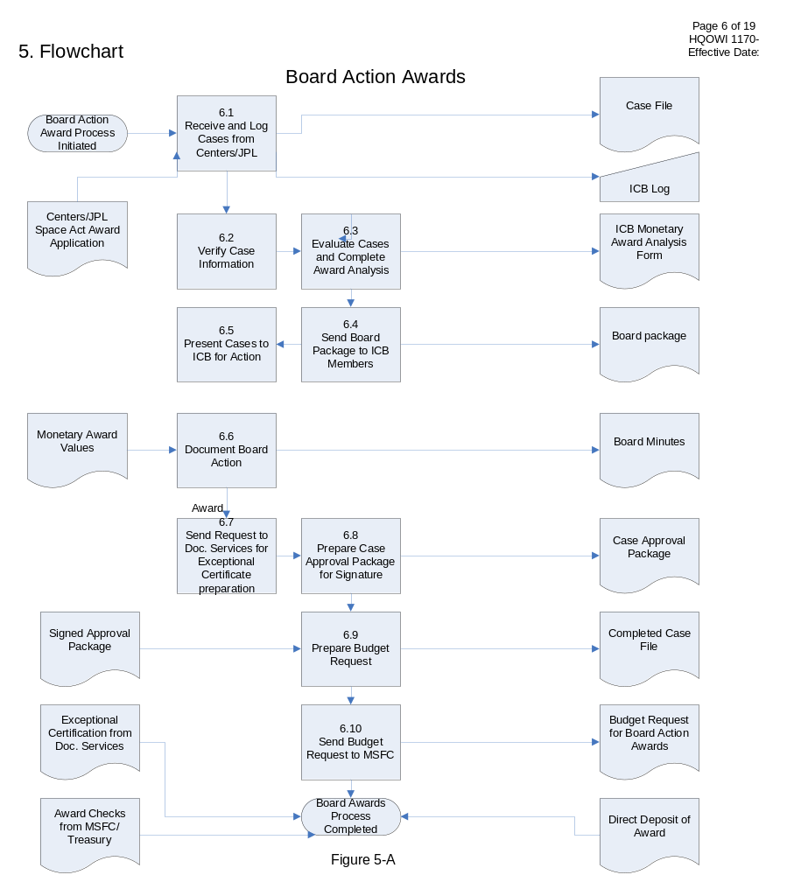
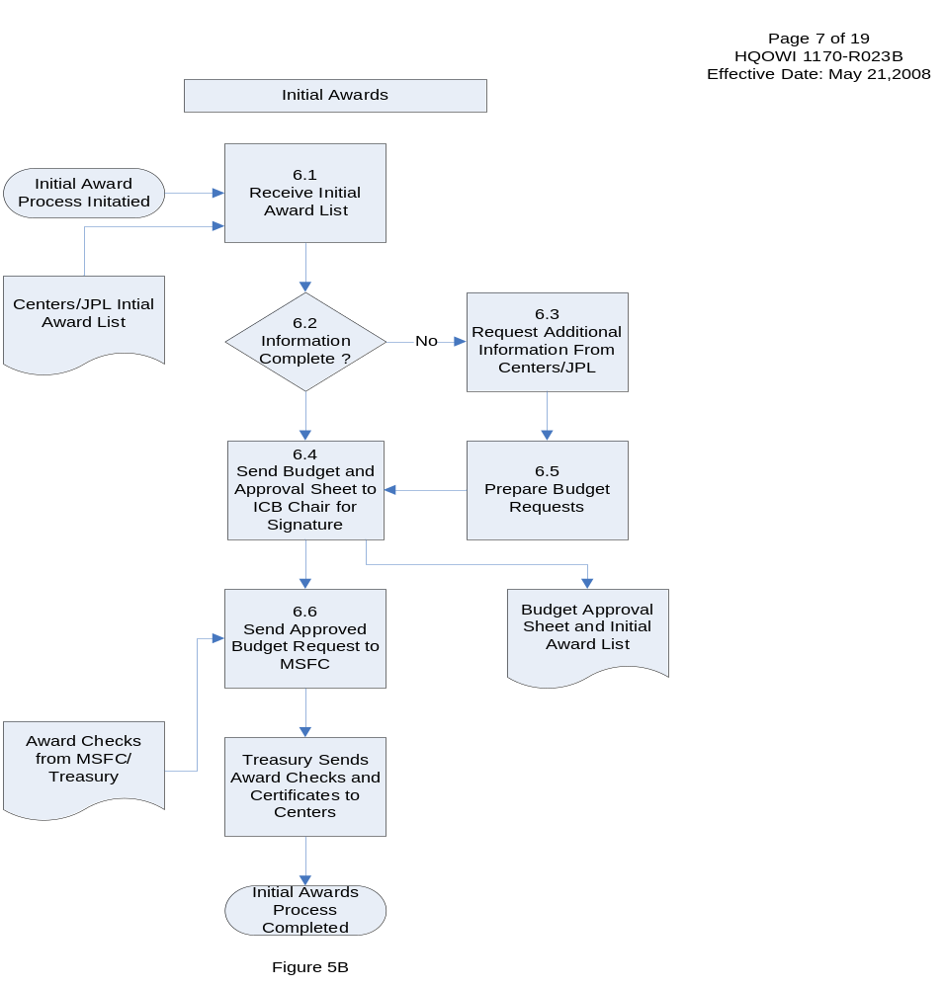

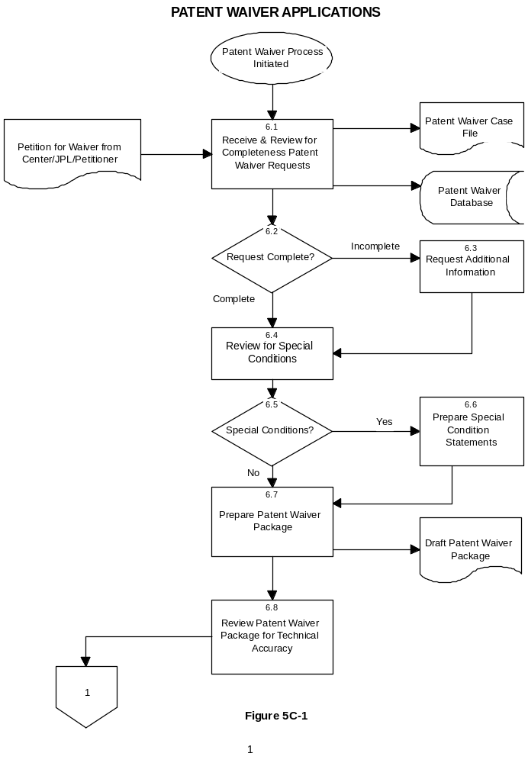

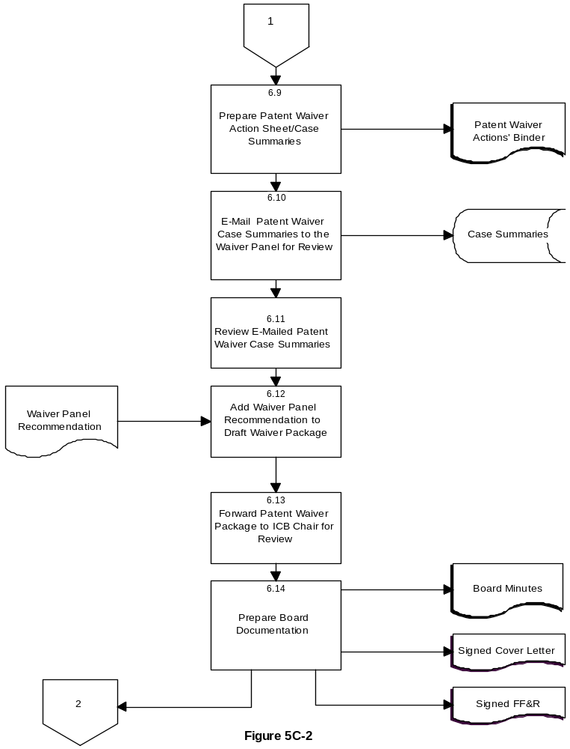

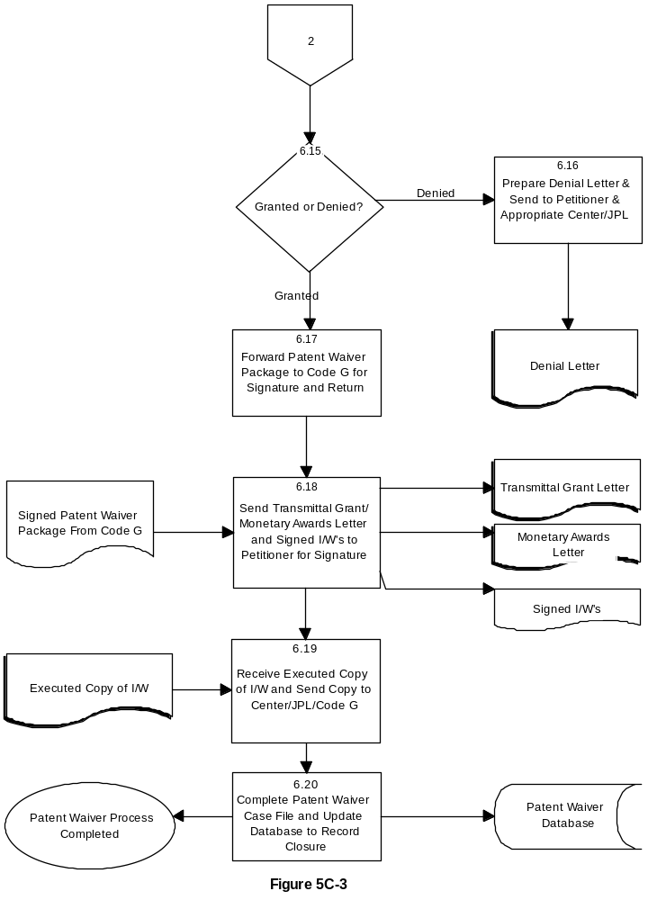

6. Procedures

The ICB meets bi-monthly to recommend contributions for monetary awards. The Board is a voting body with the majority prevailing, and in the case of a tie, the Chair casts the deciding vote. The Board requires a quorum to approve an award and, as a standard operating policy of the Board, members who have a significant personal relationship with a contributor of an award case will be recused. The Board's review material will be prepared by the ICB staff and each award case which has at least one contributor marked to receive more than $1,000 will be presented to the Board with recommendations for approval or disapproval and a recommended monetary value. Summaries of cases of lesser value will also be provided to the Board without presentation.

The awards process is a highly structured process for dealing with inventions, NASA Tech Briefs, patent applications, software dissemination, and patent waivers. The process is outlined in the following.

Board Action Awards: Figure 5A

Step | Actionee | Action
6.1 | ICB Program  Specialist | Cases received from the Centers or JPL usually involve an invention or a software development. The case files consist of NF-1329 with supporting documentation, signed by the Center Awards Liaison Officer (ALO). Each case is logged with number, title, and filed by Center.
6.2 | ICB Staff Director | All cases are investigated and verified for completeness and accuracy of information.
6.3 | ICB Senior Technologist | Each case is evaluated from information provided, and additional information may be obtained during the investigation from industry or other Centers. Based on the evaluation, an "ICB Monetary Award Analysis Form" is filled out and provides a numerical score for the significance, development, use, and creativity of the contribution and incorporated into the case file. Add award analysis to case file.
6.4 | ICB Program  Specialist | A Board package is assembled including an agenda, patent waivers, and Board action awards. The Board package is sent to the Board members approximately two weeks prior to the Board meeting.
6.5 | ICB Technical Staff | During the Board meeting the ICB technical staff presents each case to the members. The Board decides whether to accept the staff recommendation or to change the amount of the recommended award.
6.6 | Board Secretary | The Board Secretary records the Board proceedings and documents all decisions and actions in board minutes. The monetary award values for each case are sent to the respective Award Liaison Officers at the Centers via e-mail.
6.7 | ICB Program  Specialist | The ICB Program Specialist sends Word diskettes with the title of the contribution and the names of the recipient to Headquarters Correspondence Management Office and Documentation Services to be incorporated on the pre-printed exceptional certificates.
6.8 | ICB Program  Specialist | The ICB Program Specialist prepares the case approval package for the Administrator's signature, which provides the recommendation of the ICB for award determination.
6.9 | ICB Program  Specialist | Upon authorization and approval by the Administrator the award determination is prepared and electronically forwarded through the ICB Director and the Chair of the ICB for concurrence and approval. The signed approval package is entered into the Case File for completion.
6.10 | ICB Program  Specialist | MSFC receives report for Space Act award distribution.

Automatic Awards for NASA Tech Briefs, Patent Applications, and Software Dissemination Awards: Figure 5B

6.1 | ICB Staff Specialist | The Centers provide a list of NASA Tech Briefs, published patent applications, and software approved for release by the NASA Center releasing authority. These lists are submitted on the following forms  - NASA Tech Briefs and software dissemination award recommendations are provided from the Commercial Technology Office at each Center, and submitted on NASA Form-1546 and 1661 respectively.  -Patent applications awards are submitted from the Awards Liaison Officer on NASA Form-1548. Each award list is date stamped and filed.
6.2 | ICB Staff Specialist | All awards requested are investigated and verified for accuracy and completeness of information. All automatic awards lists should contain the following information:  - Appropriate signature  - The proper box checked identifying which automatic award type.  - Complete name(s) list with case number  - Title of contribution  - Social security number of all individuals  - Home address  - Company name or government affiliation  - Government/Non-Government
6.3 | ICB Staff Specialist | If forms are incomplete, additional information will be requested from the Award Liaison Officer or the Commercial Technology Officer at the Center/JPL.
6.4 | ICB Staff Specialist | The ICB Staff Specialist sends a Word diskette with the title of the contribution and the name(s) of the recipient to Documentation Services to be incorporated on the pre-printed certificates.
6.5 | ICB Staff Specialist | Individual Procurement Requests (PR) (NF-163) are prepared for NASA Tech Briefs, patent applications, and software dissemination. All PR's are electronically forwarded through the ICB Director for approval. The PR's are also forwarded to the appropriate Managers of Fund Source (FS-41) and (FS-43) in the Office of Headquarters Operations for approval.
6.6 | ICB Staff Specialist | The PR, approval sheet, and a copy of the automatic award list are forwarded to the Chair of the ICB for signature.
6.7 | ICB Staff Specialist | The approved PR, approval sheet, and a copy of the automatic award list are forwarded to Payroll (Code C) for issuance of award checks.
6.8 | ICB Staff Specialist | The ICB Staff Specialist will prepare a transmittal letter for the ICB Staff Director's signature. The letter is addressed to the Award Liaison Officer at the Center(s) or JPL and will contain the following enclosures: (a) award checks, (b) certificates, (c) list of recipients, and (d) NASA Headquarters Division Form 622.
6.9 | ICB Staff Director/ICB Staff Secretary | The transmittal letter will be signed and forwarded to the Centers or JPL Award Liaison Officer for presentation to the recipient(s). The NASA Headquarters Division Form 622 is to be completed and returned to the ICB office. The completed receipt form is filed with the transmittal letter.

Patent Waiver Applications: Figure 5C

6.1 | ICB Staff Specialist | The petition for waiver is received from the contractor (petitioner). The letter for petition may come directly from the petitioner or through the Center/JPL Patent Counsel Office. A patent waiver case file is prepared and assigned a waiver number. All correspondence relating to the petition is filed in the Patent Waiver Case File. All pertinent information is also logged into the patent waiver database for tracking the status of the case throughout the process and reporting purposes.  The petition for waiver is reviewed to ensure that it contains the following information:  -Place of business, address, phone number, business counsel contact and/or party with whom the Board will communicate;  -Signature of the business representative and date of the petition;  -A citation to the Patent Waiver Regulations (CFR 1245.1 under which the petition is submitted, i.e.,  (1245.104) Advance Waivers, (1245.105) Waivers after reporting inventions, and (1245.106) Waiver of Foreign Rights and a designation of countries;  -If the petitioner is an employee inventor of the contractor and does the contractor object to the petition; and  -Is the petitioner an entity of or under the control of a foreign government.  The petition for waiver should also include:  -The NASA Center’s Patent Counsel cover memo with comments relative to the petition;  -The Contract Specialist’s request letter;  -A Waiver Questionnaire – Technical Evaluation, (Invention Waiver), NASA Form 1524, or (Advance Waiver), NASA Form 1523; and  -A Statement of Work for an Advance Waiver or an Invention Disclosure for an Identified Waiver.
6.2 | ICB Staff Specialist | If complete, go to step 6.4. If incomplete, go to step 6.3.
6.3 | ICB Staff Specialist | If petition for waiver is not complete, additional information is requested from the Center Patent Counsel or the petitioner. All additional information provided is entered into the patent waiver case file and database.
6.4 | ICB Staff Specialist/  ICB Counsel | The ICB Staff Specialist in conjunction with ICB Counsel will identify special conditions to a requested patent waiver. Examples of waivers subject to special conditions include:  -All waivers being requested from participants in the High Speed Civil Transport (HSCT), High Speed Research (HSR), or the Advanced Subsonic Technology (AST) Programs, and those alike, in which the contract has a Limited Exclusive Rights Data clause (LERD). The requirement is that they share the technical data among all members of the group;  -All waivers that have a Government employee as a co-inventor; and  -All waivers with joint petitioners.
6.5 | ICB Staff Specialist | If special conditions are required, go to step 6.6. If not go to step 6.7.
6.6 | ICB Staff Specialist | Special condition statements will be prepared for inclusion in the Findings of Fact and Recommendations (FF&R) and in the Reservations paragraph in the Instrument of Waiver (I/W). Special conditions statement language includes:  -The waiver recipient agrees that it is required to license inventions under the waiver to other HSR/AST Industry Team members for a reasonable royalty;  -Notwithstanding any other provision in this Instrument of Waiver, when a Government employee is a co-inventor on the invention covered by this Instrument of Waiver, then the waiver recipient and the United States Government shall be co-owners of the invention. As co-owners, both parties agree to negotiate in good faith with respect to (1) the cost of obtaining and maintaining any patent, (2) the exploitation of the invention (including the possibility of providing exclusive rights to the waiver recipient), and (3) the sharing of any licensing revenue.  Nevertheless, if both parties fail to agree, then each co-owner may act separately to the extent permitted by law.  -Note: A single representative for purposes of notice and reporting has been designated for the joint petitioner and I/W provides specifically that licenses will be executed by both entities.
6.7 | ICB Staff Specialist | Prepare a draft patent waiver package that includes: a cover letter, the FF&R’s, I/W, and an addendum of foreign countries from the completed petition for waiver.
6.8 | ICB Senior Technologist | Examine applications for accuracy of technical description and that it adequately describes the innovation. If the description is inaccurate, the ICB Senior Technologist will contact the Center Technical Evaluator and/or petitioner for clarification.
6.9 | ICB Staff Specialist | Prepare Patent Waiver Action sheet that lists all waivers ready for Waiver Panel/Board review. The action sheet will include: waiver no., Center/JPL, case no., petitioner, title, and recommendation for grant or denial. Also, prepare the Patent Waiver Case Summaries that list descriptions of the inventions for Waiver Panel/Board review. The documents are filed in the ICB Patent Waiver Actions’ Binder for reporting purposes.
6.10 | ICB Staff Specialist | Forward e-mail patent waiver case summaries to the Waiver Panel for consideration and recommendation.
6.11 | ICB Panel Members | The Waiver Panel reviews the e-mailed patent waiver case summaries and forwards their recommendations for granting or denial to the ICB Staff Specialist.
6.12 | ICB Staff Specialist | Upon receipt of the Waiver Panel recommendation on the summaries of the petition for waiver, the ICB Staff Specialist will add these recommendations to the draft waiver package.
6.13 | ICB Staff Specialist | The patent waiver packages are forwarded to the ICB Chair for review.
6.14 | Board Secretary | The Board considers the Waiver Panel’s recommendations and votes for grant or denial. Based on the Panel's recommendation, the ICB Chair signs the FF&R and cover letter. The ICB Secretary prepares the minutes that document the decisions of the Board’s actions.
6.15 | Board Secretary | If the Board recommends denial, go to step 6.16; if it grants, go to step 6.17.
6.16 | ICB Staff Specialist | The ICB Staff Specialist prepares a denial letter with a statement of the grounds for denial in coordination with ICB Counsel. The letter is signed by the ICB Chair. The ICB Staff Specialist sends a letter to the Petitioner with copies to appropriate Center/JPL.
6.17 | ICB Staff Specialist | When the Board grants the waiver, the granted patent waiver package (a cover letter, the FF&R, I/W, and an addendum of foreign countries) is forwarded to the General Counsel for legal review and signature. After signature, the grant date is logged into the patent waiver database.
6.18 | ICB Staff Specialist | Send transmittal grant letter and two signed original I/W to the petitioner for signature. The petitioner signs both copies, retains one, and the other is returned to the ICB for filing. The patent waiver is granted upon signature of the petition. The monetary awards letter is also sent to the petitioner who is the originator of an invention reported under a NASA contract. The petitioner shall be considered for a monetary Space Act Award upon the filing of a U.S. patent application for the invention.
6.19 | ICB Staff Specialist | Receive signed (executed) copy of I/W and distribute copies to the Center/JPL for filing and Office of General Counsel for preparation of a confirmatory license.
6.20 | ICB Staff Specialist | Complete Patent Waiver case file with all pertinent incoming material and update database to record closure.

- Quality Records

Record Identifi-cation | Owner | Loca-tion | Record Media: Electronic or Hard Copy | Schedule Number and Item Number (NPG 1441.1) | Retention/Disposition
Com-  pleted Case File | ICB Director | RI | Hard Copy | Schedule 1, Item 16D | Retire to Federal Records Center when 3 years old. Destroy when 22 years old.
Board Minutes | ICB Director | RI | Hard Copy | Schedule 1, Item 16A1 | PERMANENT Transfer to NARA when 5 years old.
Trans-  mittal Letter | ICB Director | RI | Hard Copy | Schedule 10, Item 5 | Destroy in 3 years
Signed Approval Package | ICB Director | RI | Hard Copy | Schedule 10, Item 5 | Destroy in 3 years
Procure-ment  Request for Board Action Awards | ICB Director | RI | Hard Copy | Schedule 3, Item 40D | Destroy in 3 years
NHQ DIV FORM 622 | ICB Director | RI | Hard Copy | Schedule 10, Item 5 | Destroy in 3 years
Procure-ment Request,Approval Sheet and  Automa-tic Award List | ICB Director | RI | Hard Copy | Schedule 3, Item 40D | Destroy in 3 years
Patent/  Waiver Actions' Binder | ICB Director | RI | Hard Copy | Schedule 5, Item 36 | Retire to FRC when 2 years old. Destroy when 25 years old.
Trans-mittal Grant Letter | ICB Director | RI | Hard Copy | Schedule 5, Item 36 | Retire to FRC when 2 years old. Destroy when 25 years old.
Signed Cover Letter | ICB Director | RI | Hard Copy | Schedule 5, Item 36 | Retire to FRC when 2 years old. Destroy when 25 years old.

Record Identifi-cation | Owner | Loca-tion | Record Media: Electronic or Hard Copy | Schedule Number and Item Number (NPG 1441.1) | Retention/Disposition
Signed FF&R | ICB Director | RI | Hard Copy | Schedule 5, Item 36 | Retire to FRC when 2 years old. Destroy when 25 years old.
Denial Letter | ICB Director | RI | Hard Copy | Schedule 5, Item 36 | Retire to FRC when 2 years old. Destroy when 25 years old.
Monetary Awards Letter | ICB Director | RI | Hard Copy | Schedule 5, Item 36 | Retire to FRC when 2 years old. Destroy when 25 years old.
Executed Copy of I/W | ICB Director | RI | Hard Copy | Schedule 5, Item 36 | Retire to FRC when 2 years old. Destroy when 25 years old.

