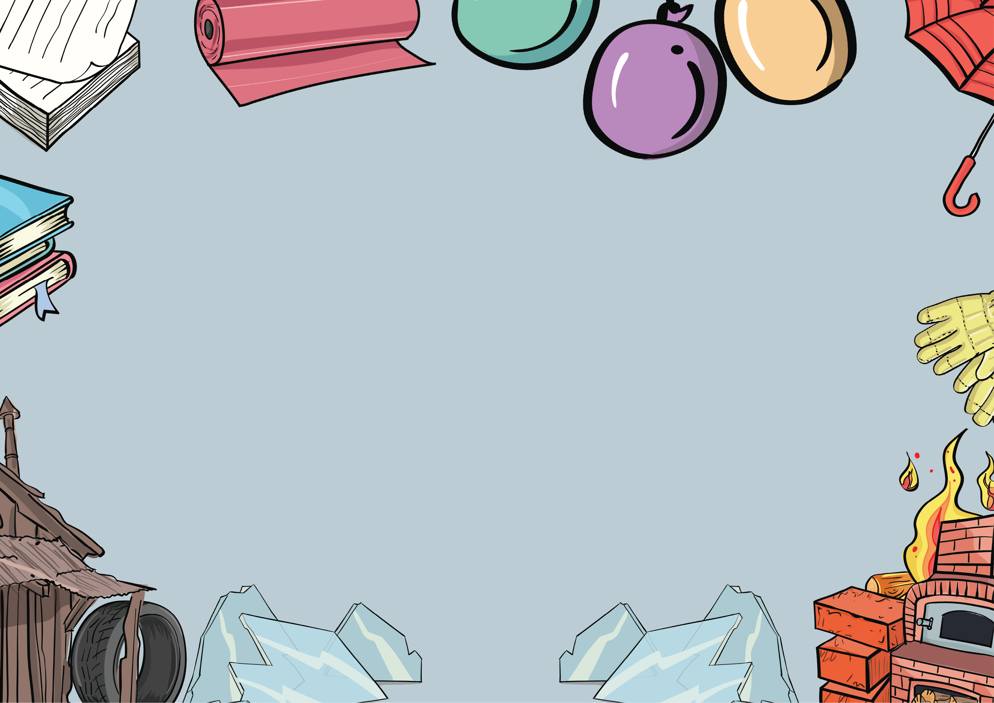

Everyday Materials
Knowledge Organiser
There are lots of different types of materials and they are all good for making different things because they have different properties.
Everyday Materials Knowledge Organiser

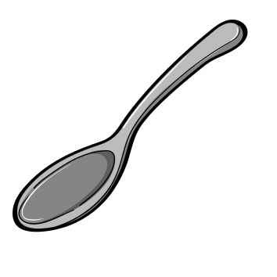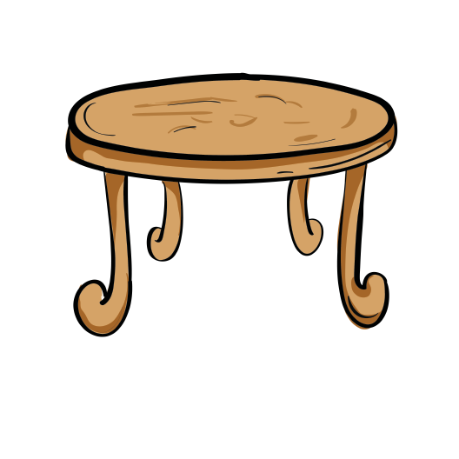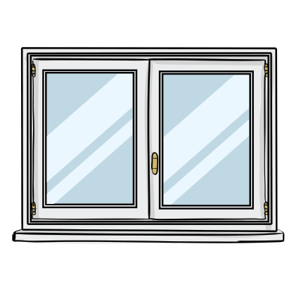
Metal
We can make cars, spoons and some musical instruments from metal because it is hard and smooth. You can’t see through it.
Wood
We can make tables, chairs and some toys from wood because it is hard. It can be rough or smooth.
Glass
We can make windows, mirrors and glasses from glass because it hard and see-through. It is
very fragile.


www.grammarsaurus.co.uk

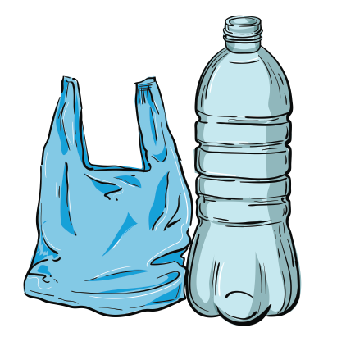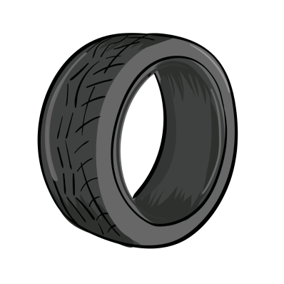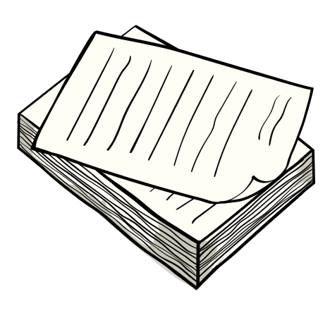
Plastic
We can make toys and food packaging from plastic because it is smooth and strong. It can be hard or bendy.
Rubber
We can make wellington boots, car tyres and bouncy balls from rubber because it is squashy and waterproof. You can bend it.
Paper
We can make wrapping paper and books from paper because it is smooth. It can tear easily.
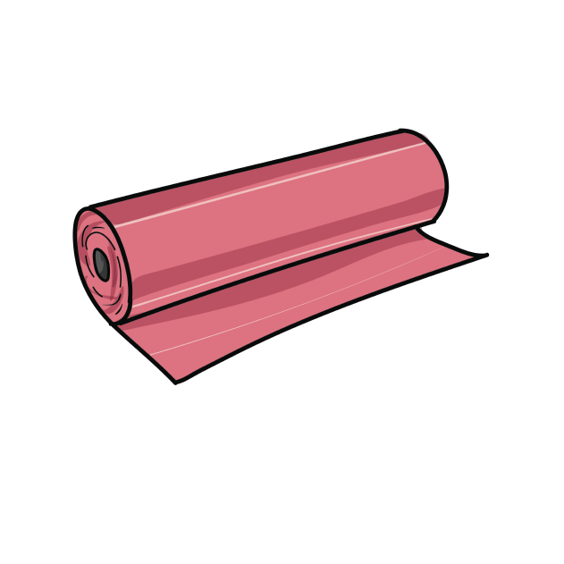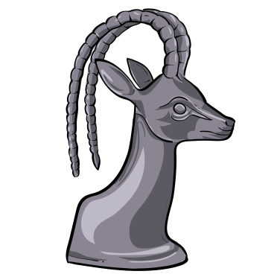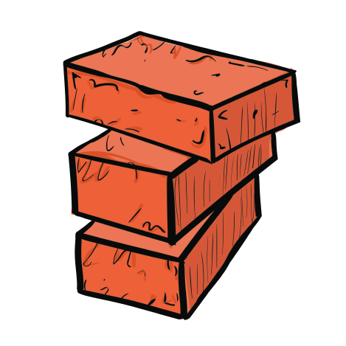
Fabric
We can make clothes and bedding from fabric because it is soft. It is usually smooth.
www.grammarsaurus.co.uk
Rock
We can make tiles and some jewellery from rock because it can be hard. Some rock can also be fragile.
Brick
We can make buildings from brick because it is very hard. It can be rough.

