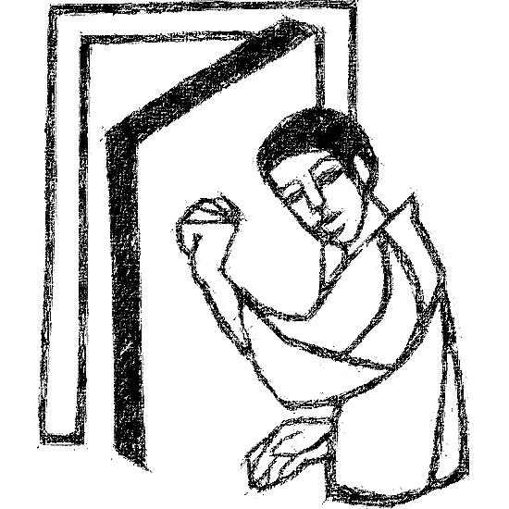

Welcome to
Resurrection Lutheran Church

740 West 10th Street, Juneau, Alaska 99801
Office: (907) 586-2380 rlcoffice@ak.net
Pastor: (907) 885-6824 (voice only) rlcpastor@ak.net
(808) 782-6653 (text and voice)

www.rlcjuneau.org www.rlclive.org

July 24, 2022 Lectionary 17 / 7th Sunday after Pentecost

Introduction to the day
Persistence in prayer is encouraged by Jesus and wins the attention of God when Abraham intercedes for Sodom. The life of the baptized—to be rooted and built up in Christ Jesus—is to be nurtured with prayer. God hears and answers prayer and so strengthens God’s own. “When I called, you answered me; you increased my strength within me.”

Welcome and Announcements

Prelude

GATHERING
The Holy Spirit calls us together as the people of God.

Confession and Forgiveness
Blessed be the holy Trinity,☩ one God,
whose steadfast love endures forever.
Amen.

Let us confess our sin in the presence of God and of one another.

Merciful God,
we confess that we have not followed your path
but have chosen our own way.
Instead of putting others before ourselves,
we long to take the best seats at the table.
When met by those in need,
we have too often passed by on the other side.
Set us again on the path of life.
Save us from ourselves
and free us to love our neighbors.
Amen.

Hear the good news!
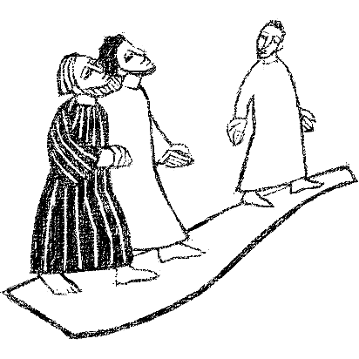
God does not deal with us according to our sins
but delights in granting pardon and mercy.
In the name of ☩ Jesus Christ, your sins are forgiven.
You are free to love as God loves.
Amen.

Gathering Song: Will You Come and Follow Me (The Summons)



Greeting
The grace of our Lord Jesus Christ, the love of God,
and the communion of the Holy Spirit be with you all.
And also with you.
KyriE

Canticle of Praise



Prayer of the Day
Let us pray.

Almighty and ever-living God, you are always more ready to hear than we are to pray, and you gladly give more than we either desire or deserve. Pour upon us your abundant mercy. Forgive us those things that weigh on our conscience, and give us those good things that come only through your Son, Jesus Christ, our Savior and Lord.
Amen.

WORD
God speaks to us in scripture reading, preaching, and song.

First Reading: Genesis 18:20-32
In today’s reading, Abraham undertakes the role of a mediator between God and sinful humanity. Appealing to God’s justice, Abraham boldly asks for mercy for the city of Sodom for the sake of the few righteous people there, including Abraham’s nephew, Lot.

A reading from Genesis.

²⁰Then the Lord said, “How great is the outcry against Sodom and Gomorrah and how very grave their sin! ²¹I must go down and see whether they have done altogether according to the outcry that has come to me; and if not, I will know.”

²²So the men turned from there, and went toward Sodom, while Abraham remained standing before the Lord. ²³Then Abraham came near and said, “Will you indeed sweep away the righteous with the wicked? ²⁴Suppose there are fifty righteous within the city; will you then sweep away the place and not forgive it for the fifty righteous who are in it? ²⁵Far be it from you to do such a thing, to slay the righteous with the wicked, so that the righteous fare as the wicked! Far be that from you! Shall not the Judge of all the earth do what is just?” ²⁶And the Lord said, “If I find at Sodom fifty righteous in the city, I will forgive the whole place for their sake.” ²⁷Abraham answered, “Let me take it upon myself to speak to the Lord, I who am but dust and ashes. ²⁸Suppose five of the fifty righteous are lacking? Will you destroy the whole city for lack of five?” And he said, “I will not destroy it if I find forty-five there.” ²⁹Again he spoke to him, “Suppose forty are found there.” He answered, “For the sake of forty I will not do it.” ³⁰Then he said, “Oh do not let the Lord be angry if I speak. Suppose thirty are found there.” He answered, “I will not do it, if I find thirty there.” ³¹He said, “Let me take it upon myself to speak to the Lord. Suppose twenty are found there.” He answered, “For the sake of twenty I will not destroy it.” ³²Then he said, “Oh do not let the Lord be angry if I speak just once more. Suppose ten are found there.” He answered, “For the sake of ten I will not destroy it.”

The word of the Lord.
Thanks be to God.

Psalm: Psalm 138
Your steadfast love endures forever; do not abandon the works of your hands. (Ps. 138:8)

¹I will give thanks to you, O Lord, with my whole heart;
before the gods I will sing your praise.
²I will bow down toward your holy temple and praise your name,
because of your steadfast love and faithfulness;
for you have glorified your name and your word above all things. R

³When I called, you answered me;
you increased my strength within me.
⁴All the rulers of the earth will praise you, O Lord,
when they have heard the words of your mouth.
⁵They will sing of the ways of the Lord,
that great is the glory of the Lord.
⁶The Lord is high, yet cares for the lowly,
perceiving the haughty from afar. R

⁷Though I walk in the midst of trouble, you keep me safe;
you stretch forth your hand against the fury
of my enemies; your right hand shall save me.
⁸You will make good your purpose for me;
O Lord, your steadfast love endures forever;
do not abandon the works of your hands. R

Second Reading: Colossians 2:6-15 [16-19]
The writer of this letter warns the congregation in Colossae about “the empty lure” of philosophies and traditions that compromise faith. Through the gift of faith, the church is mystically connected with Christ in his death and resurrection which is enacted in baptism.

A reading from Colossians.

⁶As you therefore have received Christ Jesus the Lord, continue to live your lives in him, ⁷rooted and built up in him and established in the faith, just as you were taught, abounding in thanksgiving.

⁸See to it that no one takes you captive through philosophy and empty deceit, according to human tradition, according to the elemental spirits of the universe, and not according to Christ. ⁹For in him the whole fullness of deity dwells bodily, ¹⁰and you have come to fullness in him, who is the head of every ruler and authority. ¹¹In him also you were circumcised with a spiritual circumcision, by putting off the body of the flesh in the circumcision of Christ; ¹²when you were buried with him in baptism, you were also raised with him through faith in the power of God, who raised him from the dead. ¹³And when you were dead in trespasses and the uncircumcision of your flesh, God made you alive together with him, when he forgave us all our trespasses, ¹⁴erasing the record that stood against us with its legal demands. He set this aside, nailing it to the cross. ¹⁵He disarmed the rulers and authorities and made a public example of them, triumphing over them in it.

[ ¹⁶Therefore do not let anyone condemn you in matters of food and drink or of observing festivals, new moons, or sabbaths. ¹⁷These are only a shadow of what is to come, but the substance belongs to Christ. ¹⁸Do not let anyone disqualify you, insisting on self-abasement and worship of angels, dwelling on visions, puffed up without cause by a human way of thinking, ¹⁹and not holding fast to the head, from whom the whole body, nourished and held together by its ligaments and sinews, grows with a growth that is from God.]

The word of the Lord.
Thanks be to God.

Children’s’ Time Amanda Beebe-Bay

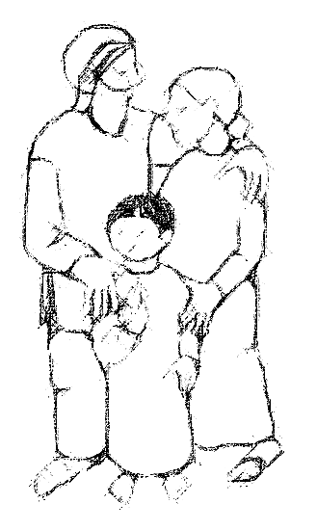

Gospel Acclamation

Gospel: Luke 11:1-13
In teaching his disciples this prayer, Jesus also reminds them to focus on God’s coming reign, God’s mercy, and the strengthening of the community. Jesus encourages his disciples to childlike trust and persistence in prayer.

The holy gospel according to Luke.
Glory to you, O Lord.

¹[Jesus] was praying in a certain place, and after he had finished, one of his disciples said to him, “Lord, teach us to pray, as John taught his disciples.”²He said to them, “When you pray, say:
Father, hallowed be your name.
Your kingdom come.
³Give us each day our daily bread.
⁴And forgive us our sins,
for we ourselves forgive everyone indebted to us.
And do not bring us to the time of trial.”
⁵And he said to them, “Suppose one of you has a friend, and you go to him at midnight and say to him, ‘Friend, lend me three loaves of bread; ⁶for a friend of mine has arrived, and I have nothing to set before him.’ ⁷And he answers from within, ‘Do not bother me; the door has already been locked, and my children are with me in bed; I cannot get up and give you anything.’ ⁸I tell you, even though he will not get up and give him anything because he is his friend, at least because of his persistence he will get up and give him whatever he needs.
⁹“So I say to you, Ask, and it will be given you; search, and you will find; knock, and the door will be opened for you. ¹⁰For everyone who asks receives, and everyone who searches finds, and for everyone who knocks, the door will be opened. ¹¹Is there anyone among you who, if your child asks for a fish, will give a snake instead of a fish? ¹²Or if the child asks for an egg, will give a scorpion? ¹³If you then, who are evil, know how to give good gifts to your children, how much more will the heavenly Father give the Holy Spirit to those who ask him!”

The gospel of the Lord.
Praise to you, O Christ.

Sermon Rev. Karen Perkins

Hymn of the Day: Our Father, God in Heaven Above (abridged)

Apostles’ Creed
Let us confess together,

I believe in God, the Father almighty,
creator of heaven and earth.

I believe in Jesus Christ, God’s only Son, our Lord,
who was conceived by the Holy Spirit,
born of the virgin Mary,
suffered under Pontius Pilate,
was crucified, died, and was buried;
he descended to the dead.
On the third day he rose again;
he ascended into heaven,
he is seated at the right hand of the Father,
and he will come to judge the living and the dead.

I believe in the Holy Spirit,
the holy catholic church,
the communion of saints,
the forgiveness of sins,
the resurrection of the body,
and the life everlasting. Amen.

Prayer Refrain: O Living Breath of God
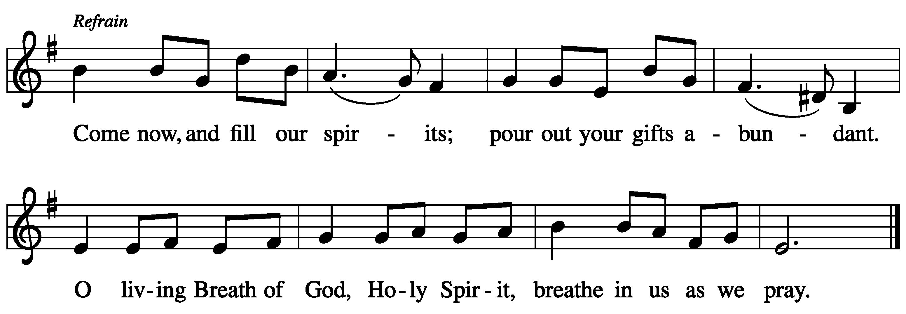

The Prayers
Trusting in God’s extraordinary love, let us come near to the Holy One in prayer.

Rooted and built up in Christ, we pray for the church. Embolden church leaders to take risks for the sake of the gospel, and equip the baptized to proclaim your extravagant love for the whole world. Merciful God,
receive our prayer.

Rejoicing in the works of your hands, we pray for the natural world. Make rivers and lakes, oceans and all waterways, sparkle with your radiance. Protect water sources and strengthen those who defend them. Guard those fighting devastating wildfires in Alaska, Nevada, New Mexico and Texas. Merciful God,
receive our prayer.

Interceding on behalf of the vulnerable, we pray for the peoples of the world. Inspire all rulers and governing authorities with your justice. Guide the work of legislators and public officials, that they advocate for the well-being of those they serve. Merciful God,
receive our prayer.

Persistent in prayer, we pray for our neighbors in need. To all who have hunger, give daily bread. To all who have bread, give hunger for justice. Open us to the cries of those who suffer, especially those in Africa awaiting resumed grain shipments from Odessa. Merciful God,
receive our prayer.

Abounding in thanksgiving, we pray for this congregation. Bless the prayer and fellowship ministries in this place. Call us together in times of praise and blessing, trouble and sorrow, in your holy name. Merciful God,
receive our prayer.

Rooted and built up in Christ, we pray for all bishops, pastors, missionaries, and other ministers of the gospel, especially Presiding Bishop Elizabeth Eaton, Alaska Synod Bishop Shelly Wickstrom, Bishop Tessa Moon Leiseth of our sister synod, and Pastor Karen Perkins. Bless our neighbors in the Alaska Southeast Cluster, and River of Life Lutheran Church, Chugiak. Merciful God,
receive our prayer.

For what else do the people of God pray?

Buried with Christ in baptism and raised with him to new life, we give thanks for your saints who rest in your eternal presence. Join our voices with theirs as we sing of your great glory. Merciful God,
receive our prayer.

Receive the prayers of your children, merciful God, and hold us forever in your steadfast love; through Jesus Christ, our holy Wisdom.
Amen.

Repeat Prayer Refrain



Peace
The peace of the Lord be with you always.
And also with you.

We greet each other with a gesture of peace. We are conscious there are different comfort levels around social-distancing at this time. A nod, wave, phone call or email may be most appropriate for you. This greeting is a sign of the risen Christ who unites us and calls us to recognize the peace of God in one another.

MEAL
God feeds us with the presence of Jesus Christ.

Presentation of the Gifts

Offering Prayer
Let us pray.

God of abundance:

you have set before us a plentiful harvest.
As we feast on your goodness,
strengthen us to labor in your field,
and equip us to bear fruit for the good of all,
in the name of Jesus.
Amen.

Dialogue
The Lord be with you.
And also with you.

Lift up your hearts.
We lift them to the Lord.

Let us give thanks to the Lord our God.
It is right to give our thanks and praise.

Preface
It is indeed right, our duty and our joy,
that we should at all times and in all places
give thanks and praise to you,
almighty and merciful God,
through our Savior Jesus Christ;
who on this day overcame death and the grave,
and by his glorious resurrection opened to us
the way of everlasting life.

And so, with all the choirs of angels,
with the church on earth and the hosts of heaven,
we praise your name and join their unending hymn:

Holy, Holy, Holy

Thanksgiving at the Table
Holy God,
our Maker, Redeemer, and Healer,
in the harmonious world of your creation,
the plants and animals,
the seas and stars
were whole and well in your praise.

When sin had scarred the world,
you sent your Son to heal our ills
and to form us again into one.

In the night in which he was betrayed,
our Lord Jesus took bread, and gave thanks;
broke it, and gave it to his disciples, saying:
Take and eat; this is my body, given for you.
Do this for the remembrance of me.

Again, after supper, he took the cup, gave thanks,
and gave it for all to drink, saying:
This cup is the new covenant in my blood,
shed for you and for all people for the forgiveness of sin.
Do this for the remembrance of me.

Remembering, therefore,
his acts of healing,
his body given up,
and his victory over death,
we await that day when all the peoples of the earth
will come to the river to enjoy the tree of life.

Send your Spirit upon us and this meal:
as grains scattered on the hillside become one bread,
so let your Church be gathered from the ends of the earth,
that all may be fed with the Bread of life, your Son.

Through him all glory and honor is yours,
Almighty Father, with the Holy Spirit,
in your holy Church,
both now and forever.
Amen


Lord’s Prayer
Gathered into one by the Holy Spirit, let us pray as Jesus taught us.

Our Father, who art in heaven,
hallowed be thy name,
thy kingdom come,
thy will be done,
on earth as it is in heaven.
Give us this day our daily bread;
and forgive us our trespasses,
as we forgive those
who trespass against us;
and lead us not into temptation,
but deliver us from evil.
For thine is the kingdom,
and the power, and the glory,
forever and ever. Amen.

Communion Distribution
All are welcome to the communion table! God is the host and God's love extends to all people. During this period of social distancing due to COVID-19, not all in our community are ready to be present at Resurrection. Nevertheless, there are ways for you to participate! We celebrate this holy meal as the community of peace, love and mercy.

- We have resources on our website to help you celebrate Holy Communion at home, either along with a live broadcast or at another time.
- Pastor Karen can bring the Eucharist to you at home. Please contact the office or Pastor Karen to make arrangements.

We would be happy to light a candle in thankfulness, of concern, or in memory of a person at your request.

Invitation to Communion
In Christ’s presence there is fullness of joy.
Come to the banquet.

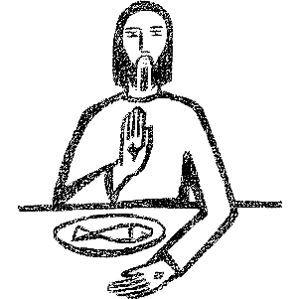

Communion Song

Communion
The body of Christ, given for you.
Amen.
The blood of Christ, shed for you.
Amen

Post Communion Blessing
The body and blood of our Lord Jesus Christ
strengthen you and keep you in God's grace. Amen.

Song after Communion



Prayer After Communion
Life-giving God,
through this meal you have bandaged our wounds
and fed us with your mercy.
Now send us forth to live for others,
both friend and stranger,
that all may come to know your love.
This we pray in the name of Jesus.
Amen.

SENDING
God blesses us and sends us in mission to the world.

Mission Statement
Let us announce together:

The mission of Resurrection Lutheran Church is to promote spiritual growth in Christ and service to all people.

Blessing
The God of peace,
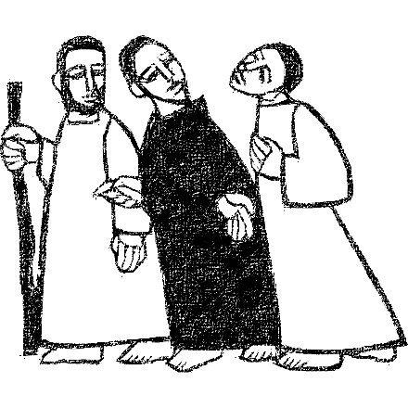
Father, ☩ Son, and Holy Spirit,
bless you, comfort you,
and show you the path of life
this day and always.
Amen.

Sending Song: I Want Jesus to Walk with Me

Dismissal
Go in peace. Love your neighbor.
Thanks be to God.

Texts for Sunday, July 31, 2022
Lectionary 18 / 8th Sunday after Pentecost
Ecclesiastes 1:2, 12-14; 2:18-23
Psalm 49:1-12
Colossians 3:1-11
Luke 12:13-21

From sundaysandseasons.com. Copyright © 2022 Augsburg Fortress.
All rights reserved. Used by permission.

