Ormerod 2 Documentation
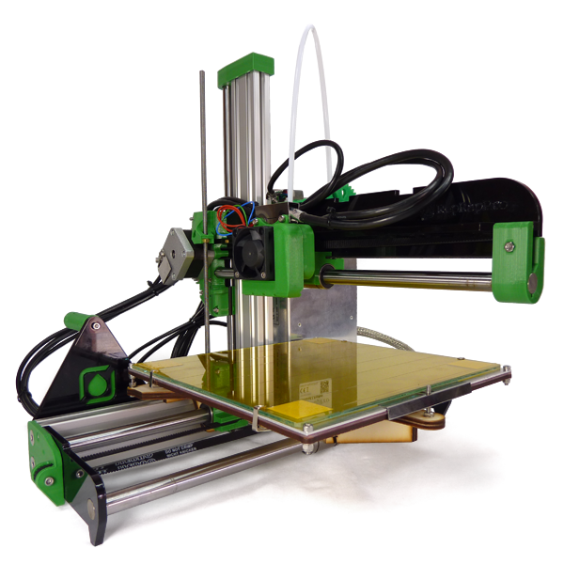

Table of Contents
Ormerod 2 3
Overview 3
General Notes 3
Ormerod 2 Versions 3
Printing Parts for Ormerod 2 3
Get Support 3
Archived Documents for Older Versions 3
Tool List 3
Required 3
For Adjusting Plastic Parts, if Necessary 3
Nice to Have, But Not Necessary 3
Y Axis Assembly 4
Z Axis Assembly 5
Y Carriage 6
X Axis Assembly 7
X Axis Mounting 8
Heated Bed Assembly 9
Extruder Drive Assembly 10
Hot End Assembly – Quick-set 11
Hot End Assembly 12
Electronics 13
Wiring 14
Commissioning 15
Calibration 16
Printing 17
Maintenance 18
Troubleshooting 19

Ormerod 2

Overview
The RepRap Pro Ormerod 2 is the latest RepRap self-replicating 3D printer from RepRap Pro. The machine is a faster to assemble, networked 3D printer with non-contact bed probe for full geometric compensation.
These pages are the complete instructions for building, commissioning and using the RepRapPro Ltd version of RepRap Ormerod 2. Like all RepRap machines, RepRapPro Ormerod 2 is fully open-source. It is licensed under the GPL. All the design files and software are available from the RepRapPro Ltd Github repository.
The RepRapPro Ormerod 2 is fitted with the open-source Duet electronics.
If you want to print the plastic parts for a RepRapPro Ormerod 2, see this web page.

General Notes
BEFORE YOU ATTEMPT TO ASSEMBLE ANY PART OF THE RepRapPro ORMEROD 2 3D PRINTER, PLEASE READ THESE BUILD INSTRUCTIONS FULLY AND ENSURE YOU UNDERSTAND THEM. Although all parts are covered by warranty, this will be invalidated by your not following these build instructions. You are building a complicated machine; many different skills are required to build, to commission and to operate a 3D printer. Try not to rush your build, or you may miss out something vital!
- Give yourself plenty of space and ensure your work area is clean. Dust and dirt are a 3D printer’s worst enemy.
- All printed parts have been printed on RepRapPro’s own machines. Despite the fact that these machines are highly tuned RepRap 3D printers, some holes and features may need a little fettling to get the best performance from the RepRapPro Ormerod 2. There is a video how-to on fettling 3D printed parts here on Vimeo.
- Before you start the build, please ensure you have all the components as listed on the packing list included in the kit. If anything is missing or damaged, please contact us through our contact page.
- We understand that people may want to change aspects of the machine’s design, and in fact we encourage this as it is one of the benefits of open-source development. Before changing anything, please be aware that the RepRapPro Ormerod 2 has been designed to maximise its build volume relative to the the machine’s footprint, and as such many of its components fit closely to others. So consider your changes carefully before you try to implement them. And when you find improvements, please tell us and the world so that we can include them in future kits, and so that existing owners can upgrade their own machines.
- The RepRapPro Ormerod 2 is a robust RepRap machine once assembled; however it does require a certain amount of care during assembly. If in doubt, force is usually not the answer! There are many ways to get support and advice; see below.

Ormerod 2 Versions
Some sections of the instructions are arranged in tabs, with alternate parts and instructions, depending on the version of your kit. Below is the changelog, which shows the differences between kit versions. The tabs refer to the version number of the Ormerod kit. Your Ormerod kit version number is marked on the sticker on the power supply (on 528.2 and later kits ), or on the x-rib (for earlier kits). Use the LATEST version number – some kits have the 528.2 PSU, but the 528.1 x-rib. Use the set of instructions that relate to your printer.

528.0 | Sept 2014: Original shipping version of Ormerod 2.
528.1 | Oct 2014: Changes to packing. Acrylic fan spacer replaces printed fan-duct and nozzle-duct.
528.2 | Dec 2014: Change to supplied power supply, and added lasercut acrylic parts to mount Duet on new PSU.
528.3 | Feb 2015: Changes to packing.
528.4 | New heated bed design, new bed wiring loom.
528.5 | Ships with new Quick-set nozzle. Separate hot end and fan looms. Cooling fan and duct supplied. Small updates to some printed parts (x-carriage, z-upper-mount, y-motor-mount). Changes to packing.

Printing Parts for Ormerod 2
If you have bought the hardware-only version of the Ormerod 2 kit, you will want to print the parts. You may also want to print spare parts for your printer. The list below shows the part number, part name, quantity and location of the parts. Parts are available as STL and SolidWorks files, and there should also be a STEP assembly of the whole printer.
For Ormerod 2, part number 528.0 to 528.4, the easiest place to get the parts is here: https://github.com/reprappro/Ormerod/releases
For 528.5 onwards, we use the part number, rather than the name of the part, for the file name. For the latest version of the parts, which should be backwards compatible with all the previous versions, see the Ormerod github repository. Some parts common to all our machines are in the Library github repository.
You can download the whole github repository, or download the parts individually; the ‘Location’ in the link below links to the stl page. This will also help you identify the parts. If you download the parts individually, make sure you download the ‘RAW’ version of the file; if you right-click on a link and download, you will end up with a file with the right name (with .stl on the end), but it will actually be an html document!

# | Description | Qty | Location
547 | y-idler-bracket | 1 | Ormerod/STLs
548 | y-motor-bracket | 1 | Ormerod/STLs
469 | z-motor-brace | 1 | Ormerod/STLs
437 | z-lower-mount | 1 | Ormerod/STLs
438 | z-upper-mount | 1 | Ormerod/STLs
527 | z-corner-bracket | 1 | Ormerod/STLs
503 | z-foot | 1 | Ormerod/STLs
549 | y-bearing-belt-clamp | 1 | Ormerod/STLs
550 | y-bearing-clamp-tagged | 1 | Ormerod/STLs
462 | x-idler-bracket | 1 | Ormerod/STLs
546 | x-carriage | 1 | Ormerod/STLs
501 | nozzle-mount (one-piece nozzle, 528.4 and before) | 1 | Ormerod/STLs
1079 | nozzle-mount (Quick-set nozzle, 528.5 onwards) | 1 | Ormerod/STLs
473 | x-motor-bracket | 1 | Ormerod/STLs
407 | z-runner-mount | 1 | Ormerod/STLs
441 | z-gear-driven | 1 | Ormerod/STLs
440 | z-gear | 1 | Ormerod/STLs
492 | z-bearing-clamp | 2 | Ormerod/STLs
425 | z-nut-trap | 1 | Ormerod/STLs
554 | Extruder drive block | 1 | Ormerod/STLs
446 | Extruder small gear | 1 | Ormerod/STLs
447 | Extruder large gear | 1 | Ormerod/STLs
152 | Tongue | 1 | Library/STLs
820 | PSU cover | 1 | Library/STLs
821 | PSU brace | 1 | Ormerod/STLs
442 | Spool spigot | 1 | Ormerod/STLs
525 | Spool clip | 1 | Ormerod/STLs
1123 | Cooling fan duct | 1 | Ormerod/STLs

Get Support
If you find you need help or advice with assembling, commissioning or using your RepRapPro Ormerod 2 3d printer, you can use the following channels:
- Check the instructions again; we are regularly updating them with feedback from our growing user-base.
- Contact the support department of the company that sold you your printer.
- Check the RepRap community forum, Ormerod section.
- Contact us on our irc (internet relay chat) channel RepRapPro on freenode irc
- Contact us via email; see our contact page.

Archived Documents for Older Versions
If you have an older RepRapPro Ormerod and want a past copy of this documentation see these links:
- RepRapPro Ormerod 1 Instructions

Tool List
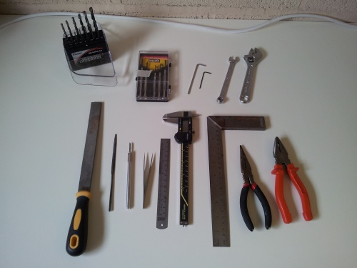
Tools required for the build of the RepRapPro Ormerod 2 3D printer:

Required
Allen keys: 1.5mm, 2mm, 2.5mm, 4mm (the long reach type, with a ‘ball’ hex on the end, are very useful)
- Medium, cross-head screwdriver
- 8mm (M5) socket and/or spanner
- 15cm adjustable spanner
- Fine tweezers
- Ruler, at least 300mm
- Fine-nosed pliers
- Scissors
- Drill: 2mm
- Hand chuck, pin vice or small electric drill
- Small, flat-bladed, electrical screwdriver
- Pencil sharpener
- Digital Multimeter
- Hot air gun, or cigarette lighter (or other heat source such as a gas cooker ring for heating PTFE heatshrink; a hair dryer is not sufficient)

For Adjusting Plastic Parts, if Necessary
- Drills: 3mm, 4mm
- File
- Half round needle file
- Sharp craft knife

Nice to Have, But Not Necessary
- 5.5mm (M3) socket and/or spanner
- Vernier or digital callipers

Y Axis Assembly

Z Axis Assembly

Y Carriage

X Axis Assembly

X Axis Mounting

Heated Bed Assembly

Extruder Drive Assembly

Hot End Assembly – Quick-set

Hot End Assembly

Electronics

Wiring

Commissioning

Calibration

Printing

Maintenance

Troubleshooting

