Ormerod 2 Build Manual
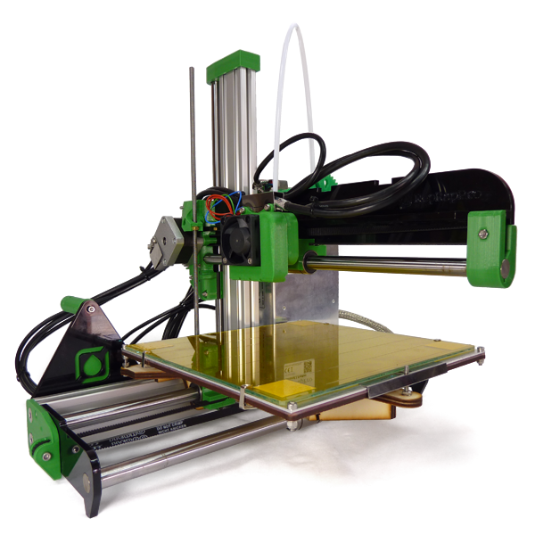

Forward

Credits & License
Original Machine Design: | Jean-Marc Giacalone  Adrian Bowyer
Original Documentation: | Ian Stratford
Documentation Conversion to ODT/PDF: | Wesley Brooks
License: | GPL

Original Documentation Hosts:
Web Archive | https://web.archive.org/web/20160106171632/https://reprappro.com/documentation/ormerod-2/
cheeseandham  (RepRap Forum) | http://reprappro.cheeseandham.me.uk/reprappro.com/documentation/index.html

This Documentation Iteration Host:
DocTrucker GitHub | https://github.com/DocTrucker/Ormerod/tree/master/Documentation

Table of Contents
Forward 2
Credits & License 2
Original Documentation Hosts: 2
This Documentation Iteration Host: 2
Ormerod 2 4
Overview 4
General Notes 4
Ormerod 2 Versions 4
Get Support 4
Tool List 5
Required 5
Nice to Have, But Not Necessary 5
Commissioning 6
Calibration 7
Printing 8
Maintenance 9
Troubleshooting 10
Wiring 11

Ormerod 2

Overview
The RepRap Pro Ormerod 2 is the latest RepRap self-replicating 3D printer from RepRap Pro. The machine is a faster to assemble, networked 3D printer with non-contact bed probe for full geometric compensation.
These pages are the complete instructions for commissioning and using the RepRapPro Ltd version of RepRap Ormerod 2. Like all RepRap machines, RepRapPro Ormerod 2 is fully open-source. It is licensed under the GPL. All the design files and software are available from the RepRapPro Ltd Github repository.
The RepRapPro Ormerod 2 is fitted with the open-source Duet electronics.

General Notes

Ormerod 2 Versions
Some sections of the instructions are arranged in tabs, with alternate parts and instructions, depending on the version of your kit. Below is the changelog, which shows the differences between kit versions. The tabs refer to the version number of the Ormerod kit. Your Ormerod kit version number is marked on the sticker on the power supply (on 528.2 and later kits ), or on the x-rib (for earlier kits). Use the LATEST version number – some kits have the 528.2 PSU, but the 528.1 x-rib. Use the set of instructions that relate to your printer.

528.0 | Sept 2014: Original shipping version of Ormerod 2.
528.1 | Oct 2014: Changes to packing. Acrylic fan spacer replaces printed fan-duct and nozzle-duct.
528.2 | Dec 2014: Change to supplied power supply, and added lasercut acrylic parts to mount Duet on new PSU.
528.3 | Feb 2015: Changes to packing.
528.4 | New heated bed design, new bed wiring loom.
528.5 | Ships with new Quick-set nozzle. Separate hot end and fan looms. Cooling fan and duct supplied. Small updates to some printed parts (x-carriage, z-upper-mount, y-motor-mount). Changes to packing.

Get Support

Tool List

Required
Allen keys: 1.5mm, 2mm, 2.5mm, 4mm (the long reach type, with a ‘ball’ hex on the end, are very useful)

Nice to Have, But Not Necessary

Commissioning
https://web.archive.org/web/20160106172926/https://reprappro.com/documentation/commissioning-introduction/commissioning-duet/

Calibration
https://web.archive.org/web/20160106173018/https://reprappro.com/documentation/commissioning-introduction/calibration-duet/

Printing
https://web.archive.org/web/20160106191341/https://reprappro.com/documentation/commissioning-introduction/printing-duet/

Maintenance
https://web.archive.org/web/20160106191347/https://reprappro.com/documentation/commissioning-introduction/maintenance-duet/

Troubleshooting
https://web.archive.org/web/20160106191355/https://reprappro.com/documentation/troubleshooting-introduction/

Wiring

