Regional and Temporal Trends in Carbapenem Resistance Among Acinetobacter Bloodstream Isolates Reported to WHO GLASS, 2020–2023.

Dr. Mohammad Waqas
Independent
ORCID: 0000-0002-8789-8794

Abstract
Background: Carbapenem-resistant Acinetobacter baumannii is among the highest-priority bacterial pathogens identified by the World Health Organization (WHO) for antimicrobial resistance (AMR) surveillance and antimicrobial development. We evaluated regional and temporal trends in carbapenem resistance among Acinetobacter spp. bloodstream isolates reported through the WHO Global Antimicrobial Resistance and Use Surveillance System (GLASS) between 2020 and 2023.
Methods: Publicly available GLASS data were extracted for bloodstream isolates tested against meropenem and imipenem across the six WHO regions. For each region and year, isolate-weighted pooled resistance proportions and Wilson 95% confidence intervals (CIs) were calculated. Temporal trends were assessed separately for each region and antibiotic using binomial logistic regression, with calendar year modelled as a continuous predictor. Odds ratios (ORs), 95% CIs, and Benjamini–Hochberg adjusted p-values were reported. Because country participation varied across years, a sensitivity analysis was performed using only countries that reported continuously throughout the study period (fixed-panel analysis).
Results: Carbapenem resistance remained high across most WHO regions throughout 2020–2023. The African and Eastern Mediterranean Regions consistently reported resistance levels exceeding 70% for both meropenem and imipenem, whereas the Western Pacific Region maintained substantially lower resistance, generally ranging from approximately 30% to 42%. Logistic regression identified significant annual declines in meropenem resistance in the African Region (OR 0.884), Eastern Mediterranean Region (OR 0.894), European Region (OR 0.969), and Region of the Americas (OR 0.563). Similar declines were observed for imipenem in the African Region (OR 0.900), Eastern Mediterranean Region (OR 0.921), and Region of the Americas (OR 0.569), while significant increases in imipenem resistance were identified in the European Region (OR 1.242), South-East Asia Region (OR 1.058), and Western Pacific Region (OR 1.027). Sensitivity analyses restricted to continuously reporting countries produced broadly similar overall patterns, although the magnitude of regional trends differed in some regions.
Conclusions: Carbapenem resistance among Acinetobacter bloodstream isolates remains alarmingly high across several WHO regions despite evidence of declining resistance in some settings. The Western Pacific Region consistently demonstrated substantially lower resistance than other regions. Sensitivity analyses indicate that changes in reporting-country participation can influence the magnitude of observed temporal trends, underscoring the importance of accounting for reporting-panel composition when interpreting GLASS surveillance data..

1. Introduction
Acinetobacter baumannii is classified by the WHO as a critical-priority pathogen for antibiotic research and development [1], owing to its propensity for multidrug resistance and its clinical significance in hospital-acquired, particularly intensive care unit (ICU)-associated, bloodstream infections [3]. Carbapenems (meropenem, imipenem) have historically served as last-line agents against Gram-negative pathogens including A. baumannii; rising carbapenem resistance therefore has direct implications for empirical treatment protocols and patient outcomes in critical care settings.
The WHO Global Antimicrobial Resistance and Use Surveillance System (GLASS) aggregates country-reported antimicrobial susceptibility testing (AST) data and represents the most comprehensive publicly available cross-national AMR dataset [2]. However, GLASS data present a well-recognized analytical challenge: participating countries, and the completeness of their reporting, change from year to year, meaning naive pooled or averaged statistics across years can conflate genuine epidemiological trends with shifts in which countries are contributing data. This distinction matters for how surveillance findings should be interpreted and communicated.
This analysis had two aims: (1) to describe regional and temporal patterns in carbapenem resistance among Acinetobacter spp. bloodstream isolates reported to GLASS between 2020 and 2023, and (2) to demonstrate a methodologically defensible approach to isolating genuine trends from reporting-panel artifacts in cross-national surveillance data of this kind.

2. Methods

2.1 Data source
Country-level resistance data were obtained from the WHO GLASS-AMR data visualization dashboard (accessed July 2026), filtered to: infection type = bloodstream, pathogen = Acinetobacter spp., years 2020-2023, all six WHO regions (African Region, Region of the Americas, Eastern Mediterranean Region, European Region, South-East Asia Region, Western Pacific Region).
For each country-year-antibiotic combination, the dashboard provides the number of bacteriologically confirmed infections with interpretable AST results and the number found resistant.
South-East Asia Region data for 2021 were unavailable via the dashboard export at the time of data collection and are excluded from that region-year; all other region-year combinations were successfully retrieved.

2.2 Antibiotic scope
Analysis was restricted to the two carbapenems reported in GLASS for this pathogen-specimen combination: meropenem and imipenem. These were selected as the clinically most consequential agents for treatment decision-making in carbapenem-resistant Acinetobacter infection.

2.3 Handling of the reporting-panel problem
Because the number and identity of countries reporting to WHO GLASS varied across years within each WHO region (Supplementary Table S1), temporal comparisons based solely on pooled regional resistance estimates may be influenced by changes in reporting participation rather than true changes in antimicrobial resistance. For example, the addition of a country with relatively low resistance in a given year could reduce the apparent regional resistance estimate even if resistance remained unchanged in countries reporting consistently throughout the study period.
The primary analysis therefore included all countries contributing data in each year to provide the most comprehensive description of regional carbapenem resistance reported to GLASS. For each WHO region and year, isolate-weighted pooled resistance percentages were calculated as:
Pooled resistance (%) = (Σ resistant isolates ÷ Σ tested isolates) × 100
This isolate-weighted approach assigns greater influence to countries contributing larger numbers of tested isolates and avoids the bias that may arise from averaging country-level resistance percentages irrespective of sample size.
To evaluate the potential influence of changes in reporting-country participation on temporal trends, a sensitivity analysis was performed using a fixed-panel dataset comprising only countries that reported susceptibility data continuously throughout 2020–2023. Logistic regression analyses were repeated using this restricted dataset, and the results were compared with those obtained from the unrestricted analysis to assess the robustness of the observed regional trends.

2.4 Statistical Analysis
All statistical analyses were performed using R statistical software (R Foundation for Statistical Computing, Vienna, Austria). Data management and aggregation were conducted using the dplyr package.
Resistance was analysed separately for meropenem and imipenem. For each WHO region and calendar year, pooled resistance percentages were calculated using isolate-weighted estimates, whereby the total number of resistant isolates was divided by the total number of isolates with interpretable antimicrobial susceptibility testing (AST) results:

[
\text{Resistance (%)} = \frac{\sum \text{Resistant isolates}}{\sum \text{Interpretable AST isolates}} \times 100
]

This approach weights estimates according to the number of isolates contributed by each country and avoids the bias that may arise from averaging country-level resistance percentages irrespective of sample size Ninety-five percent confidence intervals (95% CIs) for pooled resistance proportions were calculated using the Wilson score method. The Wilson method was selected because it provides more reliable interval estimates than the conventional Wald method, particularly when sample sizes vary substantially or when proportions approach 0 or 100%.
Temporal trends in resistance were evaluated separately for each WHO region and antibiotic using binomial logistic regression. The number of resistant isolates and the number of non-resistant isolates (interpreterable AST minus resistant isolates) were modelled as a binomial outcome, with calendar year entered as a continuous predictor. Results are presented as odds ratios (ORs) representing the annual change in the odds of carbapenem resistance, together with 95% confidence intervals and two-sided p-values. Odds ratios below 1 indicate decreasing odds of resistance over time, whereas odds ratios above 1 indicate increasing odds of resistance.
Because multiple regional comparisons were performed, p-values were adjusted using the Benjamini–Hochberg procedure to control the false discovery rate. Statistical significance was defined as an adjusted p-value <0.05.
To evaluate the robustness of the findings, a sensitivity analysis was performed using a fixed-panel dataset comprising only countries that reported susceptibility data continuously throughout the 2020–2023 study period. The isolate-weighted resistance estimates and logistic regression analyses were repeated using this restricted dataset, and the results were compared with those obtained from the full dataset to assess the potential influence of changes in country participation over time.

3. Results

3.1 Dataset Characteristics
A total of 532 region–year–antibiotic observations from the WHO GLASS database were analyzed, representing bloodstream isolates of Acinetobacter spp. reported by participating countries across six WHO regions between 2020 and 2023. Pooled resistance estimates were calculated separately for meropenem and imipenem using isolate-weighted proportions, and Wilson score 95% confidence intervals were computed for each regional estimate.
Table 1. Regional pooled carbapenem resistance among Acinetobacter bloodstream isolates reported to WHO GLASS, 2020–2023.
WHO Region | Year | Antibiotic | Countries | Total Tested | Total Resistant | Resistance % (95% CI)
African Region | 2020 | Imipenem | 4 | 4772 | 3478 | 72.9 (71.6–74.1)
African Region | 2020 | Meropenem | 4 | 5195 | 3830 | 73.7 (72.5–74.9)
African Region | 2021 | Imipenem | 7 | 5211 | 4192 | 80.4 (79.3–81.5)
African Region | 2021 | Meropenem | 8 | 5339 | 4287 | 80.3 (79.2–81.3)
African Region | 2022 | Imipenem | 7 | 5913 | 4111 | 69.5 (68.3–70.7)
African Region | 2022 | Meropenem | 9 | 6196 | 4308 | 69.5 (68.4–70.7)
African Region | 2023 | Imipenem | 11 | 6619 | 4639 | 70.1 (69.0–71.2)
African Region | 2023 | Meropenem | 13 | 7036 | 4891 | 69.5 (68.4–70.6)
Eastern Mediterranean Region | 2020 | Imipenem | 16 | 1817 | 1355 | 74.6 (72.5–76.5)
Eastern Mediterranean Region | 2020 | Meropenem | 15 | 1776 | 1393 | 78.4 (76.5–80.3)
Eastern Mediterranean Region | 2021 | Imipenem | 13 | 3366 | 2414 | 71.7 (70.2–73.2)
Eastern Mediterranean Region | 2021 | Meropenem | 11 | 3423 | 2412 | 70.5 (68.9–72.0)
Eastern Mediterranean Region | 2022 | Imipenem | 16 | 5232 | 3460 | 66.1 (64.8–67.4)
Eastern Mediterranean Region | 2022 | Meropenem | 16 | 5114 | 3315 | 64.8 (63.5–66.1)
Eastern Mediterranean Region | 2023 | Imipenem | 15 | 5025 | 3487 | 69.4 (68.1–70.7)
Eastern Mediterranean Region | 2023 | Meropenem | 15 | 5074 | 3520 | 69.4 (68.1–70.6)
European Region | 2020 | Imipenem | 23 | 5818 | 3542 | 60.9 (59.6–62.1)
European Region | 2020 | Meropenem | 27 | 7704 | 4438 | 57.6 (56.5–58.7)
European Region | 2021 | Imipenem | 26 | 11666 | 8967 | 76.9 (76.1–77.6)
European Region | 2021 | Meropenem | 29 | 13733 | 9784 | 71.2 (70.5–72.0)
European Region | 2022 | Imipenem | 27 | 10478 | 7492 | 71.5 (70.6–72.4)
European Region | 2022 | Meropenem | 28 | 12455 | 8002 | 64.2 (63.4–65.1)
European Region | 2023 | Imipenem | 26 | 9138 | 7267 | 79.5 (78.7–80.3)
European Region | 2023 | Meropenem | 27 | 9388 | 5623 | 59.9 (58.9–60.9)
Region of the Americas | 2020 | Imipenem | 3 | 973 | 814 | 83.7 (81.2–85.8)
Region of the Americas | 2020 | Meropenem | 3 | 974 | 816 | 83.8 (81.3–86.0)
Region of the Americas | 2021 | Imipenem | 4 | 2380 | 1434 | 60.3 (58.3–62.2)
Region of the Americas | 2021 | Meropenem | 4 | 2830 | 1481 | 52.3 (50.5–54.2)
Region of the Americas | 2022 | Imipenem | 4 | 1754 | 797 | 45.4 (43.1–47.8)
Region of the Americas | 2022 | Meropenem | 4 | 2234 | 843 | 37.7 (35.7–39.8)
Region of the Americas | 2023 | Imipenem | 4 | 1911 | 770 | 40.3 (38.1–42.5)
Region of the Americas | 2023 | Meropenem | 5 | 2414 | 843 | 34.9 (33.0–36.8)
South-East Asia Region | 2020 | Imipenem | 6 | 2664 | 1809 | 67.9 (66.1–69.7)
South-East Asia Region | 2020 | Meropenem | 6 | 2838 | 1909 | 67.3 (65.5–69.0)
South-East Asia Region | 2022 | Imipenem | 7 | 9849 | 6350 | 64.5 (63.5–65.4)
South-East Asia Region | 2022 | Meropenem | 6 | 7666 | 4906 | 64.0 (62.9–65.1)
South-East Asia Region | 2023 | Imipenem | 9 | 13264 | 9242 | 69.7 (68.9–70.5)
South-East Asia Region | 2023 | Meropenem | 9 | 12253 | 8090 | 66.0 (65.2–66.9)
Western Pacific Region | 2020 | Imipenem | 6 | 4157 | 1321 | 31.8 (30.4–33.2)
Western Pacific Region | 2020 | Meropenem | 8 | 4950 | 1505 | 30.4 (29.1–31.7)
Western Pacific Region | 2021 | Imipenem | 8 | 5921 | 2538 | 42.9 (41.6–44.1)
Western Pacific Region | 2021 | Meropenem | 8 | 6144 | 2605 | 42.4 (41.2–43.6)
Western Pacific Region | 2022 | Imipenem | 8 | 3489 | 1063 | 30.5 (29.0–32.0)
Western Pacific Region | 2022 | Meropenem | 9 | 3998 | 1163 | 29.1 (27.7–30.5)
Western Pacific Region | 2023 | Imipenem | 8 | 6583 | 2518 | 38.3 (37.1–39.4)
Western Pacific Region | 2023 | Meropenem | 10 | 7266 | 2605 | 35.9 (34.8–37.0)

3.2 Regional Resistance Patterns
Regional pooled resistance to meropenem and imipenem varied substantially across WHO regions between 2020 and 2023 (Table 1). The African and Eastern Mediterranean Regions consistently reported the highest resistance levels for both antibiotics, with resistance generally exceeding 70% throughout the study period. The European Region showed comparatively lower meropenem resistance, whereas imipenem resistance increased over time. The Region of the Americas demonstrated marked reductions in resistance during the study period, while South-East Asia and the Western Pacific exhibited relatively stable meropenem resistance but differing trends for imipenem
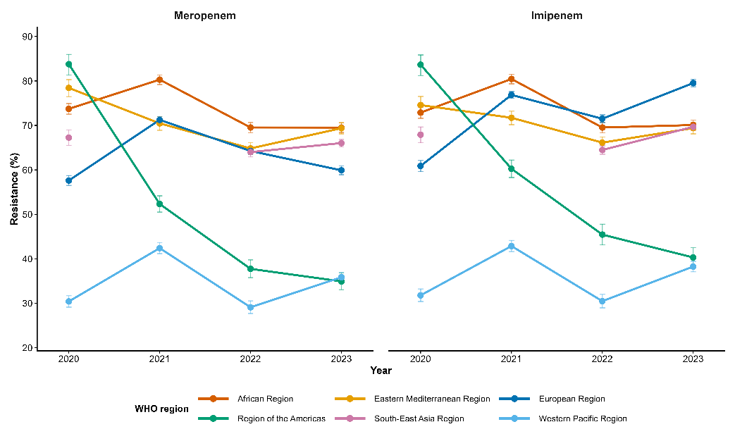

Figure 1. Regional trends in carbapenem resistance among Acinetobacter bloodstream isolates reported to WHO GLASS, 2020–2023. Isolate-weighted pooled resistance estimates were calculated using all reporting countries. Error bars represent Wilson 95% confidence intervals. South-East Asia Region data for 2021 were unavailable from the WHO GLASS dashboard.

The Western Pacific Region consistently demonstrated substantially lower carbapenem resistance than all other WHO regions throughout the study period for both meropenem and imipenem (Figure 1). This pattern remained evident in the fixed-panel sensitivity analysis, suggesting that it was unlikely to be explained solely by changes in reporting-country participation.
In contrast, the African and Eastern Mediterranean Regions consistently exhibited the highest resistance levels throughout the study period, with resistance generally exceeding 70% for both carbapenems. The Region of the Americas showed the most pronounced decline in resistance over time, whereas the European Region displayed divergent temporal patterns, characterized by declining meropenem resistance but increasing imipenem resistance.

3.3 Temporal trend analysis
The Temporal trends in carbapenem resistance were assessed using binomial logistic regression, with year treated as a continuous predictor. Odds ratios (ORs) represent the annual change in the odds of resistance, with values below 1 indicating decreasing odds over time and values above 1 indicating increasing odds.
For meropenem, significant annual decreases in the odds of resistance were observed in the African Region (OR = 0.884, 95% CI: 0.862–0.907, adjusted p < 0.001), Eastern Mediterranean Region (OR = 0.894, 95% CI: 0.863–0.925, adjusted p < 0.001), European Region (OR = 0.969, 95% CI: 0.950–0.988, adjusted p = 0.002), and the Region of the Americas (OR = 0.563, 95% CI: 0.538–0.590, adjusted p < 0.001). No statistically significant temporal trend was identified in the South-East Asia Region (OR = 0.993, 95% CI: 0.965–1.021, adjusted p = 0.610) or the Western Pacific Region (OR = 1.012, 95% CI: 0.989–1.037, adjusted p = 0.343).
For imipenem, significant annual decreases in resistance were similarly observed in the African Region (OR = 0.900, 95% CI: 0.877–0.925, adjusted p < 0.001), Eastern Mediterranean Region (OR = 0.921, 95% CI: 0.890–0.954, adjusted p < 0.001), and the Region of the Americas (OR = 0.569, 95% CI: 0.542–0.598, adjusted p < 0.001). In contrast, significant increases in the odds of resistance were observed in the European Region (OR = 1.242, 95% CI: 1.214–1.271, adjusted p < 0.001), South-East Asia Region (OR = 1.058, 95% CI: 1.028–1.088, adjusted p < 0.001), and the Western Pacific Region (OR = 1.027, 95% CI: 1.002–1.053, adjusted p = 0.044).
Figure 2 provides a complementary overview of regional carbapenem resistance across the study period by displaying pooled resistance estimates for both antibiotics over all four years. The heatmap highlights persistently high resistance in the African and Eastern Mediterranean Regions, consistently lower resistance in the Western Pacific Region, and marked declines in the Region of the Americas. It also illustrates the contrasting patterns observed in the European Region, where meropenem resistance generally declined while imipenem resistance increased over time.
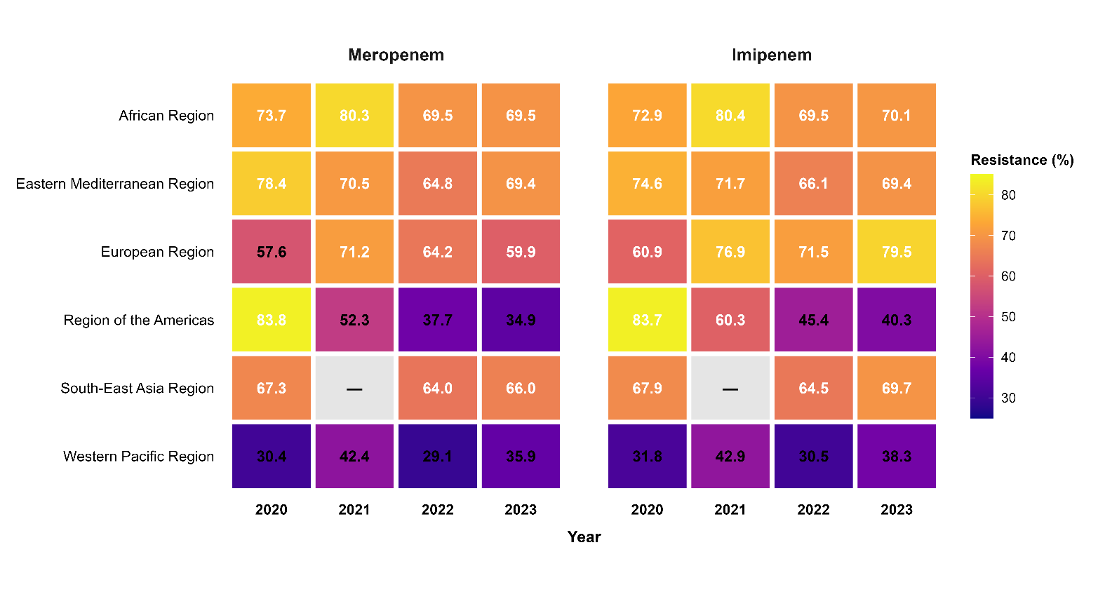
Overall, the regression analysis demonstrated substantial regional heterogeneity in temporal resistance patterns. Declining odds of carbapenem resistance predominated in the African Region, Eastern Mediterranean Region, and the Region of the Americas, whereas increasing imipenem resistance was observed in the European, South-East Asia, and Western Pacific Regions. These findings remained statistically significant following adjustment for multiple comparisons using the Benjamini–Hochberg false discovery rate procedure (Table 2).
Figure 2. Heatmap of regional carbapenem resistance among Acinetobacter bloodstream isolates reported to WHO GLASS, 2020–2023. Isolate-weighted pooled resistance estimates (%) are shown for meropenem and imipenem across WHO regions. Cell colours indicate the magnitude of resistance, with darker colours representing higher resistance. South-East Asia Region data for 2021 were unavailable from the GLASS dashboard.

WHO Region | Antibiotic | Odds Ratio (OR) per Year | 95% Confidence Interval | p-value | BH-adjusted p-value | Interpretation
African Region | Meropenem | 0.884 | 0.862–0.907 | <0.001 | <0.001 | Significant annual decrease (11.6% lower odds of resistance per year)
African Region | Imipenem | 0.900 | 0.877–0.925 | <0.001 | <0.001 | Significant annual decrease (10.0% lower odds of resistance per year)
Eastern Mediterranean Region | Meropenem | 0.894 | 0.863–0.925 | <0.001 | <0.001 | Significant annual decrease (10.6% lower odds of resistance per year)
Eastern Mediterranean Region | Imipenem | 0.921 | 0.890–0.954 | <0.001 | <0.001 | Significant annual decrease (7.9% lower odds of resistance per year)
European Region | Meropenem | 0.969 | 0.950–0.988 | 0.001 | 0.002 | Small but significant annual decrease (3.1% lower odds of resistance per year)
European Region | Imipenem | 1.242 | 1.214–1.271 | <0.001 | <0.001 | Significant annual increase (24.2% higher odds of resistance per year)
Region of the Americas | Meropenem | 0.563 | 0.538–0.590 | <0.001 | <0.001 | Significant annual decrease (43.7% lower odds of resistance per year)
Region of the Americas | Imipenem | 0.569 | 0.542–0.598 | <0.001 | <0.001 | Significant annual decrease (43.1% lower odds of resistance per year)
South-East Asia Region | Meropenem | 0.993 | 0.965–1.021 | 0.610 | 0.610 | No significant temporal trend
South-East Asia Region | Imipenem | 1.058 | 1.028–1.088 | <0.001 | <0.001 | Significant annual increase (5.8% higher odds of resistance per year)
Western Pacific Region | Meropenem | 1.012 | 0.989–1.037 | 0.314 | 0.343 | No significant temporal trend
Western Pacific Region | Imipenem | 1.027 | 1.002–1.053 | 0.037 | 0.044 | Slight but statistically significant annual increase (2.7% higher odds of resistance per year)
Abbreviations: OR, odds ratio; CI, confidence interval; BH, Benjamini–Hochberg false discovery rate correction. Odds ratios were estimated using binomial logistic regression with year modeled as a continuous variable (2020–2023). OR < 1 indicates decreasing odds of resistance over time, whereas OR > 1 indicates increasing odds of resistance.
Statistical significance was assessed using two-sided tests

3.4 Sensitivity Analysis
To assess whether temporal trends were influenced by changes in country participation, a sensitivity analysis was performed using only countries that reported carbapenem susceptibility data continuously from 2020 to 2023. Continuously reporting countries were identified within each WHO region, resulting in a reduced dataset comprising 370 observations from 48 countries across five WHO regions. The South-East Asia Region could not be included because no country met the criterion of continuous reporting throughout the study period.
Overall, the direction of temporal trends remained consistent with the primary analysis. Significant annual decreases in carbapenem resistance continued to be observed in the African Region and Eastern Mediterranean Region for both meropenem and imipenem. The European Region retained a significant decrease in meropenem resistance and a significant increase in imipenem resistance, although the magnitude of these associations differed from the primary analysis. In the Region of the Americas, declining resistance trends remained evident but were less pronounced after restricting the analysis to continuously reporting countries. In the Western Pacific Region, increasing trends became more apparent in the fixed-panel analysis. Collectively, these findings indicate that the principal conclusions were generally robust to changes in reporting participation, although the magnitude of regional trends was influenced by the composition of reporting countries.
Overall, the findings demonstrate substantial regional heterogeneity in carbapenem resistance among Acinetobacter bloodstream isolates reported to WHO GLASS between 2020 and 2023. While several regions exhibited significant declines in resistance over time, others showed stable or increasing trends, particularly for imipenem. Sensitivity analyses indicated that although changes in reporting-country participation influenced the magnitude of some regional associations, the overall direction of temporal trends remained broadly consistent.
Detailed regression estimates from the fixed-panel sensitivity analysis are presented in Supplementary Table S2

4. Discussion
This study provides a contemporary overview of regional and temporal patterns of carbapenem resistance among Acinetobacter spp. bloodstream isolates reported to the WHO GLASS surveillance system between 2020 and 2023. Carbapenem resistance remained alarmingly high across most WHO regions, particularly in the African and Eastern Mediterranean Regions, where pooled resistance frequently exceeded 70% for both meropenem and imipenem. In contrast, the Western Pacific Region consistently demonstrated substantially lower resistance than all other regions throughout the study period. Regression analyses further revealed marked regional heterogeneity in temporal trends, with significant declines in resistance observed in several regions, while increasing imipenem resistance was identified in the European, South-East Asia, and Western Pacific Regions.
Beyond describing regional resistance patterns, this study highlights an important methodological consideration for analyses based on multinational surveillance systems. Because participation in GLASS varies across countries and over time, apparent temporal changes in regional resistance may partly reflect changes in reporting composition rather than true epidemiological trends. The fixed-panel sensitivity analysis demonstrated that, although restricting analyses to continuously reporting countries altered the magnitude of several regional associations, the overall direction of temporal trends remained broadly consistent. These findings suggest that the principal conclusions are robust while emphasizing that reporting-country participation should be explicitly considered when interpreting longitudinal analyses of GLASS surveillance data.

4.1 Comparison with published literature
The regional resistance patterns observed in this study are broadly consistent with the established burden of carbapenem-resistant Acinetobacter baumannii reported in the literature, although direct numerical comparisons should be interpreted cautiously because published studies often use different epidemiological measures and study designs. A systematic review and meta-analysis of hospital-acquired A. baumannii infections in Europe, the Eastern Mediterranean, and Africa reported a substantial burden of carbapenem-resistant infections in these regions, supporting the high resistance levels observed in the present analysis, despite reporting incidence- and prevalence-based measures rather than isolate-level resistance proportions [3].
Our estimates for the African Region were higher than those reported in a systematic review of sub-Saharan Africa, which estimated a pooled carbapenem-resistant A. baumannii prevalence of 20% (95% CI: 4–43%) [4]. This discrepancy is likely to reflect methodological differences between studies, including differences in geographic coverage, surveillance populations, study selection, and outcome definitions. Whereas the present study analysed routine national surveillance data from WHO GLASS using isolate-level resistance among bloodstream infections, the published meta-analysis synthesized heterogeneous individual studies conducted in selected healthcare settings. Consequently, the two estimates should be regarded as complementary rather than directly comparable.
A recent global meta-analysis reported a continued increase in carbapenem resistance among A. baumannii, with pooled resistance exceeding 80% during the 2020–2023 period [5]. In contrast, the present analysis identified significant declines in carbapenem resistance in several WHO regions, particularly the African Region, Eastern Mediterranean Region, and Region of the Americas, while resistance remained stable or increased in others. These differing observations most likely reflect differences in data sources and analytical approaches. Published meta-analyses primarily synthesize peer-reviewed studies, which may overrepresent tertiary referral centres, outbreak investigations, or settings with particularly high resistance burdens. In contrast, WHO GLASS aggregates routine national surveillance data collected using standardized reporting procedures, providing a complementary population-level perspective on regional antimicrobial resistance trends. Together, these findings highlight the importance of considering both surveillance-based and literature-based evidence when evaluating the global epidemiology of carbapenem-resistant Acinetobacter.

4.2 Limitations
This study has several limitations. First, the analyses were based on aggregated surveillance data reported to WHO GLASS rather than patient-level data, precluding adjustment for important clinical and epidemiological factors such as patient demographics, comorbidities, healthcare setting, prior antimicrobial exposure, and infection source. Second, the completeness and quality of national surveillance systems vary across participating countries, and differences in laboratory capacity, antimicrobial susceptibility testing practices, and reporting completeness may have influenced regional estimates. Third, because participation in GLASS changes over time, apparent temporal trends may be affected by changes in reporting-country composition. Although this issue was addressed through a fixed-panel sensitivity analysis, residual bias cannot be excluded. Fourth, the number of continuously reporting countries was limited in some regions, reducing the generalizability of fixed-panel estimates. Finally, South-East Asia Region data for 2021 were unavailable from the GLASS dashboard at the time of data extraction, preventing inclusion of that year in analyses involving a continuous four-year panel.
Accordingly, these findings should be interpreted as surveillance-based estimates describing antimicrobial resistance among reporting countries rather than definitive measures of the population-level burden of carbapenem-resistant Acinetobacter bloodstream infections.

4.3 Future directions
The analytical framework presented in this study can be readily extended to other priority pathogens, specimen types, and antimicrobial classes available within the WHO GLASS surveillance system. Applying standardized methods for estimating pooled resistance, evaluating temporal trends, and accounting for changes in reporting-country participation would facilitate more robust longitudinal comparisons across pathogens and regions.
Future research should integrate GLASS phenotypic surveillance data with genomic surveillance and country-level health system indicators to better understand the drivers of regional differences in antimicrobial resistance. Linking resistance trends with information on antimicrobial consumption, infection prevention and control programmes, healthcare infrastructure, and the distribution of resistance determinants could provide a more comprehensive understanding of the factors influencing carbapenem resistance and support more targeted public health interventions.

5. Conclusion
Carbapenem resistance among Acinetobacter spp. bloodstream isolates remained alarmingly high across most WHO regions between 2020 and 2023, although substantial regional heterogeneity in both resistance levels and temporal trends was observed. The Western Pacific Region consistently demonstrated markedly lower resistance than other WHO regions, whereas the African and Eastern Mediterranean Regions maintained persistently high resistance throughout the study period.
Beyond describing contemporary global resistance patterns, this study demonstrates the importance of accounting for changes in reporting-country participation when interpreting longitudinal analyses of WHO GLASS surveillance data. Although sensitivity analyses showed that the overall direction of regional trends was generally robust, changes in reporting composition influenced the magnitude of several temporal associations. Applying standardized analytical approaches that incorporate these considerations will improve the interpretation of global antimicrobial resistance surveillance data and support more reliable evidence for public health decision-making and antimicrobial stewardship.

Data and Code Availability
Source data were obtained from the publicly accessible WHO GLASS-AMR dashboard (https://worldhealthorg.shinyapps.io/glass-dashboard/).
Data and Code Availability: Source data were obtained from the WHO GLASS dashboard. Processed datasets, analysis scripts, and code used to generate all tables and figures are publicly available in the accompanying GitHub repository: https://github.com/DocWaqas/acinetobacter-carbapenem-glass-trends.

Author Contributions
Dr. Mohammad Waqas conceived the analysis, collected and processed the data, conducted the analysis, and drafted the manuscript.

Conflicts of Interest
None declared.

Supplementary Table S1: Fixed-panel country lists by region
Region | Countries (reported all 4 years)
African Region (imipenem) | Mauritius, South Africa
African Region (meropenem) | Ethiopia, Mauritius, South Africa
Eastern Mediterranean Region | Bahrain, Iran, Iraq, Jordan, Kuwait, Oman, Pakistan, Qatar, Saudi Arabia, Tunisia, United Arab Emirates
European Region (imipenem) | 22 countries including Austria, Belgium, Croatia, Germany, Italy, Poland, Ukraine, United Kingdom
European Region (meropenem) | 24 countries, overlapping list plus Denmark, Finland, Ireland
Region of the Americas | Argentina, Brazil, Peru
Western Pacific Region (imipenem) | Australia, Japan, Philippines, Republic of Korea
Western Pacific Region (meropenem) | Australia, Brunei Darussalam, Japan, Philippines, Republic of Korea, Singapore
Full country lists available in repository.

Supplementary Table S2: Sensitivity analysis of temporal trends in carbapenem resistance among Acinetobacter bloodstream isolates using only continuously reporting countries (fixed-panel analysis), WHO GLASS 2020–2023.
This table presents the results of binomial logistic regression performed on a fixed-panel dataset comprising countries that reported continuously throughout the study period (2020–2023). Odds ratios (ORs), 95% confidence intervals (CIs), p-values, and Benjamini–Hochberg (BH) adjusted p-values are reported to evaluate the robustness of temporal resistance trends observed in the unrestricted analysis.
Region | Drug | OR | LowerCI | UpperCI | P
African Region | Meropenem | 0.916 | 0.892 | 0.941 | 2.15E-10
African Region | Imipenem | 0.913 | 0.888 | 0.938 | 6.62E-11
Eastern Mediterranean Region | Meropenem | 0.883 | 0.852 | 0.915 | 9.05E-12
Eastern Mediterranean Region | Imipenem | 0.907 | 0.875 | 0.94 | 9.88E-08
European Region | Meropenem | 0.809 | 0.792 | 0.827 | 1.6E-82
European Region | Imipenem | 1.072 | 1.044 | 1.1 | 1.91E-07
Region of the Americas | Meropenem | 0.832 | 0.776 | 0.892 | 1.88E-07
Region of the Americas | Imipenem | 0.822 | 0.765 | 0.883 | 9.04E-08
Western Pacific Region | Meropenem | 1.092 | 1.055 | 1.131 | 7.07E-07
Western Pacific Region | Imipenem | 1.146 | 1.105 | 1.188 | 2.57E-13

References
1. World Health Organization. WHO Bacterial Priority Pathogens List, 2024: Bacterial Pathogens of Public Health Importance to Guide Research, Development and Strategies to Prevent and Control Antimicrobial Resistance. Geneva: WHO; 2024.
2. World Health Organization. GLASS Manual for Antimicrobial Resistance Surveillance in Common Bacteria Causing Human Infection. Geneva: World Health Organization; 2023.
3. Ayobami O, Willrich N, Harder T, Okeke IN, Eckmanns T, Markwart R. The incidence and prevalence of hospital-acquired (carbapenem-resistant) Acinetobacter baumannii in Europe, Eastern Mediterranean and Africa: a systematic review and meta-analysis. Emerg Microbes Infect. 2019;8(1):1747-1759.
4. Arowolo MT, Orababa OQ, Olaitan MO, Osibeluwo BV, Essiet UU, Batholomew OH, et al. Prevalence of carbapenem resistance in Acinetobacter baumannii and Pseudomonas aeruginosa in sub-Saharan Africa: a systematic review and meta-analysis. PLoS One. 2023;18(11):e0287762.
5. Beig M, Parvizi E, Navidifar T, Bostanghadiri N, Mofid M, Golab N, Sholeh M. Geographical mapping and temporal trends of Acinetobacter baumannii carbapenem resistance: a comprehensive meta-analysis. PLoS One. 2024;19(12):e0311124.

