Store Management screen

* First screen on start up
* Leads to: Add Product screen, Add Customer screen, Add Purchase screen

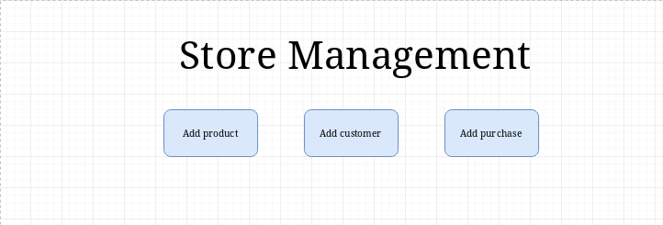

Add Product Screen

* Leads to: Successful Add popup and Add Errors popup
* CANCEL button leads to previous screen

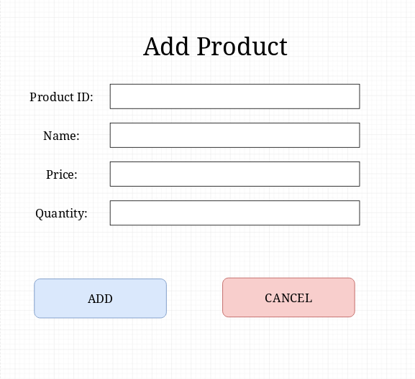

Add Customer Screen

* Leads to: Successful Add popup and Add Errors popup
* CANCEL button leads to previous screen

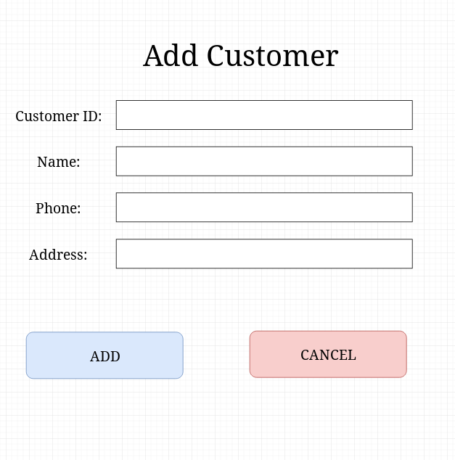

Add Purchase Screen

* Leads to: Successful Add popup and Add Errors popup
* CANCEL button leads to previous screen

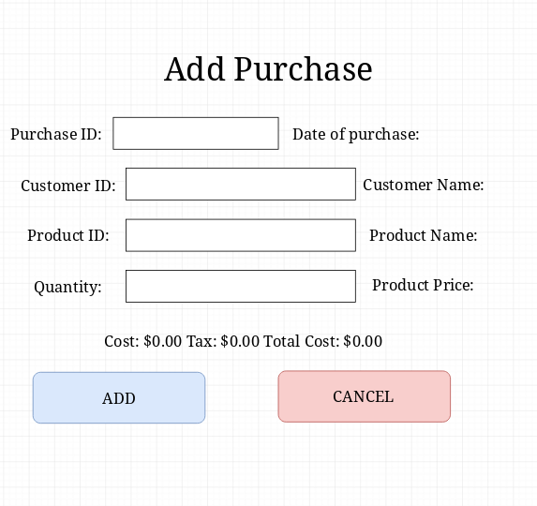

Successful Add popup

* Ok button leads to previous screen

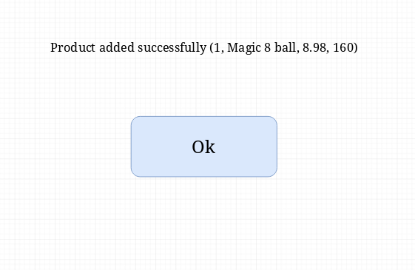

Add Errors popup

* OK button leads to previous screen

