**Use Case 1: adding a new product to the system successfully**

Step 1: Choose command “add product”.

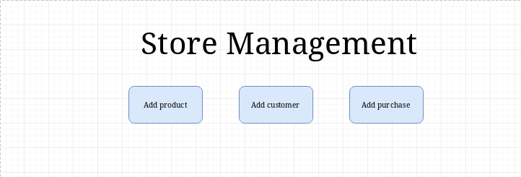

Step 2: Display “add product” screen.

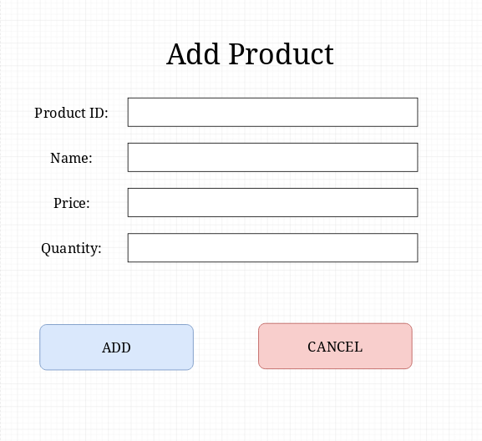

Step 3: Input data and click “ADD”.

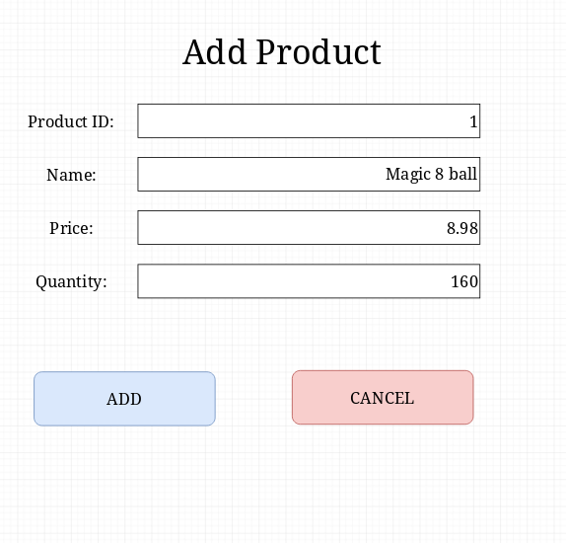

Step 4: Hide “add product” screen and display “Product Added Successfully” screen.

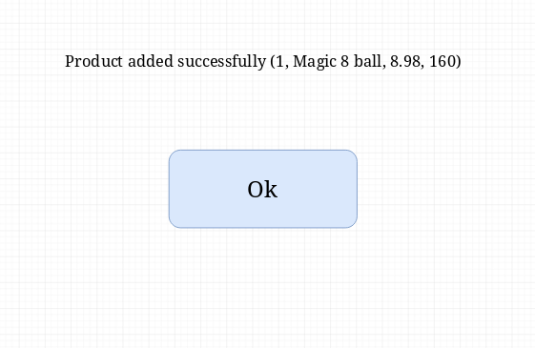

Step 5: Click the “Ok” button.

*No new screen*

Step 6: Return to the “Store Management” screen

*No new screen*

**Use Case 2: adding a duplicate product to the store and being corrected**

Step 1: Choose command “add product”.



Step 2: Display “add product” screen.



Step 3: Input data and click “ADD”.

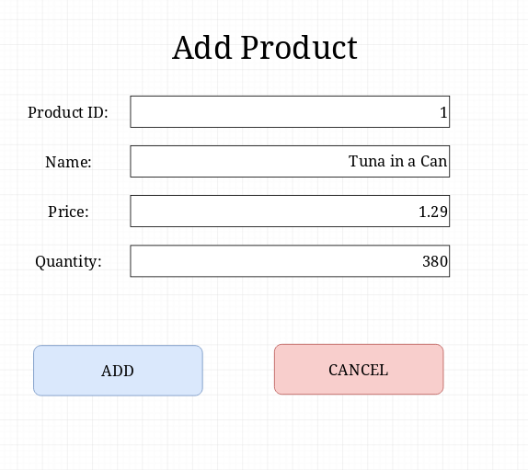

*note: there already exists a product with product ID = 1

Step 4: Display “product failed: duplicate” popup and click “OK”

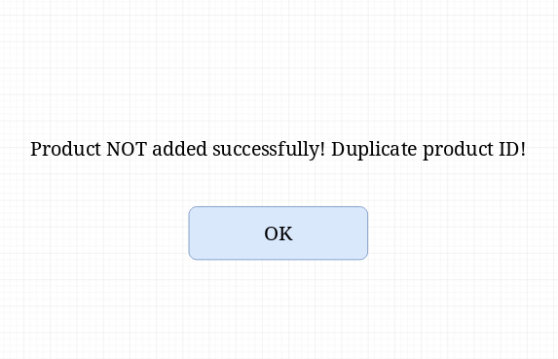

Step 5: Click the “Ok” button.

*No new screen*

Step 6: Return to the “Store Management” screen

*No new screen*

**Use Case 3: adding a new customer to the system successfully**

Step 1: Choose command “add customer”.



Step 2: Display “add customer” screen.

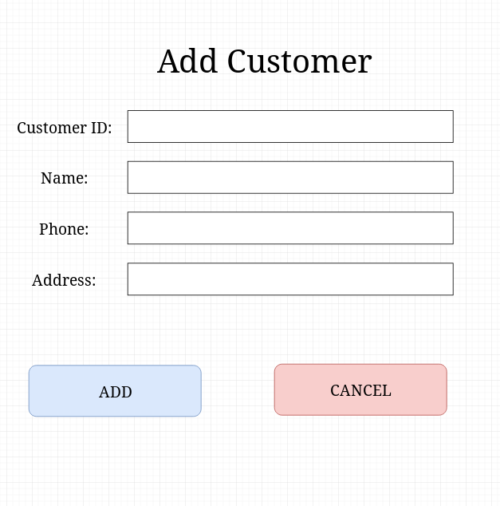

Step 3: Input data and click “ADD”.

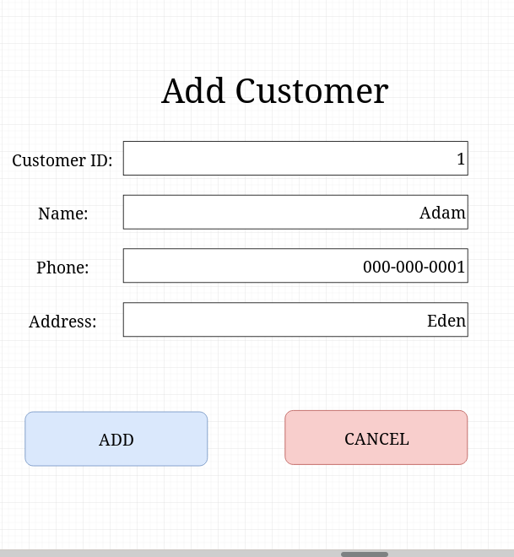

Step 4: Hide “add customer” screen and display “Customer Added Successfully” screen.

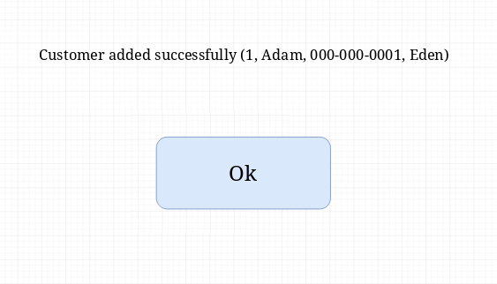

Step 5: Click the “Ok” button.

*No new screen*

Step 6: Return to the “Store Management” screen

*No new screen*

**Use Case 4: adding a new customer with no address to the store and being corrected**

Step 1: Choose command “add customer”.



Step 2: Display “add customer” screen.



Step 3: Input data and click “ADD”.

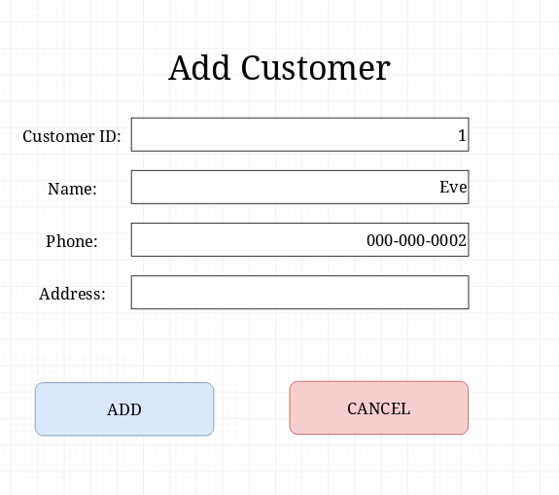

*note: Address is empty

Step 4: Hide “add customer” screen and display “Customer Added Successfully” screen.

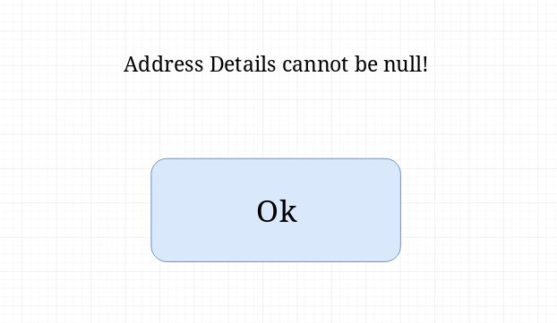

Step 5: Click the “Ok” button.

*No new screen*

Step 6: Return to the “Store Management” screen

*No new screen*

**Use Case 5: adding a purchase to the system successfully**

Step 1: Choose command “Add purchase”.



Step 2: Display “add purchase” screen.

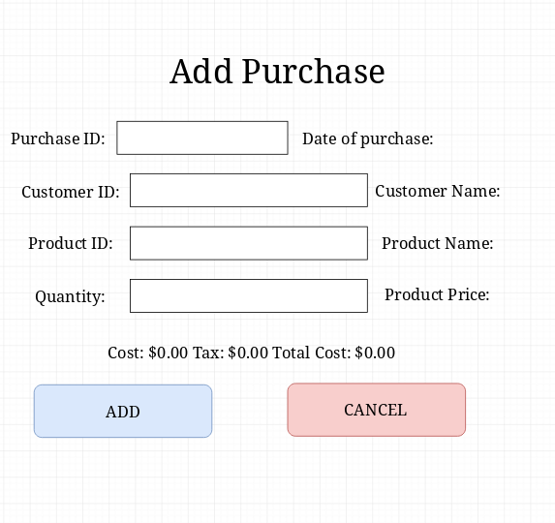

Step 3: Input data and click “ADD”.

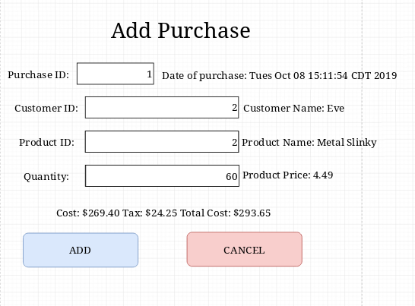

Step 4: Hide “add purchase” screen and display “Purchase1 Added Successfully” screen.

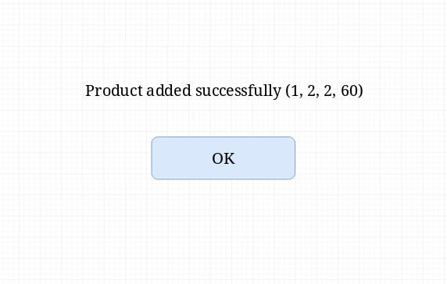

Step 5: Click the “Ok” button.

*No new screen*

Step 6: Return to the “Store Management” screen

*No new screen*

**Use Case 6: adding a purchase to the store but using an invalid customerID**

Step 1: Choose command “Add purchase”.



Step 2: Display “add purchase” screen.



Step 3: Input data and click “ADD”.

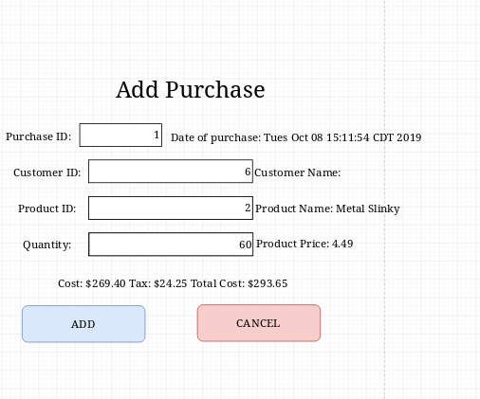

Step 4: Hide “add purchase” screen and display “error invalid Id” screen.

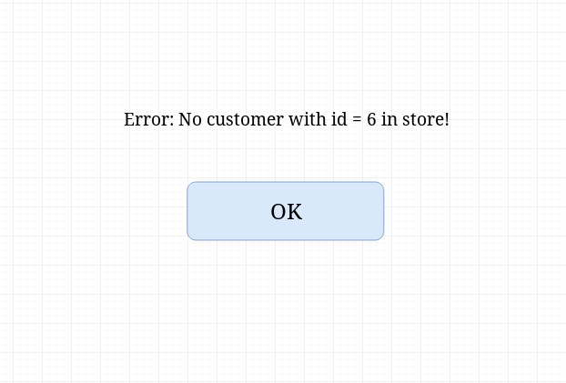

Step 5: Click the “Ok” button.

*No new screen*

Step 6: Return to the “Store Management” screen

*No new screen*