Store Management screen

* First screen on start up
* Leads to: Manage Product screen, Manage Customer screen, Manage Purchase screen

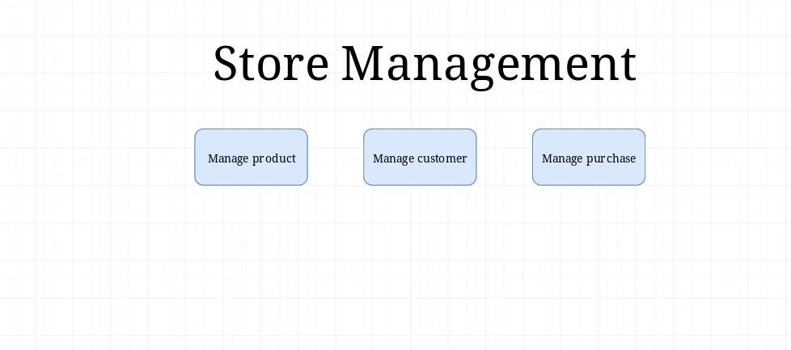

Manage Product Screen

* Load Product button leads to Available Product ID and a server response
* Save Product button loads to Product Updated Successfully and Error popup

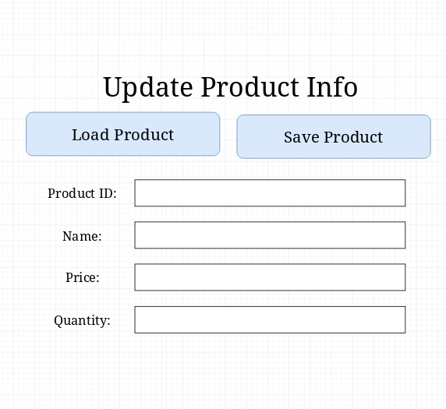

Manage Customer Screen

* Load Customer button leads to Available Customer ID and a server response
* Save Customer button loads to Customer Updated Successfully and Error popup

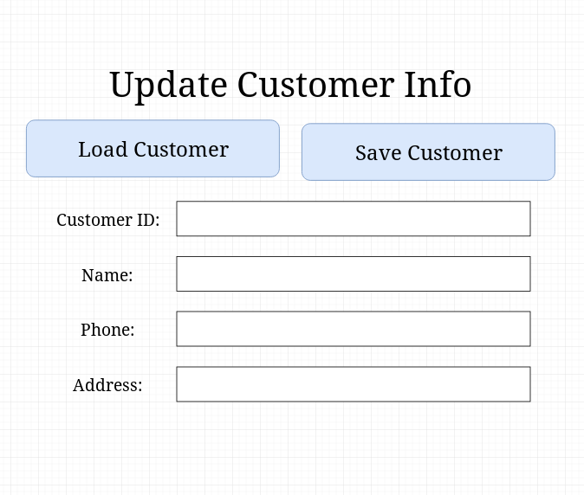

Manage Purchase Screen

* Load Purchase button leads to Available Purchase ID and a server response
* Save Purchase button loads to Purchase Updated Successfully and Error popup

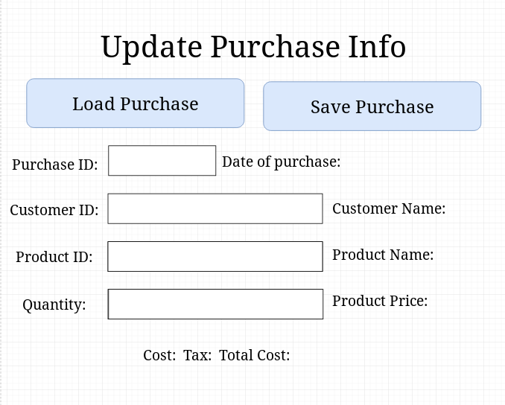

Product/Customer/Purchase Updated Successfully popup

* Ok button leads to previous screen

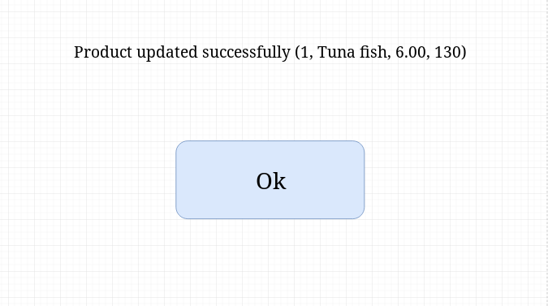

Available Product/Customer/Purchase ID popup

* Ok button leads to previous screen

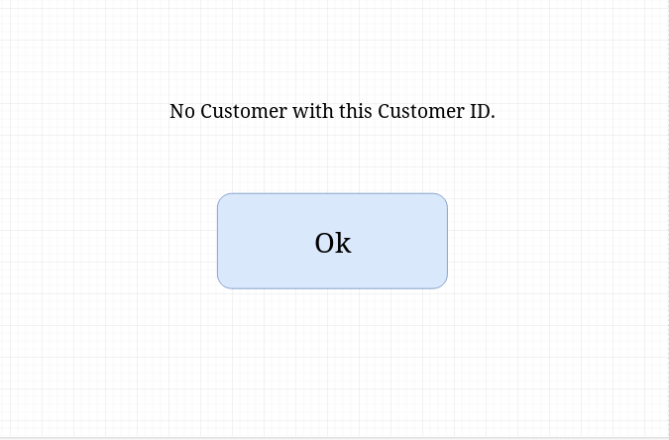

Update Errors popup

* OK button leads to previous screen

