**Use Case 1: adding a new product to the system**

Step 1: Choose command “Manage product”.

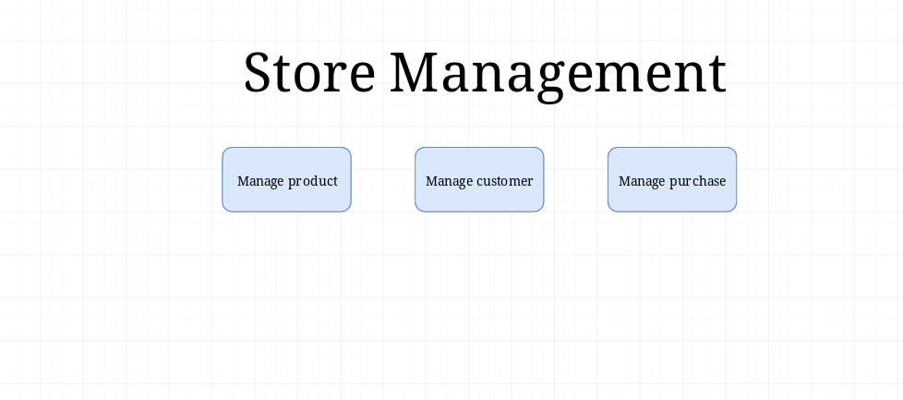

Step 2: Display “Manage product” screen.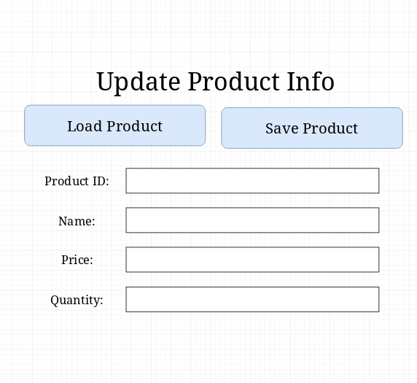

Step 3: Input Product ID and click “Load Product” to check availability.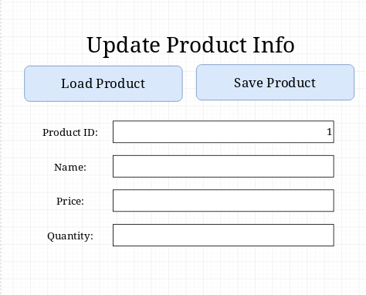

Step 4. Display “Available Product ID” screen and click “Ok”.

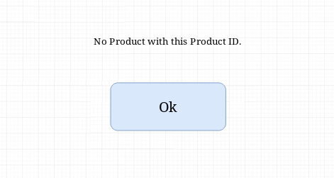

Step 5: Redisplay “Manage product” screen, enter product info into item fields and click “Save product”.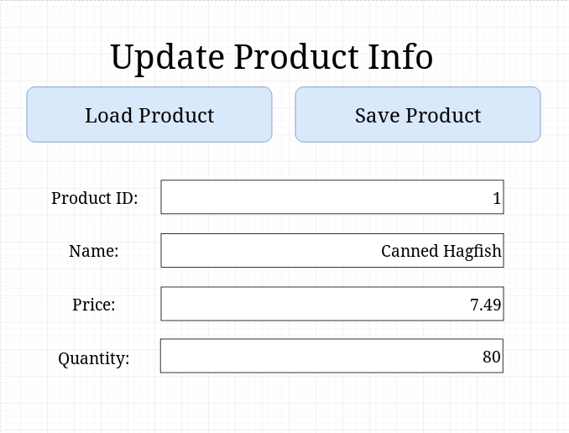

Step 6: Hide “Manage product” screen and display “Product Updated Successfully” screen.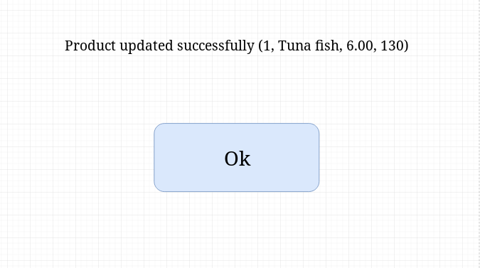

Step 7: Click the “Ok” button.

*No new screen*

Step 8: Return to the “Store Management” screen.

*No new screen*

**Use Case 2: updating a product already in the system**

Step 1: Choose command “Manage product”.

Step 2: Display “Manage product” screen.

Step 3: Input Product ID and click “Load Product” to check current values.

Step 4. Call up values from server.

Step 5: Update values so they are correct and click “Save Product”. 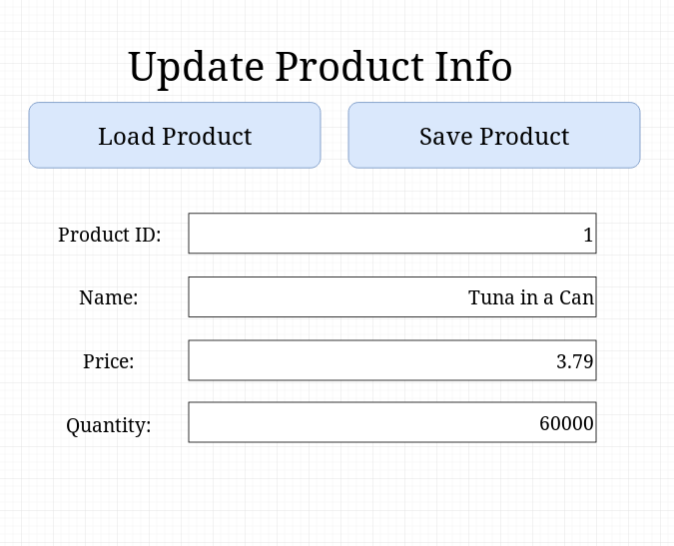

Step 6: Hide “Manage product” screen and display “Product Updated Successfully” screen.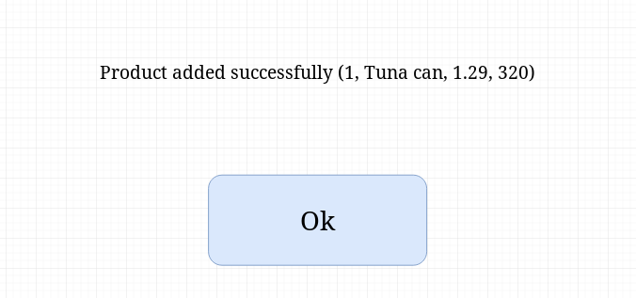

Step 7: Click the “Ok” button.

*No new screen*

Step 8: Return to the “Store Management” screen.

*No new screen*

**Use Case 3: adding a new customer to the system**

Step 1: Choose command “Manage product”.



Step 2: Display “Manage customer” screen.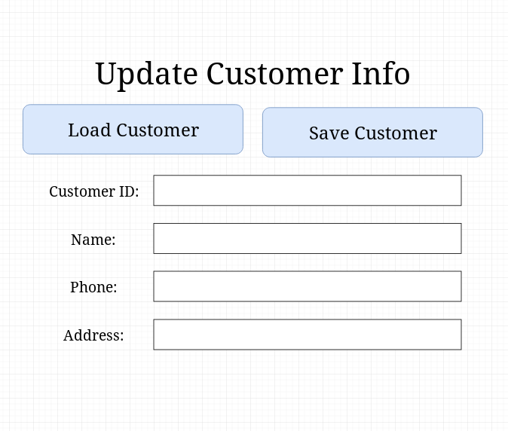

Step 3: Input Customer ID and click “Load Customer” to check availability.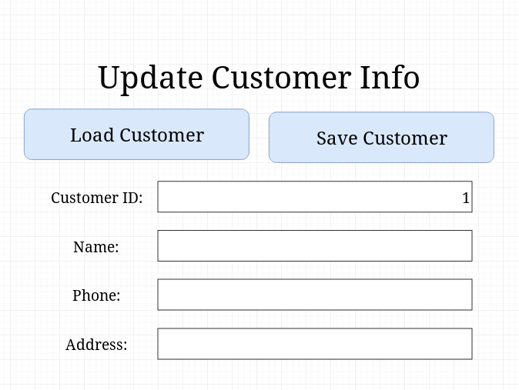

Step 4. Display “Available Customer ID” screen and click “Ok”.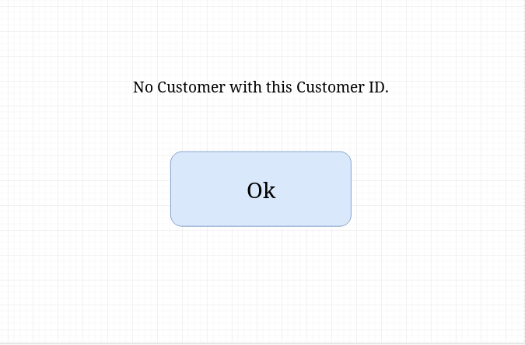

Step 5: Redisplay “Manage customer” screen, enter customer info into item fields and click “Save product”.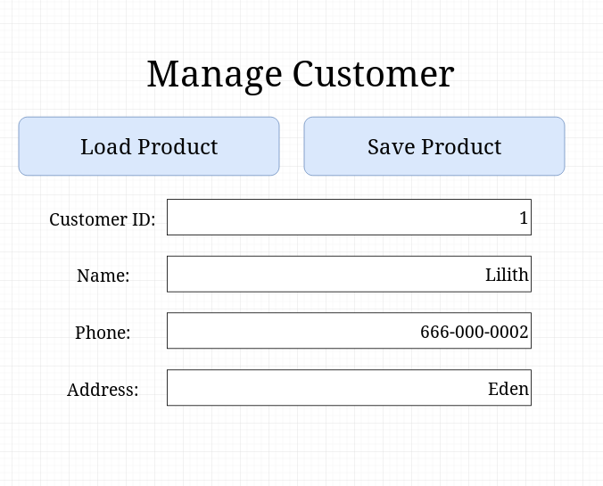

Step 6: Hide “Manage customer” screen and display “Customer Updated Successfully” screen.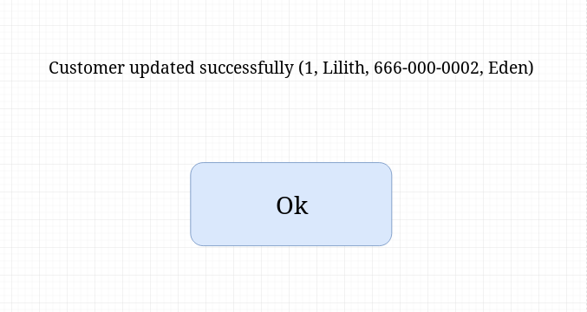

Step 7: Click the “Ok” button.

*No new screen*

Step 8: Return to the “Store Management” screen.

*No new screen*

**Use Case 4: updating a customer already in the system**

Step 1: Choose command “Manage customer”.

Step 2: Display “Manage customer” screen.

Step 3: Input Customer ID and click “Load Customer” to check current values.

Step 4. Call up values from server.

Step 5: Update values so they are correct and click “Save Product”. 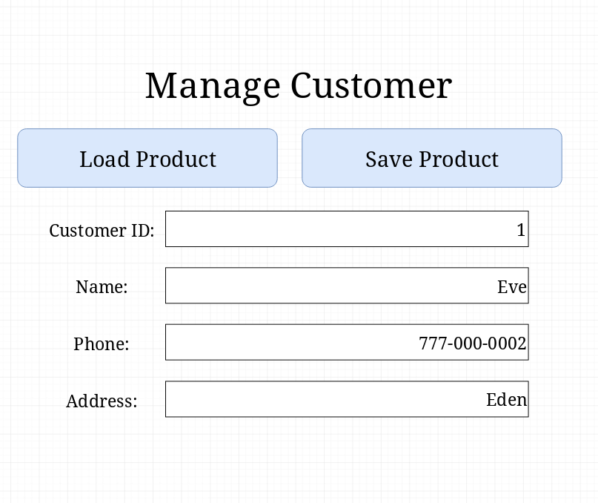

Step 6: Hide “Manage customer” screen and display “Customer Updated Successfully” screen.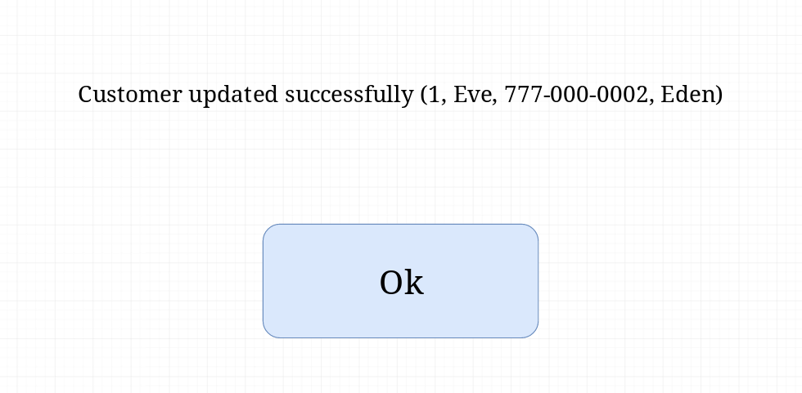

Step 7: Click the “Ok” button.

*No new screen*

Step 8: Return to the “Store Management” screen.

*No new screen*

**Use Case 5: adding a new purchase to the system**

Step 1: Choose command “Manage customer”.



Step 2: Display “Manage purchase” screen.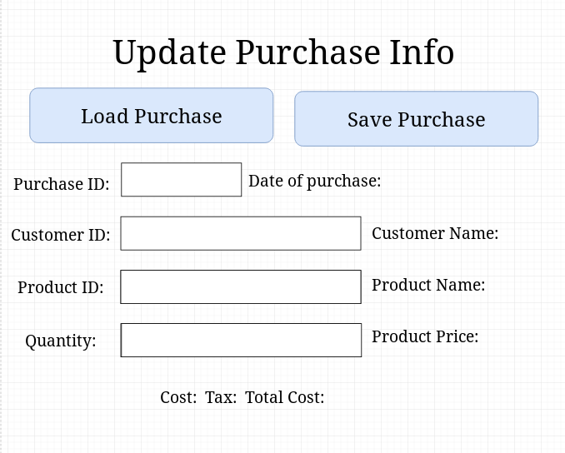

Step 3: Input Purchase ID and click “Load Purchase” to check availability.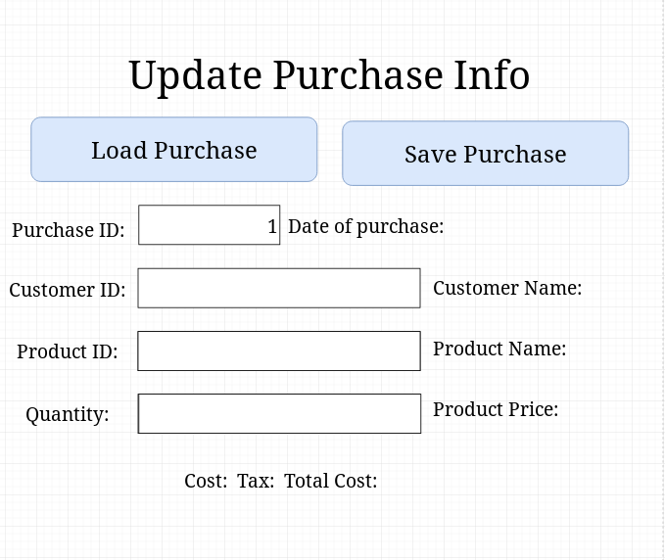

Step 4. Display “Available Purchase ID” screen and click “Ok”.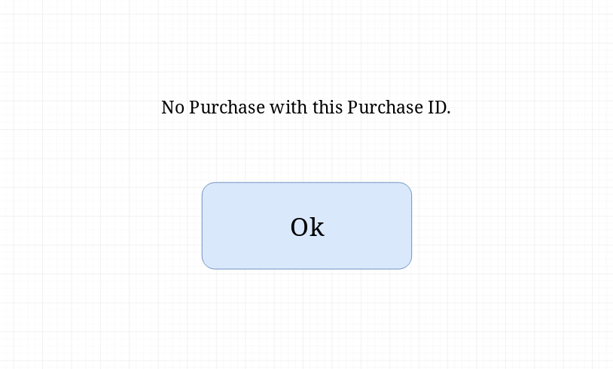

Step 5: Redisplay “Manage purchase” screen, enter purchase information into item fields and click “Save purchase”.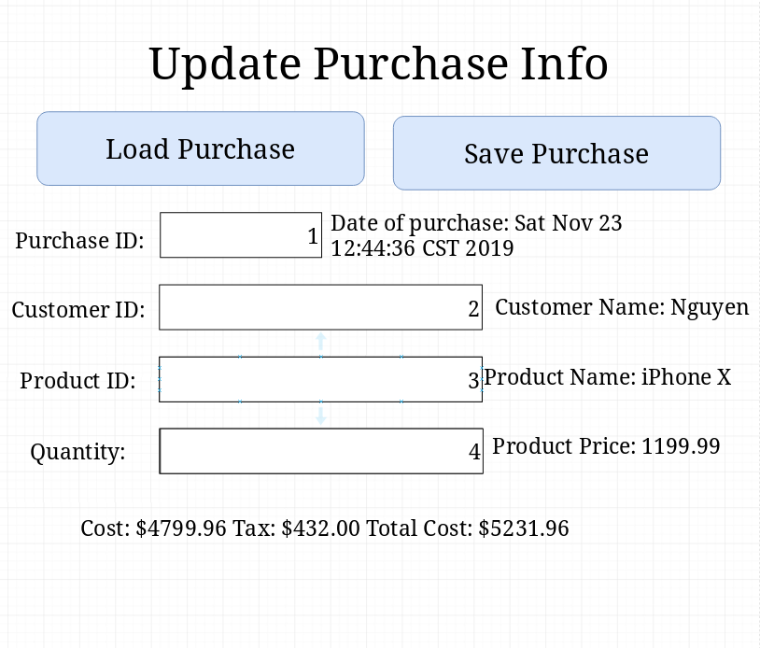

Step 6: Hide “Manage customer” screen and display “Customer Updated Successfully” screen.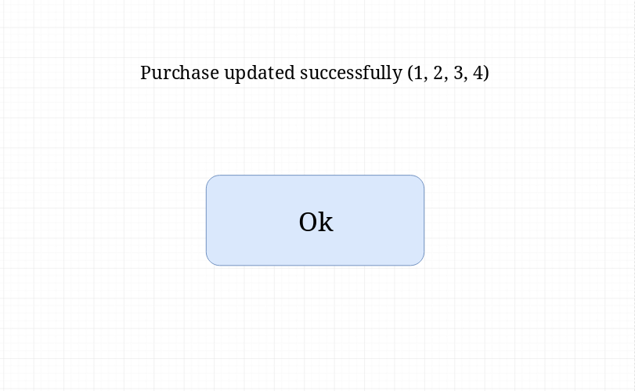

Step 7: Click the “Ok” button.

*No new screen*

Step 8: Return to the “Store Management” screen.

*No new screen*

**Use Case 6: updating a purchase already in the system**

Step 1: Choose command “Manage customer”.

Step 2: Display “Manage purchase” screen.

Step 3: Input Purchase ID and click “Load Purchase” to check current values.

Step 4. Call up values from server.

Step 5: Update values so they are correct and click “Save Product”. 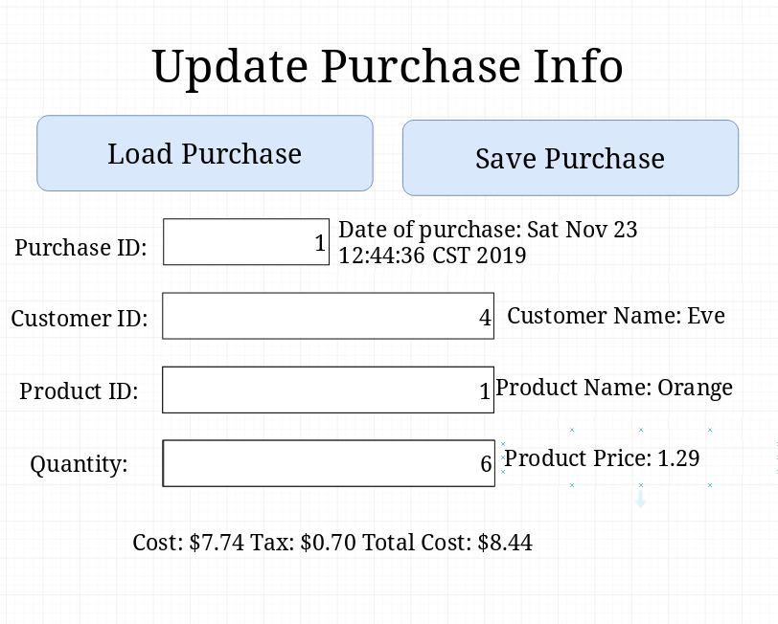

Step 6: Hide “Manage product” screen and display “Product Updated Successfully” screen.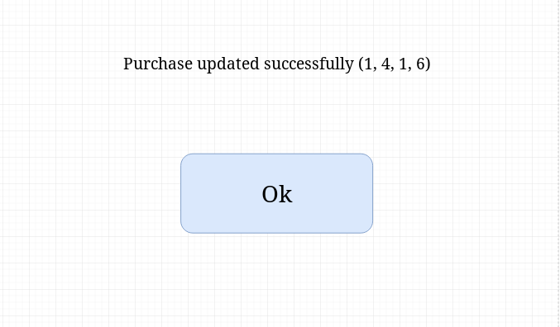

Step 7: Click the “Ok” button.

*No new screen*

Step 8: Return to the “Store Management” screen.

*No new screen*